Tokyo Japan
DWN
DSGN
CHKD
APPD
・ ・
・ ・
・ ・
・ ・
1
2
3
4
1

2
3
Ａ
Ｂ
Ｃ
Ｄ
Ｅ
Ｆ

1/15

High resolution progressive scan monochrome CCD camera
(Frame shutter)

KP-F100B
Specifications (preliminary)

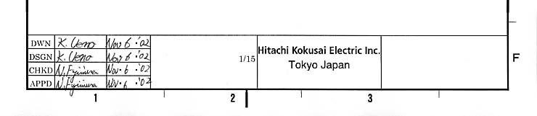
1. Outline

Hitachi's KP-F100B is a 2/3-inch size black and white CCD camera designed for high resolution and versatile functions. Progressive scan with full pixel independent readout and full frame shutter provide images of unparalleled quality at 15 frames per second non-interlaced output.
Effective picture elements number 1.45 million, while the broad array of functions includes digital output, multi-step electronic shutter, HD/VD external sync and frame on demand. The square lattice pixel format also provides excellent suitability for image processing applications.

2. Outstanding features

(1) High resolution
High grade CCD with 1392 (H) × 1040 (V) effective pixels.
(2) Frame shutter
The frame shutter function improves vertical resolution of moving objects..
(3) Multistep electronic shutter
The shutter speed can be selected in 8 steps from 1/30th to 1/50,000th of a second.
(4)Frame on demand
An external trigger signal input can be used to capture an image at a desired timing for instant view or processing. The capture time can be adjusted by the trigger and shutter.
(5) The self-contained CPU permits using RS-232C control for setting each function. The functions can also be set from rear panel switches.
(6) Digital output
An EIA-644 digital output is provided.

Tokyo Japan
DWN
DSGN
CHKD
APPD
・ ・
・ ・
・ ・
・ ・
1
2
3
4
1

2
3
Ａ
Ｂ
Ｃ
Ｄ
Ｅ
Ｆ

2/15

3. Specifications

Tokyo Japan
DWN
DSGN
CHKD
APPD
・ ・
・ ・
・ ・
・ ・
1
2
3
4
1

2
3
Ａ
Ｂ
Ｃ
Ｄ
Ｅ
Ｆ

3/15

(1) Pickup element 2/3-inch interline CCD
Total pixels 1432 (H) × 1050(V)
Effective pixels 1392 (H) × 1040 (V)
Pixel pitch 6.45 (H) × 6.45 (V) μm (square lattice)
(2) Imaging area 8.98 (H) × 6.71 (V) mm
(3) Scanning system Non-interlaced
(4) Aspect ratio 4 :3
(5) Frame rate 15frames/second (full pixel readout)
60fps (4×accelerated mode)
Factory setting is 15 fps.
Selected by rear panel switch.
(6) Horizontal scanning frequency 16 kHz
(7) Vertical scanning frequency 15 Hz
(8) Synchronization Internal/external (automatic switching)
(9) Lens mount C mount
(10) Flange focal distance 17.526 mm
(11) Video output Digital output or analog output for image checking
Analog output (option)
Digital output EIA-644
Note: Maximum digital out cable length is 10meters.
Data : single channel 10 bits, 28.64 MHz

(12)External sync input HD/VD negative
Level: see page 11(External signal level)
Input impedance: 1 kΩ
Frequency deviation: ±1%

(13)Electronic shutter speed Selectable by external switches: Off (frame rate), 1/30, 1/125, 1/250, 1/1000, 1/2000, 1/4000, 1/10000
1/50000 second.
Off: Normal exposure (frame rate)
Set by external switch; factory setting is off (1/15 second).
(14) Gamma compensation γ = 1
(15)Frame on demand External switch setting on/off and modes (fixed shutter two trigger and one trigger). Factory setting is all off.

Fixed shutter mode

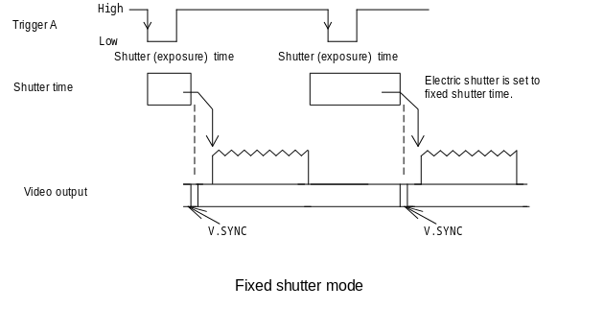
Two trigger mode
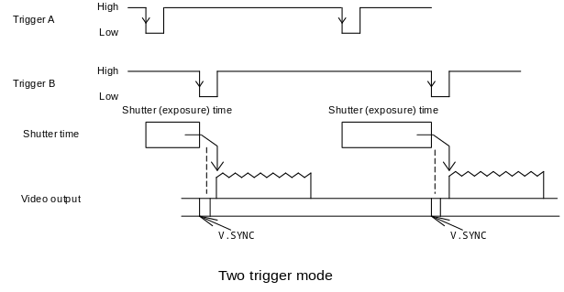
One trigger mode
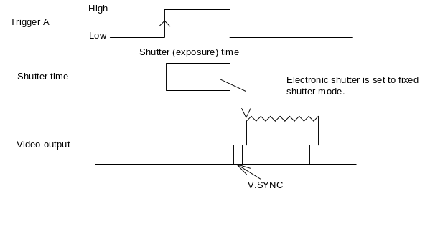

Tokyo Japan
DWN
DSGN
CHKD
APPD
・ ・
・ ・
・ ・
・ ・
1
2
3
4
1

2
3
Ａ
Ｂ
Ｃ
Ｄ
Ｅ
Ｆ

4/15

(16)Power supply voltage 12 ± 1 VDC
(17) Current consumption Approx. 320 mA

(18)Ambient, operating 0 to + 40 ℃(+32 to ; 104 F), less than 90 % RH
Ambient, storage -10 to + 50 ℃(+14 to +122 F), less than 70 % RH

Note: If operated continuously, be sure to use at less than +40 ℃(104 F) for long term stable performance.

(19) Vibration endurance 29.42 m/s² (3 directions, 30 minutes each)
(20) Shock endurance 294.2 m/s² (vertical, horizontal, once each face)
(21) External dimensions 44 (W) × 44 (H) × 78 (D) mm
(22) Mass Approx. 180 g

Tokyo Japan
DWN
DSGN
CHKD
APPD
・ ・
・ ・
・ ・
・ ・
1
2
3
4
1

2
3
Ａ
Ｂ
Ｃ
Ｄ
Ｅ
Ｆ

5/15
(23) RS-232C control
(a) Signal system
Control system Start-stop synchronization system
Transmission rate 9600 bps
Data length 8 bits
Start bit 1
Stop bits 2
Parity None
Bit transfer LSB first
(b) Communications control system
Full control by remolte control software, data send/receive by text data transfer to
camera microprocessor (BSC system handshake)
(C) Control items
1. Shutter speed (1/30, 1/125, 1/250, 1/1000, 1/2000, 1/4000, 1/10000,1/50000 second)
2. FD (frame on demand) On/off
3. Mode Fixed shutter, two trigger, one trigger
4. V-binning On/off
5. Gain Variable in 50 steps
6. Black level Variable in 50 steps
7.Input trigger Negative/Positive

Tokyo Japan
DWN
DSGN
CHKD
APPD
・ ・
・ ・
・ ・
・ ・
1
2
3
4
1

2
3
Ａ
Ｂ
Ｃ
Ｄ
Ｅ
Ｆ

6/15

4. Composition

(1) Camera (with infrared blocking filter)
(2) Operating instructions

5. Optional accessories

(1) Tripod adaptor TA-M1
(2) 12 pin plug HR10A-10P-12S(01)
(3) D. OUT connector (26 pins) DX30AM-26P or equivalent
(4) Junction box JU-M1A JU-F1*

(5) Dummy glass (AR coated) ARC1214
(6) Camera cable

 | Molded type | Assembly type | Shield type
2 m | C-201-KSM | C-201KS | C-201KSS
5 m | C-501KSM | C-501KS | C-501KSS
10 m | C-102KSM | C-102KS | C-102KSS
Note : Assembly type made to order
In Europe, use the Shield type

* 12-pin connector output pin differences
Pin | JU-F1 | KP-F100B output
4 | VIDEO 1 | VIDEO
6 | HD/TRIG-B | EXTHD
9 | VIDEO 2 | TRIG-B

6. DC input and sync connections

(1) Connections to DC IN and SYNC

Pin No. | Int.  sync | Ext. sync
Pin No. | Int.  sync | Ext.  HD/VD | Frame on demand
Pin No. | Int.  sync | Ext.  HD/VD | Fixed shutter | Two trigger | One trigger
1 | GND | GND | GND | GND | GND
2 | +12V | +12V | +12V | +12V | +12V
3 | GND | GND | GND | GND | GND
4 | VIDEO | VIDEO | VIDEO | VIDEO | VIDEO
5 | ―――― | EXTHD  (GND) | ―――― | ―――― | ――――
6 | ―――― | EXTHD  (SIGNAL) | EXTHD  (SIGNAL) | EXTHD  (SIGNAL) | ――――
7 | ―――― | EXTVD  (SIGNAL) | TRIG-A  (SIGNAL) | TRIG-A  (SIGNAL) | TRIG-A  (SIGNAL)
8 | ―――― | ―――― | ―――― | TRIG-B  (GND) | ――――
9 | ―――― | ―――― | ―――― | TRIG-B  (SIGNAL) | ――――
10 | GND | GND | GND | GND | GND
11 | +12V | +12V | +12V | +12V | +12V
12 | ―――― | EXTVD  (GND) | TRIG-A  (GND) | TRIG-A  (GND) | TRIG-A  (GND)

Connector (camera side) : Hirose HR10A-10R-12PB(01)
Plug (matching cable plug) : Hirose HR10A-10P-12S (01)

Tokyo Japan
DWN
DSGN
CHKD
APPD
・ ・
・ ・
・ ・
・ ・
1
2
3
4
1

2
3
Ａ
Ｂ
Ｃ
Ｄ
Ｅ
Ｆ

7/15

Tokyo Japan
DWN
DSGN
CHKD
APPD
・ ・
・ ・
・ ・
・ ・
1
2
3
4
1

2
3
Ａ
Ｂ
Ｃ
Ｄ
Ｅ
Ｆ

8/15

(2) Signal connections to D. OUT (26 pin)

Pin No. | Signal | Pin No. | Signal | Pin No. | Signal | Pin No.. | Signal
1 | DATA 0-H | 8 | DATA 3-L | 15 | DATA 7-H | 22 | VD-L
2 | DATA 0-L | 9 | DATA 4-H | 16 | DATA 7-L | 23 | HD-H
3 | DATA 1-H | 10 | DATA 4-L | 17 | DATA 8-H | 24 | HD-L
4 | DATA 1ｰL | 11 | DATA 5-H | 18 | DATA 8-L | 25 | CLK-H
5 | DATA 2-H | 12 | DATA 5-L | 19 | DATA 9-H | 26 | CLK-L
6 | DATA 2-L | 13 | DATA 6-H | 20 | DATA 9-L
7 | DATA 3-H | 14 | DATA 6-L | 21 | VD-H

Connector (camera side) : Hirose DX10GM-26S or an equivalent
Plug(matching cable plug) : Hirose DX30AM-26P or an equivalent
Cover : Hirose DX30M-26CV or an equivalent

The digital out cable should be comprised of a twisted pair of wires having 100Ω characteristic impedance and an outer sheath shield type conductor. Connect the shield (ground) of the digital out cable to the ground terminal of the video equipment, frame grabber, etc.

(3) Remote (RS-232C control) cable pin connections
(Connect the cable between the camera Remote connector and the personal computer serial interface connector (D-SUB 9 pin).

Pin no. | Signal name
1 | -
2 | RD
3 | TD
4 | Manual/remote
5 | Ground
6 | -

Connector (camera) HR10-7R-6SA (Hirose) or equivalent
Plug (cable matching plug) HR10A-7P-6P (Hirose) or equivalent
Notes: At the camera Remote plug, connect pin 4 Manual/remote and pin 5 ground.
At the computer serial interface connector (D-SUB), short pins 7 (RTS) and 8 (CTS).

7. Rear panel switches

Tokyo Japan
DWN
DSGN
CHKD
APPD
・ ・
・ ・
・ ・
・ ・
1
2
3
4
1

2
3
Ａ
Ｂ
Ｃ
Ｄ
Ｅ
Ｆ

9/15

The rear panel includes switches for electronic shutter data, readout rate, and field on demand on/off and mode switches.
1/30 1/125 1/250 1/1000 1/2000 1/4000 1/10000 1/50000

(1) Electronic shutter switches

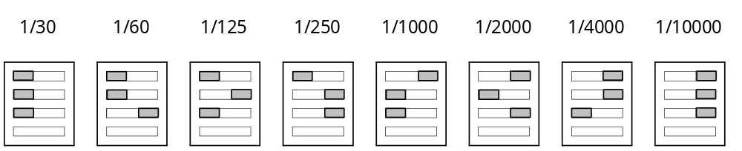
(2)Remote hold
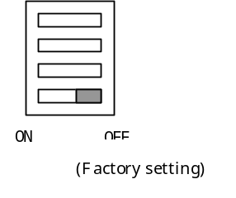

 | Remote hold
 | ON | OFF
Remote cable Connection | REMOTE | REMOTE
Remote cable  Non Connection | REMOTE | SWITCH

(3)Frame on demand (FD) on/off switch

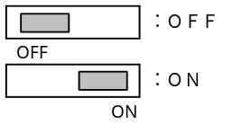
(Factory setting)

(4) Frame on demand mode switch

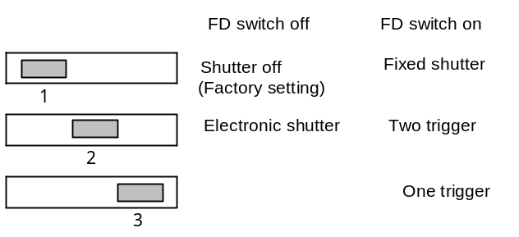

8. Input/output signal levels and timing

(1) Digital output

Tokyo Japan
DWN
DSGN
CHKD
APPD
・ ・
・ ・
・ ・
・ ・
1
2
3
4
1

2
3
Ａ
Ｂ
Ｃ
Ｄ
Ｅ
Ｆ

10/15
H sync phase relationship
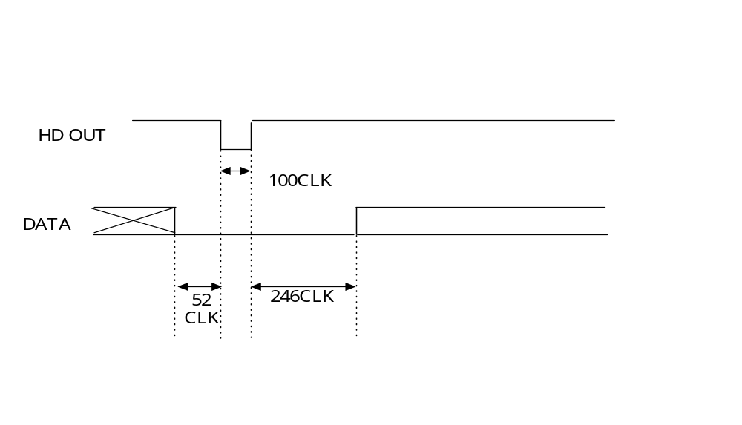
HD OUT is obtained at EIA-644 rating from the digital connector pins 23 and 24.
HD=16kHz=1790CLK

V sync phase relationship

Tokyo Japan
DWN
DSGN
CHKD
APPD
・ ・
・ ・
・ ・
・ ・
1
2
3
4
1

2
3
Ａ
Ｂ
Ｃ
Ｄ
Ｅ
Ｆ

/15
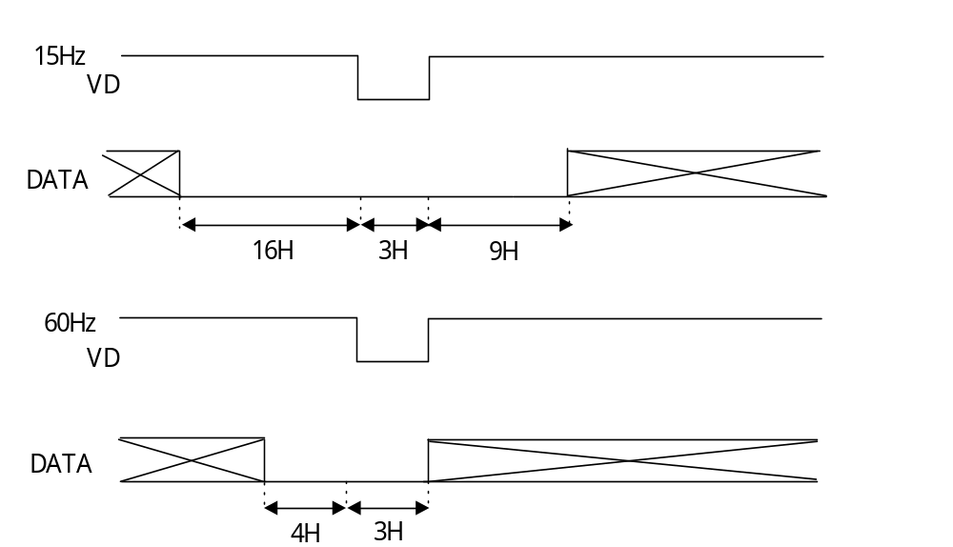

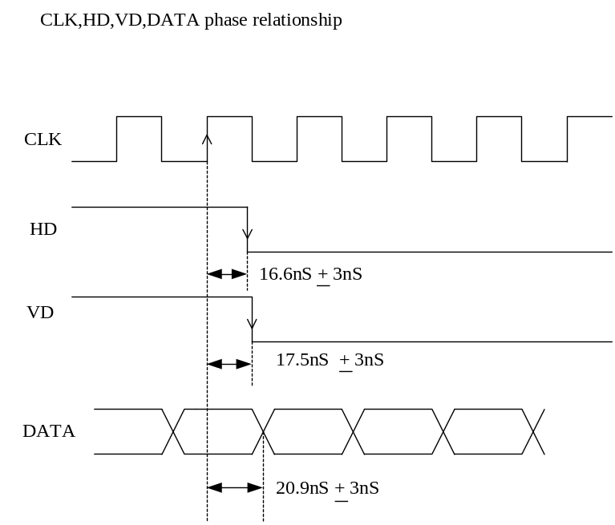

Tokyo Japan
DWN
DSGN
CHKD
APPD
・ ・
・ ・
・ ・
・ ・
1
2
3
4
1

2
3
Ａ
Ｂ
Ｃ
Ｄ
Ｅ
Ｆ

11/15

Level: EIA-644A (Hi: more than 1.41V, Low: less than 1.075V)
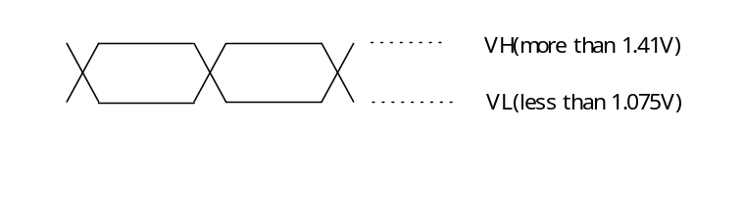
External signal level
Condition of external signal input
Ringing of external signal input( Trig-A / Trig-B / Ext-HD / Ext-VD )：0.3V or less

Less than 5.3V

More than +2.5V
High

Less than +0.5V

More than –0.3V
Low

External signal input waveform

(2)TRIG-A input and HD & VD phase during Fixed shutter mode

Tokyo Japan
DWN
DSGN
CHKD
APPD
・ ・
・ ・
・ ・
・ ・
1
2
3
4
1

2
3
Ａ
Ｂ
Ｃ
Ｄ
Ｅ
Ｆ

12/15

TRIG-A level: see page 11(External signal level)

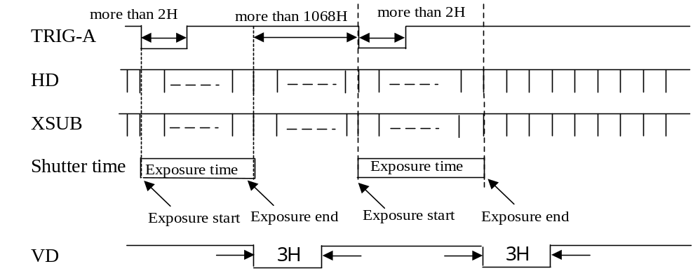

(3)TRIG-A & B input phase and HD & VD phase during Two trigger mode

TRIG-A & B level: see page 11(External signal level)
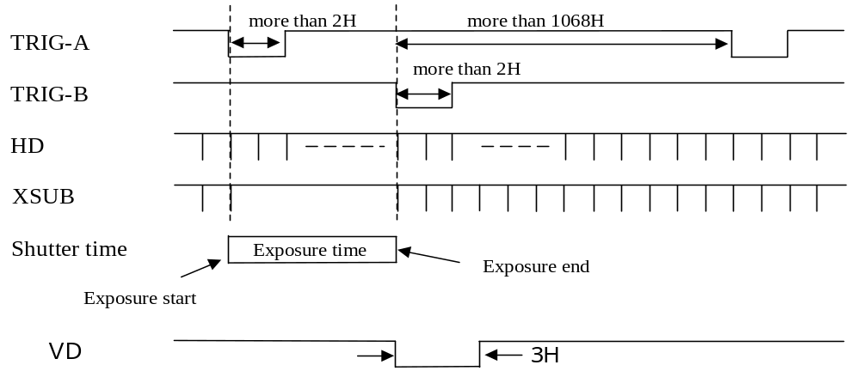

(4)One trigger mode

TRIG-A level: see page 11(External signal level)
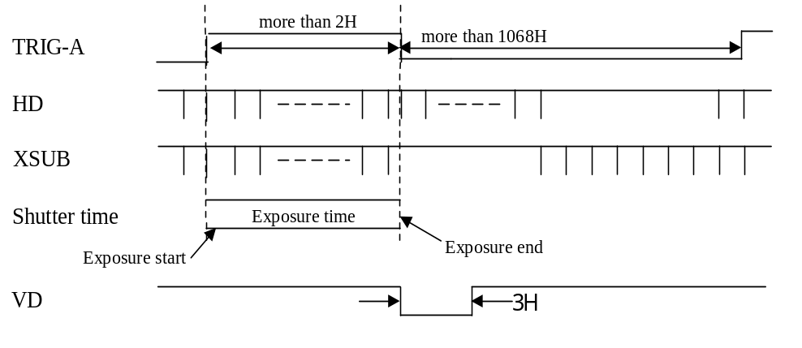

Tokyo Japan
DWN
DSGN
CHKD
APPD
・ ・
・ ・
・ ・
・ ・
1
2
3
4
1

2
3
Ａ
Ｂ
Ｃ
Ｄ
Ｅ
Ｆ

13/15
(5) External HD & VD input levels and phase
level: see page 11(External signal level)

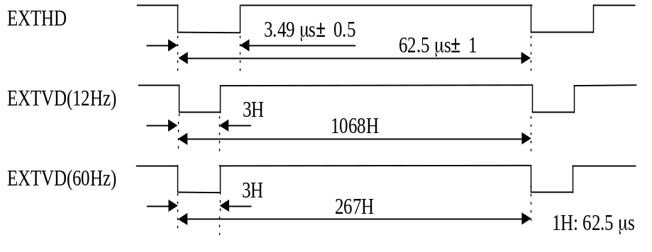

Align falling edges of external HD and VD.
VD output is delayed 2H compared to EXTVD

Tokyo Japan
DWN
DSGN
CHKD
APPD
・ ・
・ ・
・ ・
・ ・
1
2
3
4
1

2
3
Ａ
Ｂ
Ｃ
Ｄ
Ｅ
Ｆ

14/15

Notice:
These specifications are subject to change without prior notice due to product improvement.
Confirm the most recent specifications at time of order.
Hitachi Denshi certifies this product complies with the standard warranty conditions of Hitachi Denshi, and that quality control is implemented to the extent required to comply with these conditions.

Warranty and service:

- The guarantee period is one year after the data purchase. However, the defects due to erroneous use or intentional act are excluded.
- As the defect after expiration of the guarantee period, where product repair is possible, repair will be performed at charge. .
- The present Warranty pertains only to the camera unit. Secondary malfunctions attributable to camera failure as well as expenses incurred by disassembly and reassembly of the related system, are beyond the scope of this Warranty.
(4) Compensation for loss of business, loss or damage to software, database and other contingent losses are beyond the scope of this Warranty.
- Hitachi Kokusai Electric Inc. is not liable for the losses caused when the equipment is used in a system, use for business trades, production process, medical fields, crime prevention applications, etc.
(6) The parts used in the equipment have their respective lives. The lives of such parts will be shortened under the environments of high temperature or high humidity.
When the stable operation is required for a long time, it is recommended to perform periodical maintenance and inspection every year or every two years.



