TABLE OF CONTENTS

1.INTRODUCTION 1
2.TUNER 1
3.IF PART (TDA9885/86) 1
4.VIDEO SWITCH TEA6415 2
5.MULTI STANDARD SOUND PROCESSOR 2
6.SOUND OUTPUT STAGE WITH TDA7480L 2
7.VERTICAL OUTPUT STAGE WITH TDA8177F 2
8.VIDEO OUTPUT AMPLIFIER TDA6109 3
9.POWER SUPPLY (SMPS) 3
10.MICROCONTROLLER SDA5550 3
10.1.General Features 3
10.2.External Crystal and Programmable Clock Speed 3
10.3.Microcontroller Features 3
10.4.Memory 3
10.5.Display Features 3
10.6.ROM Characters 4
10.7.Acquisition Features 4
10.8.Ports 4
11.SERIAL ACCESS 32K EEPROM 4
12.CLASS AB STEREO HEADPHONE DRIVER TDA1308 4
13.SAW FILTERS 4
14.IC DESCRIPTIONS 5
14.1.TDA6109 5
14.1.1.General Description 5
14.1.2.Features 5
14.1.3.Pinning 5
14.2.27W401 6
14.2.1.Description 6
14.2.2.Features 6
14.2.3.Connections 6
14.3.24LC32A 7
14.3.1.Description 7
14.3.2.Features 7
14.3.3.Pin Descriptions 7
14.4.SDA5275 8
14.4.1.Features 8
14.4.2.Pin Definition and functions 8
14.5.DRAM 4MX4 9
14.5.1.General Description 9
14.5.2.Features 10
14.5.3.Pin Assignment 10
14.6.SDA9400 10
14.6.1.General Description 10
14.6.2.Features 10
14.6.3.Pin Definition 11
14.7.LM317T 12
14.7.1.Description 12
14.7.2.Features 12
14.8.DDP3310 12
14.8.1.Description 12
14.8.2.Features 12
14.8.3.Pin connection and short descriptions 13
14.9.SDA5550 14
14.9.1.General definition 14
14.9.2.Features 15
14.10.TEA6415C 16
14.10.1.General Description 16
14.10.2.Features 16
14.10.3.Pinning 16
14.11.VPC3230D 17
14.11.1.General Description 17
14.11.2.Pin Connections and Short Descriptions 17
14.12.TDA1308T 19
14.12.1.General Description 19
14.12.2.Features 19
14.12.3.Pinning 19
14.13.MSP34X1G (MSP3411G) 19
14.13.1.Description 19
14.13.2.Features 20
14.13.3.Pin connections 20
14.14.TL431 22
14.14.1.Description 22
14.14.2.Features 22
14.14.3.Pin Configurations 22
14.15.TDA9885/86 22
14.15.1.Introduction 22
14.15.2.Features 22
14.15.3.Pin Configurations 23
14.16.LM7808 23
14.16.1.Description 23
14.16.2.Features 23
14.17.TDA8177F 24
14.17.1.Description 24
14.17.2.Features 24
14.17.3.Pin connections 24
14.17.4.Block Diagram 24
14.18.LM1086 24
14.18.1.Description 24
14.18.2.Features 24
14.18.3.Applications 25
14.18.4.Connection Diagrams 25
14.19.MC44608 25
14.19.1.Description 25
14.19.2.General Features 25
14.19.3.Pin Connections 26
14.20.TCET1102G 26
14.20.1.Description 26
14.20.2.Applications 26
14.20.3.Features 26
14.21.TDA7480L 27
14.21.1.Description 27
14.21.2.Features 27
14.21.3.Pin Functions 27
14.22.SAA3010T 27
14.22.1.Description 27
14.22.2.Features 28
14.22.3.Pinning 28
15.AK52 CHASSIS MANUAL ADJUSTMENTS PROCEDURE 29
15.1.PRELIMINARY 29
15.2.SYSTEM VOLTAGE ADJUSTMENTS 29
15.3.AFC ADJUSTMENTS 29
15.4.FOCUS ADJUSTMENTS 29
15.5.SCREEN ADJUSTMENTS 29
15.6.IF ADJUSTMENT FOR L’ MODE 29
16.AK52 CHASSIS PRODUCTION SERVICE MODE ADJUSTMENTS 29
16.1.PRELIMINARY 30
16.2.H/V (HORIZONTAL AND VERTICAL GEOMETRY ALIGNMENTS) 30
16.3.VIDEO ALIGNMENTS 33
16.4.SERVICE ALIGNMENTS 34
17.BLOCK DIAGRAM 36
18.CIRCUIT DIAGRAMS 37

1.INTRODUCTION
11AK52 is a 100Hz flicker free colour television capable of driving 28”4:3/16:9, 32” 16:9, 33”4:3 and 29”4:3 real flat picture tubes.
The chassis is capable of operation in PAL, SECAM, NTSC (playback) colour standards and multiple transmission standards as B/G, D/K, I/I’, and L/L´.
Sound system output is supplying 2x10W (10%THD) for left and right outputs of 8ohm speakers.
TV supports the level 1.5 teletext standard. It is possible to decode transmissions including high graphical data.
The chassis is equipped with two full EuroScarts, one SCART for AV input/output, one front-AV input, one back-AV input, one headphone output, one SVHS input (via SCART and SVHS connector), two external speaker outputs (left and right).

2.TUNER
The hardware and software of the TV is suitable for tuners, supplied by different companies, which are selected from the Service Menu. These tuners can be combined VHF, UHF tuners suitable for CCIR systems B/G, H, L, L´, I/I´, and D/K. The tuning is available through the digitally controlled I²C bus (PLL). Below you will find info on one of the Tuners in use.

General description of UV1316:
The UV1316 tuner belongs to the UV 1300 family of tuners, which are designed to meet a wide range of applications. It is a combined VHF, UHF tuner suitable for CCIR systems B/G, H, L, L’, I and I’. The low IF output impedance has been designed for direct drive of a wide variety of SAW filters with sufficient suppression of triple transient.

Features of UV1316:
- Member of the UV1300 family small sized UHF/VHF tuners
- Systems CCIR: B/G, H, L, L’, I and I’; OIRT: D/K
- Digitally controlled (PLL) tuning via I²C-bus
- Off-air channels, S-cable channels and Hyperband
- World standardized mechanical dimensions and world standard pinning
- Compact size
- Complies to “CENELEC EN55020” and “EN55013”

Pinning:
1. Gain control voltage (AGC) : 4.0V, Max: 4.5V
2. Tuning voltage
3. I²C-bus address select : Max: 5.5V
4. I²C-bus serial clock : Min:-0.3V, Max: 5.5V
5. I²C-bus serial data : Min:-0.3V, Max: 5.5V
6. Not connected
7. PLL supply voltage : 5.0V, Min: 4.75V, Max: 5.5V
8. ADC input
9. Tuner supply voltage : 33V, Min: 30V, Max: 35V
10. Symmetrical IF output 1
11. Symmetrical IF output 2

3.IF PART (TDA9885/86)
The TDA9885 is an alignment-free single standard (without positive modulation, only PAL) vision and sound IF signal PLL.
The TDA9886 is an alignment-free multistandard (PAL, SECAM and NTSC) vision and sound IF signal PLL Both devices can be used for TV, VTR, PC and set-top box applications.
The following figure shows the simplified block diagram of the integrated circuit.
The integrated circuit comprises the following functional blocks:
VIF amplifier, Tuner and VIF-AGC, VIF-AGC detector, Frequency Phase-Locked Loop (FPLL) detector, VCO and divider, Digital acquisition help and AFC, Video demodulator and amplifier, Sound carrier trap, SIF amplifier, SIF-AGC detector, Single reference QSS mixer, AM demodulator, FM demodulator and acquisition help, Audio amplifier and mute time constant, I²C-bus transceivers and MAD (module address), Internal voltage stabilizer.

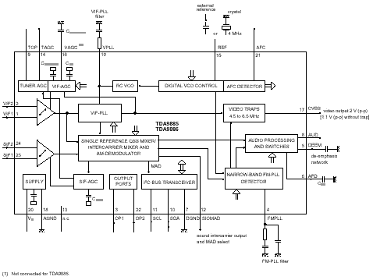
4.VIDEO SWITCH TEA6415
In case of three or more external sources are used, the video switch IC TEA6415 is used. The main function of this device is to switch 8 video-input sources on the 6 outputs.
Each output can be switched on only one of each input. On each input an alignment of the lowest level of the signal is made (bottom of sync. top for CVBS or black level for RGB signals).
Each nominal gain between any input and output is 6.5dB.For D2MAC or Chroma signal the alignment is switched off by forcing, with an external resistor bridge, 5VDC on the input. Each input can be used as a normal input or as a MAC or Chroma input (with external Resistor Bridge). All the switching possibilities are changed through the BUS. Driving 75ohm load needs an external resistor. It is possible to have the same input connected to several outputs.

5.MULTI STANDARD SOUND PROCESSOR
The MSP34x1G family of single-chip Multi-standard Sound Processors covers the sound processing of all analog TV-Standards worldwide, as well as the NICAM digital sound standards. The full TV sound processing, starting with analog sound IF signal-in, down to processed analog AF-out, is performed on a single chip. Signal conforming to the standard by the Broadcast Television Systems Committee (BTSC).
The DBX noise reduction, or alternatively, MICRONAS Noise Reduction (MNR) is performed alignment free. Other processed standards are the Japanese FM-FM multiplex standard (EIA-J) and the FM Stereo Radio standard.

6.SOUND OUTPUT STAGE WITH TDA7480L
The TDA7480L is an audio class-D amplifier assembled in Power DIP package specially designed for high efficiency applications mainly for TV and Home Stereo sets.
Mute stand-by function of the audio amplifier can be described as the following; the pin 12 (MUTE/STAND-BY) controls the amplifier status by two different thresholds, referred to ground. When Vpin 12 voltage is lower than 0.7V the amplifier is in Stand-by mode and the final stage generators are off. When Vpin 12 is higher than 4V, the amplifier is in play mode.
The TDA7480L is a 10W+10W stereo sound amplifier with mute/stand-by facility. MUTE control signal coming from microcontroller (when it is at high level) activates the mute function. IC is muted when mute pin is at low level (pin12). MUTE pin can also be activated via an external pop-noise circuitry in order to eliminate pop noise when TV is turned off. Just after the TV is turned off, this circuit switches the IC to stand-by mode by pulling the mute pin voltage to ground.

7.VERTICAL OUTPUT STAGE WITH TDA8177F
The IC TDA8177F is the vertical deflection booster circuit. Two supply voltages, +12V and -12V are needed to scan the inputs VERT+ and VERT-, respectively. And a third supply voltage, +60V for the flyback limiting are needed. The vertical deflection coil is connected in series between the output and feedback to the input.

8.VIDEO OUTPUT AMPLIFIER TDA6109
The TDA6109 includes three video output amplifiers in order to drive the three cathodes of a colour picture tube directly. To obtain maximum performance, the amplifier is used with black-current control.

9.POWER SUPPLY (SMPS)
The DC voltages required at various parts of the chassis are provided by an SMPS transformer controlled by the IC MC44608, which is designed for driving, controlling and protecting switching transistor of SMPS. The transformer generates 135V for FBT input, +/-14V for audio amplifier, 8V stand by voltage and 8V, 12V and 5V supplies for other different parts of the chassis.
An optocoupler is used to control the regulation of line voltage and stand-by power consumption. There is a regulation circuit in secondary side. This circuit produces a control voltage according to the changes in 135V DC voltage, via an optocoupler (TCET 1102G) to pin3 of the IC.
During the switch on period of the transistor, energy is stored in the transformer. During the switch off period energy is fed to the load via secondary winding. By varying switch-on time of the power transistor, it controls each portion of energy transferred to the second side such that the output voltage remains nearly independent of load variations.

10.MICROCONTROLLER SDA5550

10.1.General Features
• Feature selection via special function register
• Simultaneous reception of TTX, VPS, PDC, and WSS (line 23)
• Supply Voltage 2.5 and 3.3 V
• ROM version is used.

10.2.External Crystal and Programmable Clock Speed
• Single external 6MHz crystal, all necessary clocks are generated internally
• CPU clock speed selectable via special function registers.
• Normal Mode 33.33 MHz CPU clock, Power Save mode 8.33 MHz

10.3.Microcontroller Features
• 8bit 8051 instruction set compatible CPU.
• 33.33-MHz internal clock (max.)
• 0.360 ms (min.) instruction cycle
• Two 16-bit timers
• Watchdog timer
• Capture compare timer for infrared remote control decoding
• Pulse width modulation unit (2 channels 14 bit, 6 channels 8 bit)
• ADC (4 channels, 8 bit)
• UART (rxd, txd)

10.4.Memory
• Up to 128 Kilobyte on Chip Program ROM
• Eight 16-bit data pointer registers (DPTR)
• 256-bytes on-chip Processor Internal RAM (IRAM)
• 128bytes extended stack memory.
• Display RAM and TXT/VPS/PDC/WSS-Acquisition-Buffer directly accessible via MOVX
• UP to 16KByte on Chip Extended RAM (XRAM) consisting of;
- 1 Kilobyte on-chip ACQ-buffer-RAM (access via MOVX)
- 1 Kilobyte on-chip extended-RAM (XRAM, access via MOVX) for user software
- 3 Kilobyte Display Memory

10.5.Display Features
• ROM Character set supports all East and West European Languages in single device
• Mosaic Graphic Character Set
• Parallel Display Attributes
• Single/Double Width/Height of Characters
• Variable Flash Rate
• Programmable Screen Size (25 Rows x 33...64 Columns)
• Flexible Character Matrixes (HxV) 12 x 9...16
• Up to 256 Dynamical Redefinable Characters in standard mode; 1024 Dynamical Redefinable Characters in Enhanced Mode
• CLUT with up to 4096 colour combinations
• Up to 16 Colours per DRCS Character
• One out of 8 Colours for Foreground and Background Colours for 1-bit DRCS and ROM Characters

10.6.ROM Characters
• Shadowing
• Contrast Reduction
• Pixel by Pixel Shiftable Cursor With up to 4 Different Colours
• Support of Progressive Scan and 100 Hz.
• 3 X 4Bits RGB-DACs On-Chip
• Free Programmable Pixel Clock from 10 MHz to 32MHz
• Pixel Clock Independent from CPU Clock
• Multinorm H/V-Display Synchronization in Master or Slave Mode

10.7.Acquisition Features
• Multi-standard Digital Data Slicer
• Parallel Multi-norm Slicing (TTX, VPS, WSS, CC, G+)
• Four Different Framing Codes Available
• Data Caption only limited by available Memory
• Programmable VBI-buffer
• Full Channel Data Slicing Supported
• Fully Digital Signal Processing
• Noise Measurement and Controlled Noise Compensation
• Attenuation Measurement and Compensation
• Group Delay Measurement and Compensation
• Exact Decoding of Echo Disturbed Signals

10.8.Ports
• One 8-bit I/O-port with open drain output and optional I²C Bus emulation support (Port0)
• Two 8-bit multifunction I/O-ports (Port1, Port3)
• One 4-bit port working as digital or analogue inputs for the ADC (Port2)
• One 2-bit I/O port with secondary function (P4.2, 4.3, 4.7)
• One 4-bit I/O-port with secondary function (P4.0, 4.1, 4.4) (Not available in P-SDIP 52)

11.SERIAL ACCESS 32K EEPROM
24LC32 is the 32Kbit electrically erasable programmable memory. The memory is compatible with the I²C standard, two wire serial interface, which uses a bi-directional data bus and serial clock.

12.CLASS AB STEREO HEADPHONE DRIVER TDA1308
The TDA1308 is an integrated class AB stereo headphone driver contained in a DIP8 plastic package. The device is fabricated in a 1 mm CMOS process and has been primarily developed for portable digital audio applications.

13.SAW FILTERS
K3953M:
Standard
B/G, D/K, I, L/L’
Features
TV IF video filter with Nyquist slopes at 33,90 MHz and 38,90 MHz
Constant group delay
Suitable for CENELEC EN 55020
Terminals
Tinned CuFe alloy
Pin configuration
1 Input
2 Input - ground
3 Chip carrier - ground
4 Output
5 Output

K3958M:
Standard
B/G, D/K, I, L/L’
Features
TV IF video filter with Nyquist slopes at 33.90 MHz and 38.90 MHz
Constant group delay
Terminal and Pin configuration are the same with K3953M
K9356M:
Standard
B/G, D/K, I, L
Features
TV IF audio filter with pass band for sound carriers at 32,40 MHz (D/K, L), 32,90 MHz (I) and 33,40 MHz (B/G)
Terminal and Pin configuration are the same with K3953M

K9656M:
Standard
B/G, D/K, I, L/L’
Features
TV IF audio filter with two channels
Channel 1 (L’) with one pass band for sound carriers at 40,40 MHz (L’) and 39,75 MHz (L’- NICAM)
Channel 2 (B/G, D/K, L, I) with one pass band for sound carriers between 32,35 MHz and 33,40 MHz
Terminal and Pin configuration are the same with K3953M

14.IC DESCRIPTIONS
TDA6109 27W401
24LC32 SDA5275
DRAM 4MX4 SDA9400
LM317T DDP3310
SDA5550 TEA6415
VPC3230D TDA1308T
MSP3411G TL431
TDA9885/86 LM7808
TDA8177F LM1086
MC44608 TCET1102G
TDA7480L SAA3010T

14.1.TDA6109

14.1.1.General Description
The TDA6109JF includes three video output amplifiers in one plastic DIL-bent-SIL 9-pin medium power (DBS9MPF) package (SOT111-1), using high-voltage DMOS technology, and is intended to drive the three cathodes of a colour CRT directly. To obtain maximum performance, the amplifier should be used with black-current control.

14.1.2.Features
· Typical bandwidth of 9.0 MHz for an output signal of 60 V (p-p)
· High slew rate of 1850 V/ms
· No external components required
· Very simple application
· Single supply voltage of 200 V
· Internal reference voltage of 2.5 V
· Fixed gain of 51
· Black-Current Stabilization (BCS) circuit
· Thermal protection

14.1.3.Pinning

SYMBOL | PIN | DESCRIPTION
V_{i(1)} | 1 | inverting input 1
V_{i(2)} | 2 | inverting input 2
V_{i(3)} | 3 | inverting input 3
GND | 4 | ground (fin)
I_{om} | 5 | black current measurement output
V_{DD} | 6 | supply voltage
V_{oc(3)} | 7 | cathode output 3
V_{oc(2)} | 8 | cathode output 2
V_{oc(1)} | 9 | cathode output 1

14.2.27W401

14.2.1.Description
The M27W401 is a low voltage 4 Mbit EPROM offered in the two ranges UV (ultra violet erase) and OTP (one time programmable). It is ideally suited for microprocessor systems requiring large data or program storage and is organized as 524,288 by 8 bits. The M27W401 operates in the read mode with a supply voltage as low as 2.7V at –40 to 8C temperature range. The decrease in operating power allows either a reduction of the size of the battery or an increase in the time between battery re-charges.
The FDIP32W (window ceramic frit-seal package) has a transparent lid, which allows the user to ex-pose the chip to ultraviolet light to erase the bit pat-tern. A new pattern can then be written to the device by following the programming procedure. For application where the content is programmed only one time and erasure is not required, the M27W401 is offered in PDIP32, PLCC32 and TSOP32 (8x20 mm) packages.

14.2.2.Features
2.7V to 3.6v Low voltage in Read Operation
Access time:
–70ns at V_{CC} = 3.0V to 3.6V
–80ns at V_{CC} = 2.7V to 3.6V
Pin Compatible with M27C4001
Low Power Consumption:
–1mA max Standby Current
– 15mA max Active Current at 5MHz
Programming Time 10ms/byte
High Reliability CMOS Technology
– 2,000V ESD Protection
– 200mA Latchup Protection Immunity
Electronic Signature
– Manufacturer Code: 20h
– Device Code: 41h

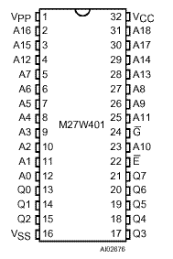
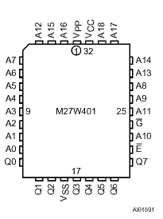
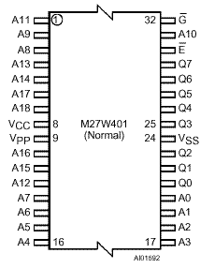
14.2.3.Connections

DIP connections LCC Connections TSOP Connections

Signal Names

A0-A18 | Address Inputs
Q0-Q7 | Data Outputs
Ē | Chip Enable
G | Output Enable
V_{pp} | Program Supply
V_{cc} | Supply Voltage
V_{ss} | Ground

14.3.24LC32A

14.3.1.Description
The Microchip Technology Inc. 24LC32A is a 4K x 8 (32K bit) Serial Electrically Erasable PROM capable of operation across a broad voltage range (2.5V to 6.0V). It has been developed for advanced, low power applications such as personal communications or data acquisition. The 24LC32A also has a page-write capability of up to 32 bytes of data. The 24LC32A is capable of both random and sequential reads up to the 32K boundary. Functional address lines allow up to eight 24LC32A devices on the same bus, for up to 256K bits address space. Advanced CMOS technology and broad voltage range make this device ideal for low-power/ low-voltage, nonvolatile code and data applications. The 24LC32A is available in the standard 8-pin plastic DIP and both 150 mil and 200 mil SOIC packaging.

14.3.2.Features
• Single supply with operation down to 2.5V
• Maximum write current 3 mA at 6.0V
• Standby current 1 mA max at 2.5V
• 2-wire serial interface bus, I 2 CÔ compatible
• 100 kHz (2.5V) and 400 kHz (5V) compatibility
• Self-timed ERASE and WRITE cycles
• Power on/off data protection circuitry
• Hardware write protect
• 1,000,000 Erase/Write cycles guaranteed
• 32 byte page or byte write modes available
• Schmitt trigger filtered inputs for noise suppression
• Output slope control to eliminate ground bounce
• 2 ms typical write cycle time, byte or page
• Up to eight devices may be connected to the same bus for up to 256K bits total memory
• Electrostatic discharge protection > 4000V
• Data retention > 200 years
• 8-pin PDIP and SOIC packages
• Temperature ranges
• Commercial (C): 0°C to +75°C
• Industrial (I): -40°C to +85°C

14.3.3.Pin Descriptions
A0, A1, A2 Chip Address Inputs
The A0..A2 inputs are used by the 24LC32A for multiple device operation and conform to the 2-wire bus standard. The levels applied to these pins define the address block occupied by the device in the address map. A particular device is selected by transmitting the corresponding bits (A2, A1, A0) in the control byte.

SDA Serial Address/Data Input/Output
This is a Bi-directional pin used to transfer addresses and data into and data out of the device. It is an open drain terminal, therefore the SDA bus requires a pull up resistor to VCC (typical 10 kΩ for 100 kHz, 2 kΩ for 400 kHz) For normal data transfer SDA is allowed to change only during SCL low. Changes during SCL HIGH are reserved for indicating the START and STOP conditions.

SCL Serial Clock
This input is used to synchronize the data transfer from and to the device.
WP
This pin must be connected to either VSS or VCC. If tied to VSS, normal memory operation is enabled (read/write the entire memory 000-FFF). If tied to VCC, WRITE operations are inhibited. The entire memory will be write-protected. Read operations are not affected.
WCC
+2.5V to 6V Power Supply
WSS
Ground

14.4.SDA5275

14.4.1.Features
• Single chip teletext IC
• Analog CVBS-input with onchip clamping circuitry
• Slicer
• Supports level 1, 2.5 and 3.5 ETSI teletext standard
• Stores up to 14 teletext pages on chip
• Stores up to 2048 teletext pages with external 16 M memory
• SDA 5275: full level 2.5 processing
• Analog RGB-output
• 41 Latin script languages
• 12 ´ 10 character size
• Parallel display attributes
• 64 from 4096 colors selectable
• Enhanced flash modes
• Dynamically redefinable character set (DRCS, PCS)
• Pixel graphics
• Full screen display (64 ´ 32 or 80 ´ 24 character positions)
• Horizontal and vertical scrolling
• Graphic cursors
• 4:3 and 16:9 display
• Multinorm display (50/60/100/120 Hz)
• RISC-processor
• Firmware downloadable
• I²C / 3 wire UART-interface (1 Mbit/s)
• Independent clocks for acquisition and display
• Tools for greatly simplified software development
• 24-Kbyte on-chip reconfigurable DRAM
• 44160-bit character ROM
• One external crystal for all standards

14.4.2.Pin Definition and functions

Pin No. P-LCC-68-1 | Symbol | Function
1 | INTQ | Interrupt request output to ext. controller
2 | CLK-IO | System clock input/output
3 | TCSQ/FLD | Composite sync output/ field output
4 | VS/VCS | Vertical sync input/output
5 | HS | Horizontal sync input/output
6 | XOUT | 20.5-MHz crystal oscillator output
7 | XIN | 20.5-MHz crystal oscillator input
8 | GPO | General purpose output
9 | TM | Test pin, leave open or connect VSS
10 | CVBS | CVBS-video signal input
11 | VDD1 | + 5 V digital supply
12 | VDDA | + 5 V analog supply
13 | VSSA1 | Analog ground
14 | N.C. | Not connected
15 | N.C. | Not connected
16 | VDD2 | + 5 V digital supply
17 | RES | Chip reset
18 | N.C. | Not connected
19 | N.C. | Not connected
20 | N.C. | Not connected
21 | VDD3 | + 5 V digital supply
22 | N.C. | Not connected
23 | VREF | + 3 V reference voltage input
24 | N.C. | Not connected
25 | VDD4 | + 5 V digital supply
26 | A8 | External DRAM-address
27 | A7 | External DRAM-address
28 | A6 | External DRAM-address
29 | A5 | External DRAM-address
30 | A4 | External DRAM-address
31 | A3 | External DRAM-address
32 | A2 | External DRAM-address
33 | A1 | External DRAM-address
34 | A0 | External DRAM-address
35 | A9 | External DRAM-address
36 | A10 | External DRAM-address
37 | A11 | External DRAM-address
38 | RASQ | Row address strobe (DRAM)
39 | WEQ | Write enable (DRAM)
40 | D1 | External DRAM-data
41 | D0 | External DRAM-data
42 | D2 | External DRAM-data
43 | D3 | External DRAM-data
44 | VSS4 | 0 V digital supply
45 | CASQ | Column address strobe
46 | N.C. | Not connected
47 | N.C. | Not connected
48 | N.C. | Not connected
49 | VSS3 | 0 V digital supply
50 | N.C. | Not connected
51 | N.C. | Not connected
52 | N.C. | Not connected
53 | N.C. | Not connected
54 | N.C. | Not connected
55 | VSS2 | 0 V digital supply
56 | VBB | Substrate bias voltage N.C.* (depends on version)
57 | N.C. | Not connected
58 | VSSA2 | Analog ground
59 | RGB-GND | RGB-ground
60 | VSS1 | 0 V digital supply
61 | R | Analog red display output
62 | G | Analog green display output
63 | B | Analog blue display output
64 | BLAN | Blanking signal open drain output
65 | CORQ | Contrast reduction open drain output
66 | SCL | Bi-directional I²C Bus clock port
67 | SDA | Bi-directional I²C Bus data port
68 | I²CEN | I²C Bus enable

14.5.DRAM 4MX4

14.5.1.General Description
The 4 Meg x 4 DRAM is a randomly accessed, solid-state memory containing 16,777,216 bits organized in a x4 con-figuration. RAS# is used to latch the row address (first 11 bits for 2K and first 12 bits for 4K). Once the page has been opened by RAS#, CAS# is used to latch the column address (the latter 11 bits for 2K and the latter 10 bits for 4K, address pins A10 and A11 are “don’t care”). READ and WRITE cycles are selected with the WE# input. A logic HIGH on WE# dictates READ mode, while a logic LOW on WE# dictates WRITE mode. During a WRITE cycle, data-in (D) is latched by the falling edge of WE# or CAS#, whichever occurs last. An EARLY WRITE occurs when WE# is taken LOW prior to CAS# falling. A LATE WRITE or READ-MODIFY-WRITE occurs when WE# falls after CAS# is taken LOW. During EARLY WRITE cycles, the data outputs (Q) will remain High-Z regardless of the state of OE#. During LATE WRITE or READ-MODIFY-WRITE cycles, OE# must be taken HIGH to disable the data outputs prior to applying input data. If a LATE WRITE or READ-MODIFY-WRITE is attempted while keeping OE# LOW, no write will occur, and the data outputs will drive read data from the accessed location. The four data inputs and the four data outputs are routed through four pins using common I/O, and pin direction is controlled by WE# and OE#.

14.5.2.Features
• Industry-standard x4 pin out, timing, functions and packages
• State-of-the-art, high-performance, low-power CMOS silicon-gate process
• Single power supply (+3.3V ±0.3V or +5V ±10%)
• All inputs, outputs and clocks are TTL-compatible
• Refresh modes: RAS#-ONLY, HIDDEN and CAS#-BEFORE- RAS# (CBR)
• Optional Self Refresh (S) for low-power data retention
• 11 row, 11 column addresses (2K refresh) or 12 row, 10 column addresses (4K refresh)
• Extended Data-Out (EDO) PAGE MODE access cycle
• 5V-tolerant inputs and I/Os on 3.3V devices

14.5.3.Pin Assignment
Top View
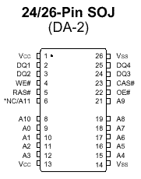
*NC on 2K refresh and A11 on 4K refresh options. Note: The “#” symbol indicates signal is active LOW.

14.6.SDA9400

14.6.1.General Description
The SDA9400 is a new component of the Micronas MEGAVISION ® IC set in a 0.35µm embedded DRAM technology (frame memory embedded). The SDA9400 is pin compatible to the SDA9401 (field memory embedded). The SDA9400 comprises all main functionalities of a digital feature box in one monolithic IC. The scan rate conversion to 100/120 Hz interlaced (50/60 Hz progressive) is based on a motion adaptive algorithm. The scan rate converted picture can be vertically expanded. The SDA9400 has a free running mode, therefore features like scan rate conversion to e.g. 70, 75 Hz with joint lines or multiple picture display (e.g. tuner scan) are possible. Due to the frame based signal processing, the noise reduction has been greatly improved. Furthermore separate motion detectors for luminance and chrominance have been implemented. For automatic controlling of the noise reduction parameters a noise measurement algorithm is included, which measures the noise level in the picture or in the blanking period. In addition a spatial noise reduction is implemented, which reduces the noise even in the case of motion. The input signal can be compressed horizontally and vertically with a certain number of factors. Therefore split screen is supported. Beside these additional functions like coloured background, windowing and flashing are implemented.

14.6.2.Features
• Two input data formats
- 4:2:2 luminance and chrominance parallel (2 x 8 wires)
- ITU-R 656 data format (8 wires)

• Two different representations of input chrominance data
- 2‘s complement code
- Positive dual code
• Flexible input sync controller
• Flexible compression of the input signal
- Digital vertical compression of the input signal (1.0, 1.25, 1.5, 1.75, 2.0, 3.0, 4.0)
- Digital horizontal compression of the input signal (1.0, 2.0, 4.0)
• Noise reduction
- Motion adaptive spatial and temporal noise reduction (3D-NR)
- Temporal noise reduction for luminance frame based or field based
- Temporal noise reduction for chrominance field based
- Separate motion detectors for luminance and chrominance
- Flexible programming of the temporal noise reduction parameters
- Automatic measurement of the noise level (5-bit value, readable by I²C bus)
• 3-D motion detection
- High performance motion detector for scan rate conversion
- Global motion detection flag (readable by I²C bus)
- Movie mode and phase detector (readable by I²C bus)
• TV mode detection by counting line numbers (PAL, NTSC, readable by I²C bus)
• Embedded memory
- 5 Mbit embedded DRAM core for field memories
- 192 kbit embedded DRAM core for line memories
• Flexible clock and synchronization concept
- Decoupling of the input and output clock system possible
• Scan rate conversion
- Motion adaptive 100/120 Hz interlaced scan conversion
- Motion adaptive 50/60 Hz progressive scan conversion
- Simple static interlaced and progressive conversion modes for 100/120 Hz interlaced or 50/60 Hz progressive scan conversion: e.g. ABAB, AABB, AA*B*B, AAAA, BBBB, AB, AA*
- Simple progressive scan conversion with joint lines:
50 Hz -> 60, 70, 75 Hz progressive
60 Hz -> 70, 75 Hz progressive
- Large area and line flicker reduction
• Flexible digital vertical expansion of the output signal (1.0, ... [1/32] ..., 2.0)
• Flexible output sync controller
- Flexible positioning of the output signal
- Flexible programming of the output sync raster
- External synchronization by backend IC possible
(e.g. split screen for one TV channel with joint lines and one PC VGA channel)
• Signal manipulations
- Insertion of coloured background
- Vertical and/or horizontal windowing with four different speed factors
- Flash generation (for supervising applications, motion flag readable by I²C bus)
- Still frame or field
- Support of split screen applications
- Multiple picture display - Tuner scan (4 and 16 times for 4:3, 12 times for 16:9 tubes)
- Support of multi picture display with PIP or front-end processor with integrated scaler
(e.g. 9 times display of PIP pictures, picture tracking, random pictures, still-in-moving picture, moving-in-still picture)
• I²C-bus control (400 kHz)
• P-MQFP-64 package
• 3.3 V ± 5% supply voltage

14.6.3.Pin Definition

Pin No. | Name | Type | Description
2,8,24,42,55 | VSS1 | S | Supply voltage ( V SS = 0 V )
9,25,41,56 | VDD1 | S | Supply voltage ( V DD = 3.3 V )
36,52,58 | VSS2 | S | Supply voltage ( V SS = 0 V )
35,51,53,57,59 | VDD2 | S | Supply voltage ( V DD = 3.3 V )
43,..,50 | YIN0...7 | I/TTL | Data input Y (see input data format)
31,..,34;37,...,40 | UVIN0...7 | I/TTL  PD | Data input UV (for 4:2:2 parallel, see input data format)  (for CCIR 656, see input data format)
30 | RESET | I/TTL | System reset. The RESET input is low active. In order to ensure correct operation a "Power On Reset" must be performed. The RESET pulse must have a minimum duration of two clock periods of the system clock CLK1.
23 | HIN | I/TTL  PD | H-Sync input  (only for full CCIR 656)
22 | VIN | I/TTL  PD | V-Sync input  (only for full CCIR 656)
29 | SYNCEN | I/TTL | Synchronization enable input
21 | SDA | I/O | I²C-Bus data line (5V ability)
20 | SCL I | I | I²C-Bus clock line (5V ability)
54 | CLK1 | I/TTL | System clock 1
17,..,10 | UVOUT0...7 | O/TTL | Data output UV (see output data format)
7,..,3;1;64;63 | YOUT0...7 | O/TTL | Data output Y (see output data format)
62 | HREF | O/TTL | Horizontal active video output
61 | VOUT/  VEXT | I/O/  TTL | EXSYN=0 (I²C-bus parameter): V-Sync output  EXSYN=1: External V-Sync input for output part
60 | HOUT/  HEXT | I/O/  TTL | EXSYN=0 (I²C-bus parameter): H-Sync output  EXSYN=1: External H-Sync input for output part
18 | INTERLACED | O/TTL | Interlace signal for AC coupled vertical deflection
28 | X1 / CLK2 | I/TTL | Crystal connection / System clock 2
27 | X2 | O/AN | Crystal connection
26 | CLKOUT | O/TTL | Clock output (depends on I²C parameters CLK11EN, CLK21EN, FREQR)
19 | TEST | I/TTL | Test input, connect to V SS for normal operation

14.7.LM317T

14.7.1.Description
The LM317T is an adjustable 3 terminal positive voltage regulator capable of supplying in excess of 1.5 amps over an output range of 1.25 to 37 volts. This voltage regulator is exceptionally easy to use and requires only two external resistors to set the output voltage. Further, it employs internal current limiting, thermal shutdown and safe area compensation, making it essentially blow–out proof. The LM317 serves a wide variety of applications including local, on card regulation. This device can also be used to make a programmable output regulator, or by connecting a fixed resistor between the adjustment and output, the LM317 can be used as a precision current regulator.

14.7.2.Features
• Output Current in Excess of 1.5 A
• Output Adjustable between 1.2 V and 37 V
• Internal Thermal Overload Protection
• Internal Short Circuit Current Limiting Constant with Temperature
• Output Transistor Safe–Area Compensation
• Floating Operation for High Voltage Applications
• Available in Surface Mount D²PAK, and Standard 3–Lead Transistor Package
• Eliminates Stocking many Fixed Voltages

14.8.DDP3310

14.8.1.Description
The DDP 3310B is a single-chip digital Display and Deflection Processor designed for high-quality back-end applications in 100/120-Hz TV sets with 4:3 or 16:9 picture tubes. The IC can be combined with members of the DIGIT 3000 IC family (VPC 32xx, TPU 3040), or it can be used with third-party products. The IC contains the entire digital video component and deflection processing and all analog interface components.

14.8.2.Features
Video processing
– linear horizontal scaling (0.25 … 4)
– non-linear horizontal scaling “panorama-vision”
– dynamic peaking
– soft limiter (gamma correction)
– color transient improvement
– programmable RGB matrix
– picture frame generator
– two analog RGB/Fast-Blank inputs. The DDP 3310B is a single-chip digital Display and Deflection Processor designed for high-quality back-

Deflection processing
– scan velocity modulation output
– high-performance H/V deflection
– EHT compensation for vertical / East/West
– soft start/stop of H-Drive
– vertical angle and bow
– differential vertical output
– vertical zoom via deflection
– horizontal and vertical protection circuit
– adjustable horizontal frequency for VGA/SVGA display

Miscellaneous
– selectable 4:1:1/ 4:2:2 YC r C b input
– selectable 27/ 32-MHz line-locked clock input
– crystal oscillator for horizontal protection
– automatic picture tube adjustment (cutoff, white-drive)
– single 5-V power supply
– hardware for simple 50/60-Hz to 100/ 120-Hz conversion (display frequency doubling)
– two I²C-controlled PWM outputs
– beam current limiter

14.8.3.Pin connection and short descriptions
NC = not connected LV = if not used, leave vacant
X = obligatory; connect as described in circuit diagram IN = Input
OUT = Output SUPPLY = Supply Pin

Pin no  PLCCK 68 pin | Pin name | Type | Connection (if not used) | Short description
1 | VSUPP | SUPPLY | X | Supply voltage, Output pin driver
2 | GNDP | SUPPLY | X | Ground, Output pin driver
3 | VS2 | IN | GNDD | Additional VSYNC input
4 | FIFORRD | OUT | LV | FIFO Read counter reset
5 | FIFORD | OUT | LV | FIFO Read Enable
6 | FIFOWR | OUT | LV | FIFO Write Enable
7 | FIFORWR | OUT | LV | FIFO Write counter reset
8 | HOUT | OUT | X | Horizontal Drive Output
9 | HFLB | IN | Hout | Horizontal Flyback Input
10 | SAFETY | IN | GNDO | Safety Input
11 | VPROT | IN | GNDO | Vertical protection Input
12 | FREQSEL | IN | X | Selection of H-Drive Frequency Range
13 | CM1 | IN | X | Clock select 40.5 or 27/32 MHz
14 | CMO | IN | X | Clock select 27/32 MHz
15 | RSW2 | OUT | LV | Range Switch2, Measurement ADC
16 | RSW1 | IN/OUT | LV | Range Switch1, Measurement ADC
17 | SENSE | IN | GNDO | Sense ADC Input
18 | GNDM | SUPPLY | X | Ground, MADC Input
19 | VERT+ | OUT | GNDO | Differantial Vertical Sawtooth Output
20 | VERT- | OUT | GNDO | Differantial Vertical Sawtooth Output
21 | EW | OUT | GNDO | Vertical Parabola Output
22 | XREF | IN | X | Reference Input for RGB DACs
23 | SVM | OUT | VSUPO | Scan Velocity Modulation
24 | ROUT | OUT | VSUPO | Analog Output Red
25 | GOUT | OUT | VSUPO | Analog Output Green
26 | BOUT | OUT | VSUPO | Analog Output Blue
27 | GNDO | SUPPLY | X | Ground, Analog Back-end
28 | VSUPO | SUPPLY | X | Supply Voltage, Analog Back-end
29 | VRD/BCS | IN | X | DAC Reference, Beam Current Safety
30 | FBLIN1 | IN | GNDO | Fast-Blank1 Input
31 | RIN1 | IN | GNDO | Analog Red1 Input
32 | GIN1 | IN | GNDO | Analog Green1 Input
33 | BIN1 | IN | GNDO | Analog Blue1 Input
34 | FBLIN2 | IN | GNDO | Fast-Blank2 Input
35 | RIN2 | IN | GNDO | Analog Red2 Input
36 | GIN2 | IN | GNDO | Analog Green2 Input
37 | BIN2 | IN | GNDO | Analog Blue2 Input
38 | TEST | IN | GNDD | Test Pin
39 | RESQ | IN | X | Reset Input, active low
40 | PWM1 | OUT | LV | I²C-controlled DAC
41 | PWM2 | OUT | LV | I²C-controlled DAC
42 | HCS | IN | GNDD | Half-contrast
43 | C0 | IN | GNDD | Picture Bas Chroma (LSB)
44 | C1 | IN | GNDD | Picture Bas Chroma
45 | C2 | IN | GNDD | Picture Bas Chroma
46 | C3 | IN | GNDD | Picture Bas Chroma
47 | C4 | IN | GNDD | Picture Bas Chroma
48 | C5 | IN | GNDD | Picture Bas Chroma
49 | C6 | IN | GNDD | Picture Bas Chroma
50 | C7 | IN | GNDD | Picture Bas Chroma (MSB)
51 | VSUPD | SUPPLY | X | Supply Voltage, Digital Circuitry
52 | GNDD | SUPPLY | X | Ground, Digital Circuitry
53 | LLC2 | IN | X | System Clock Input (27/32/40.5 MHz)
54 | Y0 | IN | GNDD | Picture Bas Luma (LSB)
55 | Y1 | IN | GNDD | Picture Bas Luma
56 | Y2 | IN | GNDD | Picture Bas Luma
57 | Y3 | IN | GNDD | Picture Bas Luma
58 | Y4 | IN | GNDD | Picture Bas Luma
59 | Y5 | IN | GNDD | Picture Bas Luma
60 | Y6 | IN | GNDD | Picture Bas Luma
61 | Y7 | IN | GNDD | Picture Bas Luma (MSB)
62 | LLC1 | IN | VSUPD | Single Line-Locked Clock Input (13.5/16 MHz)
63 | HS | IN | X | Horizontal Sync Input
64 | VS | IN | GNDD | Vertical Sync Input
65 | XTALK2 | OUT | X | Analog Crystal Output (5-MHz Security Clock)
66 | XTALK1 | IN | X | Analog Crystal Input (5-MHz Security Clock)
67 | SDA | IN/OUT | X | I²C-Bus Data
68 | SCL | IN/OUT | X | I²C-Bus Clock

14.9.SDA5550

14.9.1.General definition
The SDA5550M is a single chip teletext decoder for decoding World System Teletext data as well as Video Programming System (VPS), Program Delivery Control (PDC), and Wide Screen Signalling (WSS) data used for PAL plus transmissions (Line 23). The device provides an integrated general-purpose, fully 8051-compatible Microcontroller with television specific hardware features. Microcontroller has been enhanced to provide powerful features such as memory banking, data pointers, and additional interrupts etc. The on-chip display unit for displaying Level 1.5 teletext data can also be used for customer defined on screen displays. Internal XRAM consists of up to 17 Kbytes. This device can support external memory up to 1Mbyte ROM and RAM.TVTEXT Controller contains a data slicer for VPS, WSS, PDC and TXT, an acceleration acquisition hardware module, a display generator for Level 1.5 TXT and powerful On screen Display capabilities based on parallel attributes, and pixel oriented characters (DRCS). The 8 bit Microcontroller operates at 360nsec cycle time (min). Controller with dedicated hardware does most of the internal TXT acquisition processing, transfer data to/from external memory interface and receives/transmits data via I²C-firmware user interface. SDA5550M is realized in 0.25 micron technology with 2.5V supply voltage and 3.3V I/O compatible. The IC produces the following input or output control signals; AGC_CON, MODE_SW, L / L’, PIP_MODS, PIP_SEL, ON/OFF (stand-by), SC1..3_IN_AV (pin 8 information from 3 SCARTs), AFC, MUTE (to mute audio output IC), I²CEN.

14.9.2.Features
General
• Feature selection via special function register
• Simultaneous reception of TTX, VPS, PDC, and WSS (line 23)
• Supply Voltage 2.5 and 3.3 V

External Crystal and Programmable clock speed
Single external 6MHz crystal, all necessary clocks are generated internally
CPU clock speed selectable via special function registers.
Normal Mode 33.33 MHz CPU clock, Power Save mode 8.33 MHz

Microcontroller Features
• 8bit 8051 instruction set compatible CPU.
• 33.33-MHz internal clock (max.)
• 0.360ms (min.) instruction cycle
• Two 16-bit timers
• Watchdog timer
• Capture compare timer for infrared remote control decoding
• Pulse width modulation unit (2 channels 14 bit, 6 channels 8 bit)
• ADC (4 channels, 8 bit)
• UART

Memory
• Non-multiplexed 8-bit data and 16 … 20-bit address bus (ROMless Version)
• Memory banking up to 1Mbyte (Romless version)
• Up to 128 Kilobyte on Chip Program ROM
• Eight 16-bit data pointer registers (DPTR)
• 256-bytes on-chip Processor Internal RAM (IRAM)
• 128bytes extended stack memory.
• Display RAM and TXT/VPS/PDC/WSS-Acquisition-Buffer directly accessible via MOVX
• UP to 16KByte on Chip Extended RAM (XRAM) consisting of;
- 1 Kilobyte on-chip ACQ-buffer-RAM (access via MOVX)
- 1 Kilobyte on-chip extended-RAM (XRAM, access via MOVX) for user software
- 3 Kilobyte Display Memory

Display Features
• ROM Character Set Supports all East and West European Languages in single device
• Mosaic Graphic Character Set
• Parallel Display Attributes
• Single/Double Width/Height of Characters
• Variable Flash Rate
• Programmable Screen Size (25 Rows x 33...64 Columns)
• Flexible Character Matrixes (HxV) 12 x 9...16
• Up to 256 Dynamical Redefinable Characters in standard mode; 1024 Dynamical Redefinable Characters in Enhanced Mode
• CLUT with up to 4096 color combinations
• Up to 16 Colors per DRCS Character
• One out of Eight Colors for Foreground and Background Colors for 1-bit DRCS and ROM Characters
• Shadowing
• Contrast Reduction
• Pixel by Pixel Shiftable Cursor With up to 4 Different Colors
• Support of Progressive Scan and 100 Hz.
• 3 X 4Bits RGB-DACs On-Chip
• Free Programmable Pixel Clock from 10 MHz to 32MHz
• Pixel Clock Independent from CPU Clock
• Multinorm H/V-Display Synchronization in Master or Slave Mode
Acquisition Features
• Multistandard Digital Data Slicer
• Parallel Multi-norm Slicing (TTX, VPS, WSS, CC, G+)
• Four Different Framing Codes Available
• Data Caption only Limited by available Memory
• Programmable VBI-buffer
• Full Channel Data Slicing Supported
• Fully Digital Signal Processing
• Noise Measurement and Controlled Noise Compensation
• Attenuation Measurement and Compensation
• Group Delay Measurement and Compensation
• Exact Decoding of Echo Disturbed Signals

Ports
• One 8-bit I/O-port with open drain output and optional I²C Bus emulation support (Port 0)
• Two 8-bit multifunction I/O-ports (Port 1, Port 3)
• One 4-bit port working as digital or analog inputs for the ADC (Port 2)
• One 2-bit I/O port with secondary functions (P4.2, 4.3, 4.7)
• One 4-bit I/O-port with secondary function (P4.0, 4.1, 4.4) (Not available in P-SDIP 52)

14.10.TEA6415C

14.10.1.General Description
The main function of the IC is to switch 8 video input sources on 6 outputs. Each output can be switched on only one of each input. On each input an alignment of the lowest level of the signal is made (bottom of synch. top for CVBS or black level for RGB signals). Each nominal gain between any input and output is 6.5dB. For D2MAC or Chroma signal the alignment is switched off by forcing, with an external resistor bridge, 5 VDC on the input. Each input can be used as a normal input or as a MAC or Chroma input (with external resistor bridge). All the switching possibilities are changed through the BUS. Driving 75Ω load needs an external transistor. It is possible to have the same input connected to several outputs. The starting configuration upon power on (power supply: 0 to 10V) is undetermined. In this case, 6 words of 16 bits are necessary to determine one configuration. In other case, 1 word of 16 bits is necessary to determine one configuration.

14.10.2.Features
• 20MHz Bandwidth
• Cascadable with another TEA6415C (Internal address can be changed by pin 7 voltage)
• 8 Inputs (CVBS, RGB, MAC, CHROMA,...)
• 6 Outputs
• Possibility of MAC or chroma signal for each input by switching-off the clamp with an external resistor bridge
• Bus controlled
• 6.5dB gain between any input and output
• 55dB crosstalk at 5mHz
• Fully ESD protected

14.10.3.Pinning
1. Input : Max : 2Vpp, Input Current: 1mA, Max : 3mA
2. Data : Low level : -0.3V Max: 1.5V,
High level : 3.0V Max : Vcc+0.5V
3. Input : Max : 2Vpp, Input Current: 1mA, Max : 3mA
4. Clock : Low level : -0.3V Max: 1.5V,
High level : 3.0V Max : Vcc+0.5V
5. Input : Max : 2Vpp, Input Current: 1mA, Max : 3mA
6. Input : Max : 2Vpp, Input Current: 1mA, Max : 3mA
7. Prog
8. Input : Max : 2Vpp, Input Current: 1mA, Max: 3mA
9. Vcc : 12V
10. Input : Max : 2Vpp, Input Current: 1mA, Max : 3mA
11. Input : Max : 2Vpp, Input Current: 1mA, Max : 3mA
12. Ground
13. Output : 5.5Vpp, Min : 4.5Vpp
14. Output : 5.5Vpp, Min : 4.5Vpp
15. Output : 5.5Vpp, Min : 4.5Vpp
16. Output : 5.5Vpp, Min : 4.5Vpp
17. Output : 5.5Vpp, Min : 4.5Vpp
18. Output : 5.5Vpp, Min : 4.5Vpp
19. Ground
20. Input : Max : 2Vpp, Input Current : 1mA, Max : 3mA

14.11.VPC3230D

14.11.1.General Description
The VPC 323xD is a high-quality, single-chip video front-end, which is targeted for 4:3 and 16:9, 50/60-Hz and 100/120 Hz TV sets. It can be combined with other members of the DIGIT3000 IC family (such as DDP 331x) and/or it can be used with 3rd-party products. The main features of the VPC 323xD are;
– high-performance adaptive 4H comb filter Y/C separator with adjustable vertical peaking
– multi-standard color decoder PAL/NTSC/SECAM including all substandards
– four CVBS, one S-VHS input, one CVBS output
– two RGB/YC r C b component inputs, one Fast Blank (FB) input
– integrated high-quality A/D converters and associated clamp and AGC circuits
– multi-standard sync processing
– linear horizontal scaling (0.25 ... 4), as well as non-linear horizontal scaling ‘Panorama-vision’
– PAL+ preprocessing
– line-locked clock, data and sync, or 656-output interface
– peaking, contrast, brightness, color saturation and tint for RGB/ YC r C b and CVBS/ S-VHS
– high-quality soft mixer controlled by Fast Blank
– PIP processing for four picture sizes (1/4, 1/9, 1/16 or 1/36 of normal size) with 8-bit resolution
– 15 predefined PIP display configurations and expert mode (fully programmable)
– control interface for external field memory
– I²C-bus interface
– one 20.25-MHz crystal, few external components
– 80-pin PQFP package

14.11.2.Pin Connections and Short Descriptions
NC = not connected
LV = if not used, leave vacant
X = obligatory; connect as described in circuit diagram
SUPPLYA = 4.75...5.25 V, SUPPLYD = 3.15...3.45 V

Pin No.  PQFP  80-pin | Pin Name | Type | Connection  (if not used) | Short Description
1 | B1/CB1IN | IN | VREF | Blue1/Cb1 Analog Component Input
2 | G1/Y1IN | IN | VREF | Green1/Y1 Analog Component Input
3 | R1/CR1IN | IN | VREF | Read1/Cr1 Analog Component Input
4 | B2/CB2IN | IN | VREF | Blue2/Cb2 Analog Component Input
5 | G2/Y2IN | IN | VREF | Green2/Y2 Analog Component Input
6 | R2/CR2IN | IN | VREF | Read2/Cr2 Analog Component Input
7 | ASGF |  | X | Analog Shield GND_{F}
8 | FFRSTWIN | IN | LV or GND_{D} | FIFO Reset Write Input
9 | V_{SUPCAP} | OUT | X | Digital Decoupling Circuitry Supply Voltage
10 | V_{SUPD} | SUPPLYD | X | Supply Voltage, Digital Circuitry
11 | GND_{D} | SUPPLYD | X | Ground, Digital Circuitry
12 | GND_{CAP} | OUT | X | Digital Decoupling Circuitry GND
13 | SCL | IN/OUT | X | I²C Bus Clock
14 | SDA | IN/OUT | X | I²C Bus Data
15 | RESQ | IN | X | Reset Input, Active Low
16 | TEST | IN | GND_{D} | Test Pin, connect to GND_{D}
17 | VGAV | IN | GND_{D} | VGAV Input
18 | YCOEQ | IN | GND_{D} | Y/C Output Enable Input, Active Low
19 | FFIE | OUT | LV | FIFO Input Enable
20 | FFWE | OUT | LV | FIFO Write Enable
21 | FFRSTW | OUT | LV | FIFO Reset Write/Read
22 | FFRE | OUT | LV | FIFO Read Enable
23 | FFOE | OUT | LV | FIFO Output Enable
24 | CLK20 | IN/OUT | LV | Main Clock output 20.25 MHz
25 | GND_{PA} | OUT | X | Pad Decoupling Circuitry GND
26 | V_{SUPPA} | OUT | X | Pad Decoupling Circuitry Supply Voltage
27 | LLC2 | OUT | LV | Double Clock Output
28 | LLC1 | IN/OUT | LV | Clock Output
29 | V_{SUPLLC} | SUPPLYD | X | Supply Voltage, LLC Circuitry
30 | GND_{LLC} | SUPPLYD | X | Ground, LLC Circuitry
31 | Y7 | OUT | GND_{Y} | Picture Bus Luma (MSB)
32 | Y6 | OUT | GND_{Y} | Picture Bus Luma
33 | Y5 | OUT | GND_{Y} | Picture Bus Luma
34 | Y4 | OUT | GND_{Y} | Picture Bus Luma
35 | GND_{Y} | SUPPLYD | X | Ground, Luma Output Circuitry
36 | V_{SUPY} | SUPPLYD | X | Supply Voltage, Luma Output Circuitry
37 | Y3 | OUT | GND_{Y} | Picture Bus Luma
38 | Y2 | OUT | GND_{Y} | Picture Bus Luma
39 | Y1 | OUT | GND_{Y} | Picture Bus Luma
40 | Y0 | OUT | GND_{Y} | Picture Bus Luma (LSB)
41 | C7 | OUT | GND_{C} | Picture Bus Chroma (MSB)
42 | C6 | OUT | GND_{C} | Picture Bus Chroma
43 | C5 | OUT | GND_{C} | Picture Bus Chroma
44 | C4 | OUT | GND_{C} | Picture Bus Chroma
45 | V_{SUPC} | SUPPLYD | X | Supply Voltage, Chroma Output Circuitry
46 | GND_{C} | SUPPLYD | X | Ground, Chroma Output Circuitry
47 | C3 | OUT | GND_{C} | Picture Bus Chroma
48 | C2 | OUT | GND_{C} | Picture Bus Chroma
49 | C1 | OUT | GND_{C} | Picture Bus Chroma
50 | C0 | OUT | GND_{C} | Picture Bus Chroma (LSB)
51 | GND_{SY} | SUPPLYD | X | Ground Sync Pad Circuitry
52 | V_{SUPSY} | SUPPLYD | X | Supply Voltage, Sync Pad Circuitry
53 | INTLC | OUT | LV | Interlace Output
54 | AVO | OUT | LV | Active Video Output
55 | FSY/HC/HSYA | OUT | LV | Front Sync/ Horizontal Clamp Pulse/Front-End Horizontal Sync Output
56 | MSY/HS | IN/OUT | LV | Main Sync/Horizontal Sync Pulse
57 | VS | OUT | LV | Vertical Sync Pulse
58 | FPDAT/VSYA | IN/OUT | LV | Front End/Back-End Data/Front-End Vertical Sync Output
59 | V_{STBYY} | SUPPLYA | X | Standby Supply Voltage
60 | CLK5 | OUT | LV | CCU 5 MHz Clock Output
61 | NC | - | LV or GND_{D} | Not Connected
62 | XTAL1 | IN | X | Analog Crystal Input
63 | XTAL2 | OUT | X | Analog Crystal Output
64 | ASGF |  | X | Analog Shield GND_{F}
65 | GND_{F} | SUPPLYA | X | Ground, Analog Front-End
66 | VRT | OUTPUT | X | Reference Voltage Top, Analog
67 | I2CSEL | IN | X | I²C Bus Address Select
68 | ISGND | SUPPLYA | X | Signal Ground for Analog Input, connect to GND_{F}
69 | V_{SUPF} | SUPPLYA | X | Supply Voltage, Analog Front-End
70 | VOUT | OUT | LV | Analog Video Output
71 | CIN | IN | LV | Chroma/Analog Video 5 Input
72 | VIN1 | IN | VRT | Video 1 Analog Input
73 | VIN2 | IN | VRT | Video 2 Analog Input
74 | VIN3 | IN | VRT | Video 3 Analog Input
75 | VIN4 | IN | VRT | Video 4 Analog Input
76 | V_{SUPAI} | SUPPLYA | X | Supply Voltage, Analog Component Inputs Front-End
77 | GND_{AI} | SUPPLYA | X | Ground, Analog Component Inputs Front-End
78 | VREF | OUTPUT | X | Reference Voltage Top, Analog Component Inputs Front-End
79 | FB1IN | IN | VREF | Fast Blank Input
80 | AISGND | SUPPLYA | X | Signal Ground for Analog Component Inputs, connect to GND_{AI}

14.12.TDA1308T

14.12.1.General Description
The TDA1308 is an integrated class AB stereo headphone driver contained in an SO8 or a DIP8 plastic package. The device is fabricated in a 1 mm CMOS process and has been primarily developed for portable digital audio applications. It gets its input from two analog audio outputs (DACA_L and DACA_R) of MSP3411G. The gain of the output is adjustable by the feedback resistor between the inputs and outputs.

14.12.2.Features
• Wide temperature range
• No switch ON/OFF clicks
• Excellent power supply ripple rejection
• Low power consumption
• Short-circuit resistant
• High performance
• high signal-to-noise ratio
• High slew rate
• Low distortion
• Large output voltage swing.

14.12.3.Pinning

SYMBOL | PIN | DESCRIPTION
OUTA | 1 | Output A
INA(neg) | 2 | Inverting input A
INA(pos) | 3 | Non-inverting input A
V_{SS} | 4 | Negative supply
INB(pos) | 5 | Non-inverting input B
INB(neg) | 6 | Inverting input B
OUTB | 7 | Output B
V_{DD} | 8 | Positive supply

14.13.MSP34X1G (MSP3411G)

14.13.1.Description
The MSP 34x1G family of single-chip Mullet-standard Sound Processors covers the sound processing of all analog TV-Standards worldwide, as well as the NICAM digital sound standards. The full TV sound processing, starting with analog sound IF signal-in, down to processed analog AF-out, is performed on a single chip. Figure shows a simplified functional block diagram of the MSP34x1G. The MSP34x1G has all functions of the MSP34x0G with the addition of a virtual surround sound feature. Surround sound can be reproduced to a certain extent with two loudspeakers. The MSP34x1G includes our virtualizer algorithm “3D-PANORAMA” which has been approved by the Dolby 1) Laboratories for compliance with the "Virtual Dolby Surround" technology. In addition, the MSP34x1G includes the “PANORAMA” algorithm. These TV sound processing ICs include versions for processing the multi-channel television sound (MTS) signal conforming to the standard recommended by the Broadcast Television Systems Committee (BTSC). The DBX noise reduction, or alternatively, Micronas Noise Reduction (MNR) is performed alignment free. Other processed standards are the Japanese FM-FM multiplex standard (EIA-J) and the FM Stereo Radio standard. Current ICs have to perform adjustment procedures in order to achieve good stereo separation for BTSC and EIA-J. The MSP34x1G has optimum stereo performance without any adjustments. All MSP 34xxG versions are pin and software downward compatible to the MSP 34xxD. MSP34x1G further simplifies controlling software. Standard selection requires a singleI²C transmission only. The MSP34x1G has built-in automatic functions: The IC is able to detect the actual sound standard automatically (Automatic Standard Detection). Furthermore, pilot levels and identification signals can be evaluated internally with subsequent switching between mono/stereo/bilingual; no I²C interaction is necessary (Automatic Sound Selection).

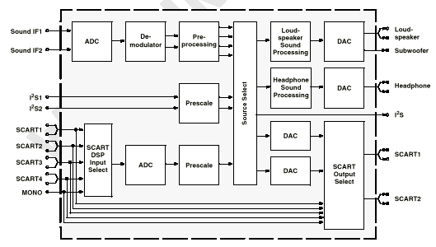

14.13.2.Features
3D-PANORAMA virtualizer (approved by Dolby Laboratories) with noise generator
PANORAMA virtualizer algorithm
Standard Selection with single I²C transmission
Automatic Standard Detection of terrestrial TV standards/Automatic Carrier Mute function
Automatic Sound Selection (mono/stereo/bilingual), new registers MODUS, STATUS
Two selectable sound IF (SIF) inputs
Interrupt output programmable (indicating status change)
Loudspeaker / Headphone channel with volume, balance, bass, treble, loudness
Loudspeaker channel with MDB (Micronas Dynamic Bass)
AVC: Automatic Volume Correction
Subwoofer output with programmable low-pass and complementary high-pass filter
5-band graphic equalizer for loudspeaker channel
Spatial effect for loudspeaker channel; processing of all deemphasis filtering
Four Stereo SCART (line) inputs, one Mono input; two Stereo SCART outputs
Complete SCART in/out switching matrix
Two I²S inputs; one I²S output
All analog FM-Stereo A2 and satellite standards
All analog Mono sound carriers including AM-SECAM L
Simultaneous demodulation of (very) high-deviation FM-Mono and NICAM
Adaptive deemphasis for satellite (Wegener-Panda, acc. to ASTRA specification)
ASTRA Digital Radio (ADR) together with DRP 3510A
All NICAM standards
Korean FM-Stereo A2 standard

14.13.3.Pin connections
NC = not connected; leave vacant
LV = if not used, leave vacant
X = obligatory; connect as described in circuit diagram
DVSS: if not used, connect to DVSS
AHVSS: connect to AHVSS

Pin No. |  |  |  |  | Pin Name | Type | Connection  (if not used) | Short Description
PLCC  68-pin | PSDIP  64-pin | PSDIP  52-pin | PQFP  80-pin | PLQFP  64-pin
1 | 16 | 14 | 9 | 8 | ADR_WS | OUT | LV | ADR word strobe
2 | - | - | - | - | NC |  | LV | Not connected
3 | 15 | 13 | 8 | 7 | ADR_DA | OUT | LV | ADR Data Output
4 | 14 | 12 | 7 | 6 | I2S_DA_IN1 | IN | LV | I²S1 data input
5 | 13 | 11 | 6 | 5 | I2S_DA_OUT | OUT | LV | I²S data output
6 | 12 | 10 | 5 | 4 | I2S_WS | IN/OUT | LV | I²S word strobe
7 | 11 | 9 | 4 | 3 | I2S_CL | IN/OUT | LV | I²S clock
8 | 10 | 8 | 3 | 2 | I2C_DA | IN/OUT | X | I²C data
9 | 9 | 7 | 2 | 1 | I2C_CL | IN/OUT | X | I²C data
10 | 8 | - | 1 | 64 | NC |  | LV | Not connected
11 | 7 | 6 | 80 | 63 | STANDBYQ | IN | X | Stand-by (low-active)
12 | 6 | 5 | 79 | 62 | ADR_SEL | IN | X | I²C bus address select
13 | 5 | 4 | 78 | 61 | D_CTR_I/O_0 | IN/OUT | LV | D_CTR_I/O_0
14 | 4 | 3 | 77 | 60 | D_CTR_I/O_1 | IN/OUT | LV | D_CTR_I/O_1
15 | 3 | - | 76 | 59 | NC |  | LV | Not connected
16 | 2 | - | 75 | 58 | NC |  | LV | Not connected
17 | - | - | - | - | NC |  | LV | Not connected
18 | 1 | 2 | 74 | 57 | AUD_CL_OUT | OUT | LV | Audio clock output  (18.432 MHz)
19 | 64 | 1 | 73 | 56 | TP |  | LV | Test pin
20 | 63 | 52 | 72 | 55 | XTAL_OUT | OUT | X | Crystal oscillator
21 | 62 | 51 | 71 | 54 | XTAL_IN | IN | X | Crystal oscillator
22 | 61 | 50 | 70 | 53 | TESTEN | IN | X | Test pin
23 | 60 | 49 | 69 | 52 | ANA_IN2+ | IN | AVSS via 56 pF/LV | IF Input 2 (can be left vacant, only if IF input 1 is also not in use)
24 | 59 | 48 | 68 | 51 | ANA_IN- | IN | AVSS via 56 pF/LV | IF common (can be left vacant, only if IF input 1 is also not in use)
25 | 58 | 47 | 67 | 50 | ANA_IN1+ | IN | LV | IF input 2
26 | 57 | 46 | 66 | 49 | AVSUP |  | X | Analog power supply 5v
- | - | - | 65 | - | AVSUP |  | X | Analog power supply 5v
- | - | - | 64 | - | NC |  | LV | Not connected
- | - | - | 63 | 48 | NC |  | LV | Not connected
27 | 56 | 45 | 62 | 48 | AVSS |  | X | Analog ground
- | - | - | 61 | - | AVSS |  | X | Analog ground
28 | 55 | 44 | 60 | 47 | MONO_IN | IN | LV | Mono input
- | - | - | 59 | - | NC |  | LV | Not connected
29 | 54 | 43 | 58 | 46 | VREFTOP |  | X | Reference voltage IF A/D converter
30 | 53 | 42 | 57 | 45 | SC1_IN_R | IN | LV | SCART 1 input, right
31 | 52 | 41 | 56 | 44 | SC1_IN_L | IN | LV | SCART 1 input, left
32 | 51 | - | 55 | 43 | ASG |  | AHVSS | Analog Shield Ground
33 | 50 | 40 | 54 | 42 | SC2_IN_R | IN | LV | SCART 2 input, right
34 | 49 | 39 | 53 | 41 | SC2_IN_L | IN | LV | SCART 2 input, left
35 | 48 | - | 52 | 40 | ASG |  | AHVSS | Analog Shield Ground
36 | 47 | 38 | 51 | 39 | SC3_IN_R | IN | LV | SCART 3 input, right
37 | 46 | 37 | 50 | 38 | SC3_IN_L | IN | LV | SCART 3 input, left
38 | 45 | - | 49 | 37 | ASG |  | AHVSS | Analog Shield Ground
39 | 44 | - | 48 | 36 | SC4_IN_R | IN | LV | SCART 4 input, right
40 | 43 | - | 47 | 35 | SC4_IN_L | IN | LV | SCART 4 input, left
41 | - | - | 46 | - | NC |  | LV or AHVSS | Not connected
42 | 42 | 36 | 45 | 34 | AGNDC |  | X | Analog reference voltage
43 | 41 | 35 | 44 | 33 | AHVSS |  | X | Analog ground
- | - | - | 43 | - | AHVSS |  | X | Analog ground
- | - | - | 42 | - | NC |  | LV | Not connected
- | - | - | 41 | - | NC |  | LV | Not connected
44 | 40 | 34 | 40 | 32 | CAPL_M |  | X | Volume capacitor MAIN
45 | 39 | 33 | 39 | 31 | AHVSUP |  | X | Analog power supply 8V
46 | 38 | 32 | 38 | 30 | CAPL_A |  | X | Volume capacitor AUX
47 | 37 | 31 | 37 | 29 | SC1_OUT_L | OUT | LV | SCART output 1, left
48 | 36 | 30 | 36 | 28 | SC1_OUT_R | OUT | LV | SCART output 1, right
49 | 35 | 29 | 35 | 27 | VREF |  | X | Reference ground 1
50 | 34 | 28 | 34 | 26 | SC2_OUT_L | OUT | LV | SCART output 2, left
51 | 33 | 27 | 33 | 25 | SC2_OUT_R | OUT | LV | SCART output 2, right
52 | - | - | 32 | - | NC |  | LV | Not connected
53 | 32 | - | 31 | 24 | NC |  | LV | Not connected
54 | 31 | 26 | 30 | 23 | DACM_SUB | OUT | LV | Subwoofer output
55 | 30 | - | 29 | 22 | NC |  | LV | Not connected
56 | 29 | 25 | 28 | 21 | DACM_L | OUT | LV | Loudspeaker out, left
57 | 28 | 24 | 27 | 20 | DACM_R | OUT | LV | Loudspeaker out, right
58 | 27 | 23 | 26 | 19 | VREF2 |  | X | Reference ground 2
59 | 26 | 22 | 25 | 18 | DACA_L | OUT | LV | Headphone out, left
60 | 25 | 21 | 24 | 17 | DACA_R | OUT | LV | Headphone out, right
- | - | - | 23 | - | NC |  | LV | Not connected
- | - | - | 22 | - | NC |  | LV | Not connected
61 | 24 | 20 | 21 | 16 | RESETQ | IN | X | Power-on-reset
62 | 23 | - | 20 | 15 | NC |  | LV | Not connected
63 | 22 | - | 19 | 14 | NC |  | LV | Not connected
64 | 21 | 19 | 18 | 13 | NC |  | LV | Not connected
65 | 20 | 18 | 17 | 12 | I2S_DA_IN2 | IN | LV | I²S2-data input
66 | 19 | 17 | 16 | 11 | DVSS |  | X | Digital ground
- | - | - | 15 | - | DVSS |  | X | Digital ground
- | - | - | 14 | - | DVSS |  | X | Digital ground
67 | 18 | 16 | 13 | 10 | DVSUP |  | X | Digital power supply 5V
- | - | - | 12 | - | DVSUP |  | X | Digital power supply 5V
- | - | - | 11 | - | DVSUP |  | X | Digital power supply 5V
68 | 17 | 15 | 10 | 9 | ADR_CL | OUT | LV | ADR clock

14.14.TL431

14.14.1.Description
The TL431 is a 3-terminal adjustable shunt voltage regulator providing a highly accurate 1 % band gap reference. TL431 acts as an open-loop error amplifier with a 2.5V temperature compensation reference. The TL431 thermal stability, wide operating current (150mA) and temperature range (0.to 105.makes it suitable for all variety of application that are looking for a low cost solution with high performance. The output voltage may be adjusted to any value between VREF and 36 volts with two external resistors. The TL431 is operating in full industrial temperature range of 0°C to 105°C. The TL431 is available in TO-92, SO-8, SOT-89 and SOT23-5 packages.

14.14.2.Features
• Trimmed Band gap to 1%
• Wide Operating Current 1mA to 150mA
• Extended Temperature Range 0. °C to 105.°C
• Low Temperature Coefficient 30 ppm /°C
• Offered in TO-92, SOIC, SOT-89, SOT-23-5
• Improved Replacement in Performance for TL431
• Low Cost Solution

14.14.3.Pin Configurations

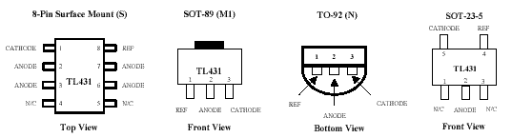

14.15.TDA9885/86

14.15.1.Introduction
The TDA9885 is an alignment-free single standard (without positive modulation) vision and sound IF signal PLL. The TDA9886 is an alignment-free multi standard (PAL, SECAM and NTSC) vision and sound IF signal PLL. Both devices can be used for TV, VTR, PC and set-top box applications.

14.15.2.Features
• 5 V supply voltage
• Gain controlled wide-band Vision Intermediate Frequency (VIF) amplifier (AC-coupled)
• Multistandard true synchronous demodulation with active carrier regeneration (very linear demodulation, good intermodulation figures, reduced harmonics, excellent pulse response)
• Gated phase detector for L/L accent standard
• Fully integrated VIF Voltage Controlled Oscillator (VCO), alignment-free; frequencies switchable for all negative and positive modulated standards via I²C-bus
• Digital acquisition help, VIF frequencies of 33.4, 33.9, 38.0, 38.9, 45.75 and 58.75 MHz
• 4 MHz reference frequency input [signal from Phase-Locked Loop (PLL) tuning system] or operating as crystal oscillator
• VIF Automatic Gain Control (AGC) detector for gain control, operating as peak sync detector for negative modulated signals and as a peak white detector for positive modulated signals
• Precise fully digital Automatic Frequency Control (AFC) detector with 4-bit digital-to-analog converter; AFC bits via I²C-bus readable
• Take Over Point (TOP) adjustable via I²C-bus or alternatively with potentiometer
• Fully integrated sound carrier trap for 4.5, 5.5, 6.0 and 6.5 MHz, controlled by FM-PLL oscillator
• Sound IF (SIF) input for single reference Quasi Split Sound (QSS) mode (PLL controlled)
• SIF AGC for gain controlled SIF amplifier; single reference QSS mixer able to operate in high performance single reference QSS mode and in intercarrier mode, switchable via I²C-bus
• AM demodulator without extra reference circuit
• Alignment-free selective FM-PLL demodulator with high linearity and low noise
• I²C-bus control for all functions
• I²C-bus transceiver with pin programmable Module Address (MAD).

14.15.3.Pin Configurations

Symbol | Pin | Description
VIF1 | 1 | VIF differential input 1
VIF2 | 2 | VIF differential input 2
OP1 | 3 | output 1 (open-collector)
FMPLL | 4 | FM-PLL for loop filter
DEEM | 5 | de-emphasis output for capacitor
AFD | 6 | AF decoupling input for capacitor
DGND | 7 | digital ground
AUD | 8 | audio output
TOP | 9 | tuner AGC TakeOver Point (TOP)
SDA | 10 | I²C-bus data input/output
SCL | 11 | I²C-bus clock input
SIOMAD | 12 | sound intercarrier output and MAD select
n.c | 13 | not connected
TAGC | 14 | tuner AGC output
REF | 15 | 4 MHz crystal or reference input
VAGC | 16 | VIF-AGC for capacitor (Not connected for TDA9885.)
CVBS | 17 | video output
AGND | 18 | analog ground
VPLL | 19 | VIF-PLL for loop filter
VP | 20 | supply voltage (+5 V)
AFC | 21 | output
OP2 | 22 | output 2 (open-collector)
SIF1 | 23 | differential input 1
SIF2 | 24 | differential input 2

14.16.LM7808

14.16.1.Description
The L7800 series of three-terminal positive regulators is available in TO-220 TO-220FP TO-3 and D 2 PAK packages and several fixed output voltages, making it useful in a wide range of applications. These regulators can provide local on-card regulation, eliminating the distribution problems associated with single point regulation. Each type employs internal current limiting, thermal shutdown and safe area protection, making it essentially indestructible. If adequate heat sinking is provided, they can deliver over 1A output current. Although designed primarily as fixed voltage regulators, these devices can be used with external components to obtain adjustable voltages and currents.

14.16.2.Features
Output Current Up To 1.5 A
Output Voltages of 5; 5.2; 6; 8; 8.5; 9; 12; 15; 18; 24V
Thermal Over load protection
Short Circuit Protection
Output Transition SOA Protection

14.17.TDA8177F

14.17.1.Description
Designed for monitors and high performance TVs, the TDA8177F vertical deflection booster can handle flyback voltage up to 70V. More than this it is possible to have a flyback voltage, which is more than the double of the supply (Pin 2). This allows to decrease the power consumption or to decrease the flyback time for a given supply voltage. The TDA8177F operates with supplies up to 35V and provides up to 3APP output current to drive the yoke.

14.17.2.Features
Power Amplifier
Thermal Protection
Output Current Up To 3.0APP
Flyback Voltage Up To 70V (on Pin 5)
Suitable For Dc Coupling Application
External Flyback Supply

14.17.3.Pin connections

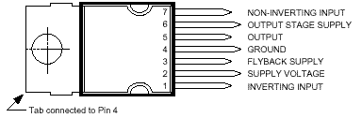

14.17.4.Block Diagram

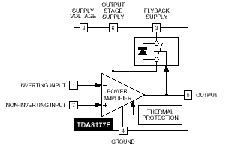

14.18.LM1086

14.18.1.Description
The LM1086 is a series of low dropout positive voltage regulators with a maximum dropout of 1.5V at 1.5A of load current. It has the same pin-out as National Semiconductor’s industry standard LM317. The LM1086 is available in an adjustable version, which can set the output voltage with only two external resistors. It is also available in five fixed voltages: 2.5V, 2.85V, 3.3V, 3.45V and 5.0V. The fixed versions integrate the adjust resistors. The LM1086 circuit includes a zener trimmed band-gap reference, current limiting and thermal shutdown.

14.18.2.Features
Available in 2.5V, 2.85V, 3.3V, 3.45V, 5V and Adjustable Versions
Current Limiting and Thermal Protection
Output Current 1.5A
Line Regulation 0.015% (typical)
Load Regulation 0.1% (typical)

14.18.3.Applications
SCSI-2 Active Terminator
High Efficiency Linear Regulators
Battery Charger
Post Regulation for Switching Supplies
Constant Current Regulator
Microprocessor Supply

14.18.4.Connection Diagrams
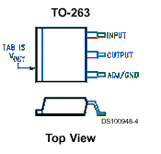
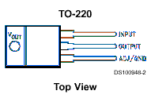

14.19.MC44608

14.19.1.Description
The MC44608 is a high performance voltage mode controller designed for off–line converters. This high voltage circuit that integrates the start–up current source and the oscillator capacitor, requires few external components while offering a high flexibility and reliability. The device also features a very high efficiency stand–by management consisting of an effective Pulsed Mode operation. This technique enables the reduction of the stand–by power consumption to approximately 1W while delivering 300mW in a 150W SMPS.
• Integrated Start–Up Current Source
• Lossless Off–Line Start–Up
• Direct Off–Line Operation
• Fast Start–Up

14.19.2.General Features
• Flexibility
• Duty Cycle Control
• Under voltage Lockout with Hysteresis
• On Chip Oscillator Switching Frequency 40, or 75kHz
• Secondary Control with Few External Components
Protections
• Maximum Duty Cycle Limitation
• Cycle by Cycle Current Limitation
• Demagnetization (Zero Current Detection) Protection
• “Over VCC Protection” Against Open Loop
• Programmable Low Inertia Over Voltage Protection Against Open Loop
• Internal Thermal Protection
GreenLineTM Controller
• Pulsed Mode Techniques for a Very High Efficiency Low Power Mode
• Lossless Startup
• Low dV/dT for Low EMI Radiations

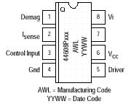
14.19.3.Pin Connections

14.19.4.Pin Function description

Pin | Name | Description
1 | Demag | The Demag pin offers 3 different functions: Zero voltage crossing detection (50mV), 24mA current detection and 120mA current detection. The 24mA level is used to detect the secondary reconfiguration status and the 120mA level to detect an Over Voltage status called Quick OVP.
2 | ISENSE | The Current Sense pin senses the voltage developed on the series resistor inserted in the source of the power MOSFET. When I sense reaches 1V, the Driver output (pin 5) is disabled. This is known as the Over Current Protection function. A 200mA current source is flowing out of the pin 3 during the start–up phase and during the switching phase in case of the Pulsed Mode of operation. A resistor can be inserted between the sense resistor and the pin 3; thus a programmable peak current detection can be performed during the SMPS stand–by mode.
3 | Control Input | A feedback current from the secondary side of the SMPS via the opto–coupler is injected into this pin. A resistor can be connected between this pin and GND to allow the programming of the Burst duty cycle during the Stand–by mode.
4 | Ground | This pin is the ground of the primary side of the SMPS.
5 | Driver | The current and slew rate capability of this pin are suited to drive Power MOSFETs.
6 | VCC | This pin is the positive supply of the IC. The driver output gets disabled when the voltage becomes higher than 15V and the operating range is between 6.6V and 13V. An intermediate voltage level of 10V creates a disabling condition called Latched Off phase.
7 |  | This pin is to provide isolation between the Vi pin 8 and the VCC pin 6.
8 | Vi | This pin can be directly connected to a 500V voltage source for start–up function of the IC. During the Start–up phase a 9 mA current source is internally delivered to the VCC pin 6 allowing a rapid charge of the VCC capacitor. As soon as the IC starts–up, this current source is disabled.

14.20.TCET1102G

14.20.1.Description
The TCET110/ TCET2100/ TCET4100 consists of a phototransistor optically coupled to a gallium arsenide infrared-emitting diode in a 4-lead up to 16-lead plastic dual inline package. The elements are mounted on one lead frame using a coplanar technique, providing a fixed distance between input and output for highest safety requirements.

14.20.2.Applications
Circuits for safe protective separation against electrical shock according to safety class II (reinforced isolation):
For appl. class I – IV at mains voltage ≤300 V
For appl. class I – III at mains voltage ≤600 V
According to VDE 0884, table 2, suitable for: Switch-mode power supplies, line receiver, computer peripheral interface, microprocessor system interface.

14.20.3.Features
VDE 0884 related features:
Rated impulse voltage (transient overvoltage) V IOTM = 8 kV peak
Isolation test voltage (partial discharge test voltage) V pd = 1.6 kV
Rated isolation voltage (RMS includes DC) V IOWM = 600 V RMS (848 V peak)
Rated recurring peak voltage (repetitive) V IORM = 600 V RMS
General features:
CTR offered in 9 groups
Isolation materials according to UL94-VO
Pollution degree 2 (DIN/VDE 0110 / resp. IEC 664)
Climatic classification 55/100/21 (IEC 68 part 1)
Special construction: Therefore, extra low coupling capacity of typical 0.2pF, high Common Mode Rejection
Low temperature coefficient of CTR
G = Leadform 10.16 mm; provides creepage distance > 8 mm, for TCET2100/ TCET4100 optional; suffix letter ‘G’ is not marked on the optocoupler
Coupling System U

14.21.TDA7480L

14.21.1.Description
The TDA7480L is an audio class-D amplifier assembled in Power DIP package specially de-signed for high efficiency applications mainly for TV and Home Stereo sets.

14.21.2.Features
10W Output Power: R_{L} = 8Ω/4Ω; THD = 10%
High Frequency
No Heatsink
Split Supply
Overvoltage Protection
St-By And Mute Features
Short Circuit Protection
Thermal Overload Protection

14.21.3.Pin Functions

Number | Name | Function
1 | -V_{CC} | NEGATIVE SUPPLY.
2 | -V_{CC} | NEGATIVE SUPPLY.
3 | -V_{CC} | NEGATIVE SUPPLY.
4 | OUT | PWM OUTPUT
5 | BOOTDIODE | BOOTSTRAP DIODE ANODE
6 | BOOT | BOOTSTRAP CAPACITOR
7 | NC | NOT CONNECTED
8 | FEEDCAP | FEEDBACK INTEGRATING CAPACITANCE
9 | FREQUENCY | SETTING FREQUENCY RESISTOR
10 | SGN-GND | SIGNAL GROUND
11 | IN | INPUT
12 | ST-BY-MUTE | ST-BY/ MUTE CONTROL PIN
13 | NC | NOT CONNECTED
14 | +V_{CC} SIGN | POSITIVE SIGNAL SUPPLY
15 | V_{REG} | 10V INTERNAL REGULATOR
16 | +V_{CC} POW | POSITIVE POWER SUPPLY
17 | -V_{CC} | NEGATIVE SUPPLY (TO BE CONNECTED TO PIN 16 VIA C5)
18 | -V_{CC} | NEGATIVE SUPPLY
19 | -V_{CC} | NEGATIVE SUPPLY
20 | -V_{CC} | NEGATIVE SUPPLY

14.22.SAA3010T

14.22.1.Description
The SAA3010 is intended as a general purpose (RC-5) infrared remote control system for use where a low voltage supply and a large debounce time are expected. The device can generate 2048 different commands and utilizes a keyboard with a single pole switch for each key. The commands are arranged so that 32 systems can be addressed, each system containing 64 different commands. The circuit response to legal (one key pressed at a time) and illegal (more than one key pressed at a time) keyboard operation is specified in the section “Keyboard operation”.

14.22.2.Features
Low voltage requirement
Biphase transmission technique
Single pin oscillator
Test mode facility

14.22.3.Pinning

Pin | Mnemonic | Function
1 | X7 (IPU) | sense input from key matrix
2 | SSM (I) | sense mode selection input
3 | Z0-Z3 (IPU) | sense inputs from key matrix
7 | MDATA (OP3) | generated output data modulated with 1/12 the oscillator frequency at a 25% duty factor
8 | DATA (OP3) | generated output information
9-13 | DR7-DR3 (ODN) | Scan drivers
14 | VSS | Ground (0V)
15-17 | DR-2-DR0 (ODN) | Scan drivers
18 | OSC (I) | Oscillator input
19 | TP2 (I) | test point 2
20 | TP1 (I) | Test point 1
21-27 | X0-X6 (IPU) | Sense inputs from key matrix
28 | VDD(I) | Voltage supply

Note:
(I): Input,
(IPU): input with p-channel pull-up transistor,
(ODN): output with open drain n-channel transistor
(OD3): output 3-state

15.AK52 CHASSIS MANUAL ADJUSTMENTS PROCEDURE

15.1.PRELIMINARY
Before starting with the alignment procedure, make sure that all the potentiometers on the chassis and also screen and focus pots are in the medium position.

15.2.SYSTEM VOLTAGE ADJUSTMENTS
Inputs AC power (220V 50Hz)
PAL B/G test pattern via RF
(PAL I test pattern for PAL I TV’s, SECAM D/K pattern, SECAM L/L’/K’ TVs.)
Outputs Digital voltmeter to anode of D110.
Display System voltage
Action Apply power. Check that the stand-by Led lights.
Select TV mode and tune to the applied test pattern via local test keyboard.
Chassis should start normally.
Adjust all analog controls (volume, bass, treble, brightness, contrast, colour) to minimum
settings.
Adjust VR127 according to the following different type of CRTs.

SYSTEM VOLTAGE TYPE OF CRT
135V±0.5V PHILIPS A66EAK552X54
135V±0.5V PHILIPS A66EAK071X54
135V±0.5V VIDEOCOLOR A66ECY13X12
135V±0.5V PHILIPS W66ESF002X44

15.3.AFC ADJUSTMENTS

AFC is automatically adjusted from software , when f (IF) is selected 38.9MHz for
negative modulation and 33.9MHz for positive modulation from the service menu.

15.4.FOCUS ADJUSTMENTS
Inputs AC power
PAL B/G test pattern via RF input.
Outputs Picture tube drive.
Display Picture
Action Select TV mode and tune to the signal.
Adjust focus potantiometer (the upper pot on the rear side of the FBT transformer) for optimum focusing drive.

15.5.SCREEN ADJUSTMENTS
Inputs AC power
PAL B/G Colour Bar test pattern via RF
Outputs 1/100 Oscilloscope probe to RGB cathodes on CRT baseboard.
NOTE: Ground pin of probe will be connected to 1st pin (GND) of the CRT socket.
Display RGB ratio
Action Select PAL B/G Colour bar pattern using the local test keyboard and the user remote control unit.
Adjust all control functions (brightness, colour and contrast) to minimum settings.
Measure the most sensitive cathode
Adjust the screen potentiometer (lower pot on the rear side of FBT transformer) until cathode voltage becomes 150V.

15.6.IF ADJUSTMENT FOR L’ MODE

AFC is automatically adjusted from software , when f (IF) is selected 33.9MHz for
positive modulation (SECAM L’) from the service menu.

16.AK52 CHASSIS PRODUCTION SERVICE MODE ADJUSTMENTS

16.1.PRELIMINARY
All system, geometry and white balance alignments are performed in production service mode. Before starting the production mode alignments, make sure that all manual adjustments are done correctly. To start production mode alignments enter the MAIN MENU and then press the digits 1, 6, 7 and 5 respectively. The following first menu appears on the screen. Production mode values will appear on the screen.
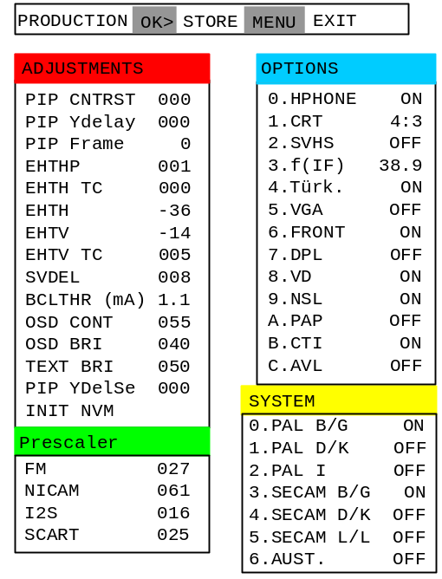
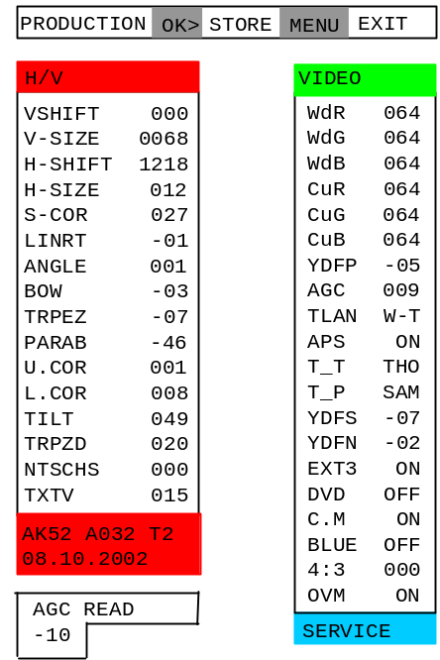
First page Second Page

SERVICE MENU

Production mode groups will be displayed with different colours of headlines, so in order to access a production alignment group press the colour button of the related group on the remote control transmitter.
- RED BUTTON is pressed to access H/V menu.
- GREEN BUTTON is pressed to access VIDEO adjust menu.
- BLUE BUTTON is pressed to go to the next page of the service menu.
- YELLOW BUTTON is used to adjust system parameters on the second page of the service menu.
After selecting one of the production service mode groups, you can access its items by pressing ∆/∇ buttons. Selected parameter will be highlighted. Inorder to change the selected parameter, use ◁/▷ buttons. Inorder to switch between other group of items press the colour key of this groups headline.
To store the settings press OK button. To exit the service menu press MENU button.
Entire service menu parameters of AK52 CHASSIS are listed below.

16.2.H/V (HORIZONTAL AND VERTICAL GEOMETRY ALIGNMENTS)
Switch the program to crosshatch test pattern. Press RED button to access this group of item. Select the parameter by pressing up/down buttons. Adjust the parameter by pressing left/right buttons. Store the settings by pressing OK button. Switch the another parameter group by pressing the colour button of the related coloured headline of that group. Exit production mode by pressing the MENU button on the remote control.

V-SHIFT
Change Vertical Shift by pressing Left/Right buttons till the test pattern is vertically centered. Horizontal line at the center of the test pattern is in equal distance both to upper and lower side of the picture tube. Check and readjust V-SHIFT item if the adjustment becomes improper after some other geometric adjustments are done.
Min. Value: -128
Max. Value: 127
Recommended Value: 000

V-SIZE
Change Vertical Size by pressing Left/Right buttons till horizontal black lines on both the upper and lower part of the test pattern become very close to the upper and lower horizontal sides of picture tube and nearly about to disappear. Check and readjust V-SIZE item if the adjustment becomes improper after some other geometric adjustments are done.
Min. Value: -128
Max. Value: 127
Recommended Value: 068

H-SHIFT
Change Horizontal Shift by pressing Left/Right buttons till the the test pattern is horizontally in equal distance both to right and left sides of the picture tube. Check and readjust H-SHIFT item if the adjustment becomes improper after some other geometric adjustments are done.
Min. Value: 0000
Max. Value: 1295
Recommended Value: 1218

H-SIZE
Change Horizontal Size by pressing Left/Right buttons till no under-scan condition will happen, i.e. no white bars on the left and right side of the test pattern will be visible nor picture will be so wide. Check and readjust H-SIZE item if the adjustment becomes improper after some other geometric adjustments are done.
Min. Value: -128
Max. Value: 127
Recommended Value: 012

S-COR
Change S-Correction by pressing Left/Right buttons till the size of squares on both the upper and lower part of test pattern become equal to the squares laying on the vertical center of the test pattern. Check and readjust S-COR item if the adjustment becomes improper after some other geometric adjustments are done.
Min. Value: -128
Max. Value: 127
Recommended Value: 027

LINRT
Change Linearity by pressing Left/Right buttons till all the size of squares of the test pattern become in equal size from the top of the screen to its bottom of the whole screen. Check and readjust LINRT item if the adjustment becomes improper after some other geometric adjustments are done. (especially after than S-COR adjustment)
Min. Value: -128
Max. Value: 127
Recommended Value: -01

ANGLE
Change Angle by pressing Left/Right buttons till the vertical lines of the crosshatch pattern become completely perpendicular to horizontal lines without any angle of vertical deviation. Check and readjust ANGLE item if the adjustment becomes improper after some other geometric adjustments are done.
Min. Value: -128
Max. Value: 127
Recommended Value: 001

BOW
Change Bow by pressing Left/Right buttons till the vertical lines especially ones close to the left and right sides will of equal and symmetrical bending, i.e. they together will neither be towards left side nor right side. Check and readjust BOW item if the adjustment becomes improper after some other geometric adjustments are done.
Min. Value: -128
Max. Value: 127
Recommended Value: -03

TRPEZ
Change Trapezium by pressing Left/Right buttons till vertical lines, especially lines at the sides of the picture frame became parallel to the both sides of picture tube as close as possible. Check and readjust TRPEZ item if the adjustment becomes improper after some other geometric adjustments are done.
Min. Value: -128
Max. Value: 127
Recommended Value: -07

PARAB
Change Parabol by pressing Left/Right buttons till vertical lines close to the both sides of the picture frame become parallel to vertical sides of picture tube without any bending to left or to right side of the screen. Check and readjust PARAB item if the adjustment becomes improper after some other geometric adjustments are done.
Min. Value: -128
Max. Value: 127
Recommended Value: -46

U.COR
Change Upper Correction by pressing Left/Right buttons till vertical lines at the upper corners of the picture frame become vertical and parallel to vertical corner sides of picture tube. Check and readjust U.COR item if the adjustment becomes improper after some other geometric adjustments are done.
Min. Value: -128
Max. Value: 127
Recommended Value: 001

L.COR
Change Lower Correction by pressing Left/Right buttons till vertical lines at the lower corners of the picture frame become vertical and parallel to vertical corner sides of picture tube. Check and readjust L.COR item if the adjustment becomes improper after some other geometric adjustments are done.
Min. Value: -128
Max. Value: 127
Recommended Value: 008

TILT
This adjustment only works when the TV has rotation option. Change TILT by pressing Left/Right buttons to rotate the complete raster clock-wise and counter clock-wise depending on the CRT. Check and readjust TRPEZ item if the adjustment becomes improper after some other geometric adjustments are done.
Min. Value: 000
Max. Value: 063
Recommended Value: 049

TRPZD
Not used for this model.

NTSCHS
Change NTSC horizontal size by pressing Left/Right buttons to adjust till no under-scan condition will happen, i.e. no white bars on the left and right side of the NTSC test pattern will be visible nor picture will be so wide. Check and readjust TRPEZ item if the adjustment becomes improper after some other geometric adjustments are done.

Min. Value: 000
Max. Value: 010
Recommended Value: 000

TXTV
Change TXTV by pressing Left/Right buttons to adjust the proper vertical size of Teletext screen. Check and readjust TRPEZ item if the adjustment becomes improper after some other geometric adjustments are done.

Min. Value: 000
Max. Value: 040
Recommended Value: 015

16.3.VIDEO ALIGNMENTS
Switch the program to colour bar test pattern. Press GREEN button to access this group of item. Select the parameter by pressing up/down buttons. Adjust the parameter by pressing left/right buttons. Store the settings by pressing OK button.

WdR, WdG, WdB: WHITE BALANCE ADJUSTMENT
Apply WHITE test pattern via RF. Adjust all analog functions to medium level and set WdR to 86, WdG to 84, WdB to 80, if needed. Use colour analyser and monitor the colour temperature (X,Y) on colour analyser. Select WdR and WdB by pressing up/down buttons and change the values by Left/Right buttons till the following values are read:
X=285±10
Y=293±10 on the colour analyser.

CuR, CuG, CuB
Set the values of these items as 64 (constant).

YDFP
Enter a PAL B/G colour and black-white bar test pattern via RF. Adjust Y-Delay for PAL till the colour transients on the colour bar of the pattern become as sharper and colours between transients do not mix with each other as possible.
Min. Value: -07
Max. Value: 001
Recommended Value: -05

AGC
Apply PAL BG signal, VHF-3 Channel-12 and 60dBuV signal level. Adjust AGC (Automatic Gain Control) item by pressing Left/Right buttons till the voltage at AGC point (pin1 of the tuner) becomes 3.0 volts.
Min. Value: 000
Max. Value: 031
Recommended Value: 016

TLAN
Text language is set. Options are W-T, W-E, W, E. W-T will be selected.

APS
The option of APS (Automatic Program Searching) item are ON and OFF. In order to active APS installation procedure when TV is turned for the very first time, select ON. Inorder to start TV without APS installation procedure, select OFF.

T_T
This item is used for the Tuner selection. The options are SAM for SAMSUNG, THO for THOMSON, SIE for SIEMENS, MK2 and MK3 for PHILIPS MP2/MP3, ALP for ALPS and TEC for Tecnisat. Select THO.

T_P
This item is also used for the Tuner selection. The options are MK2, SAM, THO, TEM. MK2 for PHILIPS, SAM for SAMSUNG, THO for THOMSON and TEM for TEMIC. Select SAM.

YDFS
Enter a SECAM B/G colour and black-white bar test pattern via RF. Adjust Y-Delay SECAM till the colour transients on the colour bar of the pattern become as sharper and colours between transients do not mix with each other as possible.
Min. Value: -07
Max. Value: 001
Recommended Value: -07

YDFN
Enter an NTSC colour and black-white bar test pattern via RF. Adjust Y-Delay NTSC till the colour transients on the colour bar of the pattern become as sharper and colours between transients do not mix with each other as possible.
Min. Value: -07
Max. Value: 001
Recommended Value: -02

EXT3
Select ON.

DVD
Select OFF.

C.M
Select ON.

BLUE
Select OFF.

4:3
Set to 0.

OVM
Select ON.

16.4.SERVICE ALIGNMENTS
IMPORTANT: There will no adjustments in this service mode during production mode alignments.
Press BLUE colour button on the remote control when Production mode is active. Press the colour button of the related item group headline colour. Press up/down buttons to select the item of group. Press Left/Right button to alter the value of the item. Press OK button to store the selected value and MENU button to exit the service alignments mode.

ADJUSTMENTS GROUP
Press RED button in order to access this group of items.
PIP CNTRST : Level of the PIP picture
PIP Ydelay : Luma delay of the PIP picture
PIP Frame : Colour selection of the PIP frame (edges of the PIP)
EHTHP : EHT compensation coefficient for horizontal phase
EHTH TC : EHT time constant for horizontal phase compensation
EHTH : EHT compensation coefficient for horizontal amplitude
EHTV : EHT compensation coefficient for vertical amplitude
EHTV TC : EHT time constant for control of vertical and horizontal amplitude EHT
compensation
SVDEL : Delay adjustment for scan velocity modulation
BCLTHR (mA) : Beam current applied to the CRT
OSD CONT : Contrast level of OSD
OSD BRI : Brightness level of OSD
TEXT BRI : Brightness level of text
PIP YDelSe : Y-Delay adjustment for pin-in-picture option
INIT NVM : Press to initiate the NVM

PRESCALER GROUP
Press GREEN button in order to access this group of items.
FM : This adjustment is to determine the pre-amplifier gain of MSP for German stereo
Set to 27.
NICAM : This adjustment is to determine the pre-amplifier gain of MSP for Nicam
Set to 61.
I2S : Not used.
SCART : This adjustment is to determine the pre-amplifier gain of MSP for Scart audio inputs
Set to 25.

OPTIONS GROUP
Press BLUE button in order to access this group of items.
0.HPHONE : ON/OFF
1.CRT : 4:3 / 16:9
2.SVHS : ON/OFF
3.f(IF) : always set to 38.9
4.Türk. : Turkish menu ON/OFF
5.VGA : ON/OFF
6.FRONT : Front AV ON/OFF
7.DPL : ON/OFF
8.VD : ON/OFF
9.NSL : ON/OFF
A.PAP : ON/OFF
B.CTI : ON/OFF
C.AVL : ON/OFF

SYSTEM GROUP
Press YELLOW button in order to access this group of items.
0.PAL B/G : ON/OFF
1.PAL D/K : ON/OFF
2.PAL I : ON/OFF
3.SECAM B/G : ON/OFF
4.SECAM D/K : ON/OFF
5.SECAM L/L’ : ON/OFF
6.AUST. : ON/OFF

NOTE: Settings values in Service menu are given for 28” 4:3 THOMSON (A66EHJ13X12) tube in this manual.

17.BLOCK DIAGRAM
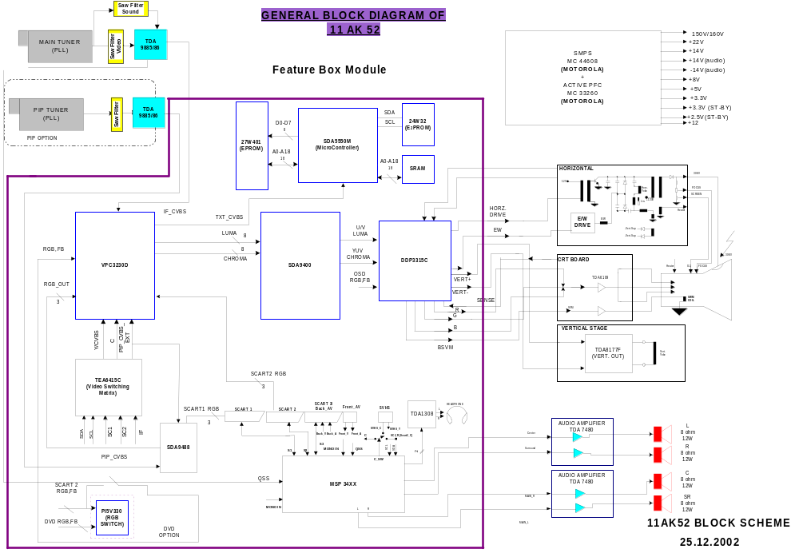

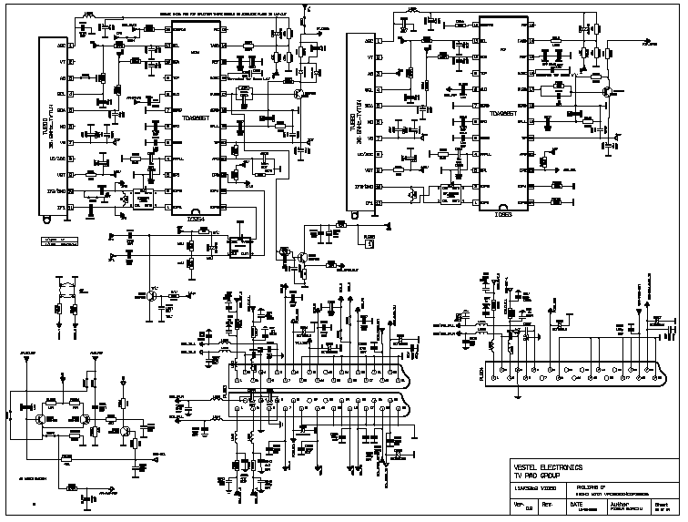
18.CIRCUIT DIAGRAMS

11ak52b4-VIDEO

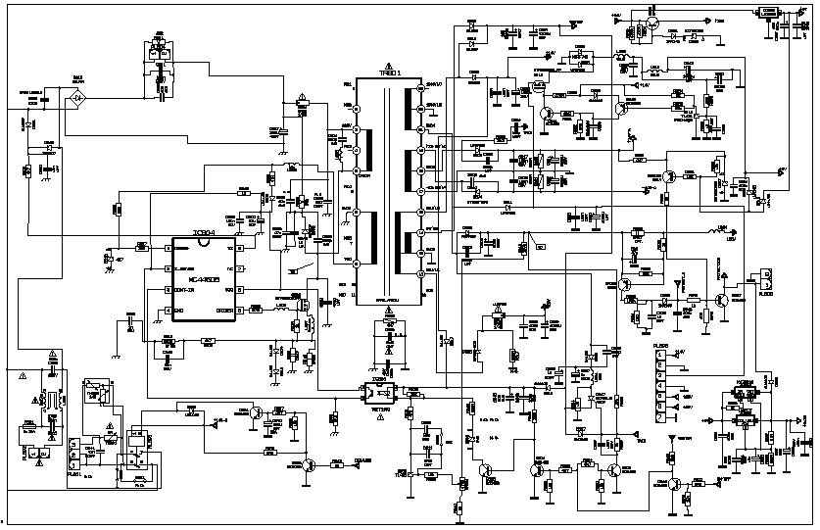

11ak52b4-2
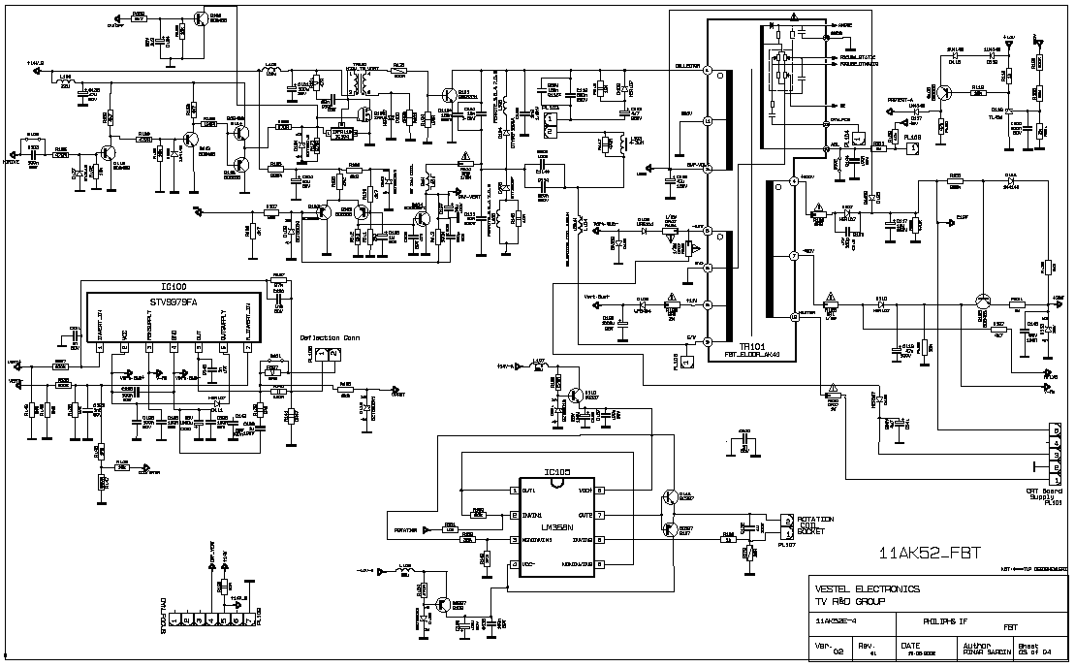

11ak52b4-3

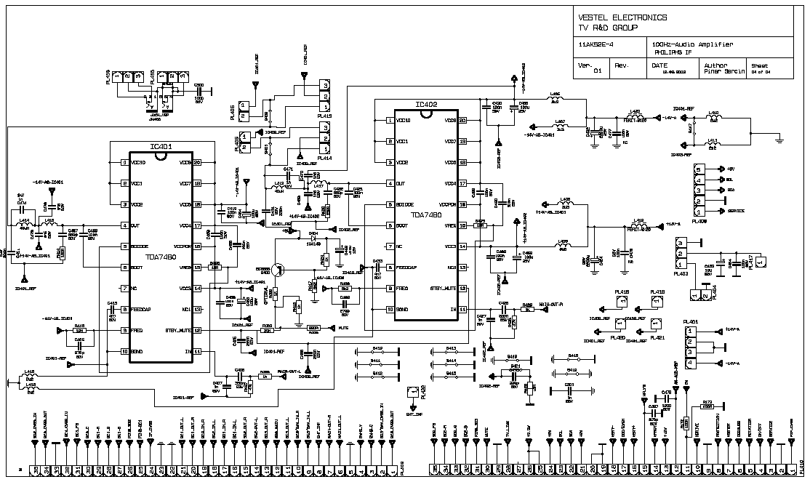
11ak52b4-4

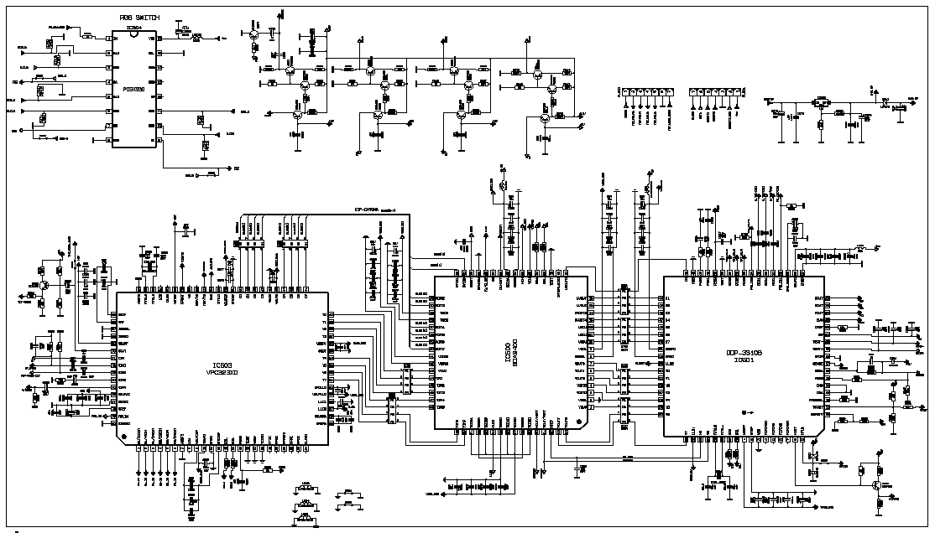
11fb2a3—1

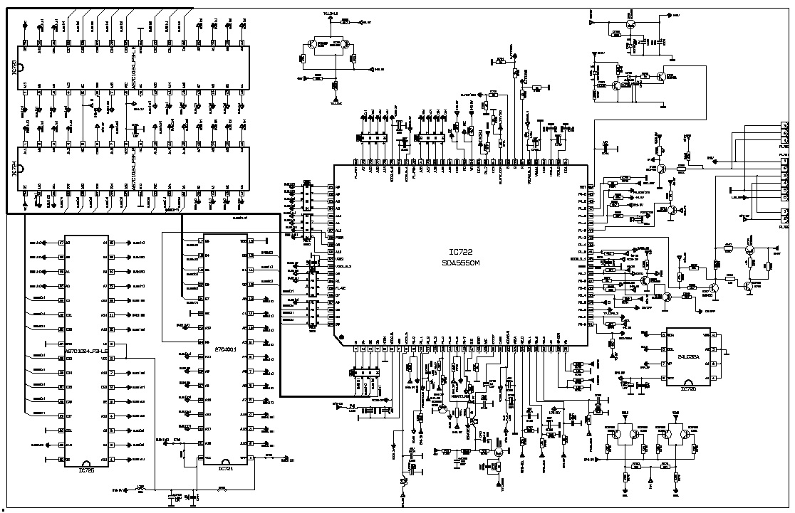
11fb2a3—2

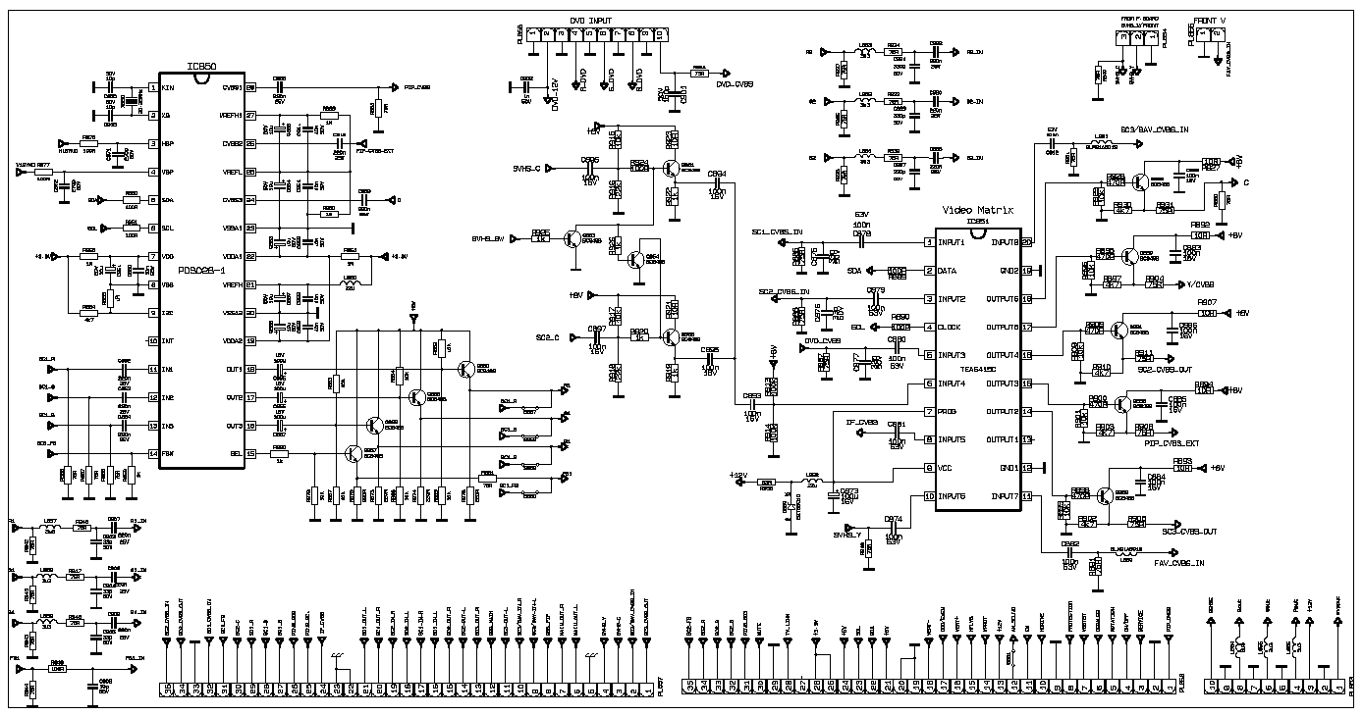

11fb2a3—3

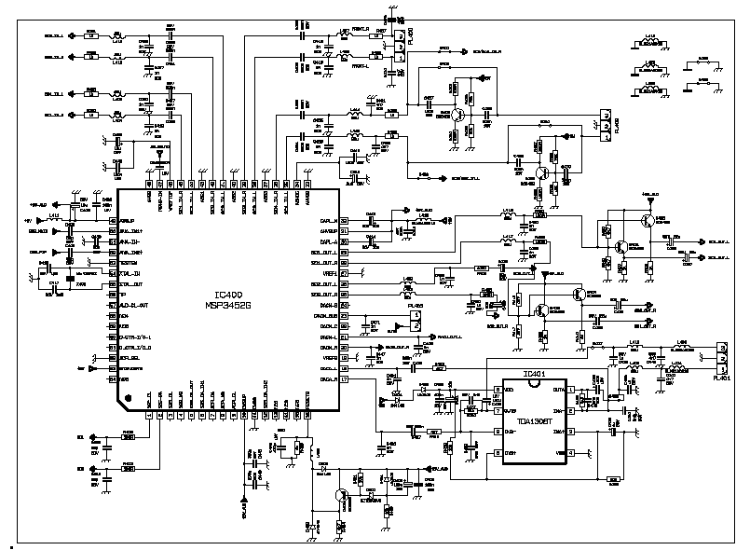

11fb2a3—4

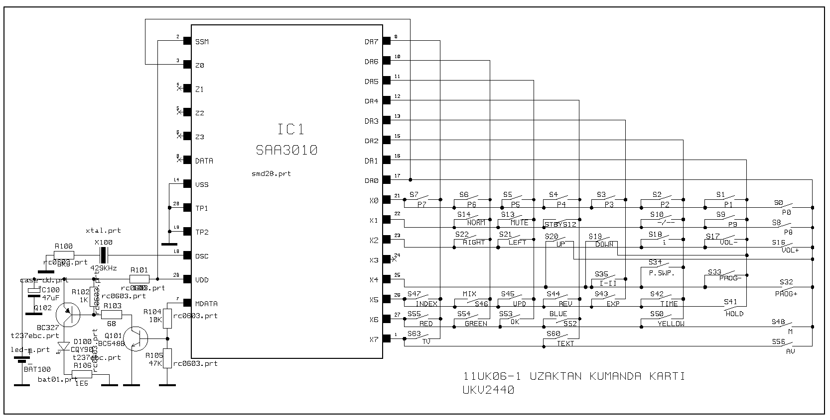
11uk06-1

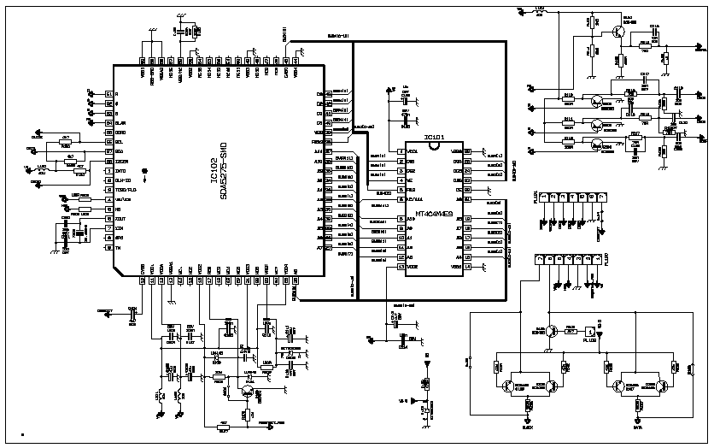

11txt52-4

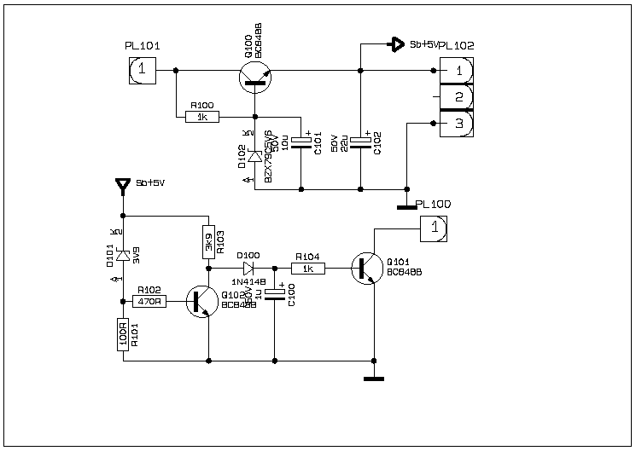

11rs52

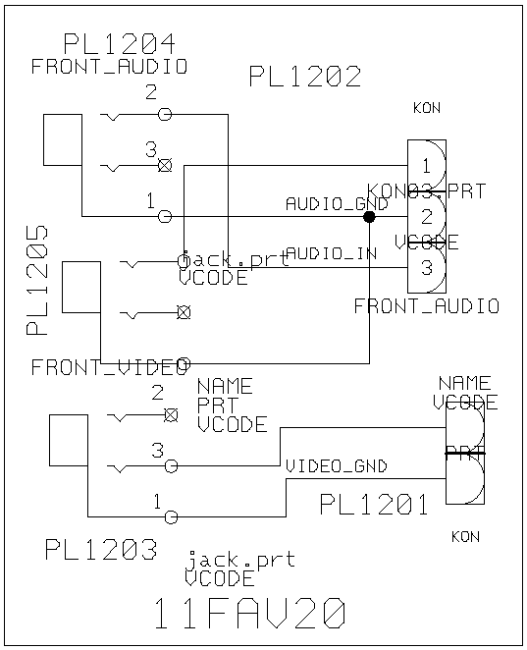

11fav19a4
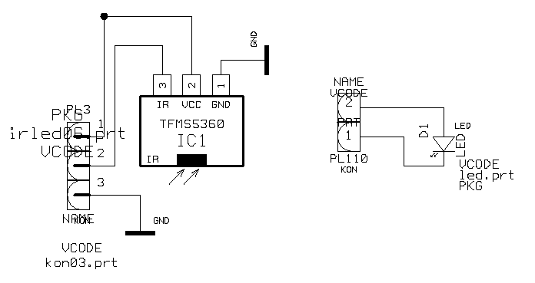

11ir2872

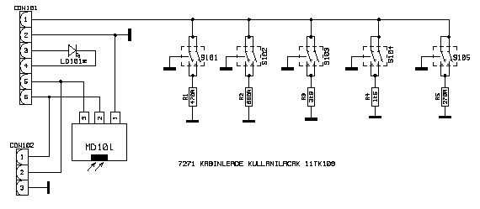

11tk109

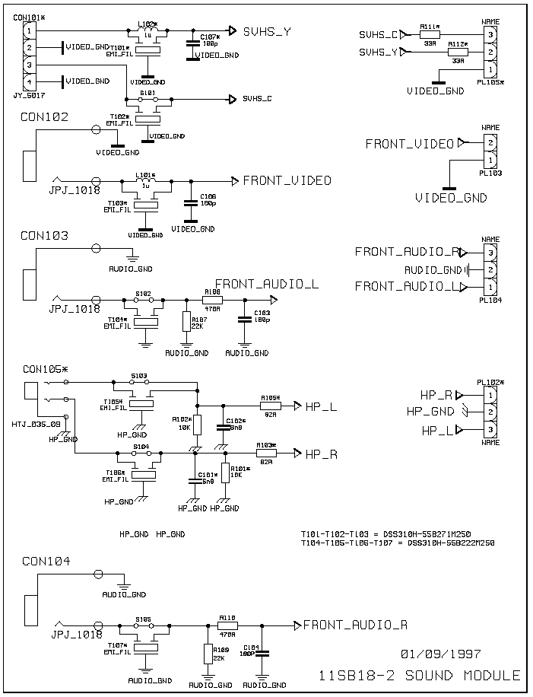
11sb18-3

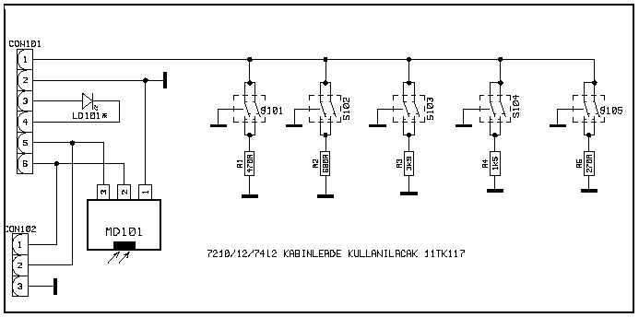

11tk117

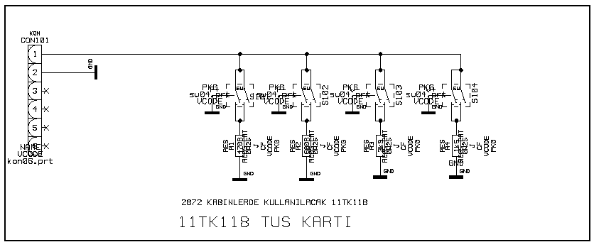

11tk118

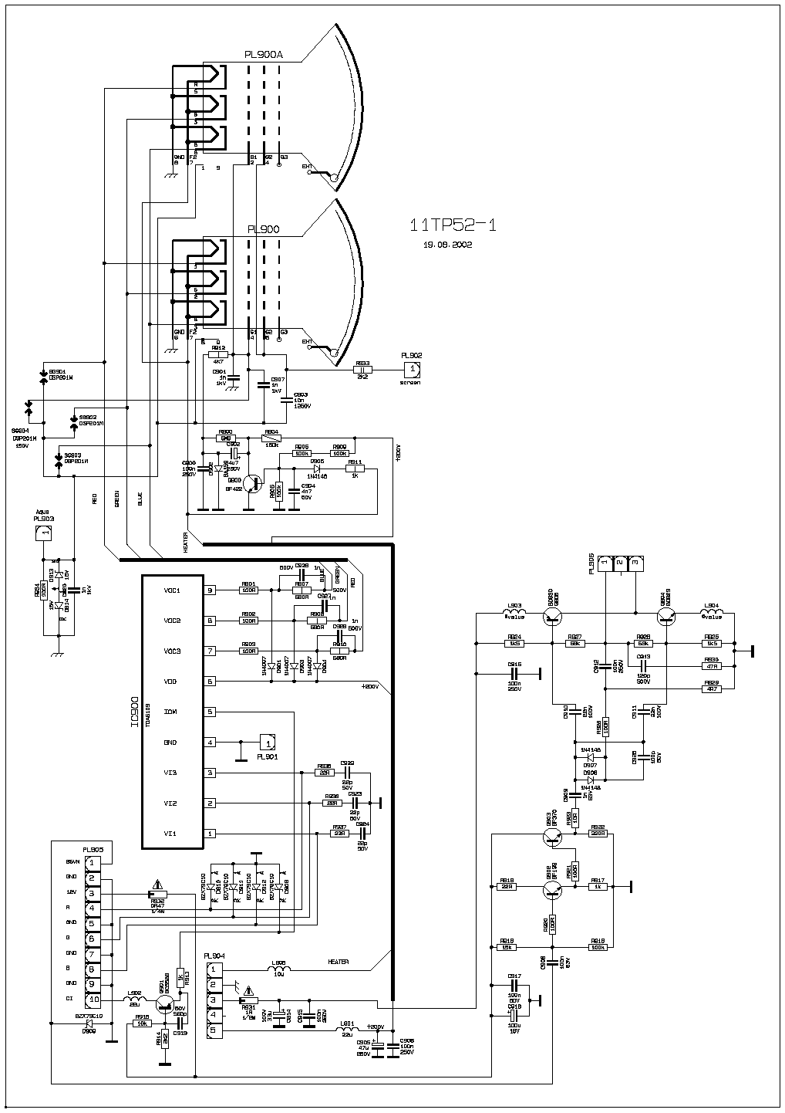

11tp52-1

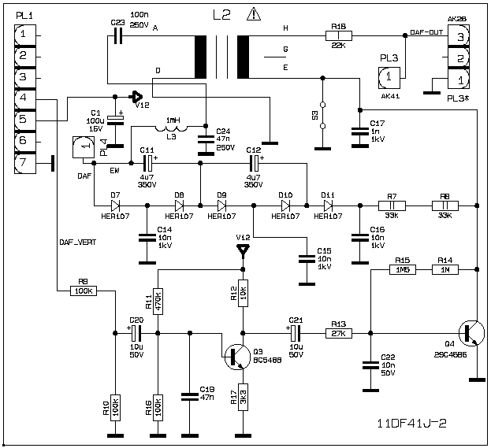

11df41j-2

