 | Tesla, Inc.  Service Bulletin |  |  | Rewrite Shunt Resistance Value
SB-20-16-002  May 29, 2021 |  |  | R1
Classification |  |  |  | Section/Group | Mobile Service
Campaign Bulletin |  |  |  | 16 - HV Battery System | Can Perform (where permitted)
Model Year |  | Model |  | Country/Region | Version
2020 |  | Model 3 |  | All | All
The model(s) and model year(s) listed are a general approximation of the affected VIN list. Refer to the VIN/Bulletin Tracker or Customer/Vehicle profile to determine applicability of this bulletin for a particular vehicle.
Campaign Bulletin: This campaign bulletin addresses a known non-safety-related condition and provides recommended technical diagnosis and repair procedures. Apply this procedure to all vehicles in the affected VIN list.
This Service Document supersedes SB-20-16-003, dated March 4, 2020. Each content change is marked by a vertical line in the left margin. Discard the previous version and replace it with this one.

Condition

Certain Model 3 vehicles were configured with incorrect shunt resistance values that can affect charging capacity and range performance.

Correction

Rewrite the shunt resistance with the correct value for the vehicle.

Correction Description | Correction | Time
SB-20-16-002 Not Applicable | S012016002 | 0.00
Rewrite Shunt Resistance Value | S022016002 | 0.15

Shop Supplies | Paint pen

Procedure

CAUTION: This procedure has time-dependent steps. Read through the entire procedure to become familiar before performing it.

NOTE: The tool to display the correct shunt resistance value for a given VIN has been integrated into step 2 of this document.

- Make sure that the vehicle is in Park, there is no charging cable connected, and the climate control system is completely powered off.

- Double-click the yellow box below to activate the tool. Type the VIN in upper case, and press the Enter key to display the correct shunt resistance value for the vehicle.

3. Click on this text to deactivate the tool in step 2.

- Record the 5-digit shunt resistance value, and have it standing by for step 9.

NOTE: For example, the shunt resistance might be 24986.

- Connect a laptop with Toolbox 3 to the vehicle.

- In Toolbox, select the Actions/Autodiag tab, type “contactors” into the search field, and click Ensure Power Off (Figure 1).

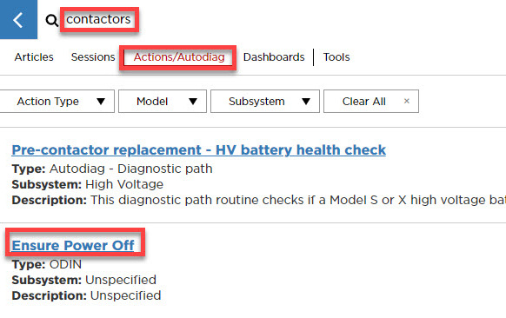

Figure 1

- Click RUN (Figure 2).

CAUTION: After the contactors open, steps 8 and 9 must be completed within 60 seconds.

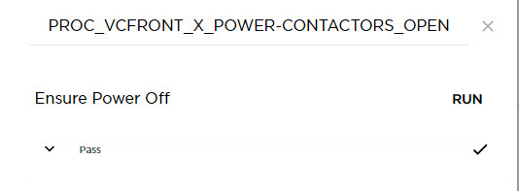

Figure 2

- Select the Actions/Autodiag tab, type “shunt” into the search field, click HVP write shunt ohm (Figure 3), and then click Run Network (Figure 4).

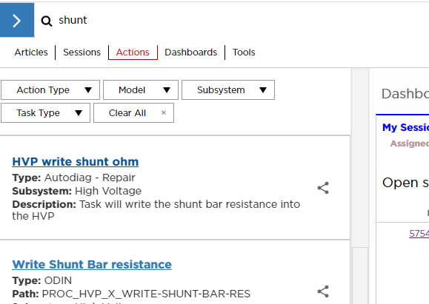

Figure 3

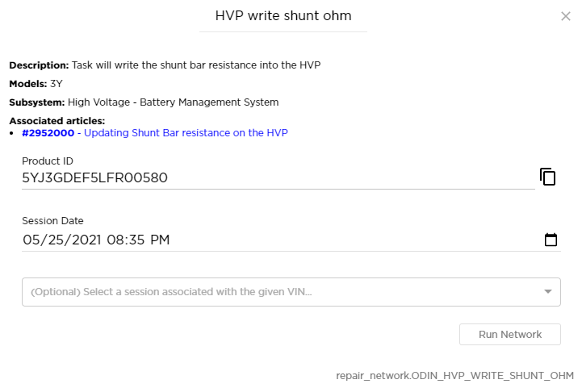

Figure 4

- In the window that opens, click on the line above “Submit”, type the 5-digit shunt resistance value from step 4, click Submit (Figure 5), and then wait for the routine to successfully complete (Figure 6).

NOTE: If the routine fails, repeat from step 6.

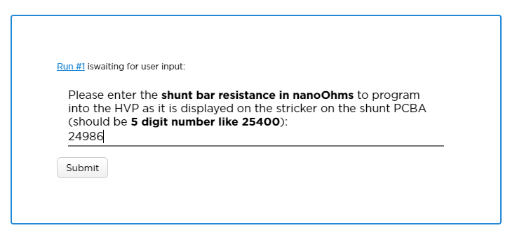

Figure 5

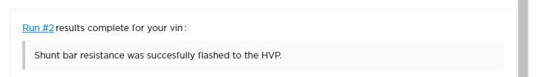

Figure 6

- Disconnect the laptop from the vehicle.

- Remove the 2nd row lower seat cushion (refer to Service Manual procedure 13051002).

- Use a paint pen to write: “Shunt res: <shuntres>, <date>” onto the penthouse cover.

Where:

- <shuntres> is the 5-digit value from step 4.
- <date> is the date.

For example: “Shunt res: 24986, 05/25/2021”

- Install the 2nd row lower seat cushion (refer to Service Manual procedure 13051002).

