Supplementary Material
Weak hydrogen bonding between acetylenic groups: the formation of diamondoid nets in the crystal structure of tetrakis(4-ethynylphenyl)methane
Elena Galoppini*ª and Richard Gilardi^{b}
ª Department of Chemistry, Rutgers University, Newark NJ 07102, USA
^{b} Laboratory for the Structure of Matter, The Naval Research Laboratory, Washington, D.C. 20375, USA
Experimental Section
General
Solution NMR spectra were obtained on a Varian INOVA500 spectrometer operating at 499.90 MHz for ¹H and 124.98 MHz for ¹³C. Mass spectral data were obtained at the Michigan State University Mass Spectrometry Facility, which is supported, in part, by a grant (DRR-00480) from the Biotechnology Research Technology Program, NIH. Tetrakis(triphenylphosphine)palladium, 1-bromoadamantane, tert-butyl bromide, aluminium chloride and [bis(trifluoroacetoxy)iodo]benzene were used as received. All reactions were performed under nitrogen unless otherwise specified. Et₃N was distilled from KOH and benzene was distilled from sodium, after removal of the azeotrope with water. Chloroform was passed through basic alumina to remove 1% ethanol present (500 ml CHCl₃/150g alumina).
Tetrakis(4-trimethysilyl-ethynylphenyl)methane 4
Dry Et₃N (14 ml), trimethylsilylacetylene (1.0 ml, 7 mmol), Cl₂Pd(PPh₃)₂ (50 mg, 4 mol%) and CuBr (10 mg, 4mol%) were added under Nitrogen to a solution of 3⁵ (0.8 g, 1.2 mmol) in dry benzene (4 ml). The solution, which became black within minutes, was stirred at 80 °C under Nitrogen for 18 h. A small amount of 3 was still present (¹H NMR). The mixture was cooled to room temperature, the solvent was evaporated in vacuo and the residue taken up in Et₂O and aqueous 10% HCl. The organic layer was separated, washed with water and dried over Na₂SO₄. The solution was then boiled with charcoal, filtered and concentrated in vacuo. The crude was purified twice by column chromatography (silica gel, benzene–hexane 3:7; benzene–hexane 5:95) to afford 4 as a pale yellow solid (0.72 g, 81%): δ_{H}(500 MHz, CDCl₃) 7.32 (d, J 8, 8H), 7.02 (d, J 8, 8H), 0.214 (s, 36 H, SiMe₃); δ_{C}(125 MHz, CDCl₃) 145.95, 131.34, 130.69, 121.14, 104.55 (C≡CSiMe₃), 94.73 (C≡CSiMe₃), 64.71 (CPh₄), −0.06 (SiMe₃).
Tetrakis(4-ethynylphenyl)methane 1
TBAF (1.20 g, 4 mmol) was added to a solution of 4 (0.65 mg, 0.9 mmol) in benzene (10 ml) and MeCN (20 ml). The clear solution was stirred at room temperature for 2 h. The reaction was complete within 30 min (TLC). The solution was poured in water (25 ml), the organic layer was separated and the aqueous layer was extracted with benzene. The combined organic layers were dried over Na₂SO₄, the solvent was removed in vacuo and the solid residue was purified by column chromatography (silica gel, benzene–hexane 1:1) to afford 1 as a white solid (0.32 g, 85%). A small portion was crystallized from hexane and recrystallized from EtOH: δ_{H}(500 MHz, CDCl₃) 7.36 (d, J 4.5, 8H), 7.32 (d, J 4.5, 8H), 3.04 (s, 4 H, C≡CH); δ_{C}(125 MHz, CDCl₃) 146.17, 131.64, 130.72, 120.25, 83.13 (C≡CH), 77.60 (C≡CH), 64.77 (CPh₄); HRMS (FAB): calc. for C₃₃H₂₀: 416.1565, found 416.1565.
1,3,5,7-Tetrakis(4-trimethylsilyl-ethynylphenyl)adamantane 7
Compound 7 (0.7 g, 84%) was obtained by the above procedure from 6⁹ (0.94 g, 1 mmol), trimethysilylacetylene (3 ml, 21 mmol), CuI (60 mg, 7 mol%), Cl₂Pd(PPh₃)₂ (200 mg, 7 mol%), toluene (20 ml) and Et₃N (25 ml): δ_{H}(500 MHz, CDCl₃) 7.43 (d, J 8.5, 8H), 7.36 (d, J 8, 8H), 2.07 (br s, 12H, CH₂), 0.226 (s, 36 H, SiMe₃); δ_{C}(125 MHz, CDCl₃) 149.36, 132.03, 124.88, 121.04, 104.93 (C≡CSiMe₃), 93.93 (C≡CSiMe₃), 46.70 (Cadam-Ph), 39.26 (CH₂), 0.00 (SiMe₃).
1,3,5,7-Tetrakis(4-ethynylphenyl)adamantane 2
Compound 2 (0.23 g, 89%) was obtained by the above procedure from 7 (0.40 g, 0.48 mmol), TBAF (0.8 g, 2.5 mmol), benzene (10 ml) and CH₃CN (20 ml). The crude was purified by column chromatography (silica gel, benzene–hexane 1:1) and pure 2 was crystallized from benzene/hexane.δ_{H}(500 MHz, CDCl₃) 7.46 (d, J 8.5, 8H), 7.39 (d, J 8.5, 8H), 3.03 (s, 4 H, C≡CH), 2.10 (br s, 12H, CH₂); δ_{C}(125 MHz, CDCl₃) 149.65, 132.23, 124.99, 120.06, 83.43 (C≡CH), 76.90 (C≡CH), 46.70 (Cadam-Ph), 39.27 (CH₂). HRMS (FAB): calc. for C₄₂H₃₂: 536.2504, found 536.2504.
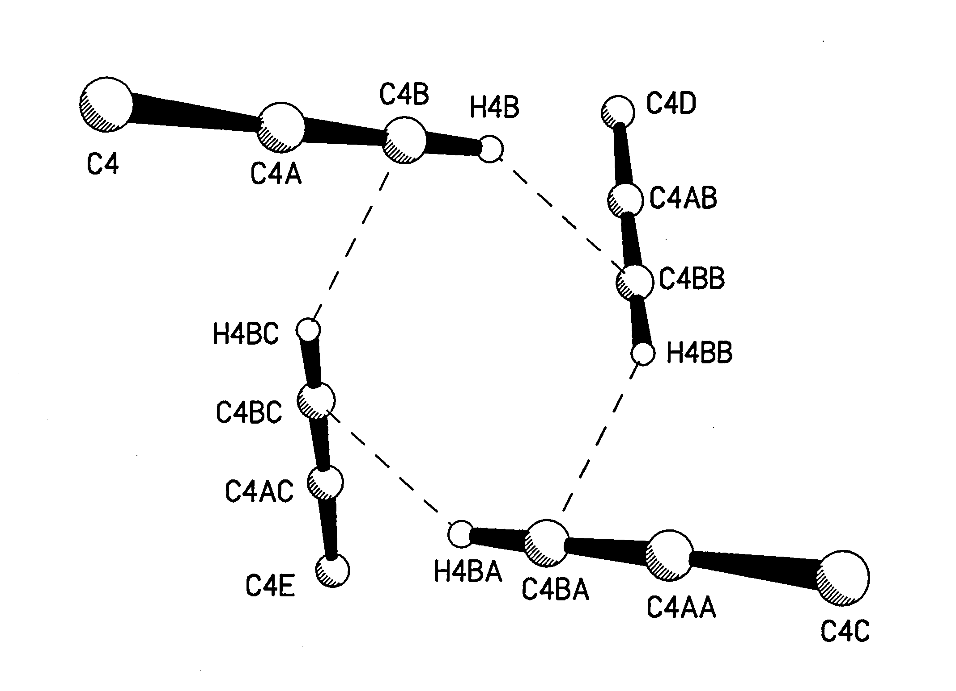
Fig. 1 A close-up view of one of the quartets of weak hydrogen bonds that involve each alkyne substituent.
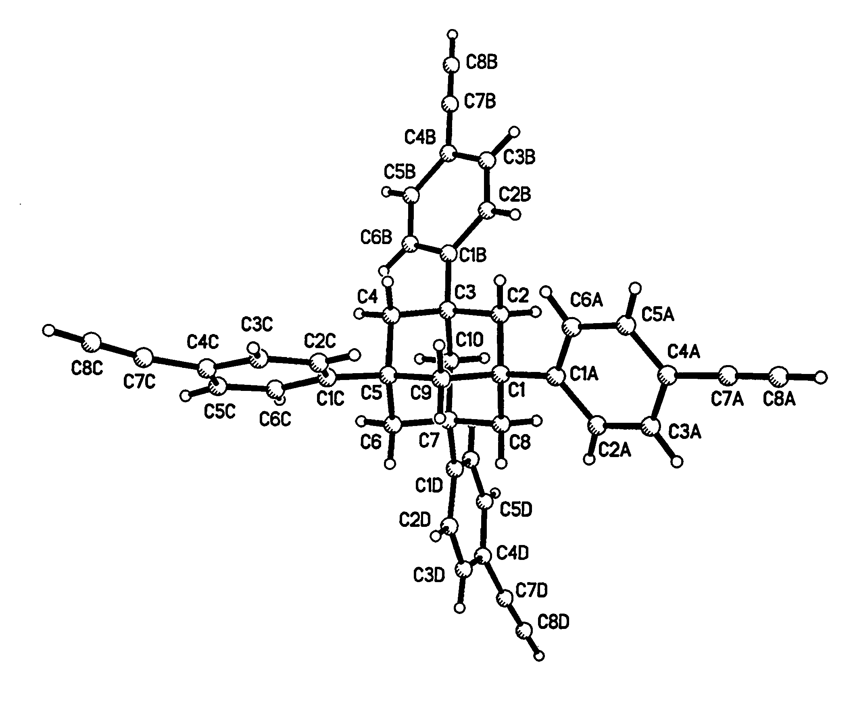
Fig. 2 Molecular structure of one of the two molecules of 2 in the crystal asymmetric unit. The arms are not in equivalent packing environments in this crystal, and thus show differences; curvature is evident in the C1C-C8C and the C1D-C8D arms.

