Supplementary data

Calibration method of a 27 MHz QCM
A 27-MHz, AT-cut QCM is commercially available from Ukou Electronics, Co., Saitama, Japan. The diameter of its quartz plate is 8 mm and Au electrodes are deposited on both sides (diameter: 2.5 mm, area: 4.9 mm²). One side of the quartz crystal was sealed with silicon rubber, maintaining it in an air environment to avoid contact with the ionic aqueous solution, while the other is exposed to aqueous buffer solution. A cased 27-MHz QCM was connected to an oscillation circuit designed to drive the quartz in aqueous solution (see Figure 1). The frequency changes were followed by a universal frequency counter (Hewlett Packard Japan, Co., Tokyo, model 53131A) attached to a microcomputer system (Macintosh Power Book 170, Apple Japan, Co., Tokyo). The Sauerbrey's equation was obtained for the AT-cut shear mode QCM,
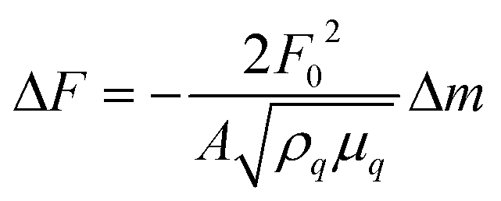 (1)
where ΔF is the measured frequency change (Hz), F₀ the fundamental frequency of the QCM (27 x 10⁶ Hz), Δm the mass change (g), A the electrode area (4.9 mm²), ρ_{q} the density of quartz (2.65 g cm⁻³), and μ_{q} the shear modulus of quartz (2.95 x 10¹¹ dyn cm⁻²). The noise level of the 27-MHz QCM was ±1 Hz in buffer solution at 30 °C, and the standard deviation of the frequency was ±2 Hz for 2 h in buffer solution at 30 °C.
When the QCM is employed in an aqueous solution, the eq. 1 cannot be simply applied due to effects interfacial liquid properties (i.e., density, viscosity, elasticity, conductivity, and dielectric constant), 1 thin film viscoelasticity, 1 electrode morphology, 1,2 and mechanism of acoustic coupling ³ impact on the QCM oscillation behavior. Therefore, we calibrated our cased 27 MHz QCM in the aqueous solution (pH 7.9, 10 mM Tris-HCl, 0.2 M NaCl, at 20 °C).
A respective amount of polymer solution was cast (0.1-15 μg cm-2), LB film of lipid monolayers was deposited (0.04-4 μg cm-2), or 10-30 mer oligonucleotides having SS groups were directly immobilized (10-60 ng cm-2) on the bare Au electrode side of the cased QCM plate. One linear relationship was observed between the deposited amount of mass and the frequency decrease of the QCM both in air phase and in the aqueous solution, independent of deposition methods and chemical compounds. The slope of this curve yielded that a frequency decrease of 1 Hz corresponded to a mass increase of 0.61 ± 0.1 ng cm-2 on the QCM electrode. This means that the Sauerbrey's equation can be applied in the aqueous solution limited in these experimental conditions. When the long chain ssDNA such as 200-300 mer was immobilized on the QCM, however, the linear correlation could not be obtained in the aqueous solution due to the effect of flexible conformation of the long DNA chains on the electrode.

References

- T. Nomura, M. Okuhara, Anal. Chim. Acta 1982, 142, 281-283; b) S. Bruckenstein, M. Shay, Electrochim. Acta 1985, 30, 1295-1298; c) K. K. Kanazawa, J. Gordon, Anal. Chim. Acta 1985, 175, 99-103.
- M. Yang, M. Thompson, W. C. Duncan-Hewitt, Langmuir 1993, 9, 802-806; b) W. Hinsberg, C. Wilson, K. K. Kanazawa, J. Electrochem. Soc. 1986, 133, 1448-1451; c) Y. Okahata, H. Ebato, Anal. Chem. 1989, 61, 2185-2188; d) Y. Okahata, K. Kimura, K. Ariga, J. Am. Chem. Soc. 1989, 111, 9190-9192.
- M. Yang, M. Thompson, Langmuir 1993, 9, 1990-1993; b) M. Urbakh, L. Daikhin, Langmuir 1994, 10, 2836-2839.

