Supplementary data
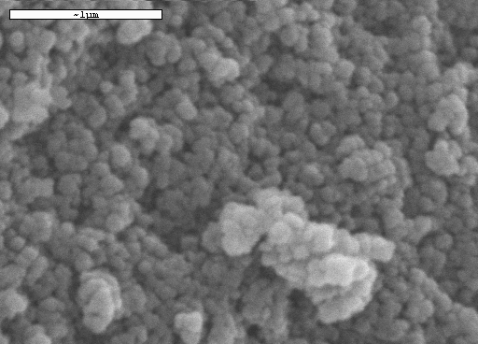
Figure 1. IR spectra of the pure MCM-41 silica material and the different MCM-41 functionalized supports (S1, S2 and S3) in the OH and CH stretching vibration region.
Spectra were recorded on KBr diluted pellets.

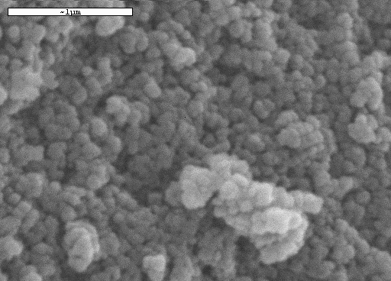
Figure 2. SEM image of the functionalized material S1(the bar represents 1 μm). Macroporous system (from 20 to 70 nm) can be appreciated. Similar SEM images were obtained for S2 and S3 solids.

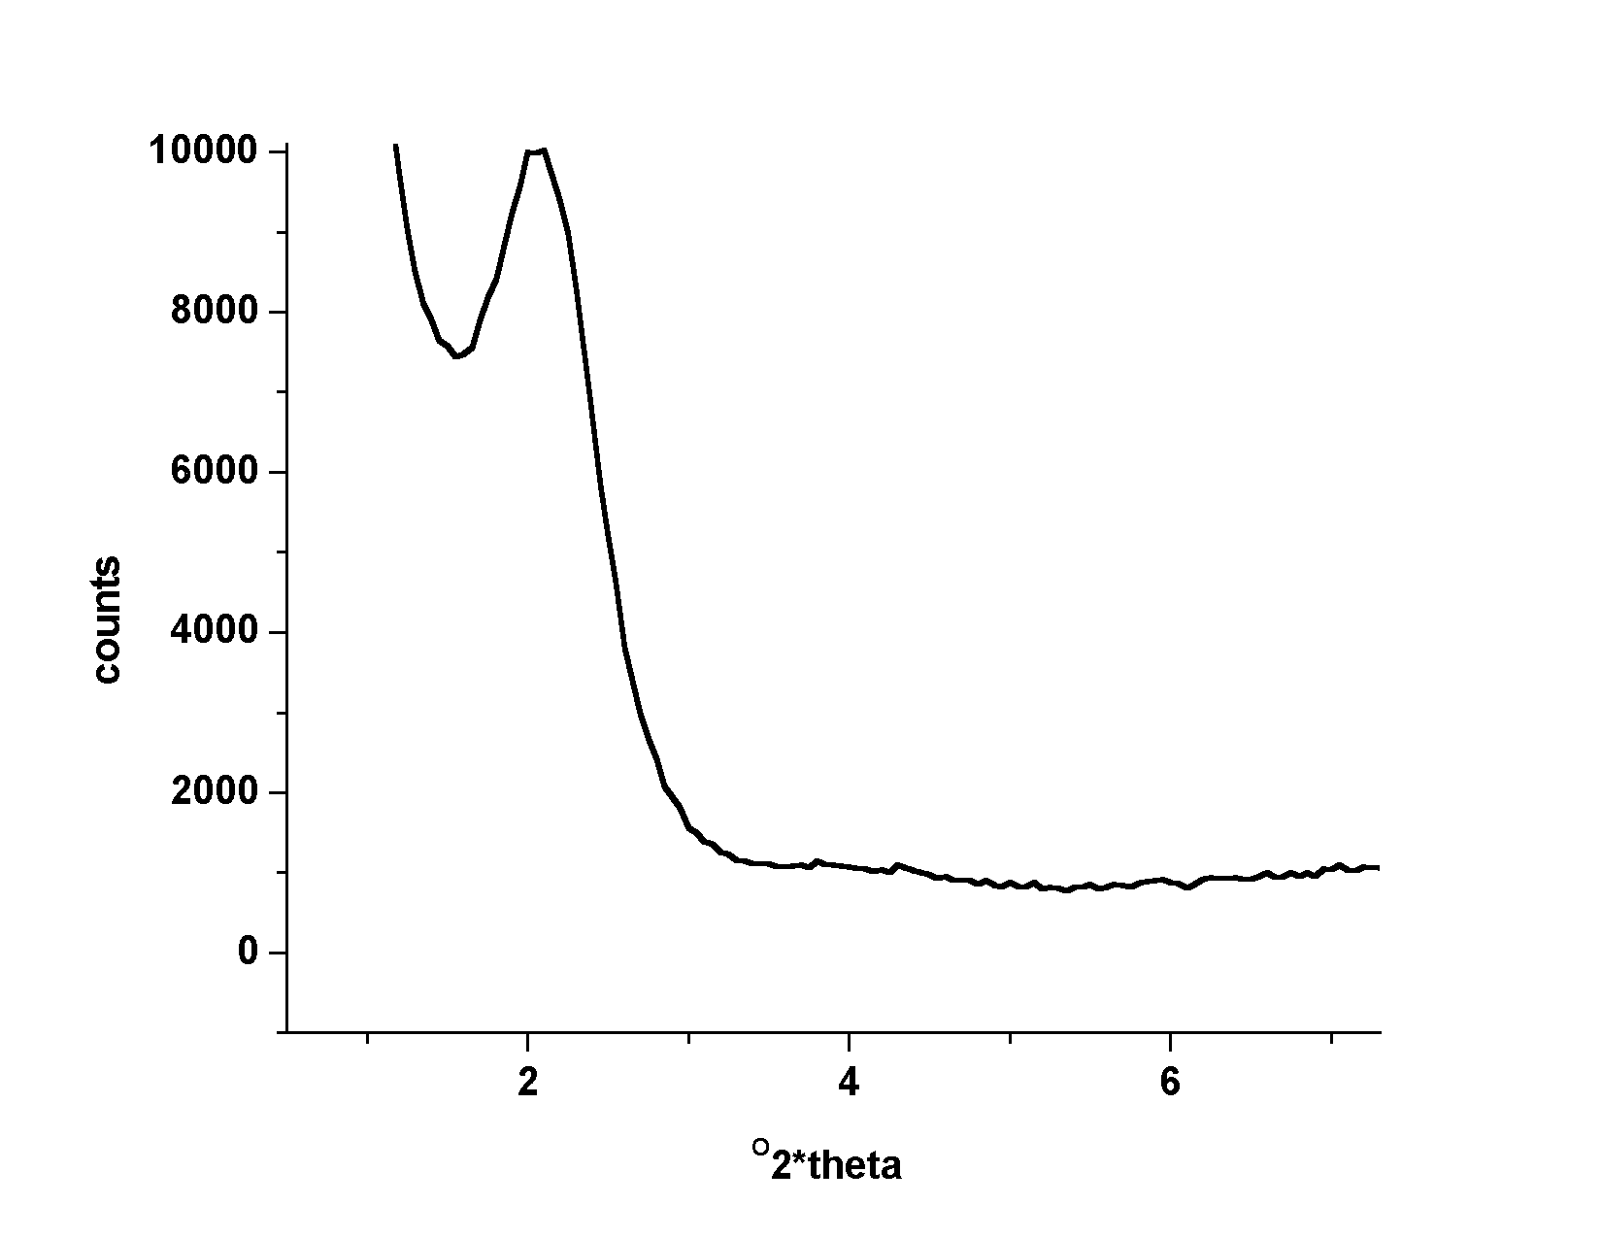
2θ (degrees)

Figure 3. X-ray diffraction pattern of S1 solid. Similar X-ray diffraction patterns were obtained for S2 and S3 solids.

Analysis of the functionalised content of the three solids were carried out by means of TG analysis of the solids obtained in each step of the synthesis process. From the registered differences the molar content of the active molecules per gram of functionalised solid can be calculated. The result obtained for the three solids are as follows:
TG/TD analysis:

S1: 0.81 mmol antracene/g solid

S2: 0.57 mmol methyl orange/g solid
S3: 0.41 mmol rhodamine/g solid.

