Supplementary data

Selective Functionalisation of TNT for Sensitive Detection by SERRS

Callum J. McHughª, Ruth Keirª, Duncan Graham^{a*} and W. Ewen Smith^{a*}
ª Department of Pure and Applied Chemistry, University of Strathclyde, 295 Cathedral Street, Glasgow G1 1XL, UK Fax: 0141 552 0876; Tel: 0141 548 4701; E-mail: duncan.graham@strath.ac.uk

Experimental

2-Amino-4,6-dinitrotoluene [1]
To a vigorously stirred solution of TNT (4.002 g, 17.6 mmol) in glacial acetic acid (88 ml) under argon at room temperature was added four portions of iron powder-325 mesh (3.280 g, 58.6 mmol) over two hours. Distilled water (80 ml) was added which caused the precipitation of a bright yellow solid. The solid was collected by filtration, washed with water and dried to leave a mixture of [1] and [2] (2.6 g, 76 %). Recrystallisation of this mixture from ethanol yielded [1]. (Analysis agreed with the published data²²) R_{f} (DCM/MeOH 9:1) 0.71. ν_{max}/cm⁻¹ 3479 (asym NH₂), 3387 (sym NH₂), 1635, 1519 (asym NO₂), 1341 (sym NO₂). ¹H NMR (Acetone-d₆) δ 2.30 (3H, s, CH₃), 5.80 (2H, s, NH₂), 7.80 (2H, s, ArH); ¹³C NMR (Acetone-d₆) δ 13.91 (CH₃) 105.54 (CNH₂) 111.04 (CMe) 121.89 (CH) 147.24 (CH) 150.42 (CNO₂) 152.50 (CNO₂). MS (EI) m/z 197.04335 [C₇H₇N₃O₄ (M)⁺ < 1.5 ppm]. Anal. Calcd for C₇H₇N₃O₄: C, 42.64; H, 3.55; N, 21.32. Found C, 42.32; H, 3.21; N, 21.34.

4-Amino-2,6-dinitrotoluene [2]
The general procedure was as for compound [1]. The crude mixture of [1] and [2] was repeatedly crystallised from ethanol to afford [2] as thick yellow/brown needles. (Analysis agreed with the published data²²) R_{f} (DCM/MeOH 9:1) 0.71. ν_{max}/cm⁻¹ 3479 (asym NH₂), 3387 (sym NH₂), 1635, 1519 (asym NO₂), 1341 (sym NO₂). ¹H NMR (Acetone-d₆) δ 2.29 (3H, s, CH₃), 5.71 (2H, s, NH₂), 7.38 (2H, s, ArH). m/z (EI) 197.04362 [C₇H₇N₃O₄ (M)⁺ < 0.2 ppm]. Anal. Calcd for C₇H₇N₃O₄: C, 42.64; H, 3.55; N, 21.32. Found C, 42.01; H, 3.39; N, 20.78.

5-(2-Methyl-3,5-dinitro-phenylazo)-quinolin-8-ol [3]
2-Amino-4,6-dinitrotoluene [1] (0.100 g, 0.51 mmol) was dissolved in hot aqueous HCl (50 %, 5 ml) and then cooled rapidly in an ice bath to precipitate the amine hydrochloride salt as a white solid. Diazotisation at 0 ºC by slow addition of a cooled solution of sodium nitrite (0.040 g, 0.56 mmol) in distilled water (2 ml) caused dissolution of the hydrochloride to give a clear pale yellow solution of the diazonium salt. After complete addition of sodium nitrite, the resulting solution was stirred until excess nitrous acid was detected by the starch iodide test. The diazonium salt was then added dropwise to a vigorously stirred solution of 8-hydroxyquinoline (0.064 g, 0.44 mmol) in 10 % NaOH solution (20 ml) and methanol (2 ml). After stirring for 20 minutes the mixture was acidified by dropwise addition of aqueous HCl (50%) to give an orange/brown precipitate. The solids were collected by filtration, washed with water and dried to produce the sodium salt of [3] as an orange/brown powder (0.110 g, 67 %). ¹H NMR (DMSO-d₆) δ 2.89 (3H, s, CH₃), 7.27 (1H, d, J8.56, ArH), 7.86 (1H, dd, ArH), 8.13 (1H, d, J8.42, ArH), 8.60 (1H, s, ArH), 8.79 (1H, s, ArH), 9.01 (1H, d, ArH), 9.31 (1H, d, JHz, ArH). m/z (EI) 353.07675 [C₁₆H₁₁N₅O₅ (M)⁺ < 2.1 ppm]. Anal. Calcd for C₁₆H₁₀N₅O₅Na: C, 51.20; H, 2.66; N, 18.66. Found C, 51.07; H, 2.99; N, 18.30.

SERRS experimental conditions

A diagram of the flowcell used to obtain SERRS spectra of 5-(2-methyl-3,5-dinitro-phenylazo)quinolin-8-ol is shown in figure 1 below. The flow system was connected to a Watson Marlow 205U peristaltic pump (Cornwall, England) using silicone tubing. Colloid was prepared by introducing solutions of silver nitrate (2.64 x 10⁻³ mol dm⁻³ in H₂O) and sodium borohydride (1.06 x 10⁻³ mol dm⁻³ in 0.1 mol dm⁻³ NaOH) through inlets 1 and 2 respectively. Dye solution in methanol and Hydrion buffer (1:1) was introduced through inlet 3. Flow rates of dye, and silver nitrate solutions, were each 0.7 cm³ min⁻¹ and the flow rate of sodium borohydride was 11.3 cm³ min⁻¹. SERRS spectra were accumulated from the solutions as they passed through the capillary.
Spectra were accumulated using a Renishaw Mark I system 2000 (Gloucs. England) with a Spectra Physics 361C 15 mW Ar ion laser (CA. USA) working at 514 nm, as the excitation source.

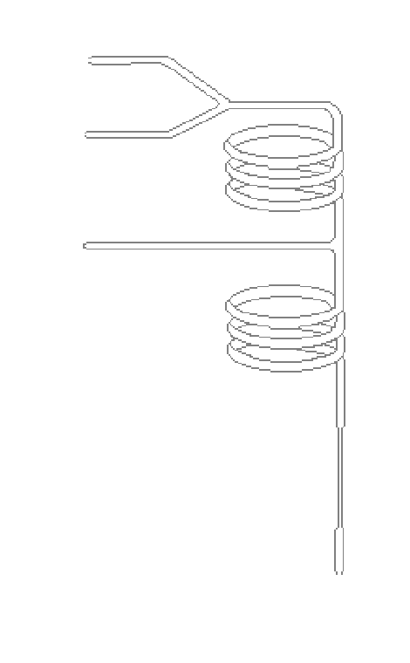
Figure 1. Diagram of flowcell used for the analysis of 5-(2-methyl-3,5-dinitro-phenylazo)quinolin-8-ol .
Capillary
Laser and Spectrometer
Waste
1
3
2

