Supplementary Material (ESI) for Chemical Communications
This journal is © The Royal Society of Chemistry 2002

The Rational Design of Novel Chiral Oxovanadium(IV) Complexes for highly Enantioselective Oxidative Coupling of 2-Naphthols

Zhibin Luo, Quanzhong Liu, Liuzhu Gong,* Xin Cui, Aiqiao Mi and Yaozhong Jiang

Union Laboratory of Asymmetric Synthesis, Chengdu Institute of Organic Chemistry, Chinese Academy of Sciences, Chengdu, 610041, China; E-mail: gonglz@cioc.ac.cn

General: NMR spectra were recorded on a Brucker-300MHz spectrometer. EI Mass spectra were recorded on VG-7010E. HPLC analysis was performed on Beckman 110B chromatography with Beckman 168 variable wavelength detector. Kromasil CHI-TBB column was purchased from Eka Chemicals AB. CCl₄ was dried with CaH₂. Petroleum ether (PE) and ethyl acetate for column chromatography were distilled before use.

Representative procedure for the preparation of the complexes:
A two-neck round bottom flask (50 mL) was charged α-amino acid (10 mmol), anhydrous NaOAc (20 mmol) and water (10 mL). After stirred at 60 ℃ under Ar atmosphere for 10 min to generate a clear solution, the reaction mixture was treated with a solution of (R)-3,3’-diformyl-2,2’-dihydroxy- 1,1’-bi-2-naphthol (5 mmol) in EtOH (15 mL) and THF (15 mL). The reaction mixture was heated at 80℃ for 15min, and then was gradually cooled down to 25 ℃ for 2 h. To the resultant Schiff base solution was added a solution of vanadyl sulfate trihydrate (10 mmol) in water (5 mL). The reaction mixture was stirred for another 2 h and then concentrated. The crude vanadyl complex was collected by filtration and washed sequentially with H₂O (5×25 mL) and cool ether (3×25 mL), and then dried in vacuum to provide the complexes as a dark green solid.
Data for 2b: IR (cm⁻¹): ν_{C=N} (1675), ν_{C=O} (1611), ν_{V=O} (988)
MS: 762 (M⁻, 20), 717 (M-C₂H₅OH+H⁺, 100)
Data for 2c: IR (cm⁻¹): ν_{C=N} (1685), ν_{C=O} (1613), ν_{V=O} (982)
MS: 783 (M- C₂H₅OH+K⁺, 100), 737(M- 2C₂H₅OH+K⁺, 38)
Data for 2d: IR (cm⁻¹): ν_{C=N} (1657), ν_{C=O} (1610), ν_{V=O} (985).

Representative procedure for the coupling of 2-naphthols
A two-neck round bottom flask (5 mL) was charged with a solution of catalyst 2c (16 mg, 0.02 mmol) in anhydrous CCl₄ (1 mL). The solution was stirred for 10 min under an oxygen atmosphere and then treated with a solution of 2-naphthol (29 mg, 0.2 mmol) in anhydrous CCl₄ (1 mL). The reaction mixture was stirred at 0 ℃ until the reaction was complete (monitored by TLC), the crude mixture concentrated under reduced pressure, and purified by column chromatography (Ethyl acetate/Petroleum ether=1/3) to give (R)-BINOL 4a.
4a: Yield 86%, ¹H NMR (300MHz, CDCl₃) δ (ppm) 7.98 (d, J=9.0 Hz, 2H, 2×HC (4)), 7.90 (d, J=7.8 Hz, 2H, 2×HC (5)), 7.38 (d, J=9.0 Hz, 2H, 2×HC (8)), 7.41-7.27 (m, 4H, 2×HC (6), 2×HC (7)), 7.16 (d, J=8.4Hz, 2H, 2×HC (3)), 5.09 (s, 2H, 2×OH). The enantiomeric excess of 83% with R-isomer major was determined by HPLC (Kromasil CHI-TBB column, Hexane/ propan-2-ol= 4: 1; flow rate 1 mL/ min; S-isomer, t_{R} 5.81 min and R-isomer, t_{R} 6.44 min)
4b: Yield 98%, ¹H NMR (300MHz, CDCl₃) δ (ppm) 7.88 (d, J=9.0 Hz, 2H, 2×HC (5)), 7.79(d, J=9.0 Hz, 2H, 2×HC (4)), 7.22 (d, J=8.7 Hz, 2H, 2×HC (3)), 7.03 (dd, J=9.0 Hz, 2.4 Hz, 2H, 2×HC (6)), 6.49 (d, J=2.4 Hz, 2H, 2×HC (8)), 5.08 (s, 2H, 2×OH), 3.59 (s, 6H, 2×OCH₃). The enantiomeric excess of 98% with R-isomer major was determined by HPLC (Kromasil CHI-TBB column, Hexane/ propan-2-ol= 4: 1; flow rate 1 mL/ min; S-isomer, t_{R} 5.88 min and R-isomer, t_{R} 6.38 min).
4c: Yield 99%, ¹H NMR (300MHz, CDCl₃) δ (ppm) 8.06 (d, J=1.8 Hz, 2H, 2×HC (4)), 7.89(d, J=9.0 Hz, 2H, 2×HC (5)), 7.37 (d, J=6.9 Hz, 2H, 2×HC (8)), 7.36 (dd, J=9.0 Hz, 1.8Hz, 2H, 2×HC (7)), 6.96 (d, J=9.0 Hz, 2H, 2×HC (3)), 5.08 (s, 2H, 2×OH). The enantiomeric excess of 88% with R-isomer major was determined by HPLC (Kromasil CHI-TBB column, Hexane/ propan-2-ol= 4: 1; flow rate 1 mL/ min; S-isomer, t_{R} 7.72 min and R-isomer, t_{R} 8.76 min)

The HPLC Spectra of 4a-c
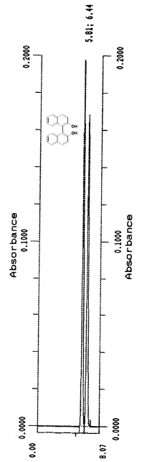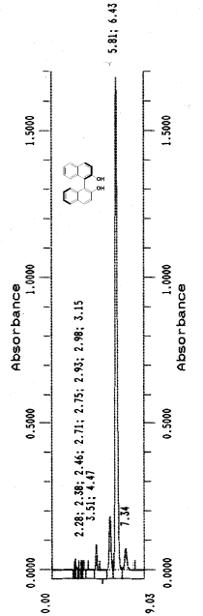
Rac-4a 4a E.e. = 83%

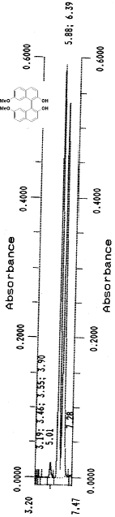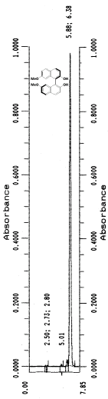
Rac.-4b 4b E.e. = 98%

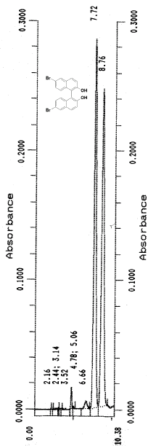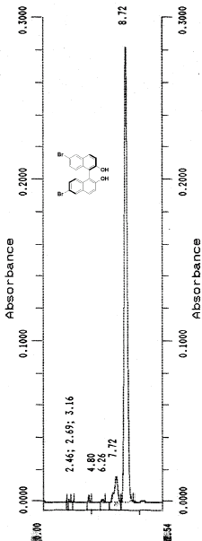
Rac-4c 4c: E.e. = 88%

