Supplementary Material (ESI) for Chemical Communications
This journal is © The Royal Society of Chemistry 2002
Plugged Hexagonal Templated Silica : A unique micro- and mesoporous composite material with internal silica nanocapsules.
P. Van Der Voort^{*,1}, P. I. Ravikovitch†, K.P. De Jong‡, A.V. Neimark†, A.H. Janssen‡, M. Benjelloun*, E. Van Bavel*, P. Cool*, B. M. Weckhuysen‡ and E.F. Vansant*.

SUPPLEMENTARY FIGURE 1 : X-Ray Diffractogram of a PHTS material

SUPPLEMENTARY FIGURE 2 : HIGH RESOLUTION TEM PICTURES

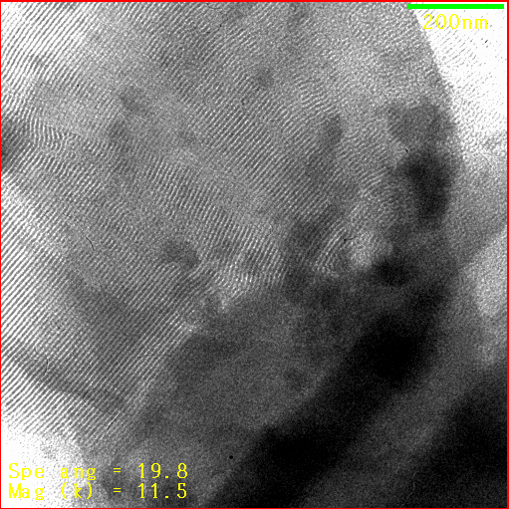
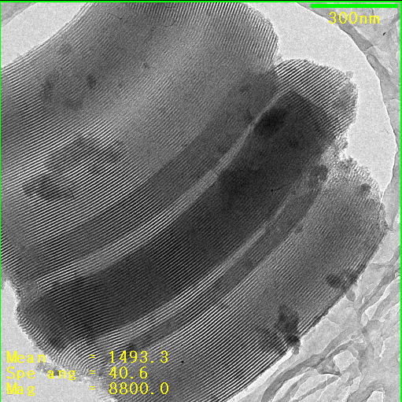

TEM pictures of SBA-15 (left) and PHTS-2 (right)

SUPPLEMENTARY FIGURE 3 : HYDROTHERMAL STABILITY

Hydrothermal stability of the most common mesoporous templated materials. Description of treatments : Mild : nitrogen flow (25% water) at 1013 hPa and 673 K for 50 hours; Medium : nitrogen flow (25% water) at 1013 hPa and 673 K for 120 hours; Hard : steaming on a grid above the water in an autoclave at 393 K and autogeneous pressure for 24 hours.

