Supplementary Material (ESI) for Chemical Communications
This journal is © The Royal Society of Chemistry 2002

“Novel Zinc Fluorescent Probe
Bearing Dansyl and Aminoquinoline Groups”

Pengju Jiang, Lizhen Chen, Jun Lin, Qin Liu, Jun Ding,
Xiang Gao and Zijian Guo*

Table of Contents
1 | The crystallographic data and the structure of L
2 | The experimental details of the 2D ¹H NMR spectra and assignment of L and ZnL₂
3 | The Experimental details of UV titration and the calculation method for the dissociation constant
4 | Studies under the presence of competitive metal ions

- Crystal structure of L

Supplementary Table 1 Crystallographic data for L
Formula | C₂₁H₁₉N₃O₂S₁ | FW | 377.4666
Crystal color, habit | Yellowish, block | Crystal system | Monoclinic
a(Å ) | 8.397 | Space group | P2(1)/c
b(Å ) | 13.967 | Dimensions(mm) | 0.85 × 0.64 × 0.24
c(Å ) | 15.759 | V(Å ) | 1841.61
α(°) | 90.03 | Z | 5
β(°) | 94.88 | Radiation, λ(Å ) | 0.71073
γ(°) | 90.00 | μ(mm⁻¹) | 0.23
R1 | 0.24 | ρ_{cald}(g/cm³) | 1.625
Rw | 0.56 | Temp(K) | 298
Scan type | ω−2θ | 2θ_{max}(degree) | 49.95

Supplementary Fig. 1 Crystal structure of L, H atoms are omitted for clarity
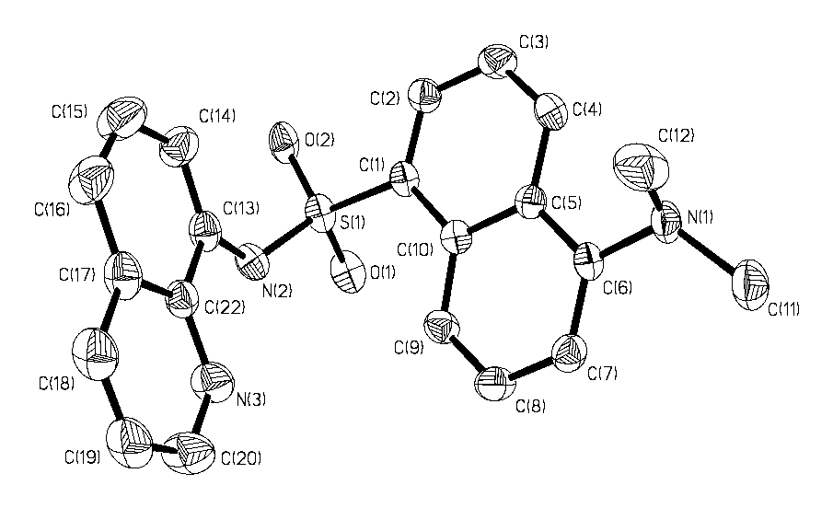

Supplementary Table 2 Selective bond length (Å) and bond angle (°) of L
Bond length (Å) |  | Bond angle (°)
S1-O1 | 1.438(6) | O2-S1-O1 | 120.1(4)
S1-N2 | 1.601(6) | O2-S1-N2 | 109.8(4)
S1-C1 | 1.772(9) | O1-S1-N2 | 103.4(3)
N1- C11 | 1.436(13) | O2-S1-C1 | 105.7(4)
N1-C6 | 1.435(10) | O1-S1-C1 | 109.2(4)
N2-C13 | 1.435(10) | N2-S1-C1 | 108.3(3)
N3-C20 | 1.342(12) | C11-N1-C6 | 116.2(7)
N3-C22 | 1.353(11) | C11-N1-C12 | 109.9(8)
C1-C2 | 1.370(11) | C6-N1-C12 | 110.7(7)
C3-C4 | 1.382(12) | C13-N2-S1 | 127.3(5)
C5-C10 | 1.452(10) | C20-N30-C22 | 119.8(9)
C5-C6 | 1.443(10) | C2-C1-S1 | 116.0(6)
C6-C7 | 1.370(11) | C10-C1-S1 | 121.7(6)
C7-C8 | 1.413(12) | C7-C6-N1 | 124.3(7)
C8-C9 | 1.276(12) | N1-C6-C5 | 116.6(6)
C9-C10 | 1.430(11) | C14-C13-N2 | 125.5(7)
C13-C14 | 1.316(12) | N2-C13-C22 | 113.6(7)
C13-C22 | 1.434(11) | N3-C20-C19 | 118.3(11)
C15-C16 | 1.330(14) | N3-C22-C17 | 124.6(7)
C17-C22 | 1.427(12) | N3-C22-C13 | 117.3(7)
C18-C19 | 1.369(16) | C7-C6-C5 | 119.1(7)
C19-C20 | 1.489(16) | C14-C13-C22 | 120.8(8)
* The crystal structure was solved and refined by direct methods using Shelx97.

- H NMR experiments
The NMR spectra were recorded on a Bruker DRX 500 MHz spectrometer in DMSO-d₆. The ¹H chemical shifts are internally referenced to residue solvent DMSO-d₆ peaks. Two-dimensional [¹H, ¹H]-COSY experiments are carried out using the COSY 45 pulse sequence. Data sets with 1024×128 points are acquired with sweep width of 1250 Hz in both dimensions and 16 scans per t1 increment.
Supplementary Fig. 2 2D ¹H COSY spectrum of L with the assignment of the cross-peaks

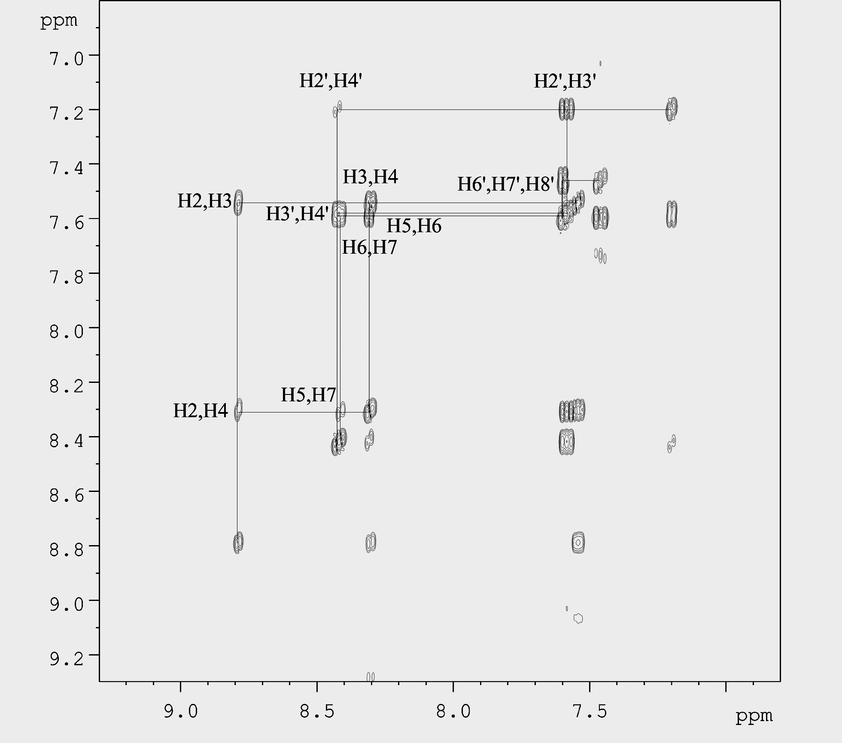

Supplementary Fig. 3 2D ¹H COSY spectrum of ZnL₂
with the assignment of the cross-peaks
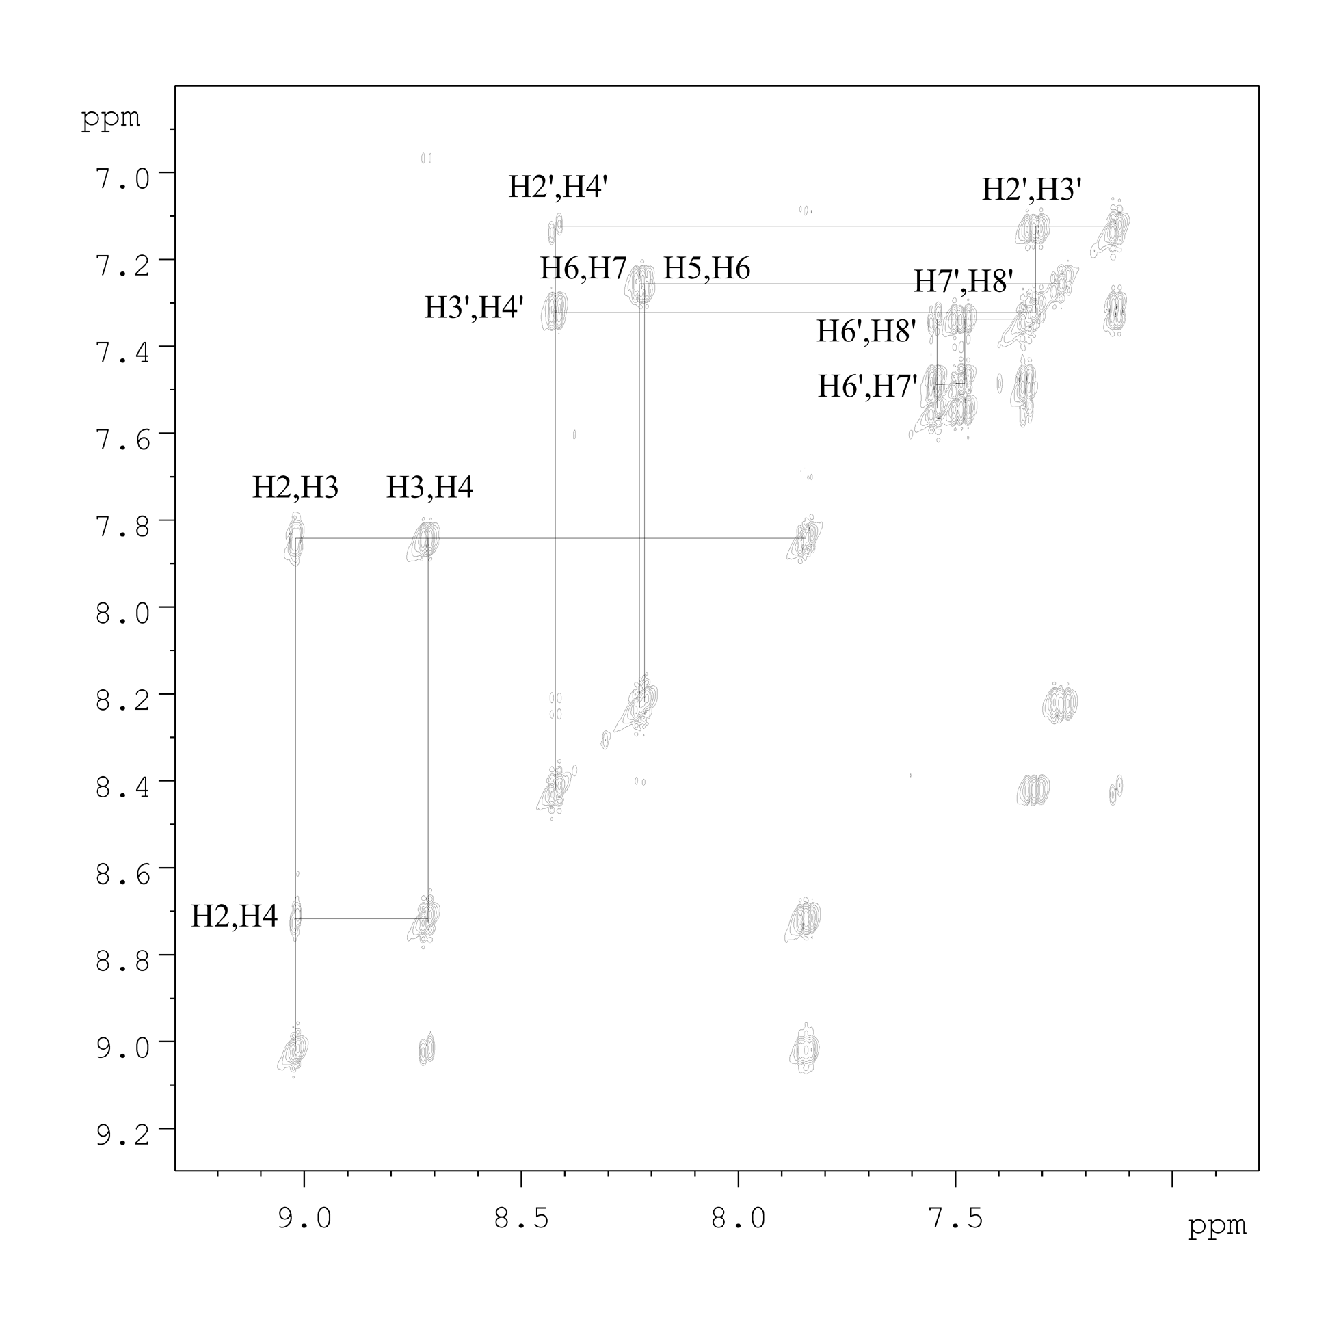

Supplementary Table 3 The assignment of the ¹H resonances and their chemical shifts.
L |  |  | ZnL₂
δ(ppm) | ³J(Hz) | Assign. | δ(ppm) | ³J(Hz) | Assign.
8.78 | 4.50, (d) | H2 | 9.01 | 5.00, (d) | H2A, B
8.42 | 10.0, (d) | H4’ | 8.71 | 8.50, (d) | H4A, B
8.41 | 8.00, (d) | H7 | 8.41 | 9.00, (d) | H4’A, B
8.31  8.31 | 7.50, (dd) | H4,  H5 | 8.22 | 8.50, (d) | H7A, B
8.31  8.31 | 7.50, (dd) | H4,  H5 | 8.21 | 7.50, (d) | H5A, B
7.60  7.60 | 8.00, (dd) | H6’,  H8’ | 7.83 | 4.00, (q) | H3A, B
7.60  7.60 | 8.00, (dd) | H6’,  H8’ | 7.54 | 9.50, (d) | H6’A, B
7.58  7.58 | 8.00, (dt) | H3’,  H6 | 7.50 | 8.00, (t) | H7’A, B
7.58  7.58 | 8.00, (dt) | H3’,  H6 | 7.33 | 8.00, (d) | H8’A, B
7.54 | 4.00, (q) | H3 | 7.31 | 8.50, (t) | H3’A, B
7.46 | 8.50, (t) | H7’ | 7.25 | 8.00, (t) | H6A, B
7.20 | 8.00, (d) | H2’ | 7.12 | 7.50, (d) | H2’A, B
2.75 | (s) (6H) | H1”,  H2” | 2.77 | (s) (12H) | H1”A, 2”A,  H1”B, 2”B
the schematic drawing showing the position of the proton resonances:

L ZnL₂
* Key: d, doublet; t, triplet; q, quadruplet; dd, doublet of doublets; dt, doublet of triplets.

- UV titration
Although L is soluble in water and other common organic solvent, a mixture of 80% DMSO and 20% H₂O was employed to mimic the polarity at the in vivo conditions. The solution of the ligand was prepared at a concentration of 10⁻⁴ mol/L and the stock solution of the metal ion was fixed to 10⁻³ mol/L in DMSO-H₂O. And the titration was carried out by adding 15 μl of metal ion solution each time to the solution of the ligand (1 cm sample cell with 3 ml in volume).
The calculation of the binding constant was according to the following equations:
$c_{L}=\frac{ε_{\text{ZnL}2⋅\text{349}\text{nm}}A_{\text{321}\text{nm}}−ε_{\text{ZnL}2⋅\text{321}\text{nm}}A_{\text{349}\text{nm}}}{b(ε_{\text{ZnL}2⋅\text{349}\text{nm}}⋅ε_{L⋅\text{321}\text{nm}}−ε_{\text{ZnL}2⋅\text{321}\text{nm}}ε_{L⋅\text{349}\text{nm}})}$

c is concentration; b stands the width of the sample cell; and ε represents the absorption coefficient.

- Studies under the presence of competitive metal ions
The florescent spectra were acquired at 395 nm excitation and 469 nm emissions. The details are listed in Supplementary Table 4.
Supplementary Table 4 Relative florescence intensity of L and with competitive ions
Solution | Relative fluorescence intensity
L | 1.00
L + K⁺, Na⁺, Mg²⁺, Ca²⁺ | 1.62
L + Zn²⁺ + K⁺, Na⁺, Mg²⁺, Ca²⁺ | 23.5
The concentrations of L and the metal ions are as follows: L, 10⁻⁵ M; and K⁺, Na⁺ 100 mM; Mg²⁺, Ca²⁺, 5 mM; Zn²⁺, 5 μM. These concentrations were used to mimic the in vivo conditions.
As can be seen from the results, the selectivity of the probe towards Zn(II) ion is over 14 times higher than to other metal ions.

_
End

