Supplementary Material (ESI) for Chemical Communications
This journal is © The Royal Society of Chemistry 2002
Experimental
The BSCFO powder was prepared by complexing EDTA-citrate method. The membrane tube was prepared by extrusion method. In order to make a slip with enough plasticity to be easily formed into tubes, the calcined ceramic powder was mixed with several additives including a solvent, a dispersant, a binder and a plasticizer. After some solvent evaporated, the slip was forced through a die to produce a hollow tube. The extruded tube was heated at 5℃/h in the temperature range of 150-400℃ to remove the gaseous species formed during decomposition of the organic additives. Then the heating rate was increased to 1℃/min and the tube was sintered at 1100-1200℃ in stagnant air for 3-5h.The sintered tube had an outside diameter of 8mm and inner diameter of about 4.5mm, and length up to 30cm.
The membrane reactor configuration is shown in Fig.1. The membrane tube was connected with a quartz tube (Φ=17mm) with ceramic powder on both ends of the membrane tube. The seal was made by heating the reactor to about 1040℃ in a stagnant atmosphere. Another quartz tube (Φ=29mm) served as the air side as the shell-and-tube reactor. A thermocouple was put along the axis of the membrane tube to profile the temperature along the reactor. Mixture of ethane and helium was fed into the reaction side while air (or pure O₂) was fed to the air side. The mixture of reactant and products (C₂H₆ and O₂, N₂, CH₄, CO, CO₂, C₂H₄) were analyzed by an on-line gas chromatograph (HP6890). The online gas chromatograph (HP6890) was equipped with two automatic valves, a sample valve and a bypass valve (shown in Fig.2). The HP Chemstation computer software was used for data collection and analysis. A serial/bypass configuration was arranged for two isothermal columns (80ºC), porapak Q and molecular sieve 13X. The injection of reaction mixture of C₂H₆ and O₂, N₂, CH₄, CO, CO₂, C₂H₄ firstly go through the porapak Q column, in which the mixture of O₂, N₂ and CO elute faster than CH₄, CO₂, C₂H₄ and C₂H₆, and quickly enter the serial-arranged molecular sieve 13X column. As soon as the mixture of O₂, N₂, and CO enter the molecular sieve 13X column, the bypass valve is activated to close the 13X column and direct the outlet of the porapak Q column (CH₄, CO₂, C₂H₄, C₂H₆) to the thermal conductivity detector. Once CH₄, CO₂, C₂H₄, and C₂H₆ elute from the porapak Q column, the bypass valve is again activated, and O₂, N₂ and CO elute from the molecular sieve 13X column to the detector. The GC graph of the total analysis is shown in Fig. 3. In this way, the concentrations of all the products including reactant were determined by using external standards. Multiple-point calibration curves were created, and recalibrated routinely for long-term studies. The quantity of H₂O was calculated based on hydrogen atomic balance. The oxygen permeation rate under reaction condition was calculated from the measured outlet flow rate and the mole fractions of oxygen-containing product gases, such as CO, CO₂, O₂ and H₂O. The carbon balance during all of the experiments was within 5%. The separation of O₂ and N₂ was used for leakage checking of the membrane tube and the sealing. The oxygen leakage can be calculated from the nitrogen leakage, in our experiments, the oxygen leakage only account for 0 to 2% the total oxygen flux.

Fig.1. Schematic diagram of setup of tubular membrane reactor
for oxidative dehydrogenation of ethane to ethylene.
Air side
Thermocouple
GC
Ceramic binder
He
Quartz tube
membrane
MFC
MFC
C₂H₆
MFC
Air
MFC
O₂
reaction side
MFC
N₂

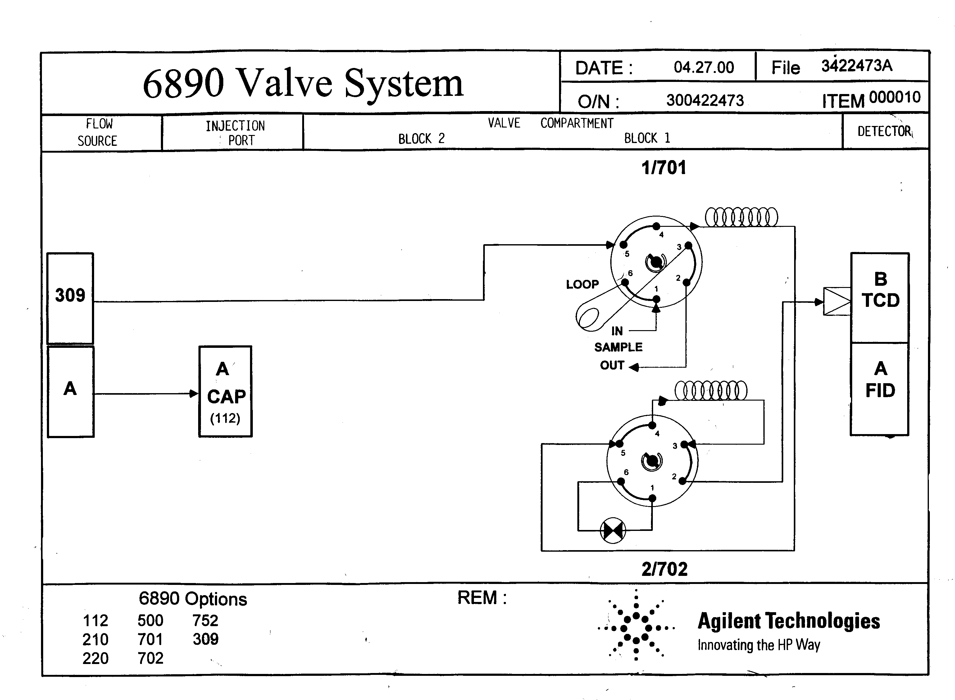
Porapak Q
13X
Fig.2 6890 valve system and the arrange of the columns
of porapak Q and 13X
Bypass valve

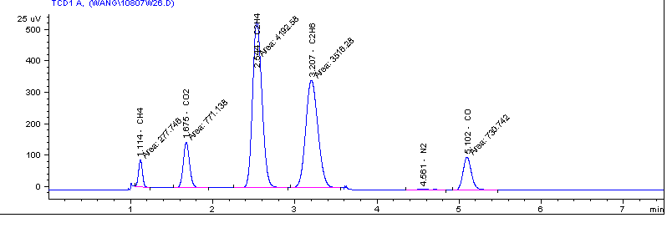
Fig.3 The typical chromatograph graph of the products using our analytic
method

