Supplementary data

Supplementary Information for “Kinetic Isotope Effects in the Copper(I)-Mediated Living Radical Polymerization of Methyl Methacrylate”

Experimental.

Materials. Methyl methacrylate (99%, inhibited with monomethyl ether hydroquinone) was obtained from Aldrich and passed over a column of activated basic alumina before use. Copper(I) bromide (Aldrich, 98%) was purified by a modification of the method of Keller and Wycoff [R. N. Keller and H. D. Wycoff, Inorg. Synth., 1947, 2, 1]. Azobis(isobutyronitrile) (ACROS Chimica, 98%) was recrystallized from methanol. All other chemicals were purchased from Aldrich or ACROS Chimica and used as received.
Copper(I)-mediated polymerizations. In a typical copper(I)-mediated living radical polymerization, 200 mL of MMA (1.87 mol) was mixed with 400 mL of xylenes, to which was added Cu(I)Br (2.87 g, 20 mmol) and N-propyl 2-pyridinylmethanimine (6.2 mL, 40 mmol). The mixture was deoxygenated by sparging with N₂ for 1 hour and heated to 60 °C before the introduction of ethyl 2-bromoisobutyrate (3.0 mL, 20 mmol) to initiate the reaction. The reaction was maintained at 60 °C under N₂ for 40 h, at which point air was introduced to stop the reaction and the mixture was allowed to cool. Conversion was measured by ¹H nmr spectroscopy (Bruker Avance 400, CDCl₃) and found to be 90.6 ± 1.0%. The molecular weight distribution was measured by gel permeation chromatography calibrated with MMA standards, giving M_{n} = 10830, PDI 1.32. Unreacted MMA was recovered by an initial, rapid vacuum distillation followed by repeated distillations to reduce the level of xylene impurities.
Free radical polymerizations. In a typical free radical polymerization, 200 mL of MMA (1.87 mol) was mixed with 400 mL of xylenes, to which was added azobis(isobutyronitrile) (1.0 g, 6.1 mmol) and 1-propanethiol (0.91 ml, 10 mmol, for molecular weight control). The resulting solution was deoxygenated by sparging with N₂ for 1 hour, and subsequently heated at 60 °C for 45 h. Conversion was measured by ¹H nmr spectroscopy (Bruker Avance 400, CDCl₃) and found to be 97.8 ± 0.1%. The molecular weight distribution was measured by gel permeation chromatography calibrated with MMA standards, giving M_{n} = 7257, PDI 1.83. Unreacted MMA was recovered by an initial, rapid vacuum distillation followed by repeated distillations to reduce the level of xylene impurities.
NMR measurements. Conversion measurements. Conversions in all reactions were measured by ¹H NMR spectroscopy at 400MHz in CDCl₃ at 25 °C. 128 scans were taken for each sample, with a delay between scans of 30s to ensure complete relaxation of the polymeric hydrogens. The conversion was calculated using the signals from the vinyl (δ 5.55 and 6.10 ppm) and methoxy (δ 3.75 ppm) hydrogens of the unreacted monomer, and the methoxy (δ 3.60 ppm) and α-methyl hydrogens (δ 0.7-1.1 ppm) of the polymer. Errors in the conversion measurements were estimated by comparing the results of at least 3 integrations of each spectrum. The error introduced into the final results as a result of error in the conversion measurement is in most cases negligible compared to error due to uncertainty in the integration of the carbon signals (see Singleton, D. A.; Thomas, A. A. J. Am. Chem. Soc. 1995, 117, 9357-8).
Quantitative carbon NMRs. All quantitative carbon NMR spectra were recorded at 125.7 MHz on a Bruker DRX 500 at 25 °C. A total of 360 scans were taken for each sample. Each spectrum was recorded with 1024k data points (512k real and 512k imaginary) with no zero filling, giving a resolution of 0.048 Hz per point. The relaxation time (T₁) of the carbons in MMA was measured by the inversion recovery technique and was found to be less than 32 s for each carbon. A 20 s acquisition time, followed by a 180 s delay ensured complete relaxation between scans. Proton decoupling was inverse gated. 10% (v/v) C6D6 was added to each sample as a spectrometer lock and reference. A 1 Hz line broadening was applied to each spectrum, but no baseline correction was made. Integrals were picked manually so as to include carbon satellites on signals and are all given relative to the OMe peak, which was set to 1. Sample spectra are shown in figures S1, S2 and S3.

Results and calculations from all reactions.
¹³C measurements were carried out for a total of 7 reactions, viz. 4 copper(I)-mediated polymerizations and 3 free radical polymerizations. The integration of the methoxy group carbon in each spectrum was set to 1. The average integrations for the other carbons in each reaction, together with the results for the starting materials, are shown in Table S1 below. The standard deviation in each result is shown in parentheses. In each case, n is the number of integrations that were carried out to obtain the result shown.
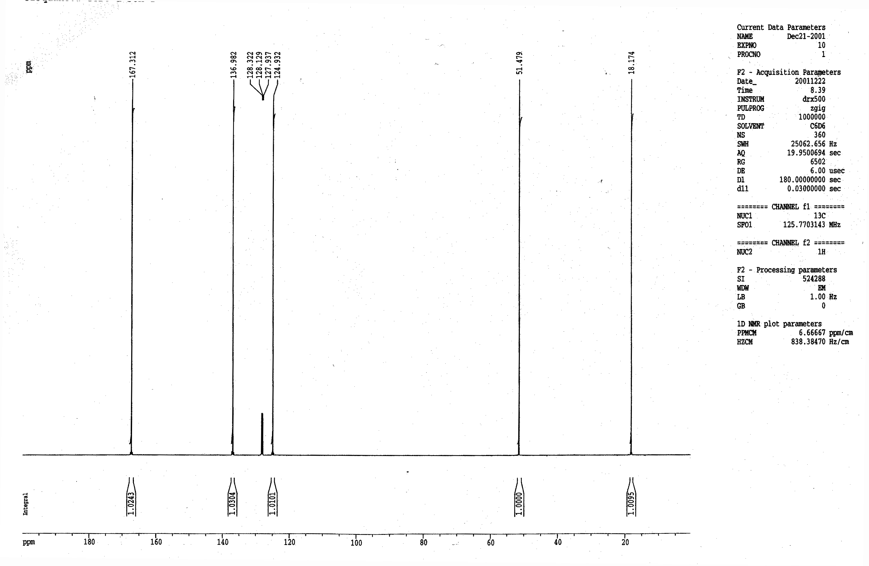
Figure S1. Sample ¹³C nmr spectrum of MMA standard. Signal to noise ratio = 5383.
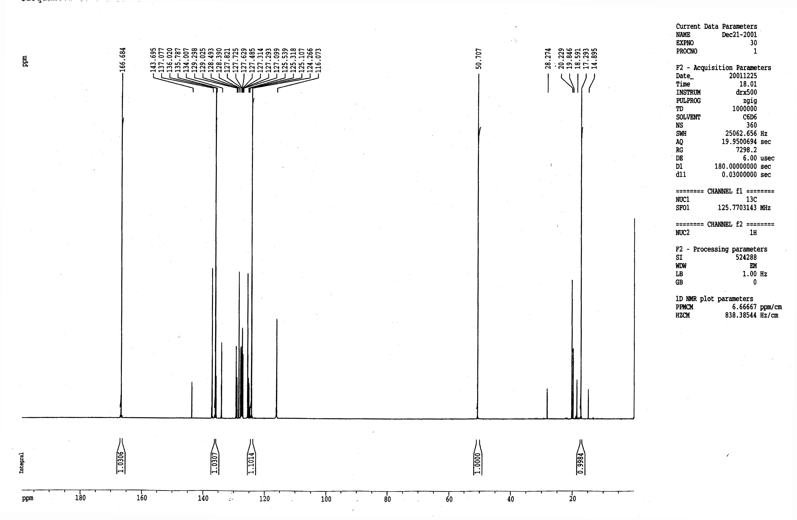
Figure S2. Sample ¹³C nmr spectrum of MMA recovered from free radical polymerization (sample 5, 85% conversion). Signal to noise ratio = 2772. Extra peaks are due to residual xylene.

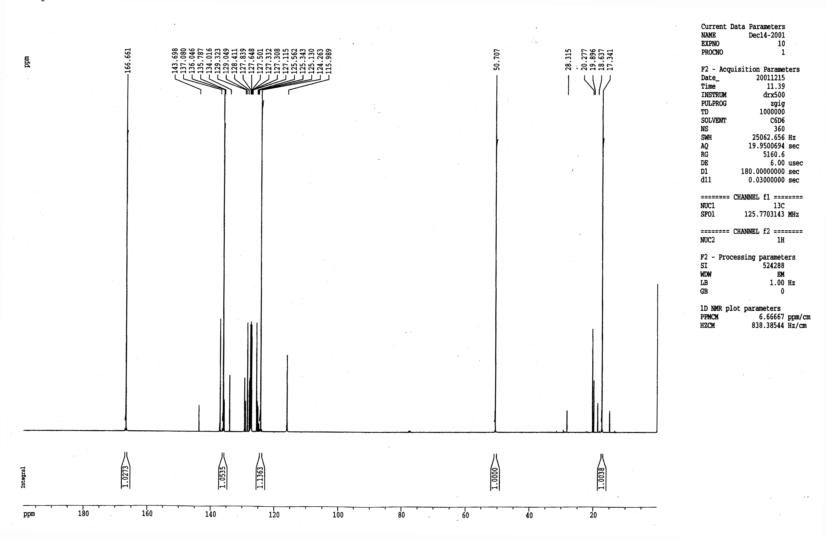
Figure S3. Sample ¹³C nmr spectrum of MMA recovered from copper-mediated polymerization (sample 2, 90.6 % conversion). Signal to noise ratio = 3033. Extra peaks are due to residual xylenes.

Table S1. Average ¹³C integrations.
Sample | Method | Conversion (%) | C₁ | C₂ | C₃ | C₄ | N
1 | CMP | 86.1(1.0) | 1.1040(71) | 1.0556(22) | 1.0076(24) | 1.0322(19) | 4
2 | CMP | 90.6(1.0) | 1.1317(88) | 1.0483(52) | 1.0089(42) | 1.0346(74) | 4
3 | CMP | 96.1(5) | 1.1624(225) | 1.0610(59) | 1.0139(89) | 1.0272(20) | 3
4 | CMP | 96.3(8) | 1.1723(20) | 1.0614(14) | 0.9972(44) | 1.0223(33) | 3
5 | FRP | 85.0(5) | 1.0978(25) | 1.0307(1) | 1.0051(49) | 1.0306(2) | 4
6 | FRP | 95.5(1) | 1.1434(95) | 1.0432(47) | 1.0008(76) | 1.0187(70) | 3
7 | FRP | 97.8(1) | 1.1923(35) | 1.0303(48) | 1.0045(24) | 1.0255(16) | 4
std for 1,2,3,6 | — | — | 1.0043(19) | 1.0296(22) | 1.0099(18) | 1.0232(11) | 6
std for 4 | — | — | 1.0032(6) | 1.0313(27) | 1.0065(7) | 1.0244(56) | 3
std for 5,7 | — | — | 1.0097(7) | 1.0298(22) | 1.0076(17) | 1.0277(24) | 4

The values for R/R₀, calculated as the ratio of average integrations in Table S1 relative to the standard, are shown in Table S2. Errors were calculated according to:

ΔR/R₀ = R/R₀ * ((ΔIntSample/IntSample)² + (ΔIntStandard/IntStandard)²)^{1/2}

Table S2. R/R₀ for ¹³C.
Sample | Method | Conversion (%) | C₁ | C₂ | C₃ | C₄
1 | CMP | 86.1(1.0) | 1.0992(74) | 1.0252(31) | 0.9977(30) | 1.0088(22)
2 | CMP | 90.6(1.0) | 1.1269(90) | 1.0181(55) | 0.9991(45) | 1.0111(73)
3 | CMP | 96.1(5) | 1.1574(226) | 1.0305(62) | 1.0040(90) | 1.0038(22)
4 | CMP | 96.3(8) | 1.1685(22) | 1.0292(30) | 0.9908(44) | 0.9980(63)
5 | FRP | 85.0(5) | 1.0873(26) | 1.0009(22) | 0.9975(51) | 1.0029(23)
6 | FRP | 95.5(1) | 1.1385(94) | 1.0132(46) | 0.9983(75) | 0.9956(68)
7 | FRP | 97.8(1) | 1.1808(36) | 1.0004(51) | 0.9969(29) | 0.9979(28)

The KIEs (Table S3) were then calculated from eq. 1, with the standard errors calculated from the following equations (taken from D. A. Singleton and A. A. Thomas, J. Am. Chem. Soc., 1995, 117, 9357):

Error in KIE due to uncertainty in conversion (ΔKIE_{F}):

ΔKIE_{F} = (∂KIE/∂F). ΔF = -ln(R/R₀)/{(1-F)ln²[(1-F)R/R₀)]}. ΔF

Error in KIE due to uncertainty in R/R₀ (ΔKIE_{R}):

ΔKIE_{R} = [∂KIE/∂(R/R₀)]. Δ(R/R₀) = -ln(1-F)/{(R/R₀)ln²[(1-F)R/R₀)]}. Δ(R/R₀)

Total error in KIE (ΔKIE):

ΔKIE = KIE*((ΔKIE_{R}/KIE)² + (ΔKIE_{F}/KIE)²)^{1/2}

Table S3. ¹³C KIEs calculated from Table 2 and Equation 1.
Sample | Method | Conversion (%) | C₁ | C₂ | C₃ | C₄
1 | CMP | 86.1(1.0) | 1.0503(42) | 1.0128(16) | 0.9988(15) | 1.0045(11)
2 | CMP | 90.6(1.0) | 1.0532(45) | 1.0077(24) | 0.9996(19) | 1.0047(31)
3 | CMP | 96.1(5) | 1.0470(68) | 1.0093(19) | 1.0012(28) | 1.0012(7)
4 | CMP | 96.3(8) | 1.0496(34) | 1.0088(11) | 0.9972(14) | 0.9994(19)
5 | FRP | 85.0(5) | 1.0461(14) | 1.0005(11) | 0.9987(27) | 1.0015(12)
6 | FRP | 95.5(1) | 1.0438(29) | 1.0043(15) | 0.9995(24) | 0.9986(22)
7 | FRP | 97.8(1) | 1.0452(10) | 1.0001(13) | 0.9992(8) | 0.9995(7)

Finally, an average KIE was calculated for each polymerization method. Errors were calculated according to the following formula:

ΔKIE = (s(KIE)² + ∑(ΔKIE_{i})²/n)^{1/2}

where s(KIE) is the standard deviation of the estimates for the KIE, KIE_{i} is the standard error associated with each individual estimate, and n is the total number of estimates (4 for CMP, 3 for FRP).

The final results are shown in Table S4.

Table S4. ¹³C KIEs for copper(I)-mediated and free radical polymerizations.

Method | C₁ | C₂ | C₃ | C₄
CMP | 1.0500(49) | 1.0096(28) | 0.9992(26) | 1.0024(32)
FRP | 1.0450(23) | 1.0016(26) | 0.9991(22) | 0.9998(21)

We are grateful to a referee for pointing out that the isotopic enrichment results for C₂ in copper-mediated polymerizations do not show a clear increase with conversion, as predicted from eq. 1 and seen in the results for C₁. As the kinetic isotope effect on this carbon is the keystone of our argument, a short justification of this result is given below.
In the case of C₂, the predicted increase as a function of conversion is small, and easily obscured by errors in the data. Figure S4 below shows the observed isotopic enrichments in C₂, together with the predictions for an isotope effect of 1.010 ± 0.003. All the observations lie within the range of predicted values, but no clear trend can be seen, even though the deviations from predicted values are relatively small (rms residual = 0.0046).
Figure S4. Observed isotopic enrichments vs. conversion at C₂ (with estimated standard errors). Predicted values for a KIE of 1.010 ± 0.002 are also shown (solid line, with upper and lower limits shown dotted).

The error bars shown in the figure are the estimated uncertainties in the observed isotopic enrichments. These may be underestimates of the true uncertainties, as they were calculated by repeatedly integrating the nmr spectrum of monomer obtained from a single experiment, and hence do not represent truly independent results. Another estimate of the sample variance, s², in the isotopic enrichment observations can be obtained from the sum of squares of residuals, S, between observed and predicted values. Applying the formula s² ~ S/df, in which df is the number of degrees of freedom (3 in this case) returns the value 2.8 × 10⁻⁵, corresponding to an estimated standard error in the observations of 0.005. This is in good agreement with the estimated errors given in Table S2, which range from 0.003 to 0.006. The reported uncertainty in the KIE should be a good estimate of the true uncertainty, as it is derived from four completely independent experiments, and takes into account the variation between experiments as well as the estimated uncertainty in each result.
In addition, there is a clear difference between results obtained from free radical and copper-mediated polymerizations, with all observed free radical isotope enrichments lower than all observed copper-mediated isotope enrichments at C₂. Assuming a normal distribution of errors with standard deviations as reported in Table S4, the null hypothesis H₀: KIE_{CMP,C2} = KIE_{FR,C2} can be rejected with 98.7 % certainty. While it is conceivable that the difference between copper-mediated and free-radical results could be due to a systematic error, this seems extremely unlikely as sample preparation was identical for each, and polymerization conditions were selected to be as similar as possible.
Thus the isotope effect observed at C₂ in copper-mediated living radical polymerization is a real effect, and indicates a difference in the mechanism of propagation between copper-mediated and conventional free radical polymerizations.

