Supplementary data

S-Figure 1. Schematic diagram of molecular sieving membranes developed with nanostructured zeolite structures. (a) Packing of large zeolite crystals (~μm), (b) Filling of inter-crystal voids with polyfurfuryl alcohol from (a), (c) Packing of zeolite nanocrystals, (d) Filling of inter-nanocrystal voids with polyfurfuryl alcohol. As illustrated in this Figure, it is obvious that sintered zeolite nanocrystals have better connections among zeolitic channels, and small crystals can pack efficiently into thin layers. By contrast, use of large zeolite crystals for a composite membrane leads to large isolated zeolite domains and extremely low flux.

Nanocrystal synthesis: Zeolite A nanocrystals were synthesized by hydrothermal synthesis from a clear solution with a composition of 1.00 Al₂O₃: 6.12 SiO₂: 7.17 (TMA)₂O: 0.16 Na₂O: 345 H₂O. The synthesis solution was prepared in 250 mL polypropylene bottles following previous literature. ¹⁴ First, aluminum isopropoxide (Aldrich) was dissolved into a solution made from 25wt% aqueous tetramethyl ammonium hydroxide (Aldrich), 97wt% sodium hydroxide (EM Science), and double distilled water. Once the aluminum isopropoxide solution was clear, then the silica source, Ludox HS-30 colloidal silica (Aldrich), was added to begin a magnetic bar stirred two-day aging process. After aging, the solution was cooked in a silica oil temperature bath with stirring at 100°C for two days. The solid product contained in the colloidal suspension was recovered by repeated cycle of a two-hour centrifugation at 48000g, careful decanting, and ultrasonic redispersion in water until pH<8. The zeolite A nanocrystals were re-dispersed in ethanol.

Characterization: Philips XL30-FEG scanning electron microscope was operated at 5 kV. Siemens D-500 diffractometer using Cu Kα radiation was used for XRD. Nitrogen adsorption-desorption measurements were carried out at –196°C on a Micromeritics ASAP 2010 instrument to determine Brunaer-Emmett-Teller (BET) surface area, and to estimate the mesopore size distribution using Barrett-Joyner-Halenda (BJH) calculation procedures. Before measurement, samples were evacuated overnight at 350°C and 1 μmHg. The total pore volume, V_{total}, was taken from the desorption branch of the isotherm at P_{i}/P₀=0.98 assuming complete pore saturation. The volume of micropores, V_{micro}, was determined by the t-plot method. The volume of mesopores, V_{meso}, was estimated from the equation: V_{meso}=V_{total} - V_{micro}

The nanocomposite membranes were tested for air separation. The samples were attached to glass holder using Torr Seal® epoxy resin (Varian). Before measurements, the membranes were dried at 120°C and evacuated for 24h to remove adsorbed water. The feed air was passed continuously at the outside of the membrane at 1atm while the inside was swept by helium, also at atmospheric pressure. The nanocomposite membranes were tested in the temperature range of 30~180°C. The composition of feed air and permeate stream was measured using a SRI 8610C gas chromatograph equipped with a thermal conductivity detector (TCD) and a molecule sieving column. Under the experimental conditions the feed composition changed very little along the membrane and the mol fraction of permeating gases in the sweep gas remained below 1%. Therefore, the permeate gas composition yielded directly the permeance P_{i} of each component i defined as
P_{i}=N_{i}/(ΔP_{i} A)
where N_{i} is the permeating flowrate of component i (mol/s), ΔP_{i} the transmembrane pressure difference of i (Pa), and A the membrane area (m²). The mixture selectivity S_{ij} is defined as the ratio of the two permeances P_{i} and P_{j}.
S_{ij}=P_{i}/P_{j}

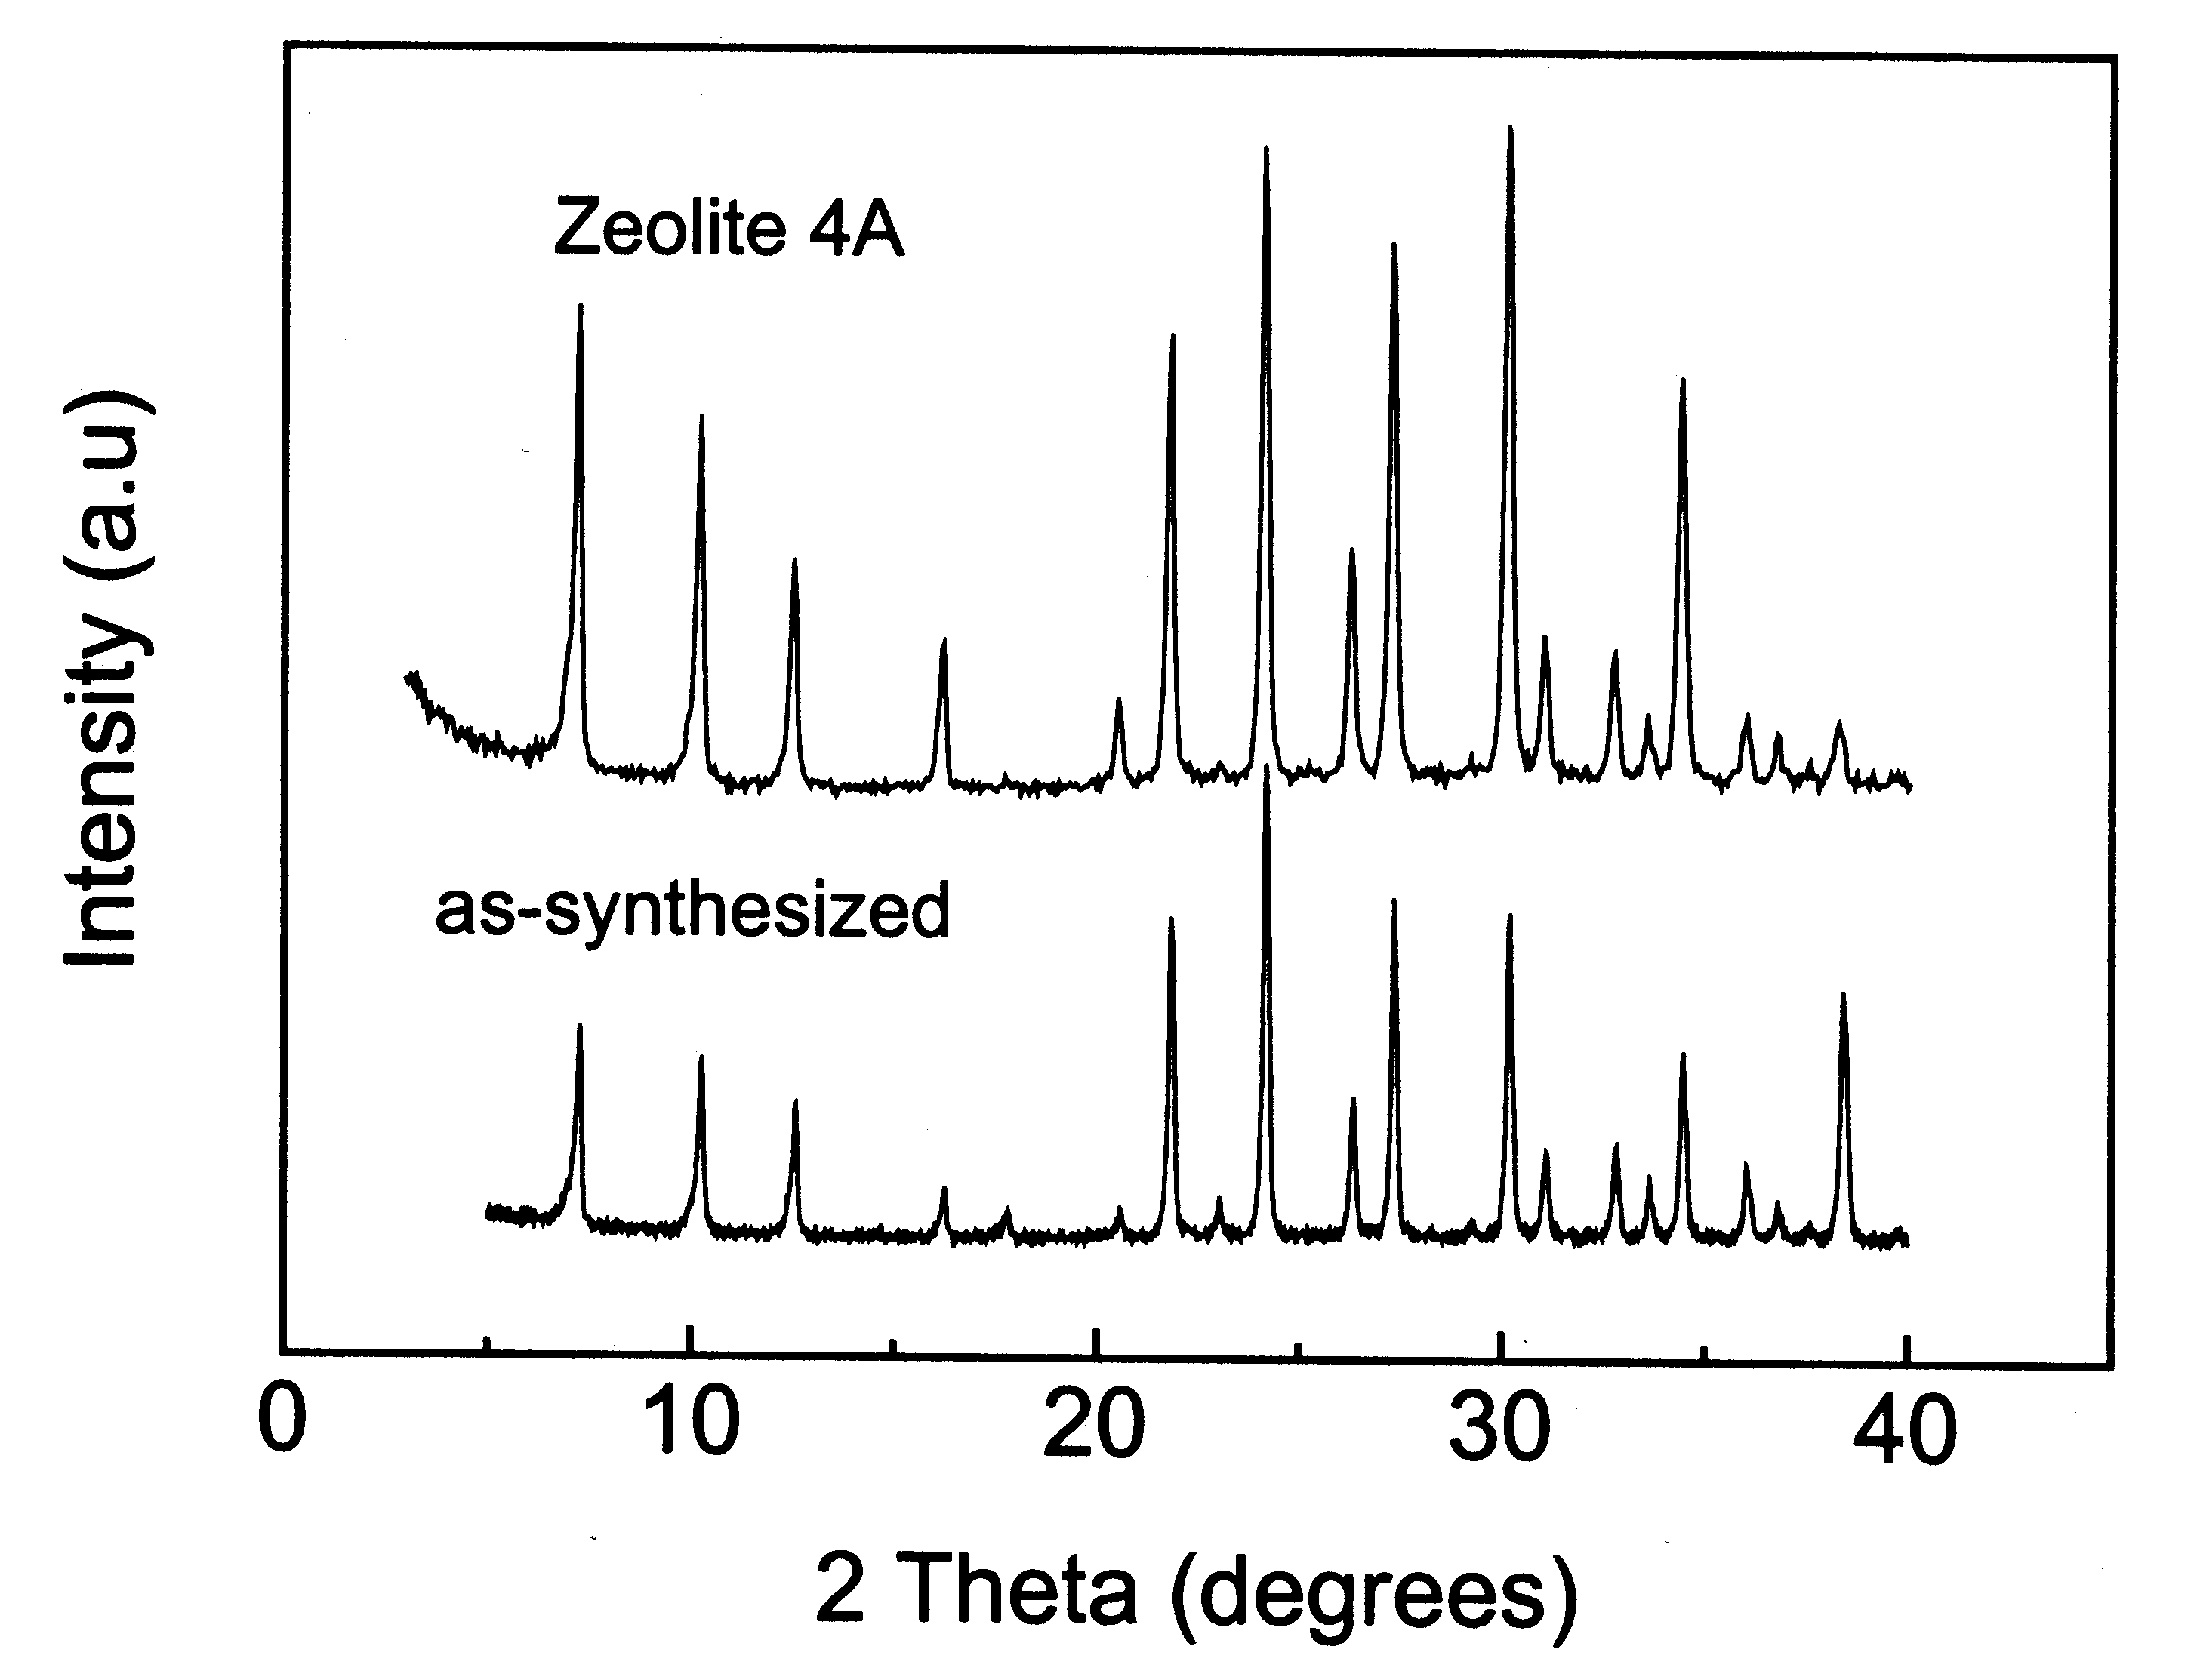
S-Figure 2. XRD patterns of as-synthesized zeolite A and sodium-exchanged zeolite A nanocrystals.
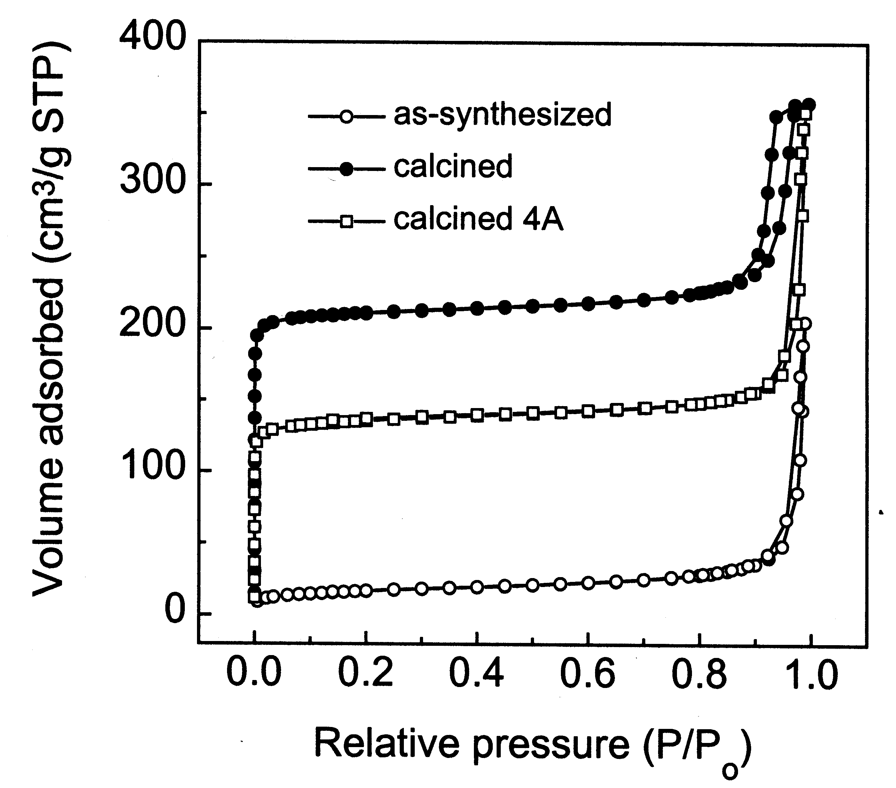
S-Figure 3. N₂ adsorption-desorption isotherms of as-synthesized, calcined zeolite A, and ion exchanged zeolite A nanocrystals.

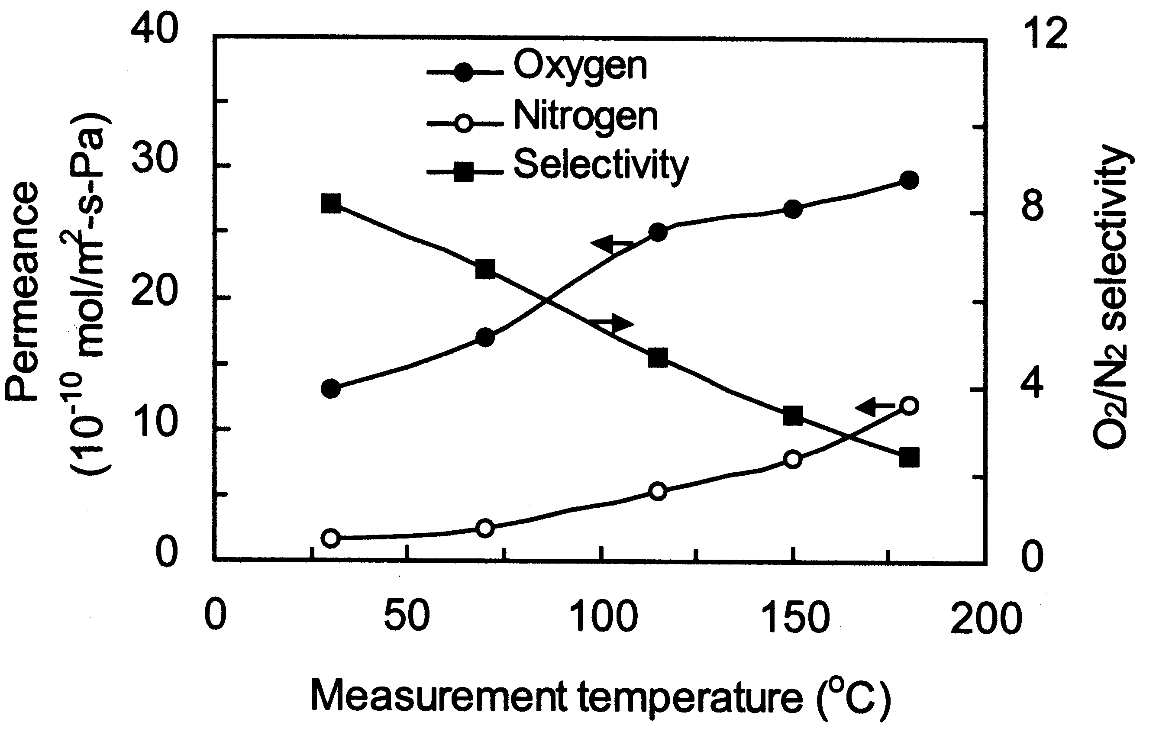

S-Figure 4. O₂ and N₂ permeances and O₂/N₂ separation factors of A-PFA nanocomposite membranes treated at 350°C (M350). The selectivity significantly decreases from 8.2 to 2.4, and oxygen permeance increases from 1.5×10⁻⁹ to 3.0×10⁻⁹ mol/m²-s-Pa with the temperature increased from 30 to 180°C. It can be explained that both O₂ and N₂ permeations through our nanocomposite layer are activated at elevated temperature, and their permeances increase whereas the selectivity decreases. This temperature-related gas separation is consistent with other microporous membranes such as zeolite membranes and carbon membranes.
.

TG analysis of PFA further shows that there is a weight loss of 12%, 26% for PFA treated at 350, 450°C. Fully carbonized PFA, for example, treated at 1000°C shows 40% weight loss and shrinks around 50% by volume.

Elemental analyses of PFA samples were carried out by Galbraith Laboratory (TN). It can be clearly seen that the content of hydrogen and oxygen elements drops with the heating temperature increased, and heat-treated PFAs still have high hydrogen content, which may correspond to structural evolution from furan rings to benzene rings.

Table 1. Elemental analysis of polyfurfuryl alcohol heat-treated at different temperatures.

