Electronic Supplementary Information

Diels-Alder reactions of nickel(II) N-confused porphyrins as dienophiles

Ziwei Xiao, Brian Patrick and David Dolphin*

Department of Chemistry, University of British Columbia, 2036 Main Mall, Vancouver, BC V6T 1Z1, Canada. E-mail: ddolphin@qltinc.com

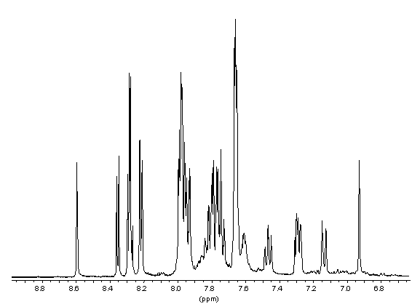

Figure 1. ¹H NMR spectrum of compound 5a (400 MHz, CD₂Cl₂).

Figure 2. ¹H/¹⁵N HSQC spectrum of 5a (400 MHz, CD₂Cl₂).

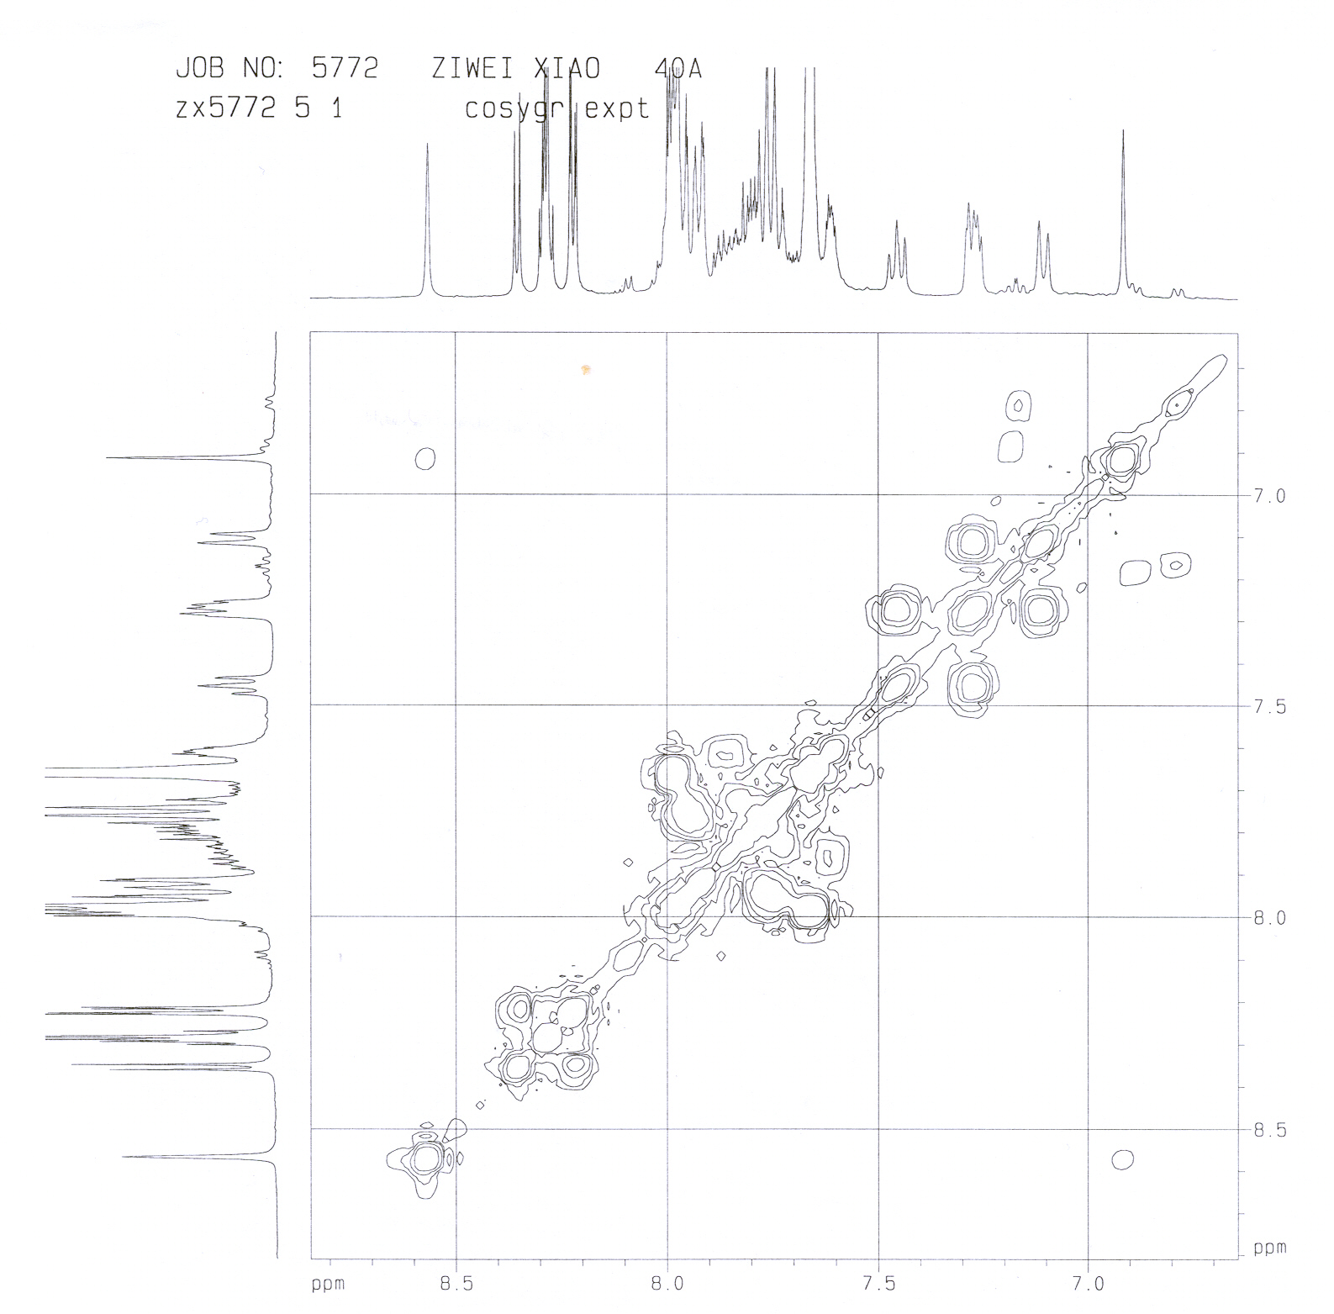
Figure 3. COSY spectrum of 5a (400 MHz, CD₂Cl₂).

