Supplementary Material (ESI) for Chemical Communications
This journal is © The Royal Society of Chemistry 2002

A communication for publication in Chemical Communications

Supporting Information

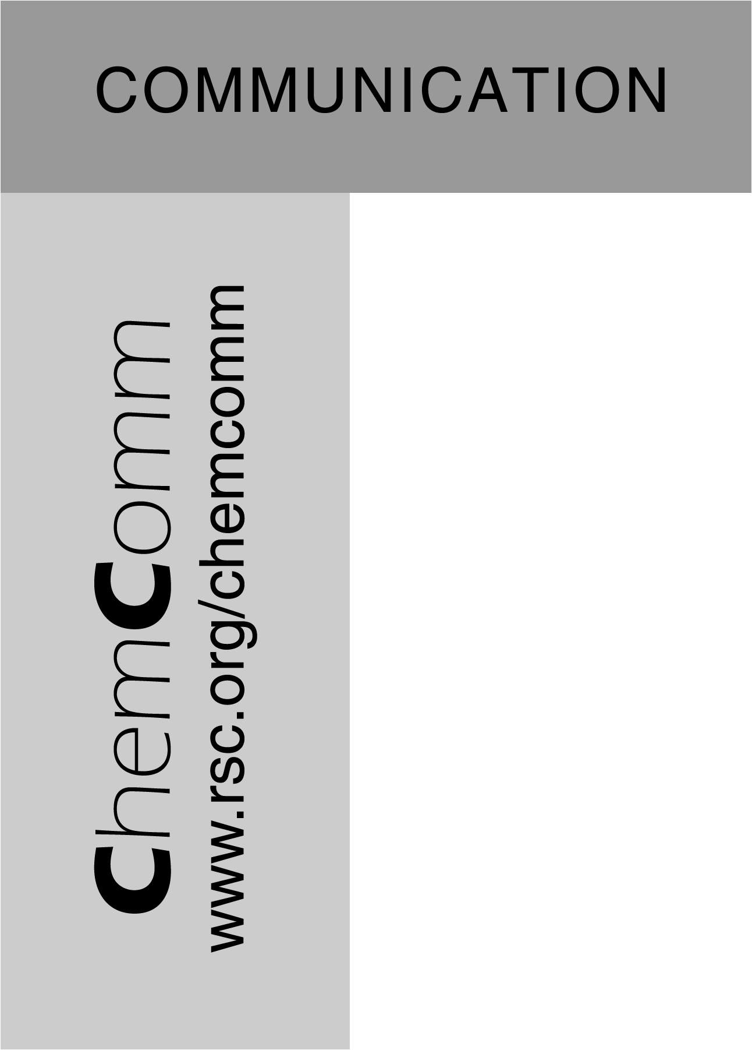
A sponge-like luminescent coordination framework via an Aufbau approach

Brett D. Chandler, Adrien P. Côté, David T. Cramb, Josephine M. Hill and George K. H. Shimizu*

Department of Chemistry, University of Calgary, 2500 University Drive N.W.
Calgary, Alberta, T2N 1N4, Canada
Ph: 1 –403 220 5347 Fax: 1 – 403-289 9488
e-mail: gshimizu@ucalgary.ca

Synthesis of dibarium europium tris(4,4’-disulfonate 2,2’-bipyridine 1,1’-dioxide) chloride

H₂L =

H₂L x 2H₂O (200 mg , 0.520 mmol) was dissolved in water (2 mL) in a 50 mL beaker and was sonicated for 5 minutes. In a second 50 mL beaker, EuCl₃ x 6H₂O (63.55 mg , 0.173 mmol) was dissolved in water (2 mL) and sonicated for 5 minutes. The two solutions were mixed and were warmed on a heating mantle for 10 minutes. A third solution was prepared by adding of BaCl₂ x 2H₂O (84.74 mg , 0.347 mmol) into a 50 mL beaker and dissolved in water (5 mL). The barium solution was then mixed with the warm europium(III) tris(4,4’-disulfonate 2,2’-bipyridine 1,1’-dioxide) solution and a white precipitate immediately began to form. Single crystals were grown by vapor diffusion using 2-3 mL of the final solution mixture and acetone as the diffusing solvent. Yield: 238 mg, 0.426 mmol, 82 %. I.R. (cm⁻¹) 3437, 1636, 1464, 1413, 1244, 1130, 1104, 1044, 892, 846, 717, 700, 594. Elem. anal. calcd. C: 21.43, H: 2.28, N: 5.00; obsvd. C: 22.12, H: 2.10, N: 4.93.

Upon dehydration, this solid becomes highly hygroscopic and rapidly absorbs moisture from the air. The IR and thermal analyses of this solid are consistent with a partially rehydrated sample related to compound 1. The IR figure shown represents a pristine sample of 1 and at two different stages of hydration.

General X-ray Crystallography. Crystals were selected under an optical microscope, coated in oil and frozen onto a glass fiber. Data for 1, were collected on a Bruker SMART APEX CCD diffractometer (Mo Kα radiation, λ = 0.71073 Å) using the ω scan mode (3° < 2θ < 57.3°). The structure was solved by direct methods and refined by full-matrix least squares, based on F², using SHELXTL. Absorption correction was applied by the SADABS routine. Europium, barium and sulfur atoms were located first and the remaining atoms found by difference Fourier maps. Hydrogen atoms were calculated to be in ideal positions. In the case of coordinated water molecules, this was achieved by using the HFIX 137 command and setting the occupancy of one of the H atoms (the atom with the most unusual H-bond orientations) to zero.
Infrared Spectrum of Compound 1:

Pristine (bottom)
Dehydrated and run immediately (middle)
Rehydrated (top)

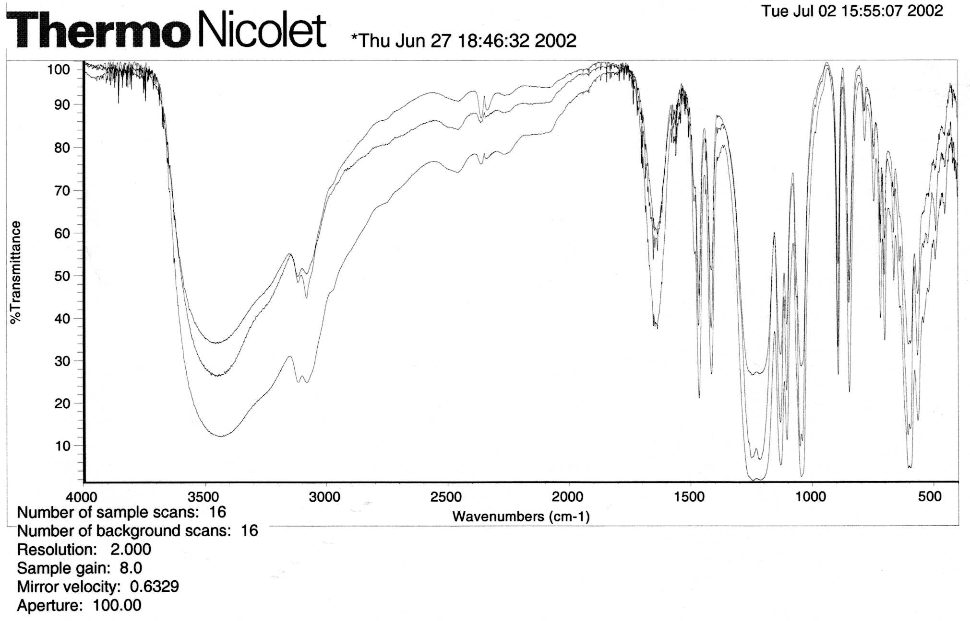

Elemental analysis for Compound 1:

Excitation and Emission Spectra of Compound 1:

DSC/TGA analysis of Compound 1:

Reversible desorption and sorption of water by Compound 1 as monitored by TGA:

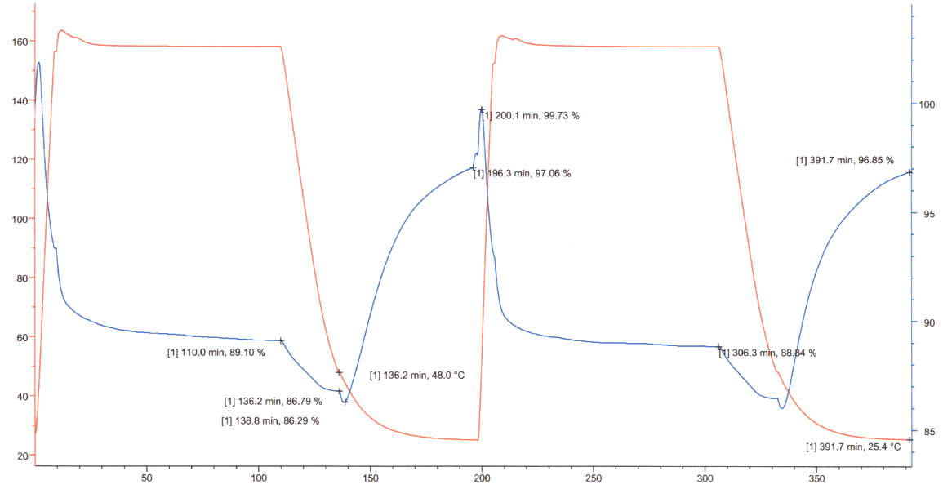

BET analysis of Compound 1 (dehydrated):

BET analysis of Compound 1 (dehydrated): (Cont)

Normalized emission spectra of Compound 1 in hydrated and dehydrated forms an in the presence of nitrobenzene:

