Supplementary Material (ESI) for Chemical Communications
This journal is © The Royal Society of Chemistry 2002

Supporting materials
The reaction in this case cannot be fulfilled completely at 160^{O}C. Even longer reacting time, higher reacting temperature and over-stoichiometric amount of HCB were used, the reaction could occur only within a limited depth of the outer shell of the sodium pellets. The products were black shells with unconsumed sodium encapsulated at the core, which could be removed by subsequent ethanol washing. The outer carbon shells hindered the full contact of the two reactants and the further reaction. SEM pictures (Figure A, B) reveal that the main content under this condition was macroporous carbon blocks with both spongy-like and square-shaped pores. Meanwhile, some serpentine tube-like products with an average diameter of 3-4μwere also found within the scope (Figure C). In many reports on the synthesis of tubular structure, catalysts were usually added into the system as active centre initiating the growth of hollow tubes. And almost all the mechanisms proposed for the growth of such tubular structure are based on the application of active centers in the reaction. [7-9] However, for this bi-component reaction without any possible effect of catalyst, the formation of pores and tubes cannot be attributed to such a mechanism. As solid NaCl is the by-product in this reaction and stayed mixed with carbon product when produced, the formation of tubular and other porous structures might be attributed to NaCl particles.
Powder XRD pattern (not shown) gave no characteristic diffraction peaks of ordered carbon materials for the above mentioned sample, except the broad hump around 2θ=24^{O}, indicating only the predominant amorphous carbon structure under this condition. This is quite different from the observation reported by Chi-Young Lee et al. in which the nanosized graphite with laminated structure dominating 70% of the final products was revealed by ¹³C-NMR and HRTEM. [11] Meanwhile, very strong NaCl diffraction peaks were also observed though the sample was thoroughly washed by boiling water, which reveals that some NaCl was still encapsulated by carbon materials and could not be removed by water washing.
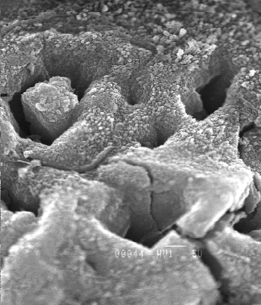
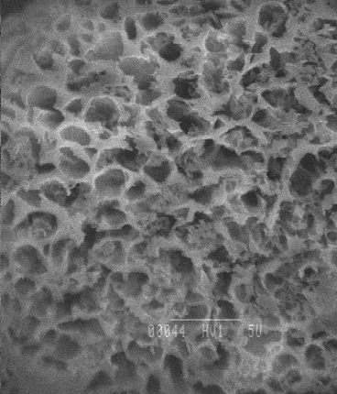
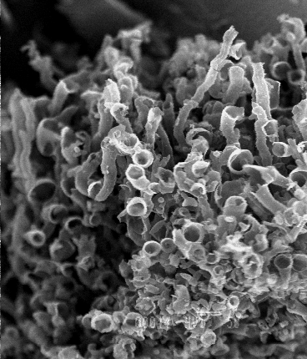
A
B
C
Figure SEM pictures of the products by simple mixing. (A) and (B) show the spongy-like and rectangular pores in the product. Tubular structure as shown in (C) is also observed.

