Supplementary Information for

Low-cost and facile synthesis of mesocellular carbon foams
Jinwoo Lee, Kwonnam Sohn and Taeghwan Hyeon*

- N₂ adsorption-desorption isotherms of AlMSU-F and AlMCF (Inset) Corresponding pore size distributions calculated using BJH (Barett-Joyner-Halenda) method from N₂ adsorption branches.
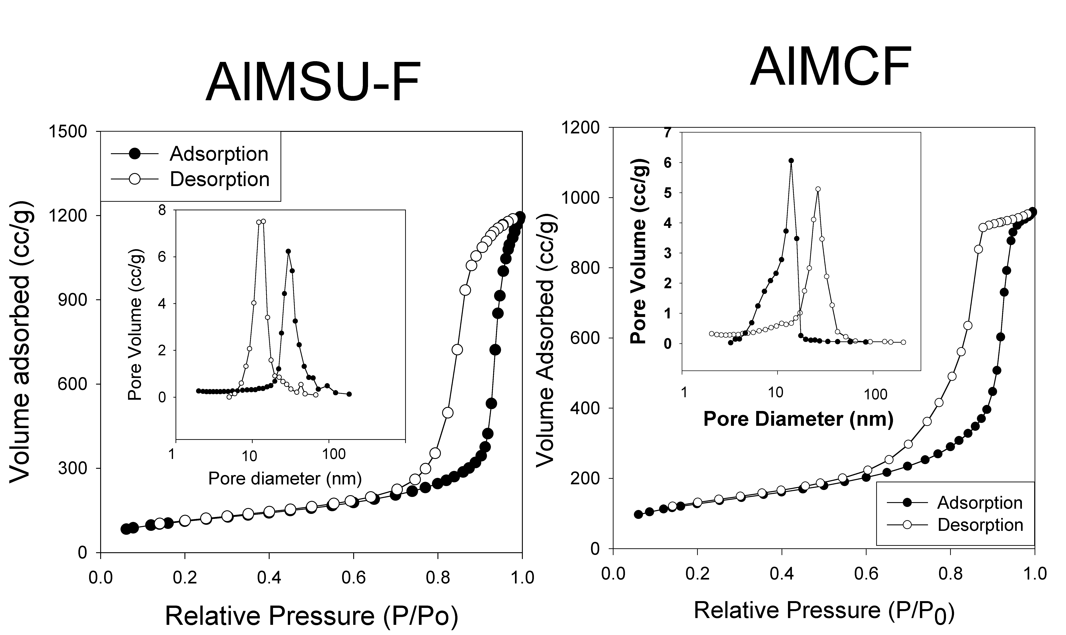

2. Transmission electron micrographic images (TEM) of AlMSU-F and AlMCF
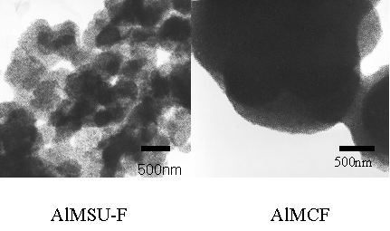
- Transmission electron micrographic images (TEM) of AlMSU-F/Carbon
composite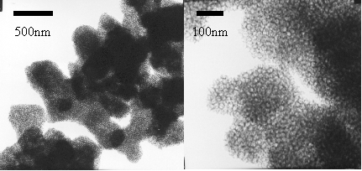

- Scanning electron microscopic images (SEM) of AlMSU-F and AlMCF

