Steric Hindrance to the Solvation of Melamines and Consequences for Noncovalent Synthesis – Supplementary Material
Ion Ghiviriga^{a,*} and Daniela C. Oniciu^{b}
ª Department of Chemistry, University of Florida, Gainescille, Florida 32611-7200
^{b} Esperion Therapeutics, Inc., 3621 S. Street, Ann Arbor, Michigan 48108.

Materials: The preparation of melamines 1-3 is presented in Scheme 1S.

Scheme 1S. Preparation of melamines 1-3. i) t-Bu-NH₂, 50 ºC, 24 hrs; ii) (CH₃)₂NH, 100 ºC, 24 hrs; t-Bu-NH₂, 120 ºC, 48 hrs; iv) CH₃NH₂·HCl, 95 ºC, 8 hrs.

2-Chloro-4,6-bis-(t-butylamino)-s-triazine (4) was obtained by cautiously adding t-butylamine (2 mL) to cyanuric chloride (2 g, 10 mmol) in 100 mL acetone, 1,4-dioxane or THF, under stirring. The reaction mixture was then heated at 50 ºC for 24 hrs, let to cool at room temperature, poured into water and extracted with dichloromethane. The organic layer was washed with water (5x50 mL), dried and the solvent removed under vacuum. The solid residue was recrystallized from ethanol. Yield 90 % (after recrystallization). M.p. 190-191 ºC (lit. m.p. 190 ºC).
2-Dimethylamino-4,6-bis-(t-butylamino)-s-triazine (1) was obtained by adding 2-chloro-4,6-bis-(t-butylamino)-s-triazine (4) (2.5 g, 10 mmol) to a solution of dimethylamine in water (40 wt. %, 50 mL), under stirring. The reaction mixture was then heated at reflux for 24 hrs, let to cool at room temperature, poured into water and extracted with dichloromethane (2x50 mL). The organic layer was washed with water (5x50 mL), dried and the solvent removed under vacuum. The solid residue was recrystallized from ethanol. Yield 75 % (after recrystallization). M.p. 191-192 oC. HRMS (EI): theoretical m/z 266.2219; experimental m/z: 266.2217. H1 NMR( 500 MHz, CDCl3) d 4.59 s 2H, 3.01 s 6H, 1.34 s 18H. C13 NMR(125 MHz, CDCl3) d 165.3, 50.4, 36.0, 29.3.
2,4,6-tris-(t-Butylamino)-s-triazine (2) was obtained by heating in an autoclave 2-chloro-4,6-bis-(t-butylamino)-s-triazine (5 g, 20 mmol) and 20 mL t-butylamine at 120 oC for 48 hrs. The reaction mixture was solubilized in dichloromethane (250 mL), washed with aqueous sodium carbonate 5% (2x100 mL), water (3x100 mL), then the organic extract dried (Na₂SO₄ anh.) and the solvent removed under vacuum. The solid residue was recrystallized from ethanol. Yield 85 % (after recrystallization). M.p. 179-180 ºC (lit. 175-180 ºC).
2,4,6-tris-(Methylamino)-s-triazine (3) was prepared according to literature procedures.

Identification of the conformers of melamine 1 was based on the nOe’s observed on the ROESY spectra (Figure 1S). The assignments of the chemical shifts in chloroform-d at -60 ºC are given in Figure 2S. The nOe between the methyl at 3.05 ppm and the t-butyl at 1.37 ppm identified the syn groups of the syn-anti conformer. A similar nOe between 3.08 ppm and 1.32 ppm identified the syn-syn conformer. A much smaller nOe between 2.96 ppm and 1.36 ppm in the anti-anti conformer is a transferred nOe due to the conformational exchange.
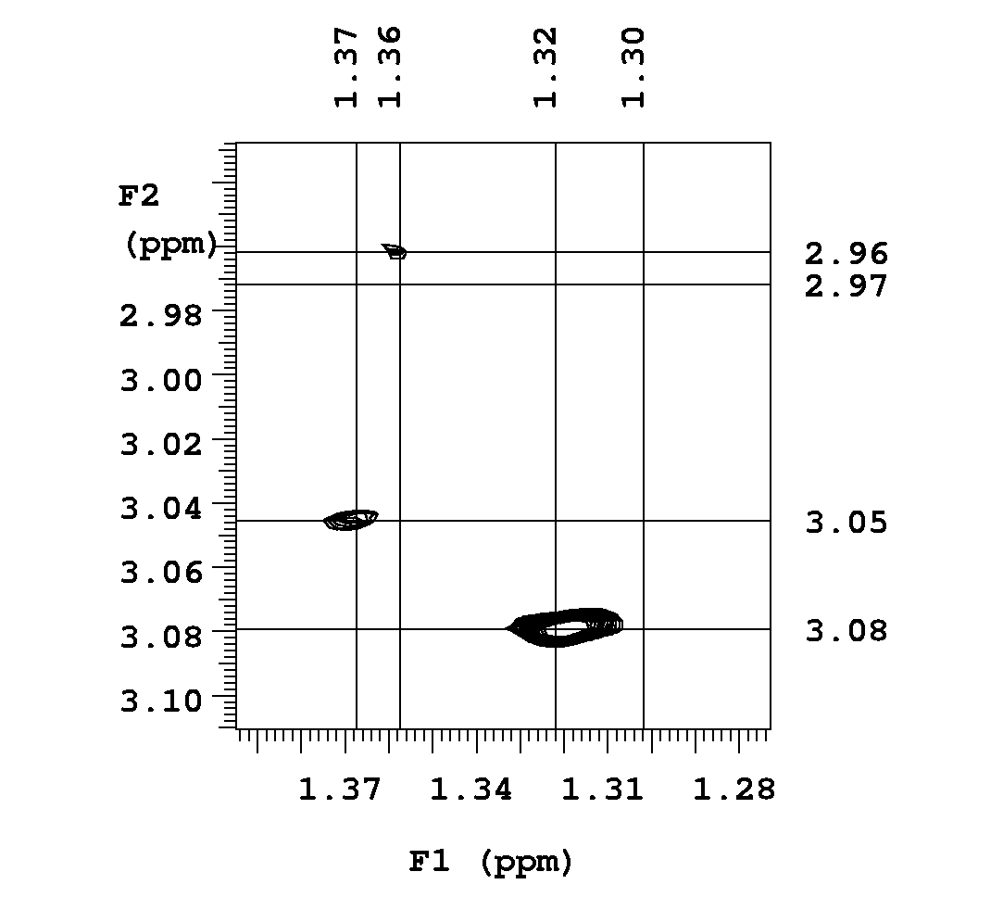
Figure 1S. The methyl – t-butyl region of the ROESY spectrum of melamine 1 in chloroform-d at -60 ºC.

Figure 2S. Proton chemical shifts assignment of melamine 1 in chloroform- d at -60 ºC.

Variable temperature proton spectra were taken on a Varian Inova, at 500 MHz, using a 5 mm indirect detection probe. In order to eliminate the effect of intermolecular association between melamine molecules, for each combination melamine-solvent three samples were run at three concentrations in a ratio 9:3:1, obtained by dilution from an initial concentration of 5-15 mM. Spectra were taken on automation every 5 ºC, from ca. 10 ºC above the freezing point of the solvent to 25 ºC. At each temperature, the sample was allowed to equilibrate for ca. 5 minutes and then was shimmed on the FID for ca. 20 minutes. The spectra were acquired in 64-128 transients, to compensate for the detuning of the probe as the temperature changed. The acquisition time was 1.5 s. A relaxation delay of 0.5 s was used for the automated shimming. A methanol sample was run in the same conditions and a quadratic fit afforded a standard error for the temperature of 0.05 ºC. The variable temperature proton spectra of melamine 1 are given in Figure 3S.
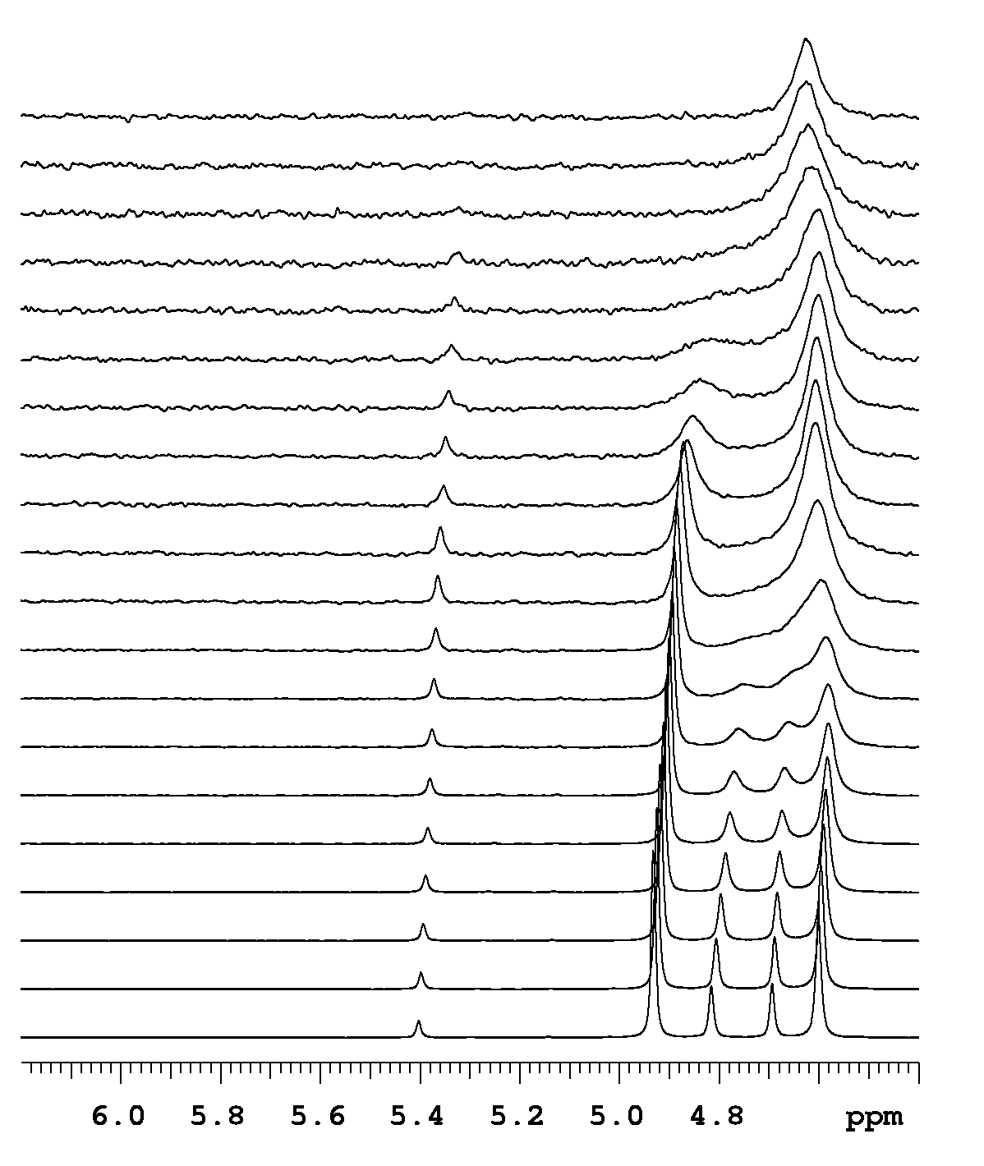
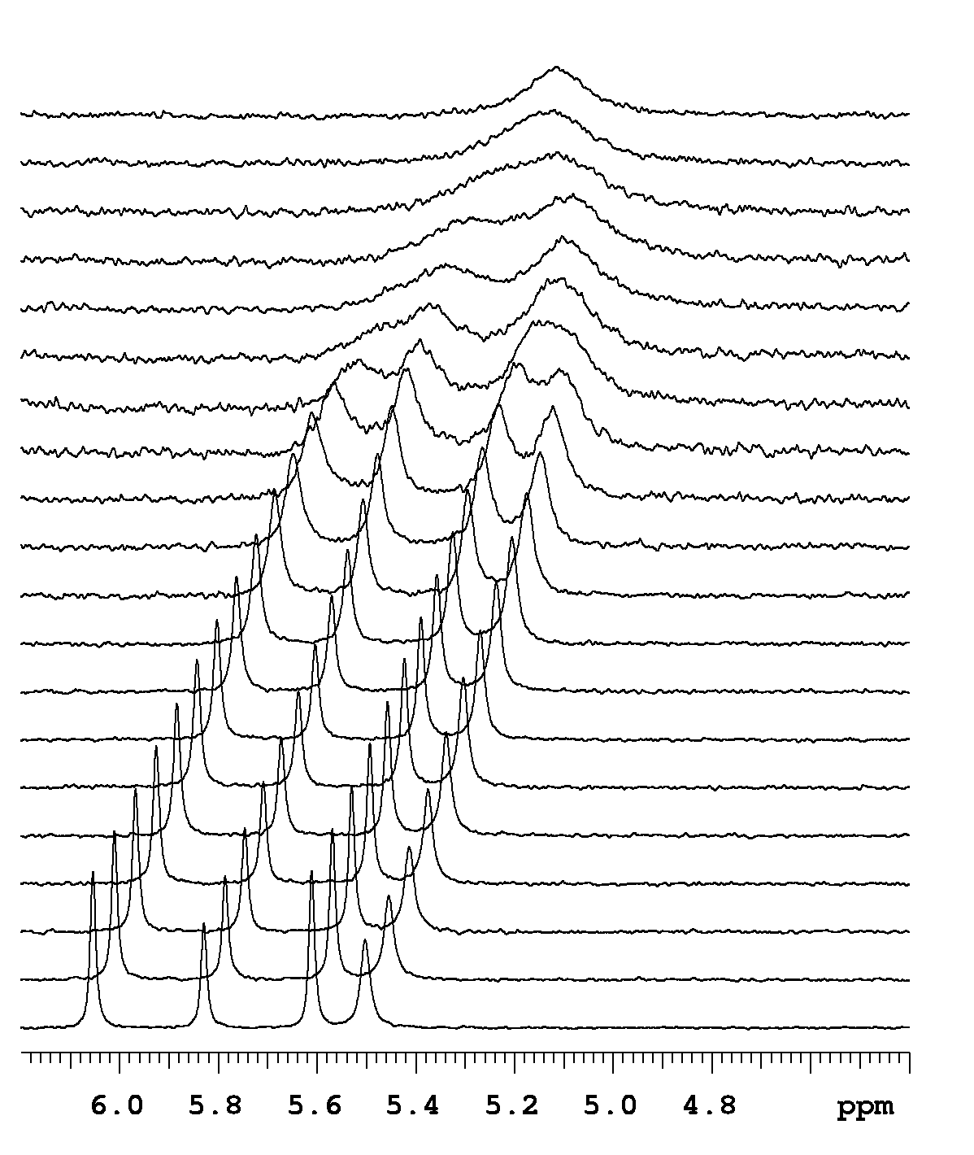
Figure 3S. The NH region of the variable temperature proton spectra of melamine 1, in chloroform-d (top series) and acetone-d6 (bottom series). In each series, the temperature increases in 5 °C increments from -55 °C (bottom spectrum) to 40 °C.

Measurement of the equilibrium constants. The ratio of the conformers was determined by integration of the signals in the proton spectrum, at temperatures bellow coalescence. The signals used for integration were the CH₃-N for compounds 1 and 3, and the NH for compound 2. The equilibrium constants were corrected for symmetry, i.e. K = 2∙[syn-syn]/[syn-anti] for melamine 1, and K = 3∙[propeller]/[asymmetric] for melamines 2 and 3. Six different concentrations in the range of 15 to 0.05 mM of a sample of melamine 2 in CDCl₃ at -55 ºC displayed a linear dependence of the equilibrium constant with the concentration. On this basis, equilibrium constants free of the effects of melamine-melamine association (K₀) were obtained by extrapolation to concentration zero. The enthalpy and the entropy for the conformational exchange were calculated as ΔH = -a/R and ΔS = b, where a is the slope and b the intercept of a linear fit of ln(K₀) vs. 1/T. Standard errors were calculated by taking into account the covariance of ΔH and ΔS, and are given in Table 1S.
Table 1S. Standard errors in ΔH and ΔS for the conformational equilibria of melamines 1-3.

Reaction | Solvent
Reaction |  | CDCl₃ | CD₂Cl₂ | Acetone-d6 | DMF-d6
1 syn-anti → → 1 syn-syn | ΔHa | 0.07 | 0.04 | 0.02 | 0.05
1 syn-anti → → 1 syn-syn | ΔSb | 0.30 | 0.19 | 0.44 | 0.20
1 syn-anti → → 1 anti-anti | ΔH | 0.07 | 0.03 | 0.05 | 0.05
1 syn-anti → → 1 anti-anti | ΔS | 0.32 | 0.13 | 0.38 | 0.19
2 asymmetric → → 2 propeller | ΔH | 0.17 | 0.22 | 0.01 | 0.02
2 asymmetric → → 2 propeller | ΔS | 3.80 | 1.06 | 0.05 | 0.07
3 asymmetric → → 3 propeller | ΔH | 0.08 | 0.02 | 0.01 | 0.01
3 asymmetric → → 3 propeller | ΔS | 0.34 | 0.09 | 0.06 | 0.06
a Standard errors for the enthalpy of reaction in kcal/mol.
b Standard errors for the entropy of reaction in cal/mol/K.

Barriers to rotation about the three nonequivalent bonds in the syn-anti conformer of 1 and the asymmetric conformer of 2 were determined by lineshape simulation in the temperature range of -50 to 0 °C, and are reported in Table 3. The complexity of the spectra precluded the use of other methods for measuring the rates in a larger temperature range, therefore reliable values for the activation enthalpies and entropies could not be measured. The simulations were performed with the gNMR program on signals of non-exchangeable protons, the methyl groups for 1 and the t-butyl groups for 2. The ratios of the conformers were calculated from the corresponding ΔG. At temperatures where some of the rates were too fast to be measured reliably, these rates were fixed to values calculated from ΔG#. Typically each exchange rate (k) was determined at 6 to 8 temperatures, corresponding to a temperature interval of 30 to 40 °C. Barriers to rotation were calculated at 232.1 K as ΔG# = ΔH# + T ΔS#, where ΔH# = -aR and ΔS# = (b-23.76)/R, a and b being the slope and the intercept of a linear fit of ln(k/T) vs. 1/T. The standard errors of the three ΔG# values determined for the three concentrations of a combination melamine-solvent were between 0.01 and 0.34. The ΔG# values in Table 3 are calculated from rates averaged over the three concentrations.
Table 2S. Relevant properties of the solvents.

 | Solvent
 |  | CHCl₃ | CH₂Cl₂ | Acetone | DMF
Σα^{H}₂ ª  Σβ^{H}₂ ^{b}  ε ^{c} |  | 0.15 | 0.10 | 0.04 | 0.00
Σα^{H}₂ ª  Σβ^{H}₂ ^{b}  ε ^{c} |  | 0.02 | 0.05 | 0.49 | 0.74
Σα^{H}₂ ª  Σβ^{H}₂ ^{b}  ε ^{c} |  | 4.81 | 8.93 | 20.70 | 36.7
a hydrogen-bond acidity, effective for solvation.
b hydrogen-bond basicity, effective for solvation.⁷
c dielectric constant.

Mazza, M.; Montanari, L. Farmaco-Ed. Sci. 1972, 27, 744
US Pat 2,691,021, 1952, cf. Chem. Abstr. 1955, 49 14817c
Ramurthy, S.; Miller, M. J. J. Org. Chem. 1996, 61, 4120-4124.
Bain, A. D.; Duns, G. J.; Ternieden, S.; Ma, J.; Werstiuk, N. H. J. Phys. Chem. 1994, 98, 7458-7463.
Bain, A. D.; Duns, G. J. J. Magn. Reson. Ser. A 1994, 109, 56-64.
Budzelaar, P. H., gNMR, Cherwell Scientific Publishing Ltd., Oxford, 1997.
⁷ Abraham, M. H. Chem. Soc. Rev. 1993, 22, 73-83.

