Supporting Information

A typical protocol for the homopolymerization of 2-gluconamidoethyl methacrylate (GAMA) via methanolic ATRP at 20 ºC

2-Gluconamidoethyl methacrylate (GAMA; 2.0 g, 6.5 mmol) was heated to 40 ºC to aid its dissolution in methanol (4.0 ml). The PEG₂₃-Br initiator (0.13 g, 0.013 mmol, target degree of polymerization = 50) was then added and this solution was purged with nitrogen for 10 minutes. Copper(I) bromide (0.018 g, 0.013 mmol) and two equivalents of 2,2’-bipyridine (0.040 g, 0.026 mmol) were added and the resulting dark brown solution was stirred under a nitrogen atmosphere. The extent of polymerization was monitored by ¹H NMR. High conversion (> 97 %) was only achieved after 15 h at 20 ºC. GPC data for the GAMA polymer indicated an M_{n} of 11,400 and an M_{w}/M_{n} of 1.23. The spent ATRP catalyst was removed by passing the reaction solution through a column packed with basic alumina. The methanol was removed under vacuum and the white polymer was re-dissolved in water and freeze-dried overnight. The isolated yield of GAMA homopolymer was 78 %. The same protocol was used for ATRP syntheses in water or water/methanol mixtures except that the GAMA did not require heating for dissolution under these conditions. The reaction times required for high conversions were significantly reduced in the presence of water.

GPC protocols used in this work:

1. Aqueous GPC at neutral pH (GAMA homopolymer)

GPC chromatograms for the homopolymers were recorded using a Viscotek instrument equipped with a Viscotek TSK alpha-3000 column, 0.10 M sodium nitrate/0.01 M sodium dihydrogen phosphate as eluent at a flow rate of 1.0 ml min⁻¹at 35 °C using a refractive index detector. Calibration was achieved using poly(ethylene oxide) standards.

2. Aqueous GPC at low pH (GAMA-DEA diblock copolymer)

GPC chromatograms for the diblock copolymers were obtained using a Viscotek TSK G5000PW_{XL} column at 30 °C in conjunction with an ERC-7515A refractive index detector. The eluent used was 0.50 M acetic acid/0.30 M sodium sulfate (approximately pH 2) at a flow rate of 1.0 ml min⁻¹. Calibration was achieved using poly(2-vinylpyridine) standards.

3. DMF GPC (selected homopolymers and copolymers)

GPC chromatograms were obtained from RAPRA, UK using a Waters 150 CV instrument equipped with two 30 cm (10 micron) Mixed Bed-B Plgel columns operating at 80 °C with a refractive index detector. DMF containing 0.01 M lithium bromide was used as the eluent at a flow rate of 1.0 ml min⁻¹. Calibration was achieved using poly(methyl methacrylate) standards.

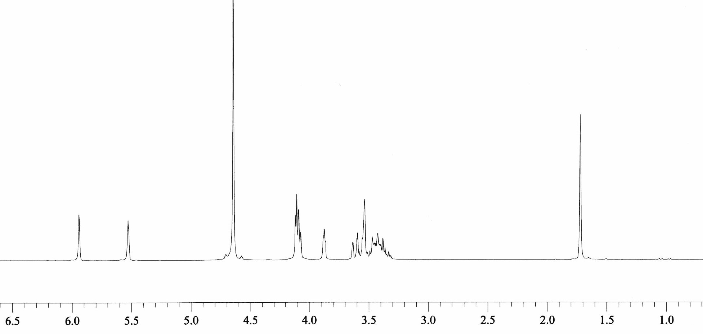
1
5,8 9 6,10,11,12
3 3’
δ (ppm)
(a)
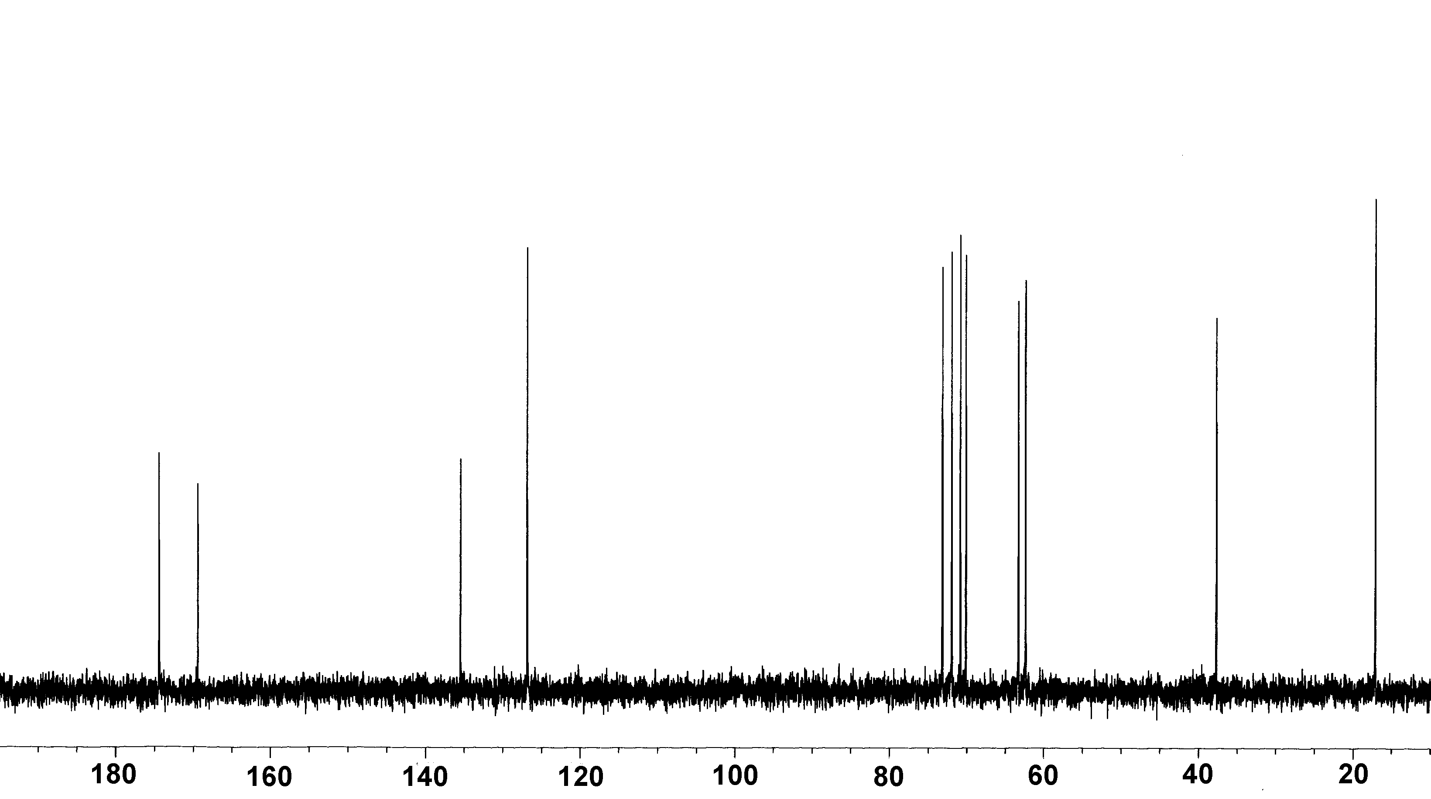
7 4
8,9,10,11,12,5
6
1
2
3
(b)
δ (ppm)

Fig. 3 (a) ¹H and (b) ¹³C NMR spectra of 2-gluconamidoethyl methacrylate (GAMA) monomer

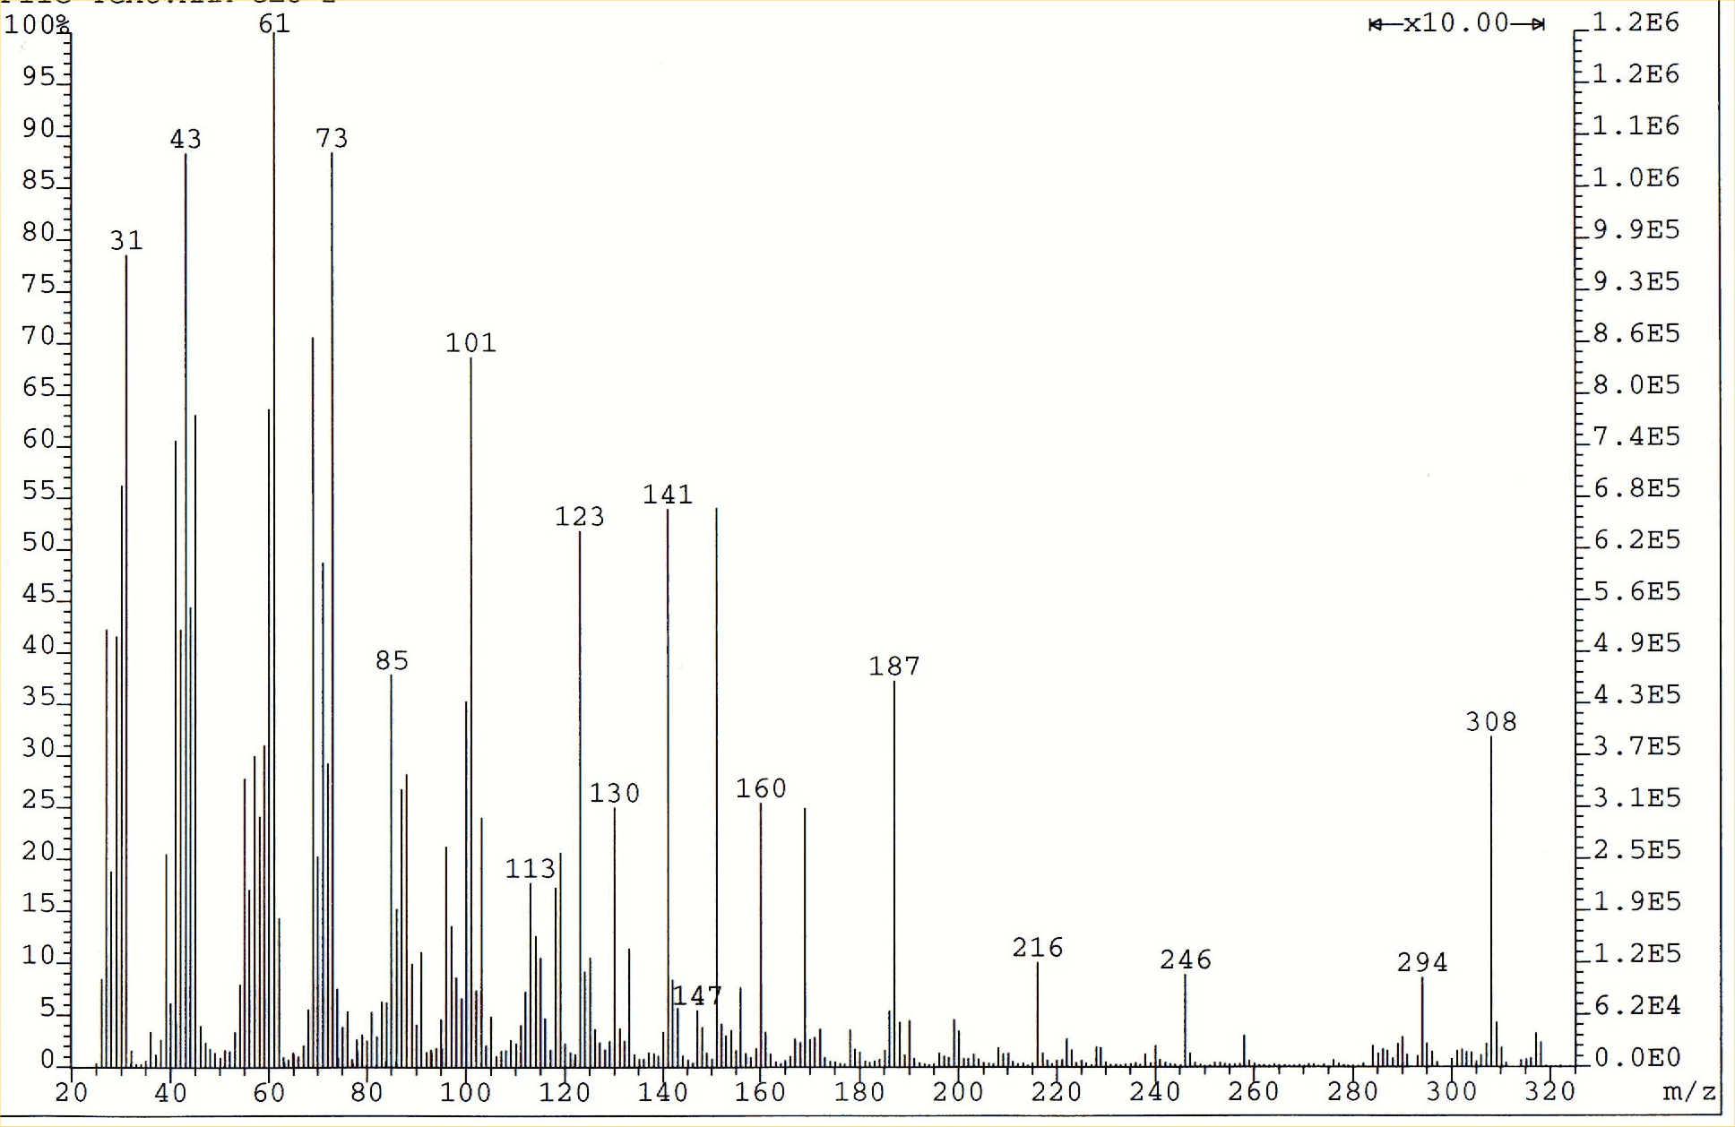
[M+1]⁺
(m/z 307)

Fig. 4. Mass spectrum of 2-gluconamidoethyl methacrylate (GAMA)

Methanol
Methanol/water (9:1)
Water
(a)
(b)

Fig. 5 (a) Kinetic plots for the homopolymerization of GAMA (target degree of polymerization = 50) at 20 ºC using PEG₂₃-Br as initiator and CuBr/2bpy as catalyst in methanol, water and a 9:1 methanol/water mixture, respectively; (b) evolution of M_{n} with conversion for the homopolymerization of GAMA at 20 ºC in methanol. In both (a) and (b) the reaction conditions were 2.0 g GAMA in 4.0 ml methanol and the relative molar ratios of GAMA: PEG₂₃-Br: Cu(I)Br: bpy were 50:1:1:2.

pH 2.5

pH 10

GAMA
Homopolymer

3,7,8,9,10,11,12,13
5
4
6
2
14,15
14,15
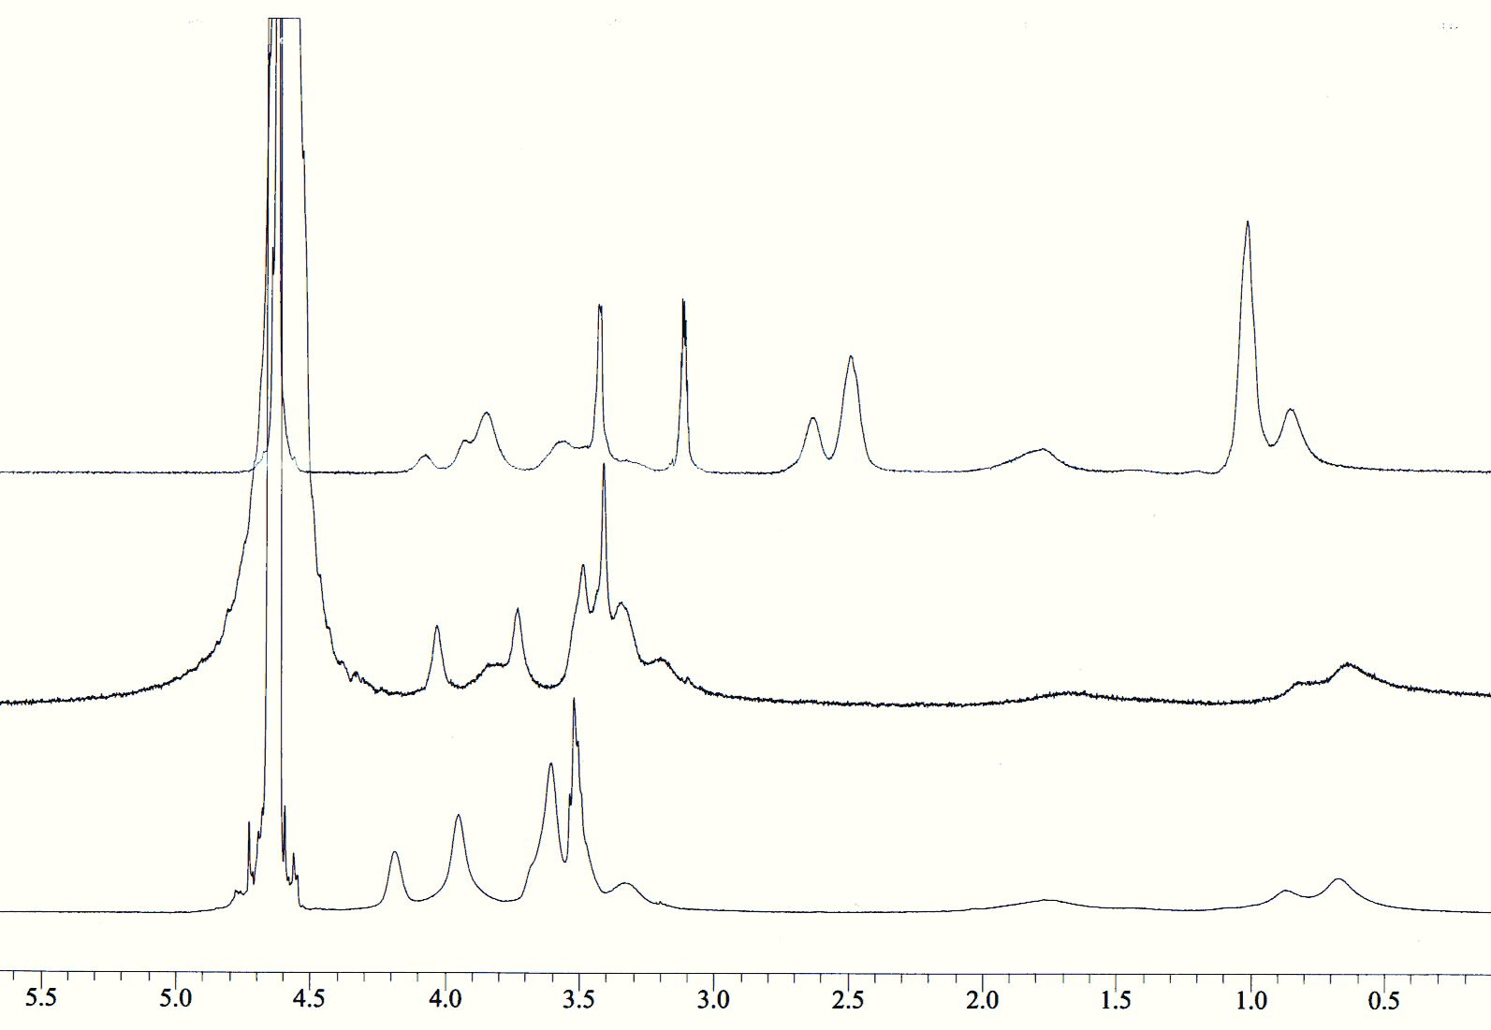
1
δ (ppm)
Fig. 6 ¹H NMR spectra (D₂O) of GAMA homopolymer and the PEG₂₃-(GAMA)₅₀-(DEA)₁₀₀ block copolymer at pH 10 and 2.5, respectively. The solution pH was adjusted using NaOD and DCl, respectively

