Electronic supplementary information.

¹⁷O MQMAS NMR studies of Na-A and Ca-A
Jennifer E. Readmanª, Namjun Kimª, Martine Ziliox^{b} and Clare P. Grey^{a*}
ª Department of Chemistry, State University of New York at Stony Brook, Stony Brook NY, 11794-3400, U.S.A
^{b} Center for Molecular Medicine, State Univeristy of New York at Stony Brook, Stony Brook, NY, 11794-5115, U.S.A.

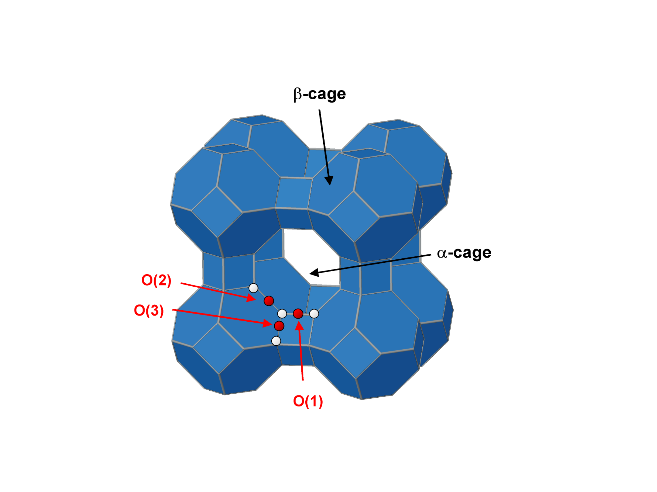
The structure of zeolite A.

Fig 1 Schematic representation of the structure of zeolite A. The red atoms represent oxygen, while the white atoms are silicon and aluminium.

Hydrated and dehydrated Na-A.

The 1-pulse and MQMAS spectra for hydrated Na-A are similar to those of Pingel et al [1] and show that there are 3 sites. The spectrum of dehydrated Na-A is quite different to that of the hydrated zeolite indicating that removal of the water molecules has an effect on the oxygen environments. This was also observed by Stebbins and co-workers [2]. Crystallographic studies show that the Si-O(1)-Al and Si-O(3)-Al bond angles do not change significantly upon dehydration [3, 4]. In contrast, the Si-O(2)-Al angle increases from 159.5° in the hydrated sample to 164° in the dehydrated sample [8, 9]. Therefore, according to the correlation of Pingel et al. [1] the isotropic shift for the O(2) resonance should shift by approximately 3 ppm to lower frequency on dehydration; experimentally, a shift from 39 to 34 ppm is seen. The Na⁺ cations in the 8-ring (which are coordinated to both O(1) and O(2)) do not sit in the centre of the 8-ring and this results in Na-O distances of 2.3Å to 4.9Å. There are 4 possible Na sites per 8-ring but only one can be simultaneously occupied due to cation repulsion. This variation in the distances is reflected in an increase in the distribution of the chemical shifts and a broadening of the O(1) and O(2) sites in the isotropic dimension on dehydration. All the sites are occupied by either Na or water, in the hydrated sample, at the approximately the same distance, so even though the Na⁺ is still off centre the presence of the water molecules appears to reduce the chemical shift distribution. In addition, the Na⁺ cations will be mobile in the hydrated sample, which may also contribute to the reduction in the chemical shift distribution. The isotropic chemical shift of the O(3) site moves from 45ppm to 42ppm upon dehydration; again, this change is not mirrored by a change in the bond angle, which increases slightly from 144.1° to 144.8°. The bond angle change is not large enough to produce the observed changes in the isotropic shift.

Hydrated Na-A
Dehydrated Na-A
Hydrated Ca-A
Dehydrated Ca-A
ppm
Fig 2 ¹⁷O 1-pulse MAS NMR spectra of hydrated Na-A, dehydrated Na-A, hydrated Ca-A and dehydrated Ca-A. A spinning speed of 13 kHz was used for all samples.
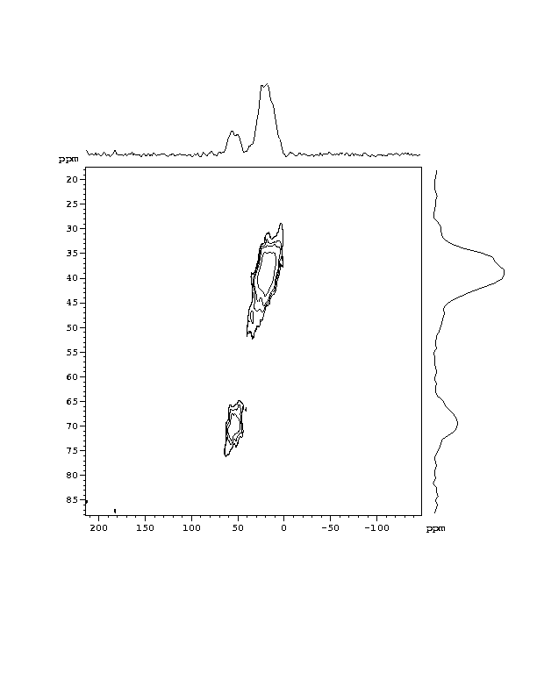
Dehydrated Ca₄Na₄-A MQMAS
Fig 3 ¹⁷O MQMAS NMR spectra of dehydrated Ca₄Na₄-A. A spinning speed of 13 kHz was used.
References:

- U-T. Pingel, J-P. Amoureux, T. Anupold, F. Bauer, H. Ernst, C. Fernandez, D. Freude and A. Samoson, Chem. Phys. Letts., 1998, 294, 345
- P. S. Neuhoff, P. Zhao and J. F. Stebbins, Microporous Mesoporous Mater.,
- J. J. Pluth and J. V. Smith, J. Am. Chem. Soc., 1980, 102, 4704
- J. M. Adams, D. A. Haselden and A. W Hewat, J. Solid State Chem., 1982, 44, 245

