Supplementary Material for the Paper: FGFG: A Fully Extended Natural Peptide
Henrik Birkedal, Dieter Schwarzenbach and Philip Pattison
Institute of Crystallography,University of Lausanne, BSP Dorigny, CH-1015 Lausanne, Switzerland

X-ray Diffraction
A small needle shaped single crystal (191(5)×13.4(1.0)×13.4(1.0) μm³, size estimated from an electron microscopy picture, Fig. S1) was selected directly from the acquired batch, SIGMA P-3751 lot 15H0482, and mounted at the tip of a glass needle. Two sets of diffraction data were collected at room temperature with a MAR345 imaging plate system using focusing optics. The first, a high resolution data set (high), was collected with an effective resolution range of 8.0-0.9 Å. The second data set (low) was collected to obtain the low order reflections. The primary beam was attenuated by a factor of about 20 with a 50 μm Cu foil. The resolution range was 15.0-1.38 Å. The total data collection time was less than three hours. Experimental and refinement details are summarized in Table S1. Full information can be found in the accompanying CIF file.
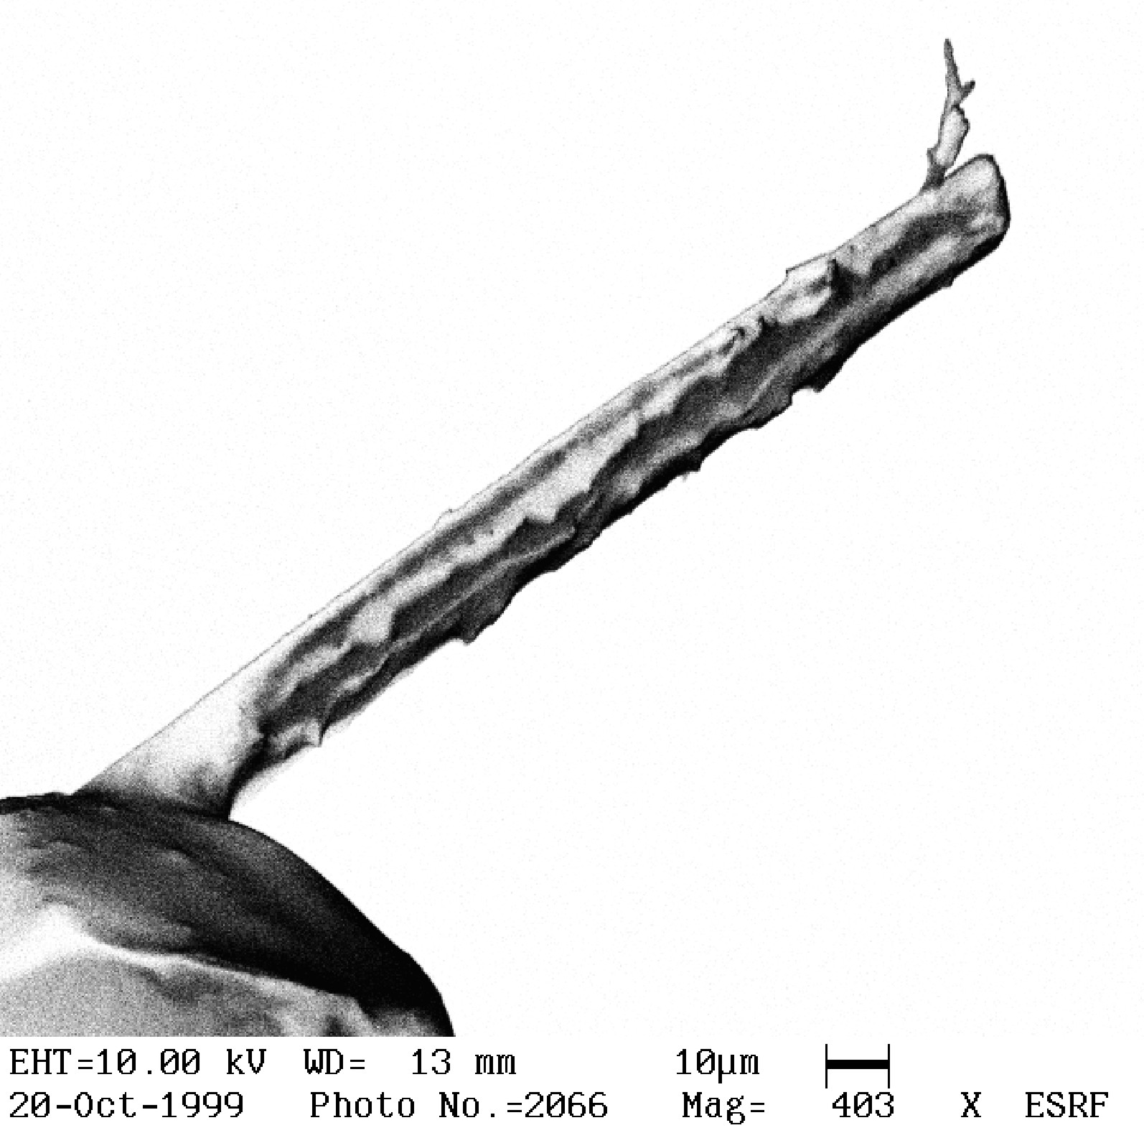
Figure S1. Electron microscopy picture of the crystal used for the experiment.
The crystal was of very high quality judged by the small mosaicity (~0.145º). The sample was not mounted in exactly the same manner during the high and low collections. Therefore, only a rough estimate of the attenuation factor of the Cu absorber foil can be made. Comparing the scales from the two data sets yields a filter factor of about 19.
During the refinement, hydrogen atoms were clearly visible in the Fourier difference electron density map. They were included in the riding model with U_{iso}(H) = xU_{eq}(Y) for a hydrogen bonded to atom Y with x = 1.5 for Y = N1A (the nitrogen of the N-terminus) and 1.2 for all other atoms. The terminal -NH₃⁺ group (N1A) was refined as a rotating group which means that the orientation of the rigid -NH₃⁺ group is refined
Ab Initio Calculations
Two series of calculations were performed: (1) the X-ray structure was directly optimized at the RHF/6-31G(d) level. (2) the X-ray structure was optimized using the semi-empirical PM3 method. The resulting structure was then optimized at the RHF/6-31G(d) level. RE refers to the ab initio structure obtained with the experimental structure as starting point. The one obtained starting from the PM3 structure is named RP. Vibrational analysis was not performed, as the cost connected herewith was deemed too high. Therefore it is not certain whether the converged structures obtained correspond to minimums on the potential energy surface of the molecule. The energies and dipole moments of the two conformers are given in Table S2. Table S3 gives the Cartesian coordinates of the optimized structures. The coordinate system is defined as follows: the origin is on C1, the z-axis is along the C1-O1 vector, and N2 is in the y, z-plane. Tables S4, S5 and S6 compare bond distances (S4), bond angles (S5) and torsion angles (S6) between the three structures. The geometry of the hydrogen bonds in the experimental and ab initio structures are detailed in Table S7. The calculated structures are compared to the experimental one in Figure S2.
CSD Search
Structures were extracted from the Cambridge Structural Database (Database version 5.17, April 1999) that fulfilled 155º ≤ |ψ_{i}| ≤ 180º (ψ_{i} = N_{i}-C^{α}_{i}-C_{i}-N_{i+1}) and contained a peptide sequence (Bit screen 67). These were further required to be acyclic. This gave 151 structures. In this data set, planar peptides were located by hand. Only four fully extended structures were found. In addition to these comes the recent study of Crisma et al. (Ref. 1) and Iwakama et al. (Ref. 4) This brings the total number of fully extended peptide structures to eight. An overview of the backbone torsion angles is given in Table S8, while the structures are shown in Figure S3. The three extended β-sheet structures are detailed in Table S9.
References
(1) Crisma, M.; Formaggio, F.; Toniolo, C.; Yoshikawa, T.; Wakamiya, T. J. Am. Chem. Soc. 1999, 121, 3272-3278.
(2) Benedetti, E.; Toniolo, C.; Hardy, P.; Barone, V.; Bavoso, A.; Di Balsio, B.; Grimaldi, P.; Lelj, F.; Pavone, V.; Pedone, C.; Bonora, G. M.; Lingham, I. J. Am. Chem. Soc. 1984, 106, 8146-8152.
(3) Benedetti, E.; Barone, V.; Bavoso, A.; Di Blasio, B.; Lelj, F.; Pavone, V.; Pedone, C.; Toniolo, C.; Leplawy, M. T.; Kaczmarek, K. Redlinski, A. Biopolymers, 1988, 27, 357-371.
(4) Imakawa, N.; Tanaka, M.; Suemune, H. Helv. Chim. Acta 2000, 83, 2823-2835.
(5) Griffin, J. F.; Langs, D. A.; Smith, G. D.; Blundell, T. L., Tickle, I. J.; Bedarkar, S. Proc. Natl. Acad. Sci. USA 1986, 83, 3272-3276.
(6) Srikrishnan, T.; Winiewicz, N.; Parthasarathy, R. Int. J. Pept. Protein Res. 1982, 19, 103-113.

Table S1. Experimental details for FGFG. Two data collections were performed: high and low. Dataset low was made with a 50 μm Cu attenuating filter, that reduced the incoming beam intensity by a factor of ~19.
Empirical Formula | C₁₉H₂₆N₂O₅
Formula Weight/g/mol | 362.42
Crystal System | orthorhombic
Space group | P2₁2₁2₁
a/Å | 5.063(1)
b/Å | 15.379(3)
c/Å | 28.912(6)
V/Å³ | 2251.3(8)
Z | 4
D_{calc}/g cm⁻³ | 1.258
λ/Å | 0.8008
F(000)/e | 904
Crystal Size/μm³ | 191(5)× 13.4(1.0)×13.4(1.0)
collection method | oscillation, Δφ = 2º
detector, pixel size | MAR345, 150 μm
collection | high | low
detector size/mm | 345 | 240
detector distance/mm | 120 | 180
exposure time/s | 20 | 15
no. of images | 84 | 48
resolution: d_{max}-d_{min}/Å | 13.58-0.90
Ntot, Nunique; R_{int} | 12283, 1920; 0.041
Data set, h; k; l (unique) | 0 → 5; 0 → 17; 0 → 31
Observed data [F² > 2σ( F²)] | 1795
Nref, Npar | 1920, 281
R₁ F² > 2σ(F²); all | 0.0298; 0.0329
wR₂ F² > 2σ(F²); all | 0.0810; 0.0840
S(all) | 1.050
min, max, rms Δρ/eÅ⁻³ | -0.119, 0.162, 0.026

Table S2. Energy and dipole moment from ab initio calculations on FGFG. ΔE is the energy difference E_{RP} - E_{RE} given in kJ mol⁻¹. The dipole moment is given in Debye and with respect to the coordinate system defined in Table S3.

 | ΔE | d_{x} | d_{y} | d_{z} | |d|
RE | 0.00 | 4.57 | -47.31 | 9.44 | 48.45
RP | -247.96 | -9.17 | -2.78 | -0.89 | 9.63

Table S3 RHF/6-31G(d) optimized Cartesian coordinates (Å) of FGFG
 | RE |  |  | RP
 | x | y | z | x | y | z
O1 | 0.00000 | 0.00000 | 1.20995 | 0.00000 | 0.00000 | 1.20216
N1 | -0.04948 | -2.36882 | 0.39163 | 0.47499 | -2.35194 | 0.11738
H11 | 0.20974 | -1.87932 | 1.24995 | 0.18556 | -2.18219 | 1.06982
H12 | 0.53330 | -3.17797 | 0.25010 | 1.56347 | -2.31592 | 0.10654
H13 | -1.00864 | -2.67504 | 0.50796 | 0.18746 | -3.28076 | -0.13895
C1 | 0.00000 | 0.00000 | 0.00000 | 0.00000 | 0.00000 | 0.00000
C1A | 0.04339 | -1.36234 | -0.72084 | -0.13294 | -1.32067 | -0.75789
H1A | 1.02323 | -1.47785 | -1.16609 | 0.46722 | -1.27610 | -1.64968
C1B | -1.05112 | -1.62349 | -1.77659 | -1.59263 | -1.66592 | -1.12859
H1B1 | -0.99804 | -0.83087 | -2.51218 | -2.01495 | -0.79422 | -1.61597
H1B2 | -0.79828 | -2.53882 | -2.30123 | -1.55758 | -2.44702 | -1.88176
C1G | -2.44728 | -1.73099 | -1.19396 | -2.48415 | -2.12119 | 0.01044
C1D1 | -3.18717 | -0.59463 | -0.87517 | -3.05252 | -1.21186 | 0.89789
H1D1 | -2.79732 | 0.38505 | -1.08368 | -2.86361 | -0.16031 | 0.78293
C1E1 | -4.44362 | -0.71383 | -0.30721 | -3.85976 | -1.64719 | 1.93393
H1E1 | -5.00121 | 0.17325 | -0.07046 | -4.28893 | -0.93054 | 2.61054
C1Z | -4.98211 | -1.96711 | -0.05315 | -4.11680 | -2.99966 | 2.10042
H1Z | -5.95940 | -2.05431 | 0.38468 | -4.74526 | -3.33506 | 2.90548
C1E2 | -4.26357 | -3.10322 | -0.38002 | -3.56602 | -3.91338 | 1.21971
H1E2 | -4.68242 | -4.07779 | -0.20733 | -3.76761 | -4.96348 | 1.33221
C1D2 | -3.00346 | -2.98443 | -0.94999 | -2.75872 | -3.47351 | 0.18142
H1D2 | -2.47075 | -3.87605 | -1.23990 | -2.35701 | -4.19352 | -0.51242
O2 | -0.20426 | 2.82537 | -2.61591 | 2.20186 | 2.88138 | -1.44727
N2 | 0.00000 | 1.06125 | -0.77491 | 0.00000 | 1.11274 | -0.76588
H2 | 0.03379 | 1.00672 | -1.77379 | 0.37837 | 1.00616 | -1.68410
C2 | -0.34593 | 3.30312 | -1.50930 | 1.74712 | 2.76377 | -0.33835
C2A | -0.08377 | 2.42280 | -0.28552 | 0.27326 | 2.40653 | -0.16528
H2A1 | 0.84341 | 2.72114 | 0.18943 | -0.03798 | 2.37813 | 0.86612
H2A2 | -0.87929 | 2.51232 | 0.44116 | -0.30223 | 3.16168 | -0.68500
O3 | -1.24200 | 6.76006 | -0.12292 | 5.21996 | 1.56080 | 1.99801
N3 | -0.70421 | 4.53790 | -1.22829 | 2.45751 | 2.93358 | 0.78976
H3 | -0.82173 | 4.84289 | -0.28111 | 2.02716 | 2.71128 | 1.65995
C3 | -1.18964 | 6.86196 | -1.33463 | 4.62672 | 1.83545 | 0.98805
C3A | -0.98436 | 5.59144 | -2.18637 | 3.89372 | 3.17653 | 0.80775
H3A | -0.11164 | 5.74480 | -2.81069 | 4.14724 | 3.55909 | -0.17052
C3B | -2.17119 | 5.27245 | -3.12461 | 4.27813 | 4.23705 | 1.85846
H3B1 | -2.39961 | 6.17051 | -3.68694 | 5.34256 | 4.15434 | 2.03675
H3B2 | -1.83191 | 4.53410 | -3.83823 | 4.10413 | 5.20773 | 1.40715
C3G | -3.42495 | 4.75889 | -2.44535 | 3.52757 | 4.19195 | 3.17905
C3D1 | -4.22748 | 5.58898 | -1.66656 | 3.90341 | 3.33851 | 4.21352
H3D1 | -3.95918 | 6.62048 | -1.53059 | 4.73187 | 2.67312 | 4.06944
C3E1 | -5.38132 | 5.10551 | -1.07353 | 3.20820 | 3.33493 | 5.41219
H3E1 | -5.98684 | 5.76492 | -0.47801 | 3.51491 | 2.66978 | 6.19991
C3Z | -5.76619 | 3.78624 | -1.25895 | 2.12644 | 4.18017 | 5.60149
H3Z | -6.67402 | 3.41989 | -0.81249 | 1.59102 | 4.17536 | 6.53438
C3E2 | -4.98393 | 2.95408 | -2.04103 | 1.74334 | 5.03392 | 4.58126
H3E2 | -5.28721 | 1.93639 | -2.21951 | 0.90934 | 5.69991 | 4.71681
C3D2 | -3.82053 | 3.43777 | -2.62237 | 2.44101 | 5.03780 | 3.38348
H3D2 | -3.22238 | 2.78873 | -3.23863 | 2.14121 | 5.71300 | 2.60032
O4" | -2.02263 | 11.40983 | -2.42773 | 3.06428 | -2.19298 | 0.21980
O3' | -1.65865 | 9.70428 | -3.83250 | 2.54620 | -0.45669 | -1.03099
N4 | -1.29244 | 7.97352 | -2.02280 | 4.52378 | 1.01474 | -0.07497
H4 | -1.25628 | 8.00402 | -3.02658 | 3.91783 | 1.29916 | -0.81602
C4 | -1.77105 | 10.25412 | -2.72717 | 3.30803 | -1.07738 | -0.28777
C4A | -1.55313 | 9.30604 | -1.50741 | 4.64697 | -0.42389 | 0.04903
H4A1 | -0.72062 | 9.66054 | -0.91149 | 4.94780 | -0.67621 | 1.05254
H4A2 | -2.43403 | 9.30909 | -0.87720 | 5.40072 | -0.80783 | -0.63202

Table S4. Bond distances in FGFG given in Å. The second column reports the experimental value while the third and fourth columns give the ab initio values. Δ_{A,B} is the difference A-B.

 |  | exp. | RE | RP | Δ_{RE,E} | Δ_{RP,E} | Δ_{RP,RE}
C1 | O1 | 1.222(3) | 1.210 | 1.202 | -0.012 | -0.020 | -0.008
N1 | C1A | 1.481(3) | 1.503 | 1.483 | 0.022 | 0.002 | -0.020
C1 | N2 | 1.335(3) | 1.314 | 1.351 | -0.021 | 0.016 | 0.037
C1 | C1A | 1.525(3) | 1.542 | 1.529 | 0.017 | 0.004 | -0.013
C1A | C1B | 1.535(3) | 1.543 | 1.545 | 0.008 | 0.010 | 0.002
C1B | C1G | 1.507(3) | 1.517 | 1.516 | 0.010 | 0.009 | -0.001
C1G | C1D1 | 1.386(4) | 1.393 | 1.392 | 0.007 | 0.006 | -0.001
C1G | C1D2 | 1.386(4) | 1.393 | 1.391 | 0.007 | 0.005 | -0.002
C1D1 | C1E1 | 1.390(4) | 1.384 | 1.384 | 0.006 | 0.006 | 0.000
C1D2 | C1E2 | 1.386(4) | 1.388 | 1.387 | 0.002 | 0.001 | -0.001
C1E1 | C1Z | 1.363(4) | 1.388 | 1.387 | 0.025 | 0.024 | -0.001
C1E2 | C1Z | 1.369(4) | 1.383 | 1.383 | 0.014 | 0.014 | 0.000
C2 | O2 | 1.224(3) | 1.214 | 1.204 | 0.010 | 0.020 | -0.010
N2 | C2A | 1.442(3) | 1.449 | 1.452 | 0.007 | 0.010 | 0.003
C2 | N3 | 1.335(3) | 1.316 | 1.344 | -0.019 | 0.009 | 0.028
C2 | C2A | 1.509(3) | 1.530 | 1.526 | 0.021 | 0.017 | -0.004
C3 | O3 | 1.228(3) | 1.217 | 1.203 | -0.011 | -0.025 | -0.014
N3 | C3A | 1.455(3) | 1.451 | 1.457 | -0.004 | 0.002 | 0.006
C3 | N4 | 1.330(3) | 1.311 | 1.347 | -0.019 | 0.017 | 0.036
C3 | C3A | 1.519(3) | 1.543 | 1.539 | 0.024 | 0.020 | -0.004
C3A | C3B | 1.544(3) | 1.546 | 1.542 | 0.002 | -0.002 | -0.004
C3B | C3G | 1.512(4) | 1.516 | 1.520 | 0.004 | 0.008 | 0.004
C3G | C3D1 | 1.388(4) | 1.393 | 1.393 | 0.005 | 0.005 | 0.000
C3G | C3D2 | 1.388(4) | 1.390 | 1.392 | 0.002 | 0.004 | 0.002
C3D1 | C3E1 | 1.389(4) | 1.385 | 1.386 | -0.004 | -0.003 | 0.001
C3D2 | C3E2 | 1.386(5) | 1.388 | 1.386 | -0.002 | 0.000 | 0.002
C3E1 | C3Z | 1.359(5) | 1.387 | 1.386 | 0.028 | 0.027 | -0.001
C3E2 | C3Z | 1.366(5) | 1.384 | 1.384 | 0.018 | 0.018 | 0.000
O4' | C4 | 1.232(3) | 1.240 | 1.232 | 0.008 | 0.000 | -0.008
O4" | C4 | 1.260(2) | 1.220 | 1.250 | -0.040 | -0.010 | 0.030
N4 | C4A | 1.453(3) | 1.452 | 1.449 | -0.001 | -0.004 | -0.003
C4 | C4A | 1.499(3) | 1.560 | 1.528 | 0.061 | 0.029 | 0.032

Table S5. Bond angles in FGFG in degrees. The second column reports the experimental value while the third and fourth columns give the ab initio values. Δ_{A,B} is the difference A-B.

 |  |  | exp | RE | RP | Δ_{RE,E} | Δ_{RP,E} | Δ_{RP,RE}
O1 | C1 | N2 | 122.8(2) | 126.14 | 124.54 | 3.3 | 1.7 | -1.6
O1 | C1 | C1A | 122.08(19) | 117.87 | 119.73 | -4.2 | -2.4 | 1.9
N2 | C1 | C1A | 115.01(19) | 115.97 | 115.51 | 1.0 | 0.5 | 0.5
N1 | C1A | C1 | 107.27(17) | 104.12 | 105.82 | -3.2 | -1.5 | 1.7
N1 | C1A | C1B | 111.63(16) | 110.44 | 111.93 | -1.3 | 0.2 | 1.5
C1 | C1A | C1B | 111.75(18) | 116.71 | 113.22 | 5.0 | 1.5 | -3.5
C1G | C1B | C1A | 115.22(19) | 113.71 | 116.25 | -1.5 | 1.0 | 2.5
C1D1 | C1G | C1D2 | 117.4(2) | 118.81 | 118.45 | 1.4 | 1.1 | 0.4
C1D1 | C1G | C1B | 121.5(2) | 121.27 | 121.52 | -0.2 | 0.0 | 0.3
C1D2 | C1G | C1B | 121.1(2) | 119.91 | 120.03 | -1.2 | -1.1 | 0.1
C1G | C1D1 | C1E1 | 121.2(3) | 120.39 | 120.67 | 0.8 | -0.5 | 0.3
C1G | C1D2 | C1E2 | 121.3(3) | 120.76 | 121.03 | -0.5 | -0.3 | 0.3
C1Z | C1E1 | C1D1 | 119.9(3) | 120.35 | 120.32 | 0.5 | 0.4 | -0.0
C1Z | C1E2 | C1D2 | 119.9(3) | 119.88 | 119.93 | -0.0 | 0.0 | 0.1
C1E1 | C1Z | C1E2 | 120.2(3) | 119.80 | 119.60 | -0.4 | -0.6 | -0.2
C1 | N2 | C2A | 121.2(2) | 124.03 | 119.96 | 2.8 | -1.2 | -4.1
O2 | C2 | N3 | 123.3(2) | 126.57 | 119.46 | 3.3 | -3.8 | -7.1
O2 | C2 | C2A | 121.5(2) | 118.87 | 124.13 | -2.6 | 2.6 | 5.5
N3 | C2 | C2A | 115.2(2) | 114.56 | 116.41 | -0.6 | 1.2 | 1.9
N2 | C2A | C2 | 109.8(2) | 106.28 | 110.08 | -3.5 | 0.3 | 3.8
C2 | N3 | C3A | 121.28(19) | 126.35 | 123.54 | 5.1 | 2.3 | -2.8
O3 | C3 | N4 | 123.4(2) | 126.16 | 124.13 | 2.8 | 0.7 | -2.0
O3 | C3 | C3A | 121.94(19) | 119.09 | 122.15 | -2.9 | 0.2 | 3.1
N4 | C3 | C3A | 114.58(19) | 114.75 | 113.71 | 0.2 | -0.9 | -1.0
N3 | C3A | C3 | 108.50(18) | 105.01 | 109.01 | -3.5 | 0.5 | 4.0
N3 | C3A | C3B | 111.95(17) | 113.52 | 111.65 | 1.6 | -0.3 | -1.9
C3 | C3A | C3B | 111.33(19) | 113.74 | 113.63 | 2.4 | 2.3 | -0.1
C3G | C3B | C3A | 115.3(2) | 115.65 | 116.66 | 0.4 | 1.4 | 1.0
C3B | C3G | CD1 | 121.4(2) | 121.69 | 122.03 | 0.3 | 0.6 | 0.3
C3B | C3G | CD2 | 121.0(3) | 120.02 | 119.68 | -1.0 | -1.3 | -0.3
C3D1 | C3G | C3D2 | 117.6(3) | 118.27 | 118.29 | 0.7 | 0.7 | 0.0
C3G | C3D1 | C3E1 | 120.6(3) | 120.77 | 120.58 | 0.2 | -0.0 | -0.2
C3G | C3D2 | C3E2 | 121.2(3) | 121.09 | 121.20 | -0.1 | 0.0 | 0.1
C3Z | C3E1 | C3D1 | 120.8(4) | 120.41 | 120.55 | -0.4 | -0.3 | 0.1
C3Z | C3E2 | C3D2 | 120.1(3) | 120.06 | 119.95 | -0.0 | -0.2 | -0.1
C3E1 | C3Z | C3E2 | 119.8(4) | 119.38 | 119.44 | -0.4 | -0.4 | 0.1
C3 | N4 | C4A | 122.1(2) | 127.27 | 122.06 | 5.2 | -0.0 | -5.2
O4' | C4 | O4" | 124.4(2) | 131.12 | 125.04 | 6.7 | 0.6 | -6.1
O4' | C4 | C4A | 119.02(19) | 114.51 | 117.35 | -4.5 | -1.7 | 2.8
O4" | C4 | C4A | 116.6(2) | 114.36 | 117.60 | -2.2 | 1.0 | 3.2
N4 | C4A | C4 | 112.90(19) | 107.77 | 109.35 | -5.1 | -3.6 | 1.6

Table S6. Selected torsion angles in FGFG (degrees).

 |  |  |  |  | Exp. | RE | RP
ψ₁ | N1 | C1A | C1 | N2 | 162.9(2) | -176.73 | 155.49
ω₁ | C1A | C1 | N2 | C2A | 172.1(2) | 177.79 | -172.99
φ₂ | C1 | N2 | C2A | C2 | -165.3(2) | -168.44 | 96.04
ψ₂ | N2 | C2A | C2 | N3 | 170.6(2) | 167.63 | -118.89
ω₂ | C2A | C2 | N3 | C3A | 178.4(2) | 178.53 | 175.19
φ₃ | C2 | N3 | C3A | C3 | -159.5(2) | -173.51 | -94.37
ψ₃ | N3 | C3A | C3 | N4 | 162.0(2) | 171.91 | 68.47
ω₃ | C3A | C3 | N4 | C4A | 174.2(2) | 176.77 | -154.81
φ₄ | C3 | N4 | C4A | C4 | 164.3(2) | -172.58 | 114.04
ψ₄¹ | N4 | C4A | C4 | O4' | -2.5(4) | -1.15 | 25.48
ψ₄² | N4 | C4A | C4 | O4" | 177.8(2) | 178.87 | -153.90
χ₁^{1,1} | N1 | C1A | C1B | C1G | 61.6(3) | 51.92 | 46.15
χ₁^{2,1} | C1A | C1B | C1G | C1D1 | 88.7(3) | 80.69 | 79.11
χ₃^{1,1} | N3 | C3A | C3B | C3G | 60.6(3) | 47.83 | 38.86
χ₃^{2,1} | C3A | C3B | C3G | C3D1 | 89.7(3) | 71.18 | 83.48

Table S7. Hydrogen bonds in the experimental and ab initio structures of FGFG. Symmetry operations for the experimental structure are (i) = 3/2-x, 2-y, 1/2+z; (ii) = 1/2-x, 2-y, 1/2+z; (iii) = 1-x, 1/2+y, 1/2-z; (iv) = 1+x, y, z and (v) = x-1, y, z.

D | H | A | D-H | H···A | D···A | D-H···A
 |  |  | Å | Å | Å | degrees
EXP
N1 | H11 | O1 | 0.89 | 2.35 | 2.676(2) | 101.9
N2 | H2 | O2 | 0.86 | 2.31 | 2.665(2) | 104.7
N3 | H3 | O3 | 0.86 | 2.34 | 2.688(2) | 104.5
N4 | H4 | O4' | 0.86 | 2.36 | 2.675(2) | 102.0
N1 | H13 | O4'^{(i)} | 0.89 | 1.90 | 2.785(2) | 171.4
N1 | H13 | O4"^{(i)} | 0.89 | 2.47 | 3.119(3) | 129.7
N1 | H11 | O4"^{(ii)} | 0.89 | 2.14 | 2.727(2) | 122.7
N1 | H12 | O4"^{(iii)} | 0.89 | 1.87 | 2.729(2) | 162.7
C1A | H1A | O1^{(iv)} | 0.98 | 2.38 | 3.147(3) | 134.7
C3A | H3A | O3^{(iv)} | 0.98 | 2.44 | 3.205(3) | 134.3
C2A | H2A2 | O2^{(v)} | 0.97 | 2.46 | 3.143(3) | 127.0
C4A | H4A1 | O4'^{(v)} | 0.97 | 2.44 | 3.158(3) | 131.0
RE
N1 | H11 | O1 | 1.022 | 1.891 | 2.507 | 115.48
N2 | H2 | O2 | 1.001 | 2.018 | 2.558 | 111.30
N3 | H3 | O3 | 1.002 | 1.969 | 2.539 | 113.41
N4 | H4 | O4' | 1.005 | 1.924 | 2.531 | 115.96
RP
N1 | H12 | O4" | 1.089 | 1.510 | 2.596 | 174.39
N1 | H12 | O4' | 1.089 | 2.391 | 3.033 | 116.18
N1 | H11 | O1 | 1.010 | 2.194 | 2.633 | 104.38
N4 | H4 | O2 | 0.999 | 2.418 | 3.280 | 144.17
C2A | H2A1 | O1 | 1.078 | 2.402 | 2.781 | 98.94
C3A | H3A | O2 | 1.081 | 2.424 | 2.835 | 100.93
C3D1 | H3D1 | O3 | 1.072 | 2.401 | 3.131 | 124.08
C4A | H4A1 | O3 | 1.078 | 2.444 | 2.840 | 100.20
C1A | H1A | O4' | 1.076 | 2.319 | 2.828 | 107.08

Table S8. Overview of fully extended peptides from the literature. Abbreviations used: ΔAla = C^{α,β}-didehydroxyalanine, Dpg = α,α-di-n-propylglucine, Deg = C^{α,α}-diethylglucine, Beg =C^{α,α}-butylethylglycine, pBrBz = para-bromobenzoyl, OMe = methoxy, OEt = ethoxy, OtBu = t-butyloxo, Tfa = trifluoroacetamido, DBH = N',N'-dibenzylacetylhydrazido.

peptide | refcode | reference | residue | φ_{i} | ψ_{i} | ω_{i}
pBrBz-(ΔAla)-OMe | - | [1] | 1 | 156.2 | 173.1 | -179.5
pBrBz-(ΔAla)₂-OMe | - | [1] | 1 | 179.5 | -170.8 | -169.7
 |  |  | 2 | 170.3 | 178.5 | 177.9
pBrBz-(ΔAla)₃-OMe | - | [1] | 1 | -178.2 | -172.3 | 179.9
 |  |  | 2 | -178.5 | 176.8 | 172.6
 |  |  | 3 | -175.8 | -179.9 | -178.8
Tfa-(Dpg)₂-DBH | CUGHIV | [2] | 1 | -176.9 | 174.4 | 167.7
 |  |  | 2 | 167.9 | -179.4 | 177.7
Tfa-(Deg)₃-OtBu | GIDLAG | [3a] | 1 | 180.0 | 180.0 | 180.0
 |  |  | 2 | 180.0 | 180.0 | 180.0
 |  |  | 3 | 180.0 | 180.0
Tfa-(Deg)₄-OtBu | GIDLEK | [3b] | 1 | -176.1 | -171.9 | -173.5
 |  |  | 2 | -172.3 | 172.0 | 177.5
 |  |  | 3 | 179.6 | 173.8 | 179.0
 |  |  | 4 | 176.4 | 179.4
Tfa-(Deg)₅-OtBu | GIDLIO | [3c] | 1 | 179.1 | 170.9 | 175.4
 |  |  | 2 | 175.5 | -174.0 | -175.0
 |  |  | 3 | -173.4 | -179.8 | -176.9
 |  |  | 4 | 170.3 | 170.5 | 174.4
 |  |  | 5 | 175.2 | -178.1
Tfa-((S)-Beg)₄-OEt | - | [4] | 1 | -177.8 | -177.7 | 177.7
 |  |  | 2 | 178.6 | 179.9 | 178.3
 |  |  | 3 | -179.2 | -179.6 | 178.6
 |  |  | 4 | -178.9 | -179.8

Table S9 Modified β-sheet peptides from the literature. Each structure has two molecules in the asymmetric unit and the residues are labeled Ai and Bi accordingly. 2(TyrGlyGlyPheLeu)·H₂O is Leucine enkephaline monohydrate. 2(TyrGlyGlyPheMet)·H₂O is Methionine enkephalin monohydrate.

peptide | refcode | reference | residue | φ_{i} | ψ_{i} | ω_{i}
2(TyrGlyGlyPheLeu)·H₂O | FABJEX | [5] | A1 |  | 162.3 | 172.9
 |  |  | A2 | 172.0 | -175.6 | 164.3
 |  |  | A3 | -167.0 | 165.4 | -179.3
 |  |  | A4 | -144.7 | 151.6 | 167.4
 |  |  | A5 | -142.9 | -38.3
 |  |  | B1 |  | 139.6 | 177.9
 |  |  | B2 | -147.1 | 155.7 | 171.7
 |  |  | B3 | -154.0 | 162.1 | -176.0
 |  |  | B4 | -159.5 | 133.6 | 171.5
 |  |  | B5 | -141.0 | -40.8
2(TyrGlyGlyPheMet)·H₂O | FABJIB | [5] | A1 |  | 164.3 | 177.1
 |  |  | A2 | -178.5 | -174.4 | -179.9
 |  |  | A3 | 171.1 | -175.1 | 178.2
 |  |  | A4 | -156.6 | 158.6 | 166.0
 |  |  | A5 | -138.2 | -24.1
 |  |  | B1 |  | 164.6 | 175.6
 |  |  | B2 | -170.8 | 166.9 | 176.8
 |  |  | B3 | -164.2 | 163.0 | 179.5
 |  |  | B4 | -152.0 | 152.9 | 172.8
 |  |  | B5 | -155.2 | -11.3
GlyGlyGly | TGLYCU10 | [6] | A1 |  | -149.9 | -176.7
 |  |  | A2 | 177.6 | -171.5 | -157.9
 |  |  | A3 | 172.8 | -172.6
 |  |  | B1 |  | -161.8 | 176.1
 |  |  | B2 | -165.9 | 174.5 | -176.1
 |  |  | B3 | 172.8 | -168.8

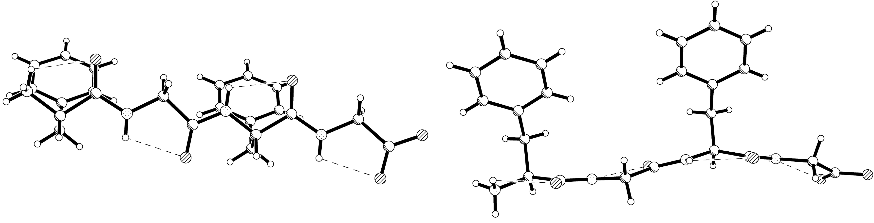
Experimental.
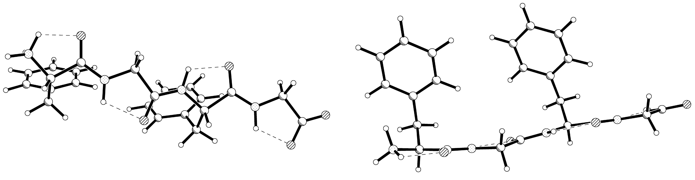
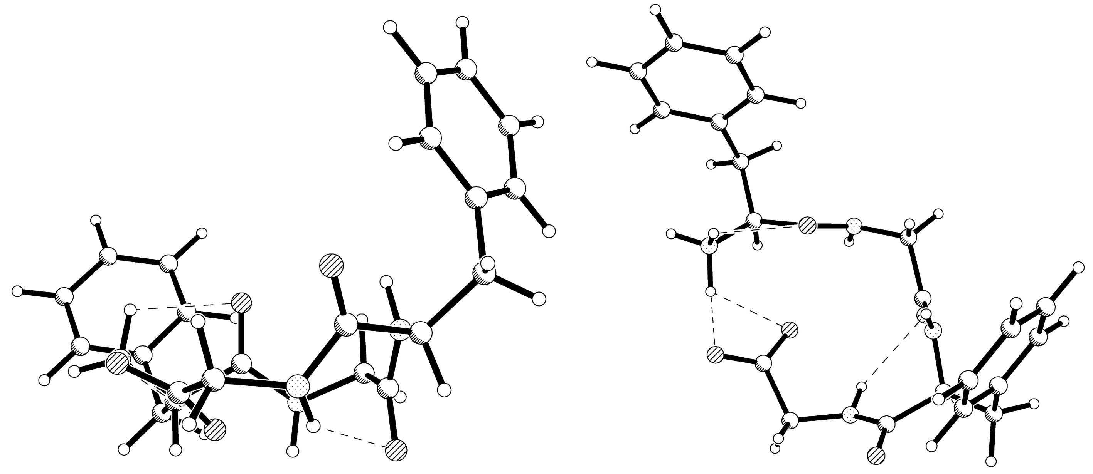
RE: RHF/6-31G(d) starting from the experimental structure.
RP: RHF/6-31G(d) starting from the PM3 structure.
Figure S2. Comparison of experimental and ab initio FGFG structures. The view to the left is onto the plane formed by O1, C1, N2 while the view to the right is perpendicular to this plane. Only N-H···O hydrogen bonds are indicated

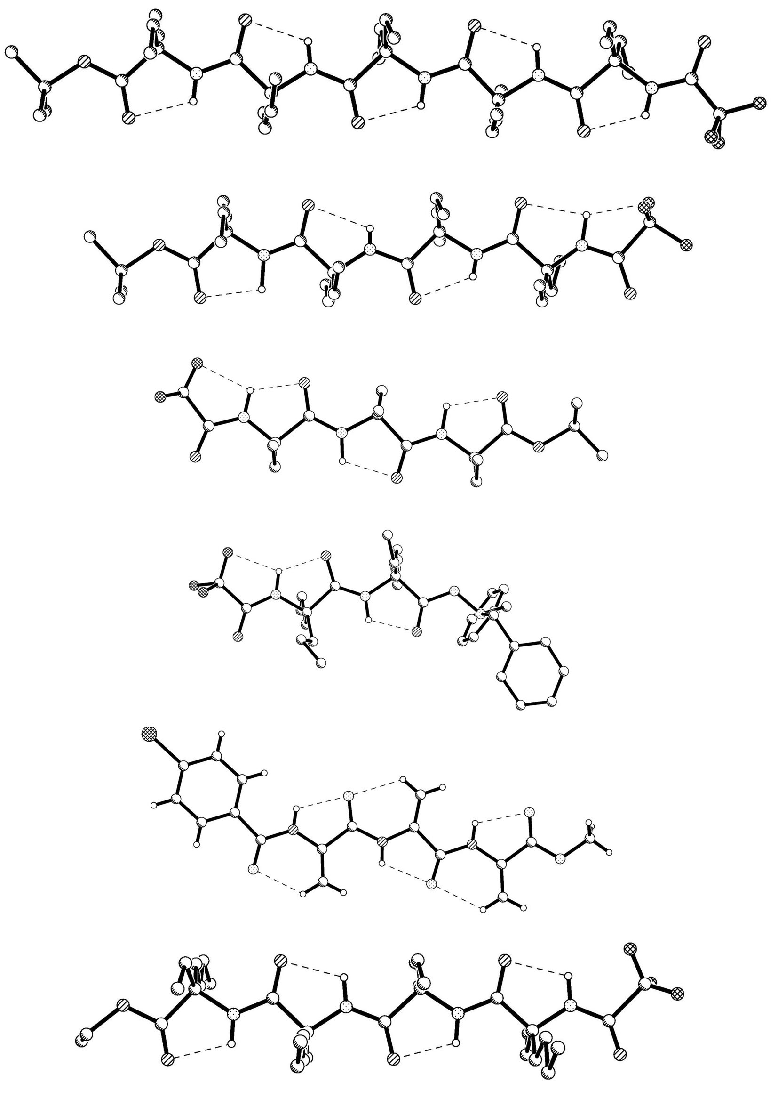
GIDLIO
Tfa-(Deg)₅-OtBu
Ref. [3]

GIDLEK
Tfa-(Deg)₄-OtBu
Ref. [3]

GIDLAG
Tfa-(Deg)₃-OtBu
Ref. [3]

CUGHIV
Tfa-(Dpg)₂-DBH
Ref. [2]

pBrBz-(ΔAla)₃-Ome
Ref. [1]

Tfa-((S)-Beg)₄-OEt
Ref. [4]

Figure S3 Fully extended peptides from the literature. Hydrogens have been left out for clarity except for pBrBz-(ΔAla)₃-Ome where they are involved in backbone hydrogen bonding. pBrBz-(ΔAla)-OMe and pBrBz-(ΔAla)₂-OMe have the same conformation and hydrogen bonding scheme as pBrBz-(ΔAla)₃-OMe. Abbreviations used: ΔAla = C^{α,β}-didehydroxyalanine, Dpg = α,α-di-n-propylglucine, Deg = C^{α,α}-diethylglucine, Beg =C^{α,α}-butylethylglycine, pBrBz = p-bromobenzoyl, OMe = methoxy, OEt = ethoxy, OtBu = t-butyloxo, Tfa = triflyoroacetamido, DBH = N',N'-dibenzylaceylhydrazido.

The optics consists of a vertically collimating Rh coated Si mirror followed by a double crystal Si(111) monochromator where the second crystal is sagitally bent for horizontal focussing. Finally the beam is vertically focussed by a second Rh coated Si mirror.
Calculating the measuring time according to the technical specifications of the MAR345 detector gives 2 h 3 min and 12 s for high and 43 min and 12 s for low. The total measuring time is thus about 2 h and 47min.
The total energies were E_{RE} = -1440.3300468 and E_{RP} = -1440.4244895 Hartree. 1 Hartree = 27.212 eV = 2.6255·10³ kJ mol⁻¹. 1 Debye = 3.33564·10⁻³⁰ C m.

