Supplementary information

- LC-MS analysis of BtrR
A: LC-TIC profile
B: LC-UV (280 nm) profile
C: Mass spectrum
D: Deconvoluted spectrum (minus the 1st Met: measured 50714.0+11.2, calculated 50702.8)

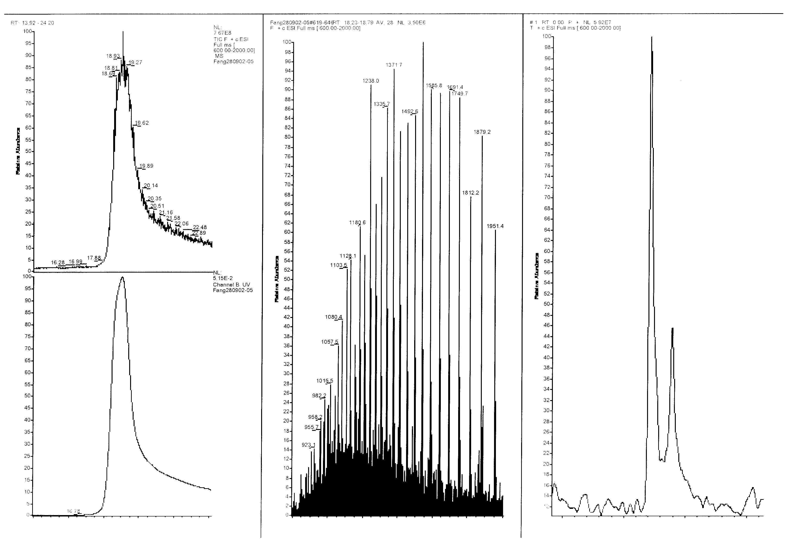
14 16 18 20 22 24
Time (min)
800 1000 1200 1400 1600 1800 2000
50000 50500 51000 51500
mass
m/z
50714.0

- TLC analysis of the BtrR-catalysed transamination (overnight incubation at 37º). A. Forward reactions. Amino donors used are indicated; C1: without enzyme; C2: without 2-deoxy-scyllo-inosose (2); C3: without amino donor; Std: 2-deoxy-scyllo-inosamine (3) standard. B. Reverse reactions. Amino acceptors used are indicated; C1: without enzyme; C2: without 2-deoxystreptamine (5); C3: without amino acceptor; Std: 3 and 5 standards.

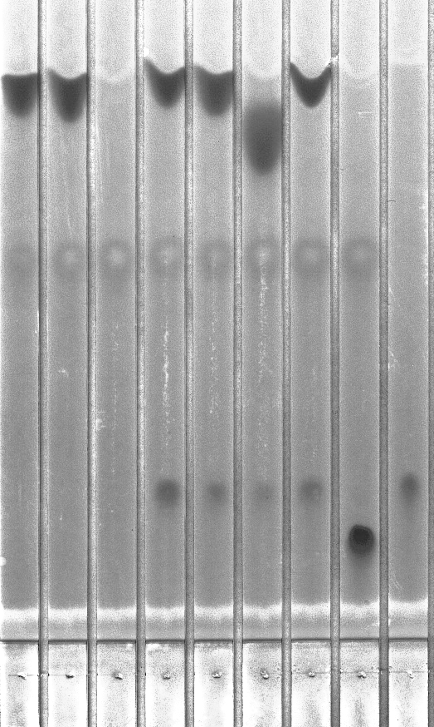
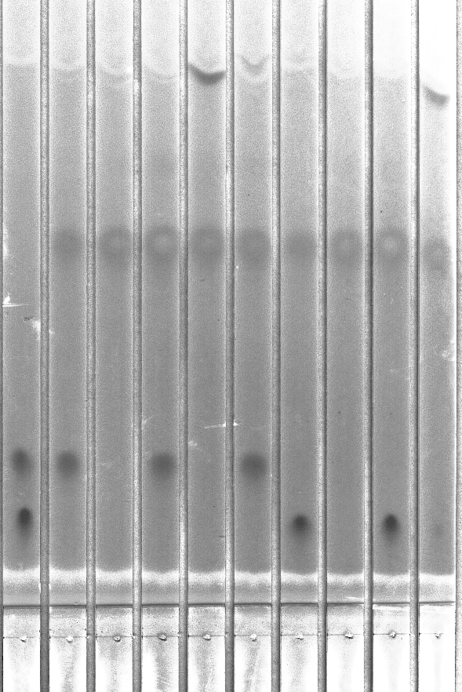
2
5
L-alanine
C1 C2 C3 Gln Ala Ser Glu Arg Std
2
Std C1 C2 C3 Pyr Std C1 C2 C3 Pyr
A
B

- ESI-Q-TOF MS Analysis of the Putative Product (2-deoxy-scyllo-inosamine, DOIA) from BtrR-Catalysed Forward Reaction. 164.1 [M+H⁺], 186.1 [M+Na⁺], 349.2 [2M+Na⁺]. A: synthetic DOIA standard; B: HPLC-purified product.

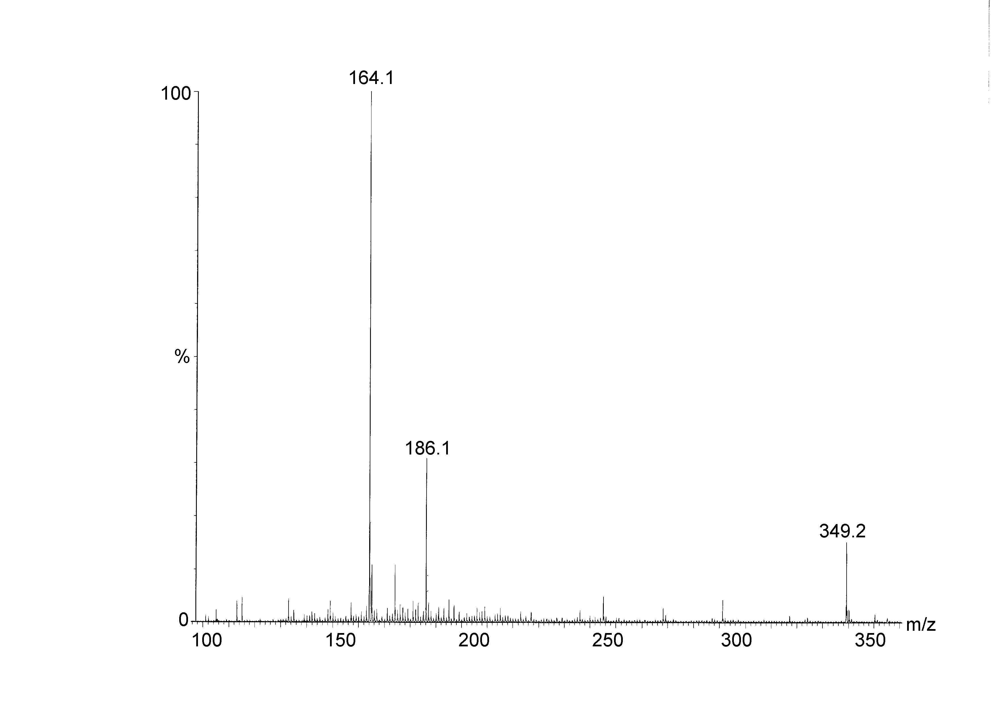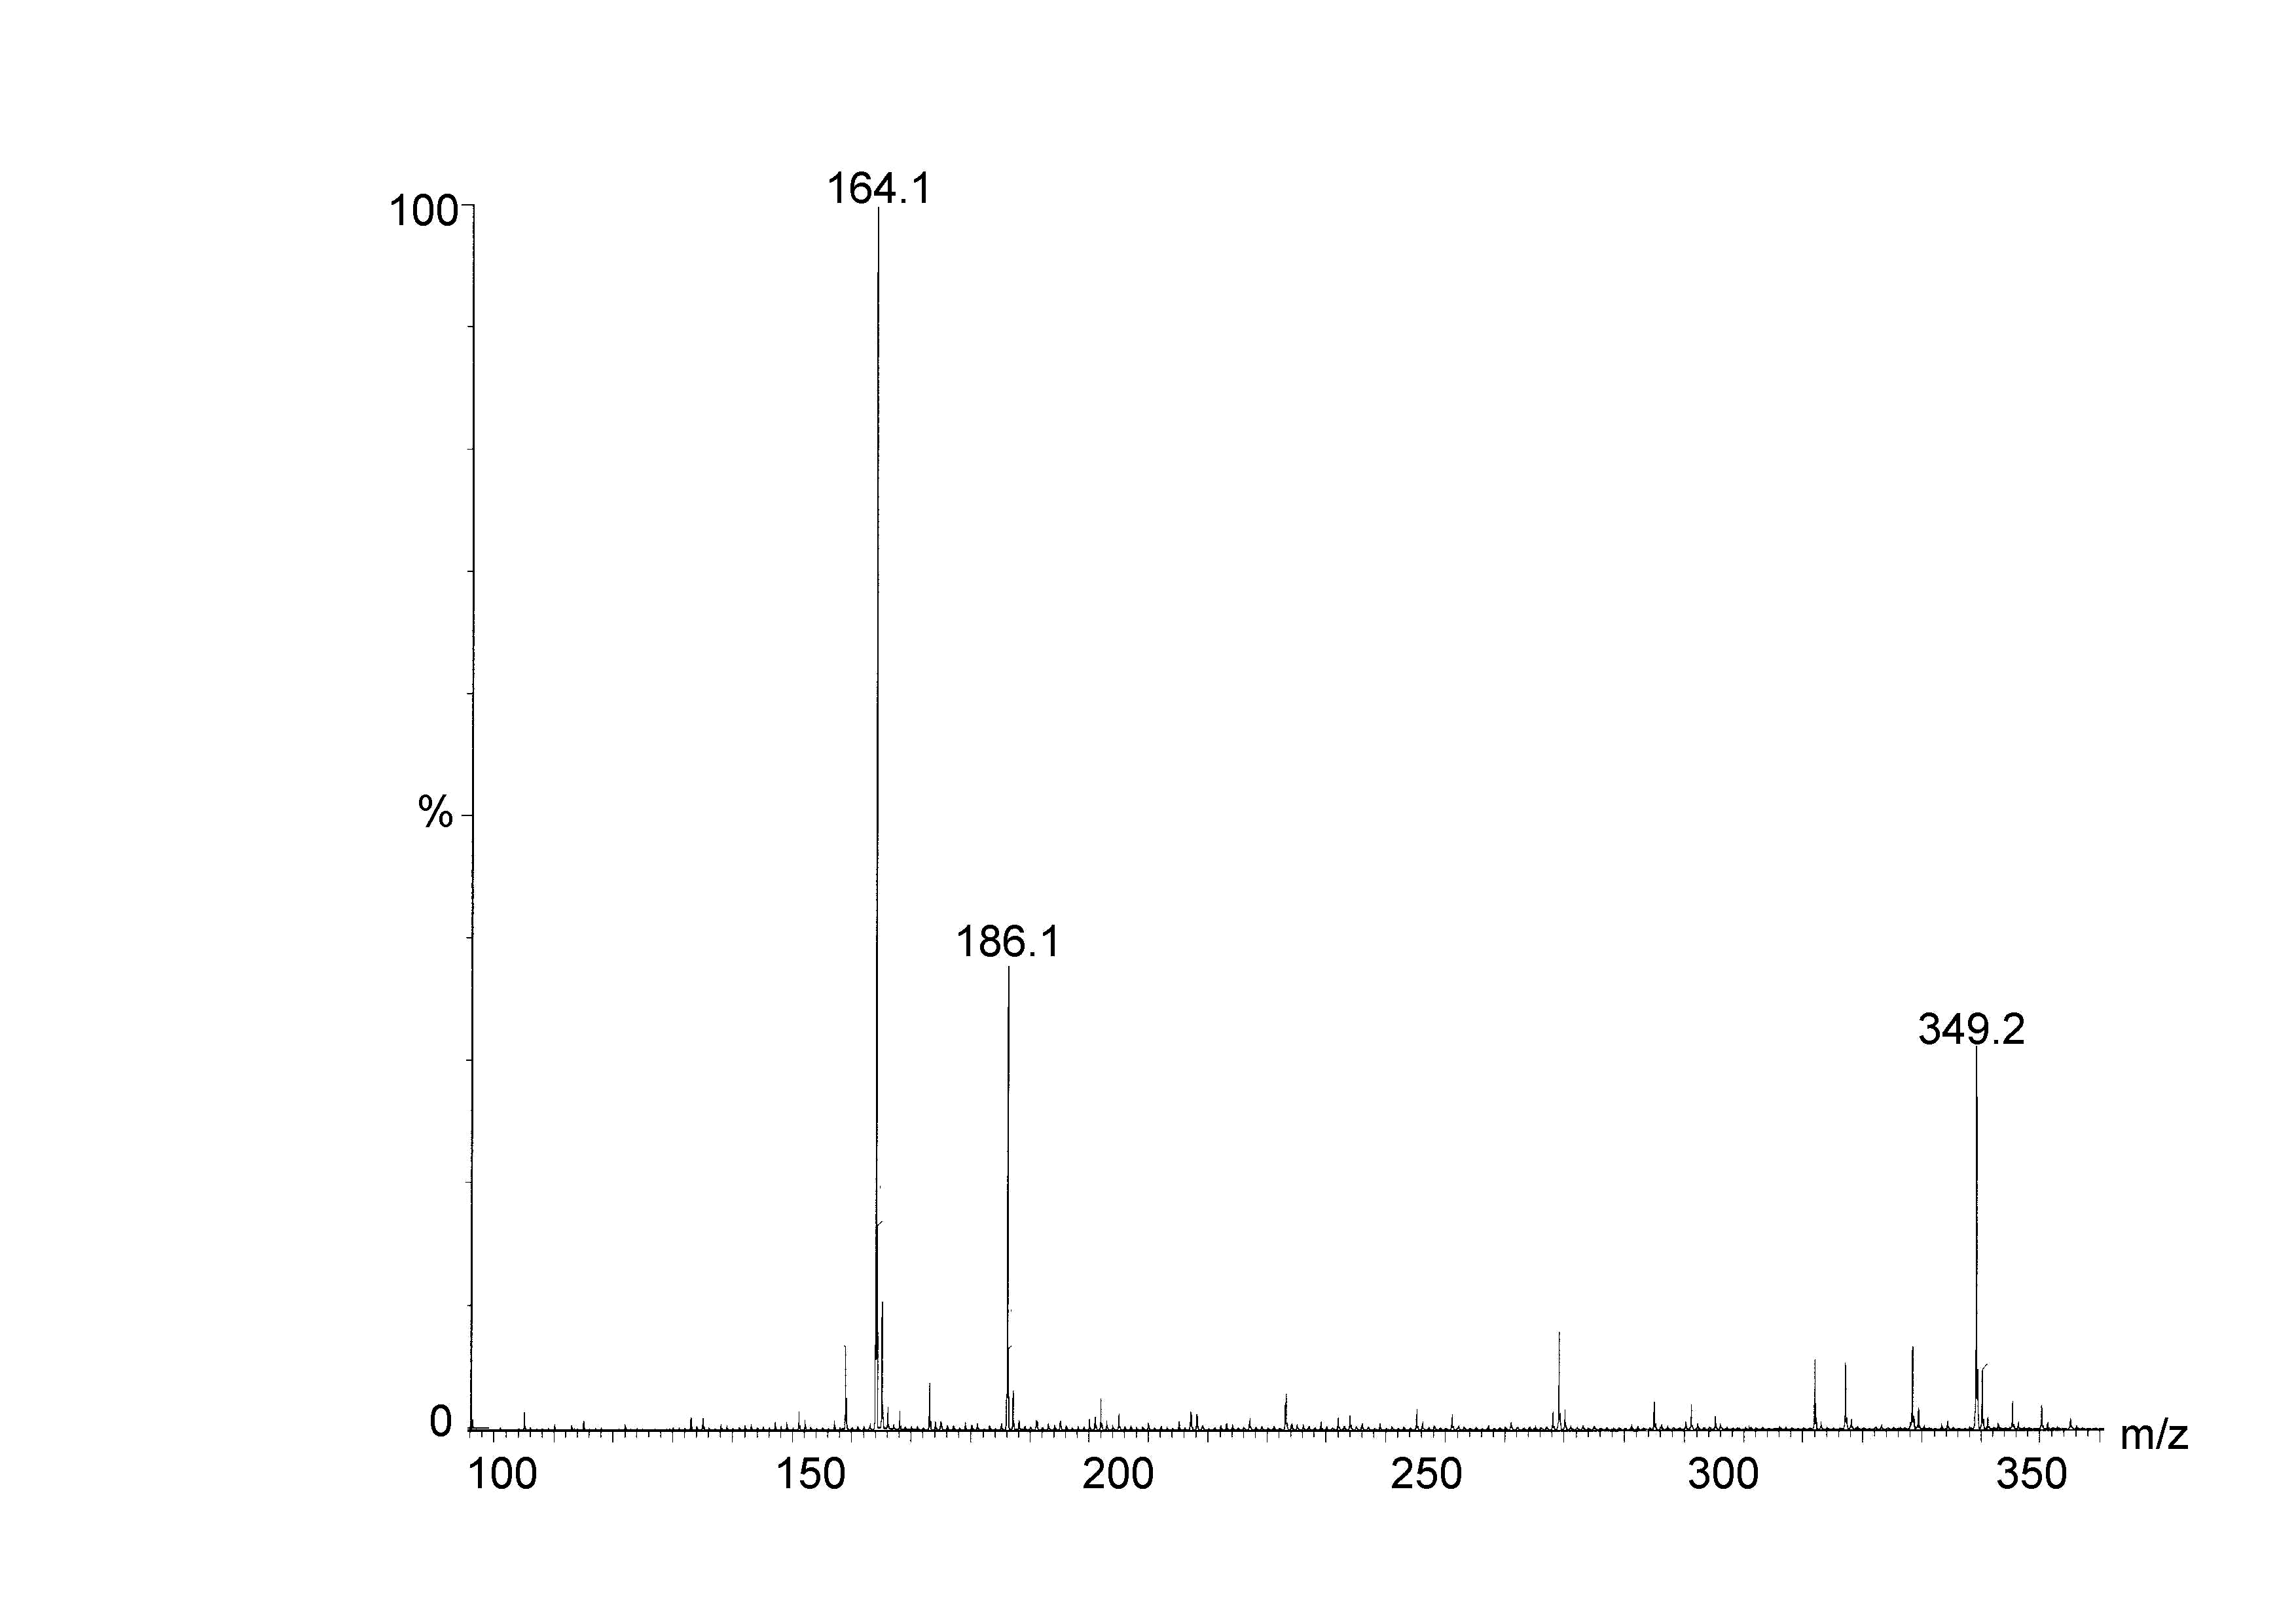
A
B

