Supplementary data

Figure S1. Fluorescence spectra of 6 (full line) and 1 (dashed line) in dichloromethane with matching absorption (OD_{665nm} = 0.05) at the excitation wavelength.

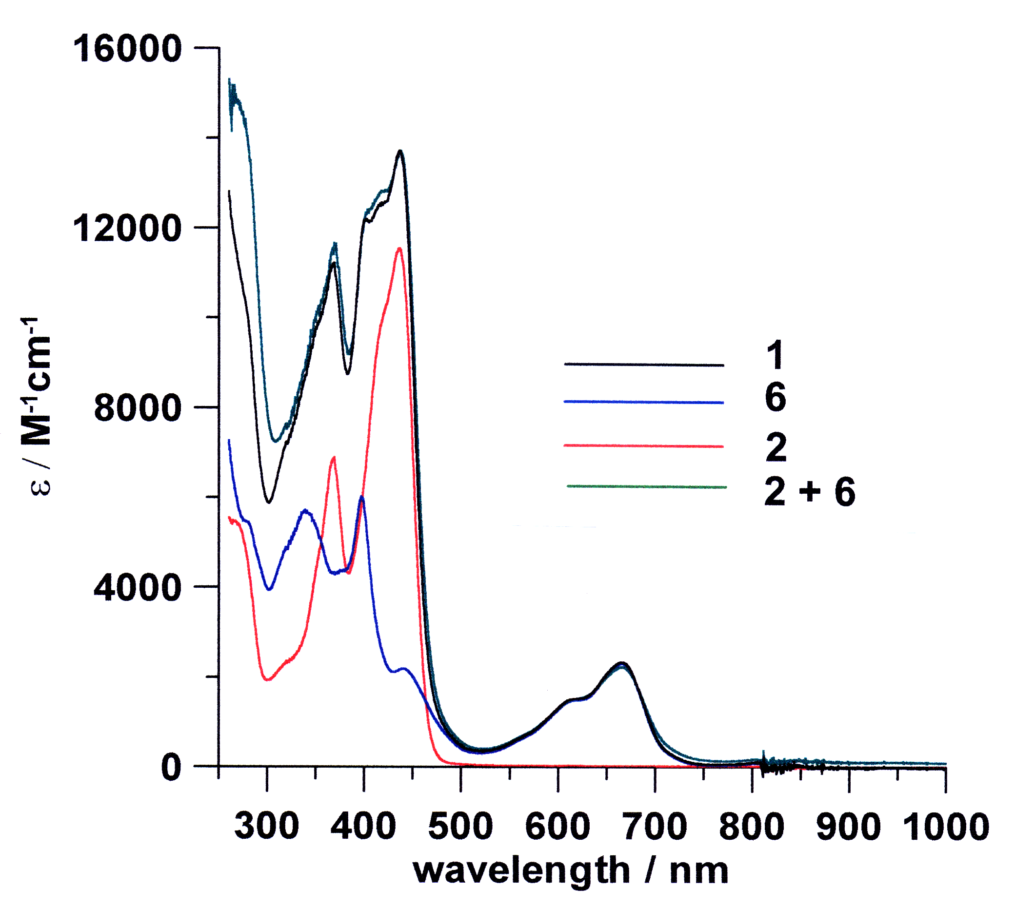

Figure S2. UV-visible absorption of compounds 6 (blue),
2 (red), 1 (black) and the sum of 2 and 6 (green). ε₃₃₇ for
2 is 2865 M⁻¹.cm⁻¹; ε₃₃₇ for 6 is 5652 M⁻¹.cm⁻¹ At 337nm,
2 absorbs 34 % of light energy whereas 6 absorbs 66 %.

