Supplementary data
The Reaction of "GaI" with a 1,3-Diyne: Synthesis, Characterisation and Reactivity of a Novel C-C Coupled Ene-diyne-bis(gem-organodigallium(III)) Complex

Robert J. Baker and Cameron Jones*

Supplementary Material

Synthesis of 2 and 3
GaI was synthesised by the ultrasonic activation of Ga (0.182 g, 2.61 mmol) and I₂ (0.331 g, 1.30 mmol) in toluene (10 cm³) for approx 2 hrs at 50 ºC. The resulting green suspension was cooled to –78 ºC and a solution of Me₃SiC≡CC≡CSiMe₃ (0.12 g, 0.62 mmol) in toluene (5 cm³) added. This was warmed to room temperature and stirred overnight to give a deep red solution and a precipitate of Ga metal. This was filtered, concentrated to ~ 5 cm³ and placed at –30 ºC overnight. The resulting colourless prisms of 2 were isolated and washed with cold hexane (2 x 2 cm³). (0.17 g, 33% based on deposition of 50% of Ga in the reaction). On several occasions small amounts (< 2%) of 3 were formed in the reaction and were manually separated from the bulk material. Data for 2 are included in the text. The isolated amounts of 3 were too small to obtain meaningful data.

Synthesis of 4
To a solution of 3 (0.102 g, 0.06 mmol) in toluene (10 cm³) at – 78ºC was added a solution of acetone (0.1 cm³) in toluene (5 cm³) also at –78°C. The resulting solution was allowed to warm to room temperature and stirred for 2 hrs. The solvent was removed in vacuo and the red residue extracted with toluene (2 x 10 cm³). Concentration and placement at -30°C yielded colourless prisms of 4 (0.097 g, 94%). Data for 4 are included in the text.
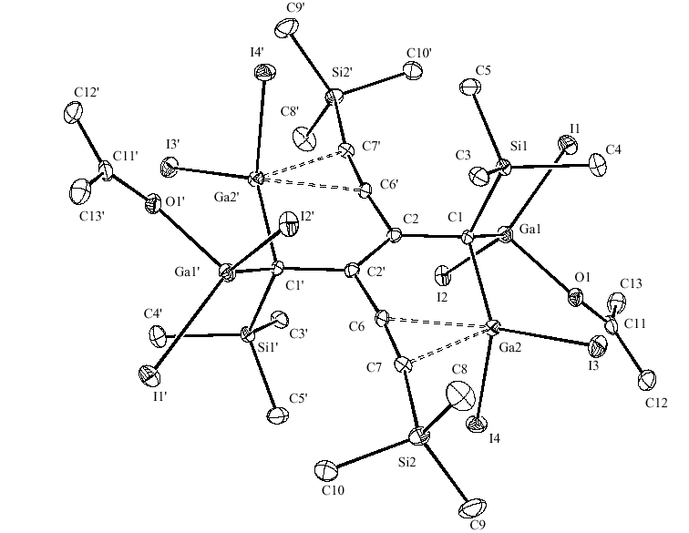
Molecular structure of 4. Selected bond lengths (Å) and angles(o): I(1)-Ga(1) 2.5442(17), I(2)-Ga(1) 2.5296(18), I(3)-Ga(2) 2.5247(16), I(4)-Ga(2) 2.5276(17), Ga(1)-C(1) 2.011(11), Ga(1)-O(1) 2.017(8), Ga(2)-C(1) 2.021(10), Ga(2)-C(6) 2.406(10), C(6)-C(7) 1.235(16), C(2)-C(2)' 1.35(2), C(1)-Ga(1)-O(1) 98.7(4), C(1)-Ga(1)-I(2) 118.4(3), O(1)-Ga(1)-I(2) 104.8(2), C(1)-Ga(1)-I(1) 123.6(3), O(1)-Ga(1)-I(1) 98.9(2), I(2)-Ga(1)-I(1) 107.83(6), C(1)-Ga(2)-C(6) 80.2(4), C(1)-Ga(2)-I(3) 120.6(3), C(6)-Ga(2)-I(3) 120.0(3), C(1)-Ga(2)-I(4) 121.1(3), C(6)-Ga(2)-I(4) 100.7(3), I(3)-Ga(2)-I(4) 109.58(6), Ga(1)-C(1)-Ga(2) 104.2(5).
'symmetry operation: -x+1, -y+1, -z+1

