Supplementary Material

Long rod-like array of bis(imidazolyl)porphyrinato cobalt(III) by successive complementary coordination

Chusaku Ikeda, Eiichi Fujiwara, Akiharu Satake, and Yoshiaki Kobuke*

General procedure.
¹H NMR spectra were recorded on either a JEOL JNM EX-270 or JEOL Lambda 600. MALDI-TOF mass spectra were obtained with Perseptive Biosystems Voyager DE-STR with dithranol (Aldrich) as a matrix. UV-vis spectra were obtained with a Shimadzu UV-3100PC spectrometer. Atomic force microscope image was obtained on a Nanoscope IIIa (Digital Instruments Co.) according to a tapping mode with a Si cantilever (spring constant of 40 N m⁻¹, tip curvature radius of 5-10 nm). Optical microscope images were obtained on a BX60 optical microscope system (Olympus Co.) equipped with Photal MCPD-7000 (Otsuka electronics Co.) for absorption measurement. Analytical gel permeation chromatograms were obtained on Shimadzu LC-workstation M10 equipped with SPD-M10 AVP photo diode array detector using a TSK GMH_{HR}-M column (TOSOH Co.).

Preparation of cobalt(III) porphyrins
5,15-bis(1-Methylimidazol-2-yl)-10,20-bis(heptadecyl)porphyrin
N-methylimidazol-2-carboxaldehyde (1.51 g, 13.7 mmol), finely grounded sodium chloride (0.4 g, 7 mmol) and meso-heptadecyldipyrromethane (5.54 g, 13.7 mmol) were added to 1.4 L of chloroform in a 2 L round bottom flask. After the solution was purged with N₂ for 5 min, TFA (1.58 mL, 20.5 mmol) was added via a syringe and the reaction mixture was stirred under dark for 6 hours. Then triethylamine (3.11 mL, 20.5 mmol) and p-chloranil (3.36 g, 13.7 mmol) was added and the crude mixture was stirred further for 6 hrs. The reaction mixture was evaporated with ca. 20 g of silica gel. The resulting black powder was placed on the top of dry silica gel column and eluted with CHCl₃ to CHCl₃/acetone (10:3). Further purification using silica gel column eluted with CHCl₃/acetone (10:3) gave the title compound (1.20g, 19%).
¹H-NMR (CDCl₃, 600MHz) δ 9.40, 8.66 (each m, 4H × 2, pyrrole-H_{β}), 7.66 (s, 2H, imidazole-H₄), 7.46(s, 2H, imidazole-H₅), 4.91(m, 4H, α-CH₂), 3.50, 3.48(each s, 6H, N-methyl), 2.52(m, 4H, β-CH₂), 1.78(quin, J = 7.2 Hz, 4H, γ-CH₂), 1.49(quin, J = 7.2 Hz, 4H, δ-CH₂), 1.34-1.24(m, 48H, alkyl-CH₂), 0.88(t, J = 7.2 Hz, 6H, -CH₃), -2.98(br, 2H, inner-NH). MS (MALDI-TOF): Found m/z = 948.44[M+H]⁺, calculated for C₆₂H₉₀N₈ 947.43
5-(1-Methylimidazol-2-yl)-10, 15, 20-tris(heptadecyl)porphyrin
N-methylimidazol-2-carboxaldehyde (0.75 g, 6.85 mmol), finely grounded sodium chloride (0.4 g, 7 mmol), meso-heptadecyldipyrromethane (5.54 g, 13.7 mmol), and heptadecanal (1.84 g, 6.85 mmol) were added to 1.4 L of chloroform in a 2 L round bottom flask. After the solution was purged with N₂ for 5 min, TFA (1.58 mL, 20.5 mmol) was added via a syringe and the reaction mixture was stirred under dark for 5 hours. Then triethylamine (3.11 mL, 20.5 mmol) and p-chloranil (3.36 g, 13.7 mmol) was added and the crude mixture was stirred further for 6 hrs. The reaction mixture was evaporated with ca. 20 g of silica gel. The resulting black powder was placed on the top of dry silica gel column and eluted with hexane/ethyl acetate (3/1). Recrystallization from CHCl₃/MeOH gave the title compound as purple powder (0.59g, 7.8 %).
¹H-NMR (CDCl₃, 600MHz) δ 9.55, 9.49, 9.41 and 8.72 (each d, J = 3.60 Hz, 2H × 4, pyrrole-H_{β}), 7.66 (s, 2H, imidazole-H₄), 7.46(s, 2H, imidazole-H₅), 5.01(t, J = 7.80 Hz, 2H, α-CH₂), 4.93(t, J = 7.80 Hz, 4H, α-CH₂), 3.39(s, 3H, N-Me), 2.54 and 2.49(each quin, 2H and 4H, respectively, β-CH₂, partially overlapped each other), 1.83 and 1.78(each quin, 2H and 4H, respectively, γ-CH₂, partially overlapped each other), 1.50(m, 6H, δ-CH₂), 1.34-1.25(m, 72H, alkyl-CH₂), 0.88(t, J = 7.2 Hz, 9H, -CH₃), -2.60(s, 2H, inner-NH). Mass (MALDI-TOF): Found m/z =1105.73 [M+H]⁺, calculated for C₇₅H₁₂₀N₆ 1104.96.

General procedure for metal insertion
To 20 mmol of free-base imidazolylporphyrin dissolved in 10 mL of chloroform was added 0.14 g (0.4 mol) of cobalt(II) salt (CoCl₂, Co(BF₄)₂·6H₂O, or Co(ClO₄) ₂·6H₂O for 1a and 2a, 1b and 2b, 1c and 2c, respectively) as a powder form. The reaction mixture was allowed to reflux for 1-3 days. The metal insertion was checked by monitoring the disappearance of the fluorescence from free-base porphyrin and also by Muldi-TOF mass spectroscopy. After cooled to room temperature, the reaction mixture was diluted with CHCl₃ and washed with an aqueous solution of appropriate acid (0.1 N HCl for 1a and 2a, 10% HClO₄ for 1b and 2b, 10% HBF₄ for 1c and 2c) then water. Organic layer was dried over Na₂SO₄ and concentrated to 2 mM, and then subjected to UV/vis spectral study and AFM observation. Cobalt(III) porphyrin with a ClO₄⁻ or BF₄⁻ counter ion could also be obtained from those with a Cl⁻ counter ion by washing with the aqueous solution of appropriate acid described above, or adding AgClO₄ or AgBF₄ to a THF solution of the Cl⁻ complex. However, we preferred the method to use Co(BF₄)₂·6H₂O or Co(ClO₄) ₂·6H₂O to avoid the contamination of any Cl⁻ ion.
1a
Mass (MALDI-TOF): Found m/z = 1163.79 [M-Cl⁻ + H]⁺, calculated for C₇₅H₁₁₈CoN₆ 1162.71.
UV-Vis(CHCl₃): λ_{max}: 404, 474, 565(after acceleration process)
1b
Mass (MALDI-TOF): Found m/z = 1063.74 [M-BF₄⁻ + H]⁺, calculated for C₇₅H₁₁₈CoN₆ 1162.71.
UV-Vis(CHCl₃): λ_{max}: 404, 474, 565(after acceleration process)
1c
Mass (MALDI-TOF): Found m/z = 1163.90 [M-ClO₄⁻ + H]⁺, calculated for C₇₅H₁₁₈CoN₆ 1162.71.
UV-Vis(CHCl₃): λ_{max}: 404, 474, 565(after acceleration process)
2a
¹H-NMR (CDCl₃, 600MHz) δ 9.96, 9.84, 9.08, 5.09(each br. s, 2H × 4, pyrrole-H_{β}), 5.24, 5.18(m, 6H, α-CH₂), 5.05(s, 1H, imidazole-H₅), 3.05(m, 2H, β-CH₂ at 15-meso), 2.95(m, 4H, β-CH₂ at 10- and 20-meso), 1.54(s, 3H, N-methyl), 1.76-1.24(m, alkyl-CH₂), 0.89(m, 9H, alkyl-CH₃), 0.09(s, 1H, imidazole-H₄).
UV-Vis(CHCl₃): λ_{max}: 440(br), 557
2b
¹H-NMR (CDCl₃, 600MHz) δ 10.12(d, J = 5.4 Hz, 2H, pyrrole-H_{β}), 10.01(d, J = 4.8 Hz, 2H, pyrrole-H_{β}), 9.27(d, J = 5.4 Hz, 2H, pyrrole-H_{β}), 5.29(m, 4H, α-CH₂ at 10- and 20-meso), 5.25(m, 2H, α-CH₂ at 15-meso), 5.10(d, J = 4.8 Hz, 2H, pyrrole-H_{β}), 5.05(s, 1H, imidazole-H₅), 3.04(m, 2H, β-CH₂ at 15-meso), 2.95(m, 4H, β-CH₂ at 10- and 20-meso), 1.54(s, 3H, N-methyl), 1.76-1.24(m, alkyl-CH₂), 0.89(m, 9H, alkyl-CH₃), 0.09(s, 1H, imidazole-H₄)
UV-Vis(CHCl₃): λ_{max}: 434(br), 550
2c
¹H-NMR (CDCl₃, 600MHz) δ 10.11(d, J = 5.3 Hz, 2H, pyrrole-H_{β}), 10.01(d, J = 4.6 Hz, 2H, pyrrole-H_{β}), 9.28(d, J = 5.3 Hz, 2H, pyrrole-H_{β}), 5.28(m, 4H, α-CH₂ at 10- and 20-meso), 5.14(m, 2H, α-CH₂ at 15-meso), 5.11(d, J = 4.6 Hz, 2H, pyrrole-H_{β}), 5.00(s, 1H, imidazole-H₅), 3.04(m, 2H, β-CH₂ at 15-meso), 2.91(m, 4H, β-CH₂ at 10- and 20-meso), 1.54(s, 3H, N-methyl), 1.76-1.24 (m, alkyl-CH₂), 0.89(m, 9H, alkyl-CH₃), 0.09(s, 1H, imidazole-H₄)
UV-Vis(CHCl₃): λ_{max}: 433.5(br), 550

Preparation of AFM sample
2 μL of chloroform solution of cobalt(III)porphyrin diluted to ca. 10⁻⁶ M (absorbance at 407 nm ≈ 1) was deposited onto freshly cleaved mica substrate and spin-coated (2000 rpm) immediately. The substrate obtained was dried under a stream of nitrogen and proceeded to AFM observation.

Spectroscopic properties of bis(imidazolyl)porphyrinato cobalt(III)

Time dependent absorption spectra
Figure S1 Time dependent spectral change of cobalt(III)bis(imidazolyl)porphyrins 1a-1c. Spectra were obtained by diluting a stock solution (2 mM, CHCl₃) to ca. 10 μM (dilution did not affect the spectral pattern). t = 0 denotes the time when work-up process was completed and concentrated the solution to ca. 2mM (see the experimental section).

Fig. S1 shows a time dependent spectral change of cobalt(III) bis(imidazolyl)porphyrins 1a-1c. For all species, peak intensities around at 404 and 474 nm’s gradually became larger upon standing. The peaks around at 404 and 474 nm’s are assumed to result from a large number of exciton interactions in polymer assembly, and the peak around at 440 nm observed for 1b and 1c can be ascribed to the residual dimer (or small oligomers) peak because the reference dimer showed a broad Soret peak at 437 nm. From these considerations, these spectral change upon standing indicates gradual elongation of the polymer assembly and the elongation rate judging from these spectra was in the order of 1c > 1b > 1a.

Accelerating the propagation

Figure S2 Absorption spectra of 1a in a chloroform solution before (a) and after (b) “acceleration- process” , which employes evaporation from tetrachloroethane-methanol(100/1 v/v) at 70ºC under reduced pressure.

As can be seen from Figure S2, we found that simple evaporation from a tetrachloroethane-methanol solvent at 70 ºC was effective to accelerate the propagation of the cobalt polymer. Combination of small amount of methanol and a non-coordinating solvent with a boiling point higher than that of methanol and evaporation at relatively high temperature (70ºC) under reduced pressure were crucial for the successful elongation of the organized structure. Addition of methanol may be effective to separate an axially-coordinated counter ion (such as Cl⁻) from cobalt and may facilitate the axial coordination of imidazole as the 6th ligand. Higher temperature may facilitate the atropisomerization of the imidazole group because cis atropisomer that has two methyl groups of imidazole ring at the same side of the porphyrin plane cannot afford oligomers higher than dimer. Evaporation may also facilitate the propagation by increasing the concentration. After the acceleration process, 1a-1c showed nearly the same spectral pattern suggesting that the polymer backbone itself was same by the choice of counter ions. Reproducibility could be obtained except small deviations of the λmax for the red-shifted Soret peak (470-475 nm), but residual dimer or small oligomer was sometime observed as a small shoulder between split Soret peaks (for example, see the absorption spectrum before GPC analysis in Figure S3).

GPC analysis of the polymer
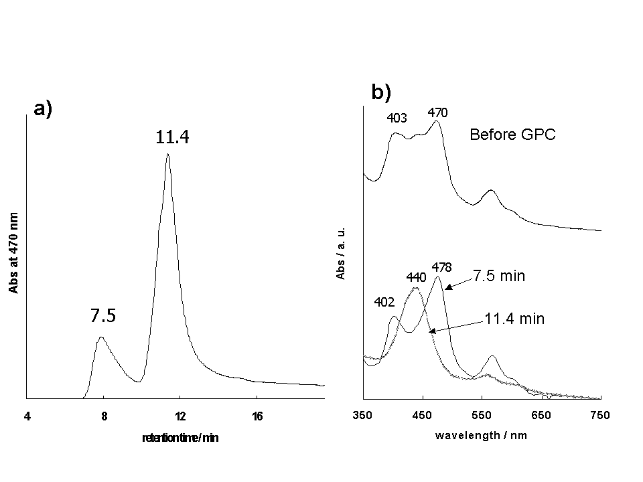
Figure S3 a) GPC chromatogram of 1a and b) absorption spectra of the sample before GPC analysis and those recorded at 7.5 and 11.4 min during the analysis. Condition: column, TOSOH GM_{HHR}-M(exclusion limit 4 ×10⁶ for polystyrene); eluent, chloroform / methanol = 98/2 v/v, 30 mM LiBr)

Since the backbone polymer consists of cationic cobalt (III) species, it is adsorbed on partially anionic GPC gel. In order to prevent the adsorption, LiBr salt was added to the eluent. As can be seen from the typical chromatogram in Figure S3a, two peaks were observed. The peak at shorter elution time started from 7.1 min and showed the peak maximum at 7.5 min. The absorption spectrum recorded at 7.5 min showed the Soret peak with a large splitting (402 and 478 nm). It confirms that the split of Soret band originates from exciton coupling among porphyrins in the complementarily coordinated polymer and not from the existence of two different porphyrin species. On the other hand, the latter peak at 11.4 min showed only a broad Soret peak at 440 nm. Since reference dimers 2a-c appeared at 11.4 min as a sharp peak, the observed peak at 11.2 min was ascribed to dimer species dissociated from polymer. Though the absorption spectrum before GPC analysis showed polymer as dominant species, the peak ratio at 7.5/11.4 min showed that the most of the polymer species were dissociated during the GPC analysis by the presence of weakly coordinating methanol and/or Br⁻ ion in the eluent.
Though accurate determination of the molecular weight of polymer was impossible due to dissociation behaviour, a rough estimation of the molecular weight of polymer was carried out as shown in Figure S4.
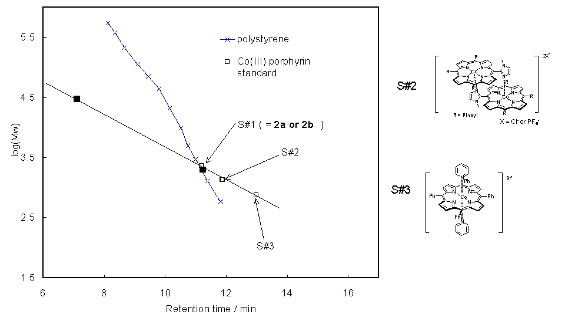
Figure S4 Calibration curves for the GPC column used in Figure S3. Open squares correspond to cobalt porphyrin standards and filled squares to observed ones in Figure S3. The filled square at 11.4 min was calculated as the dimer and the molecular weight of the filled square at 7.5 min was fitted on the line extrapolated from the porphyrin standards.
Molecular weights of the cobalt porphyrins in Figure S4 were calculated without counter ion because no differences were observed between the same compound with different counter ions (for example, 2a and 2b).¹ If the calibration curve obtained from the reference cobalt(III) dimers and monomer is extrapolated,² the molecular weight of the compound at 7.1 min corresponded to 30,000 dalton, i.e., porphyrin polymer constructed from 30 porphyrin units. However, the actual molecular weight is most likely larger than this approximation considering the dissociation behavior of the polymer and the fact that the retention time 7.1 min reaches almost the exclusion limit of this system.³

Reference for supporting information
- Dissociation of the counter ion in methanolic solvent was also reported. See: H. Sugimoto, N, Ueda, and M. Mori, Bull. Chem. Soc. Jpn., 1981, 54, 3425.
- Dissociation of the cobalt dimer species (2a, 2b, and S#2) could be neglected because the ¹H NMR study in methanol-d₄ did not show any dissociation.
- Exact retention time of exclusion limit for this column could not be determined because no polystyrene standard of molecular weight larger than reported exclusion limit (4 × 10⁶ dalton) could be available. However, the analysis using other column with same column volume but with lower exclusion limit showed the exclusion limit around at 7.0 min. For example, polystyrene standard of molecular weight 44,000 appeared at 7.1 min for the column (TOSOH G2500_{HHR}) with reported exclusion limit 20,000 for polystyrene under the same condition.

