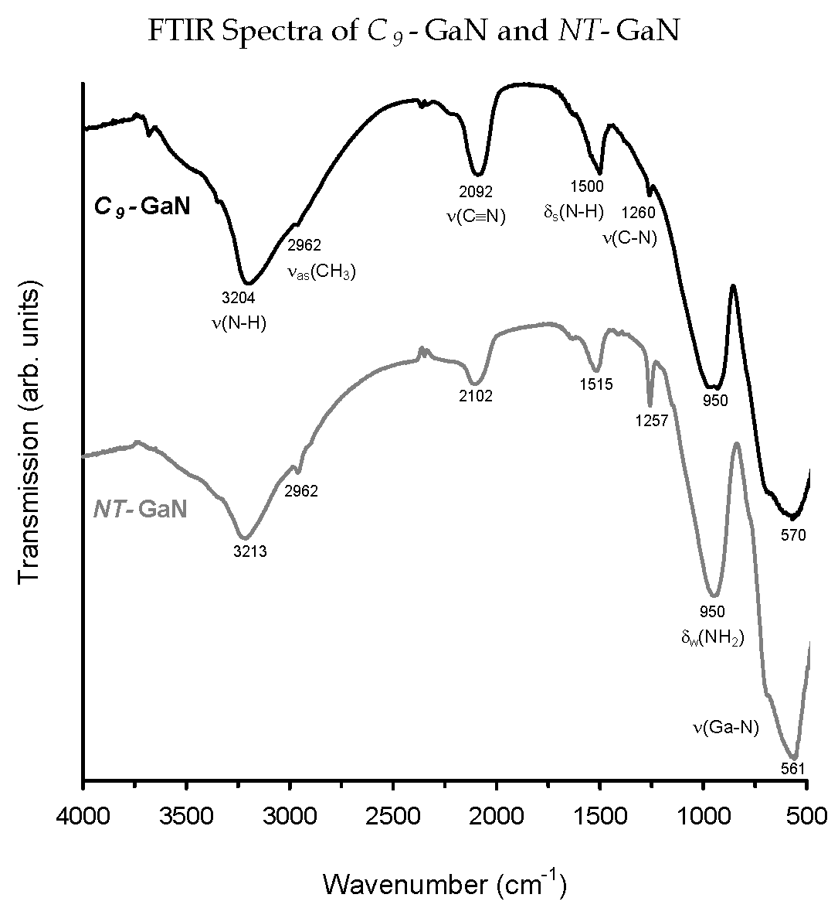

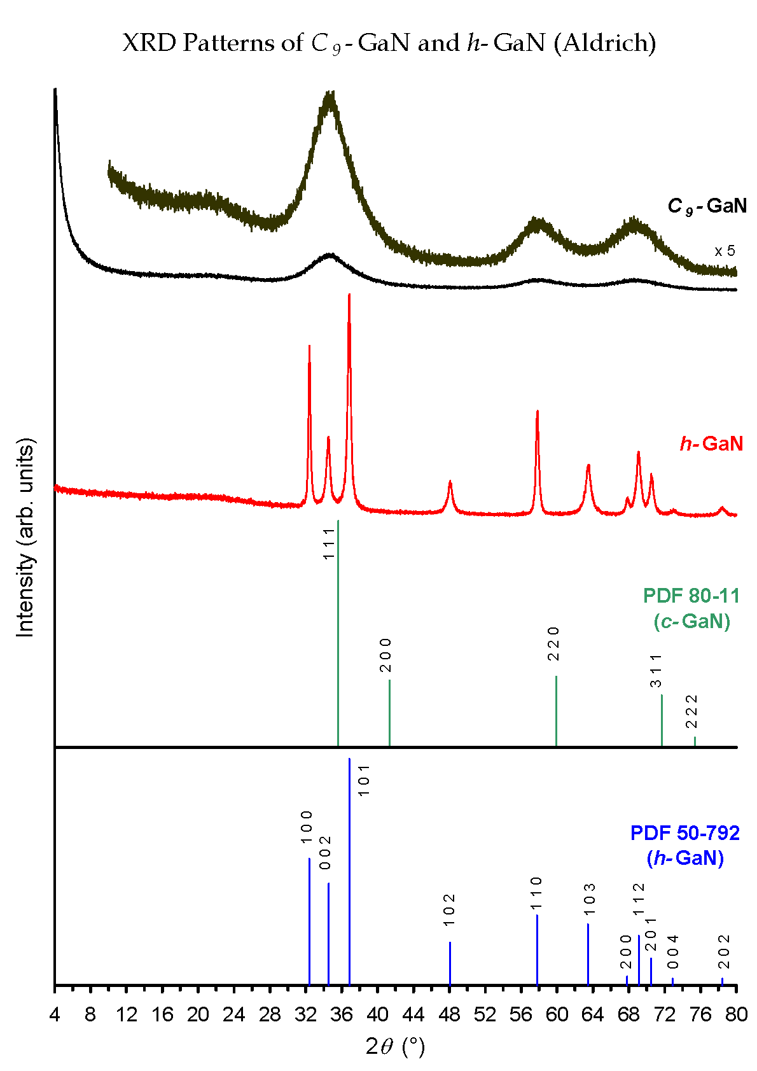

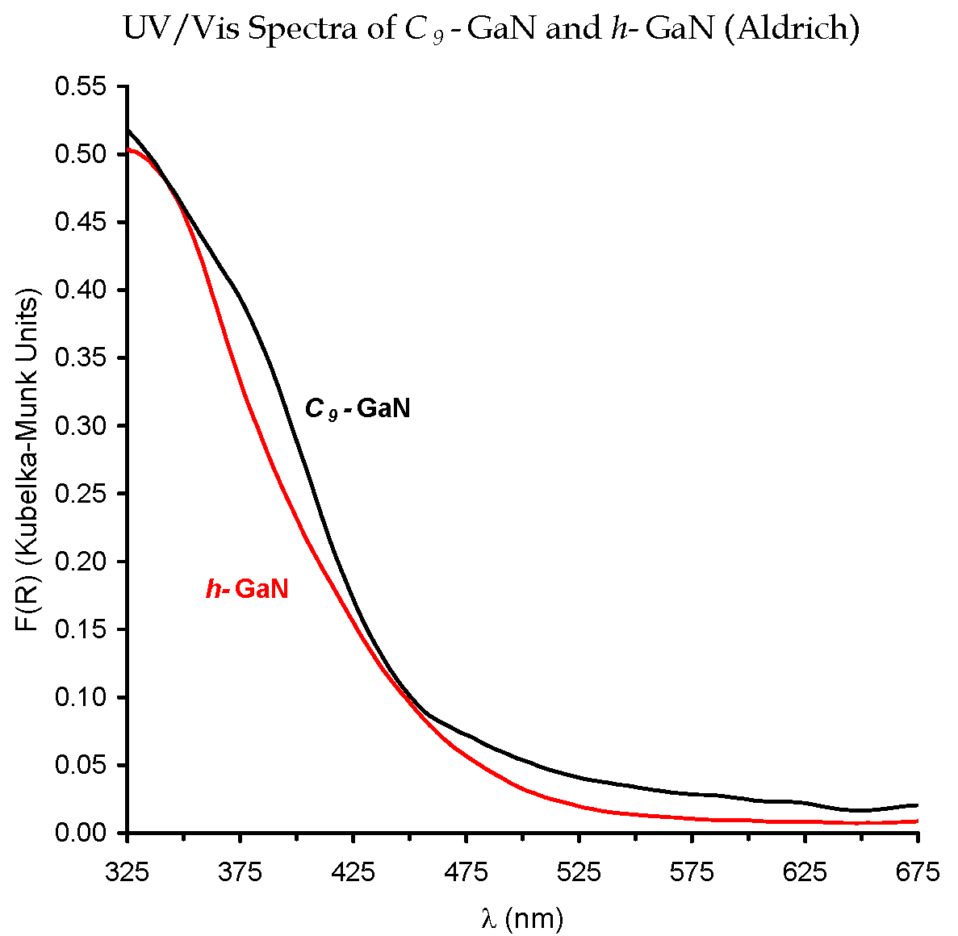

Experimental details

All manipulations were carried out under argon using a vacuum line or a glove box (O₂ < 1 ppm; H₂O < 1 ppm) and dried solvents. Nonylamine (97%, Fluka) was dried with sodium and distilled. Ga₂(NMe₂)₆ was prepared from LiNMe₂ (95%, Aldrich) and GaCl₃ (99.99%, Aldrich) and purified by recrystallization.^{30,31} For the synthesis of C₉-GaN, 1.414 g (3.5 mmol) of Ga₂(NMe₂)₆ and 16.05 g (112 mmol) of nonylamine were dissolved in 140 ml of toluene. The mixture was heated to 70 °C and purged with gaseous ammonia (4 l/h, UHP, Messer) for 2 h to give a turbid gel. After filtration, washing with hot toluene (300 ml, 343 K), and drying for 5 h (10⁻³ mbar, 293 K), the resulting white powder was suspended in 250 ml of toluene and refluxed for 18 h. After filtration and drying for 5 h (10⁻³ mbar, 293 K), 450 mg of the white powder were loaded in a quartz tube reactor supported by a quartz frit and heated subsequently to 423 K (5 K/min), 673 K (0.5 K/min) and annealed at that temperature for 3 h. Elemental Analysis: Ga 78.83%, N 18.19%, C 0.61%, H 1.34%.
For nitrogen physisorption measurements a micromeritics 2000 instrument was used. The TEM sample was prepared in a glove box using a Gatan (type 647) vacuum transfer sample holder.

