SUPPLEMENTARY DATA
A novel porous 3D network [Cu₂(glutarate)₄(4,4’-bipyridine)]·3H₂O: Single-crystal-to-single-crystal reversible dehydration

Beth Rather and Michael J. Zaworotko *
Department of Chemistry, University of South Florida, 4202 E Fowler Ave (SCA 400), Tampa, FL, 33620, USA.

Materials and Methods

Thermogravimetric analysis was performed under nitrogen (except for the rehydration of 1a powder and crystals) on TA Instruments TGA 2950 Hi-Res. XRPD data were recorded on a Rigaku RU15 diffractometer at 30kV, 15mA for Cu_{Kα} (λ = 1.5418 Å), with a scan speed of 1°/min and a step size of 0.02° in 2θ at room temperature. The simulated XRPD patterns were produced using Powder Cell for Windows Version 2.3. For guest readsorption experiments, the concentration changes were measured by GC using toluene as the internal standard. The data were fitted to the equation previously published by K. S. Min and M. P. Suh, Chem. Eur. J., 2001, 7, 303.

Table of contents
Figure S1. Conformational analysis of crystal structures containing the glutarate fragment and metals.

Figure S2. FT-IR spectra of 1a and 1b.
Figure S3. FT-IR spectra of compound 1b let in atmosphere for 55min (from t = 0 to t = 55min top to bottom).
Figure S4. FT-IR spectra of compound 1b let in MeOH (HPLC grade H2O = 0.009%) for 1 night.
Figure S5. FT-IR spectra of 2a, 2b and 2c.
Figure S6. FT-IR spectra of 2a let in atmosphere for 45min (t=0 to t=45min from top to bottom)
Figure S7. X-ray powder diffraction patterns of 1a (a) fresh sample, (b) calculated from the single crystal structure.
Figure S8. X-ray powder diffraction patterns of 1b (a) sample heated to 150ºC, (b) calculated from the single crystal structure.
Figure S9. X-ray powder diffraction patterns of 2a (a) fresh sample, (b) calculated from the single crystal structure.
Figure S10. X-ray powder diffraction patterns of (a) blue powder formed during the synthesis of 1a and (b) simulation from the structure of [Co(4,4’-bipyridine)_{1.5}(NO₃)₂]_{n} (CSD code REJVUX).
Figure S11. X-ray powder diffraction patterns of (a) blue crystals formed during the synthesis of 2a and (b) simulation from the structure of bilayer [Co(4,4’-bipyridine)_{1.5}(NO₃)₂]_{n} (CSD code NAMSEZ).
Figure S12. TGA trace of 1a.
Figure S13. TGA traces of 1a (a) and 1b let in atmosphere for <1hour (b).
Figure S14. TGA traces of the rehydration of 1b powder (a) and 1b crystals (b) under ambient atmosphere.
Figure S15. TGA traces of 2a, 2b and 2c.
Figure S16. Inclusion of apohost solid 1b with various guests from GC experiments.

CSD Refcode | Torsion Angles |  |  |  | Conformation
CSD Refcode | C1-C4 | C2-C5 | O1-C3 | O5-C3 | Conformation
MIYMOW | 65 | 75 | 17.5 | 43.5 | Gauche-Gauche
ZADJUJ | 69 | 70 | 32 | 82.5 | Gauche-Gauche
MEZSALa | 69 | 69 | 4.5 | 4.5 | Gauche-Gauche
XATNIPa | 69.5 | 69.5 | 4 | 4 | Gauche-Gauche
TODNAB | 70 | 77 | 20 | 7 | Gauche-Gauche
QANKOF | 43 | 180 | 95 | 35 | Gauche-Anti
VIRYUQ | 46 | 172 | 66.5 | 85.4 | Gauche-Anti
GLUECU | 59 | 170 | 77.6 | 31.5 | Gauche-Anti
QIVHAE | 62 | 165 | 6 | 77 | Gauche-Anti
MASXINa | 62 | 180 | 23 | 70.5 | Gauche-Anti
ACBRUA | 65 | 178 | 26.5 | 87.5 | Gauche-Anti
GLTECU | 68 | 177 | 19.5 | 27 | Gauche-Anti
SIFWEJ | 68 | 177 | 43.5 | 54 | Gauche-Anti
SUJXEA | 68 | 178 | 21.5 | 48 | Gauche-Anti
HOTGOM | 71 | 170 | 0.8 | 75 | Gauche-Anti
QIWKEM | 71 | 179 | 8 | 49 | Gauche-Anti
TODNEF | 74 | 172 | 6.5 | 49.5 | Gauche-Anti
QANKIZ disordered | 60-66 | 150-163 | 3-9 | 30-77 | Gauche-Anti
OCENUF | 166 | 179 | 51 | 34.5 | Anti-Anti
MASXINb | 169 | 174 | 17 | 21 | Anti-Anti
XEDCUE | 169 | 176 | 88 | 88 | Anti-Anti
QIVGUX | 172 | 172 | 7 | 7 | Anti-Anti
TEGMIB | 172 | 173 | 10 | 15.5 | Anti-Anti
VIRZAX | 173 | 173 | 34.5 | 95 | Anti-Anti
CDGLTR | 173 | 175 | 4.8 | 0.35 | Anti-Anti
MIYMUC | 175 | 176 | 0.5 | 32 | Anti-Anti
FUMCUL | 177 | 180 | 3.2 | 0.3 | Anti-Anti
HOTHAZ | 179 | 179 | 11 | 8 | Anti-Anti
XATNIPb | 179 | 179 | 10 | 10 | Anti-Anti
MEZSALb | 180 | 180 | 10 | 10 | Anti-Anti
BOMXOQ | no structure

Figure S1. Conformational analysis of crystal structures containing the glutarate fragment and metals.

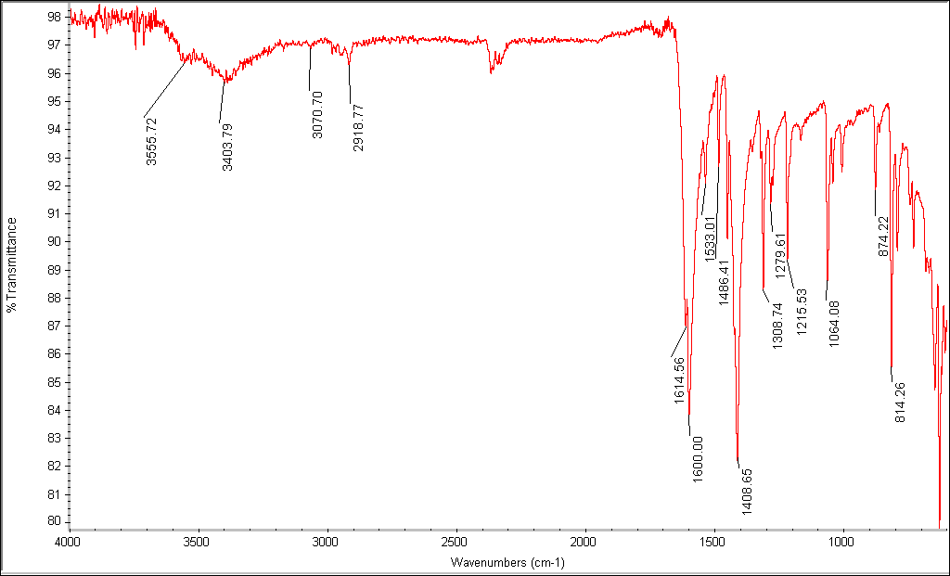
Compound 1a

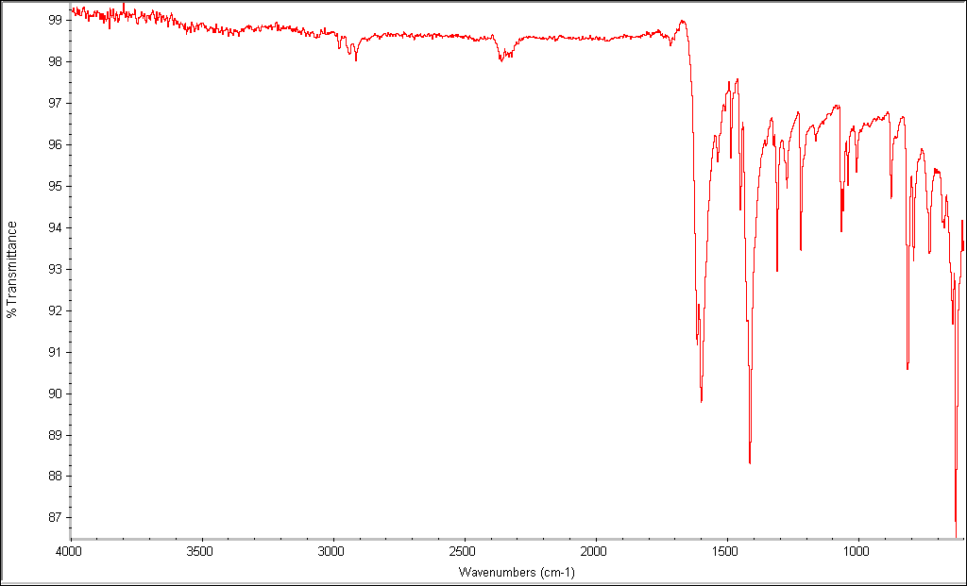
Compound 1b

Figure S2. FT-IR spectra of 1a and 1b.

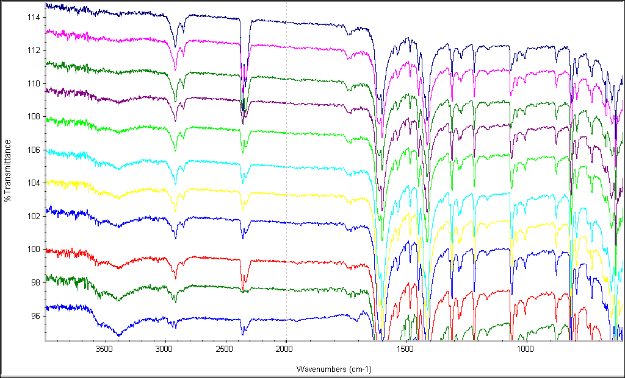

Figure S3. FT-IR spectra of compound 1b let in atmosphere for 55min (from t = 0 to t = 55min top to bottom).

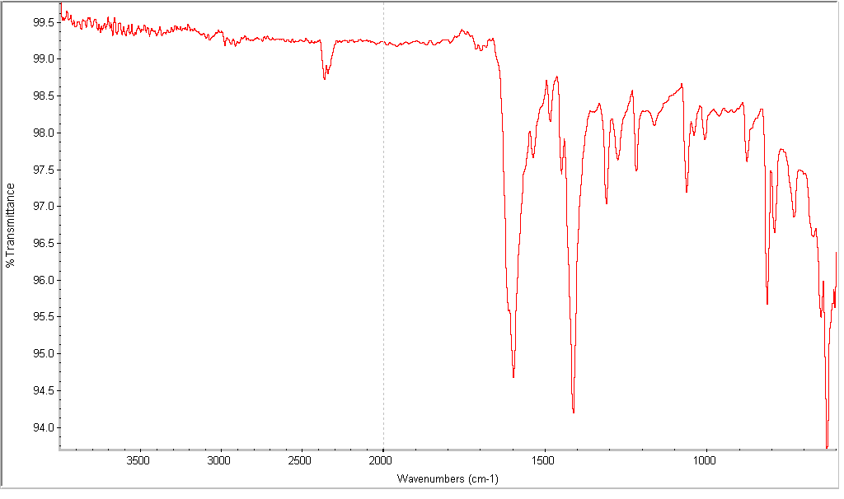

Figure S4. FT-IR spectra of compound 1b let in MeOH (HPLC grade H2O = 0.009%) for 1 night.

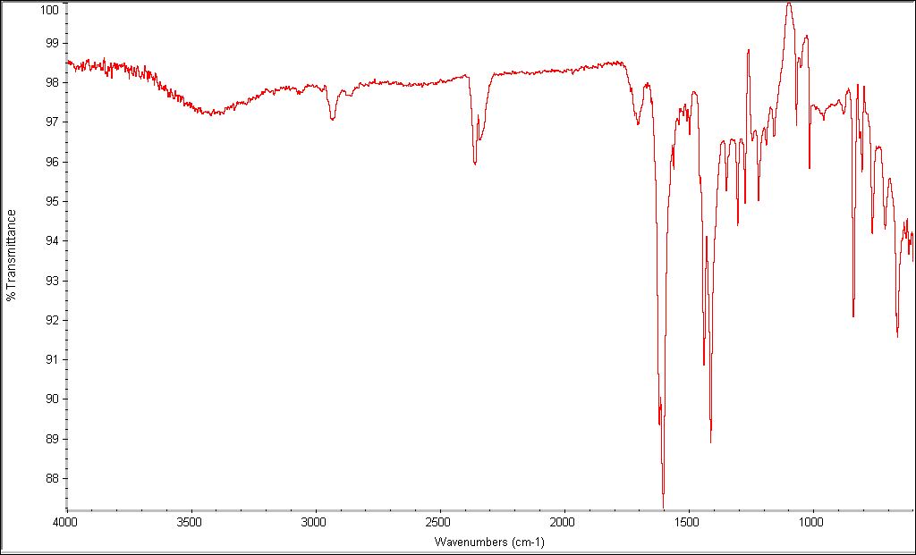
Compound 2a

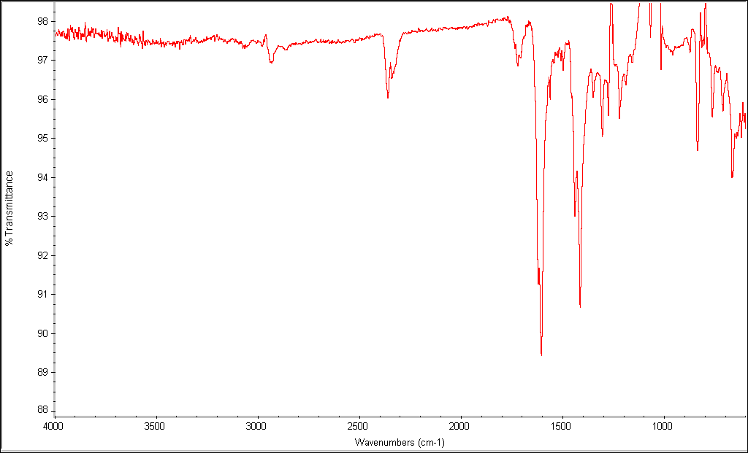
Compound 2b

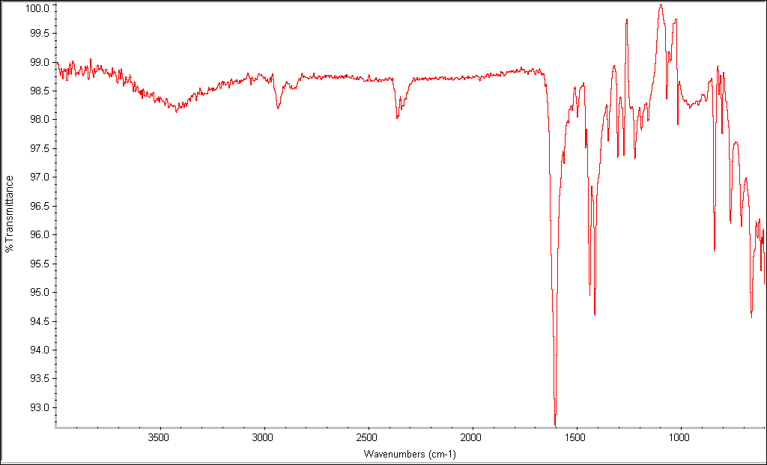
Compound 2c

Figure S5. FT-IR spectra of 2a, 2b and 2c.

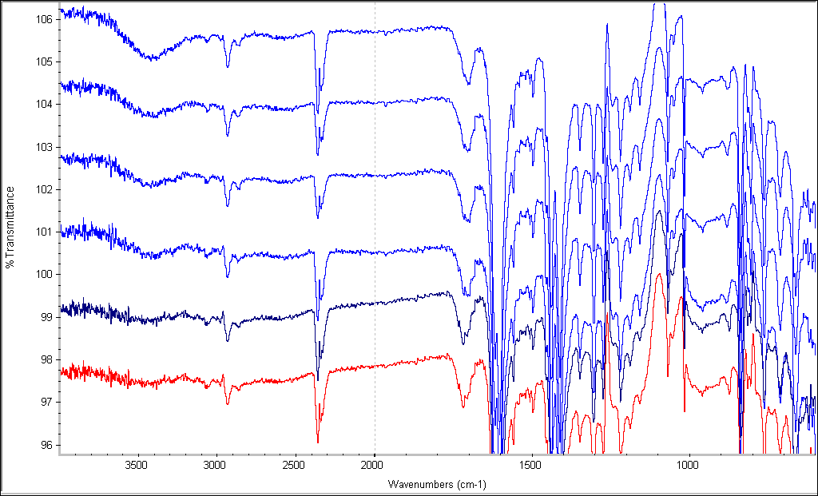

Figure S6. FT-IR spectra of 2a let in atmosphere for 45min (t=0 to t=45min from top to bottom)

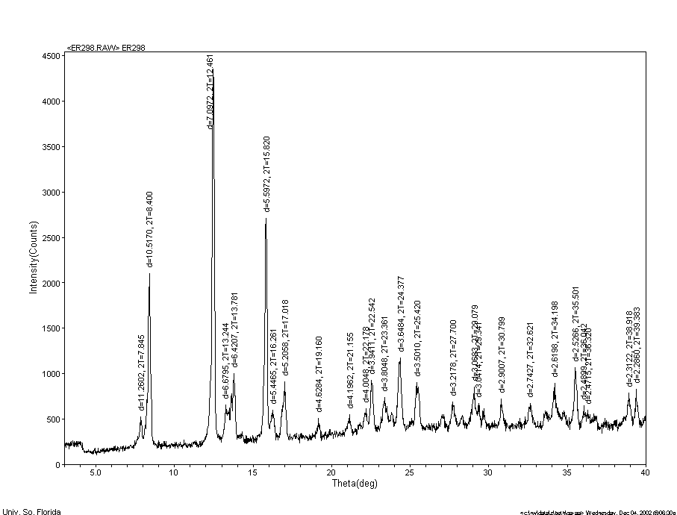

a
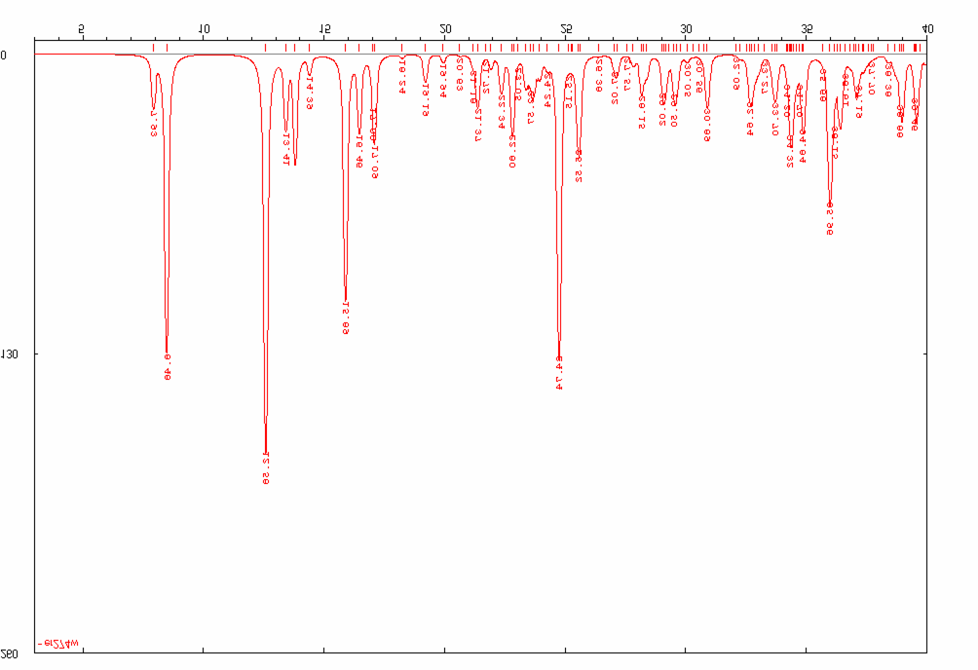

b

Figure S7. X-ray powder diffraction patterns of 1a (a) fresh sample, (b) calculated from the single crystal structure.

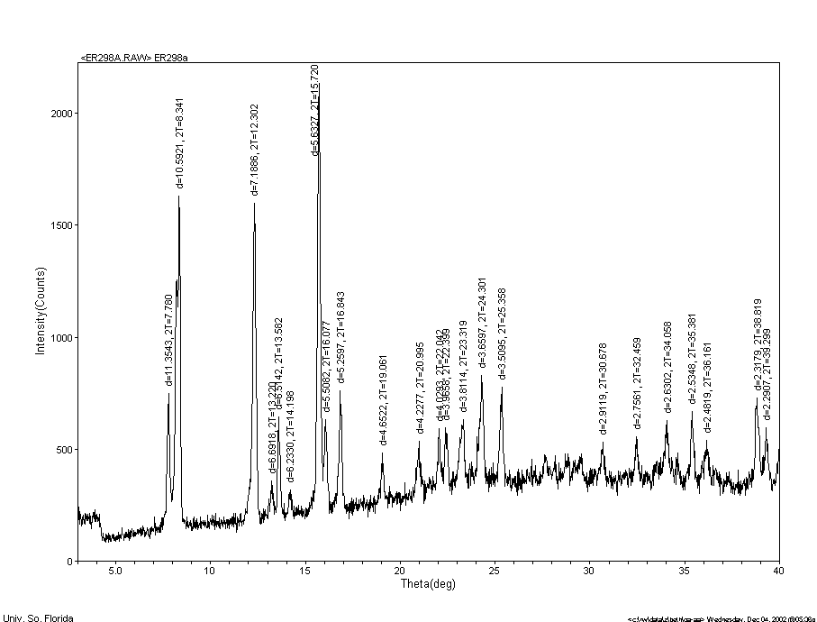

a
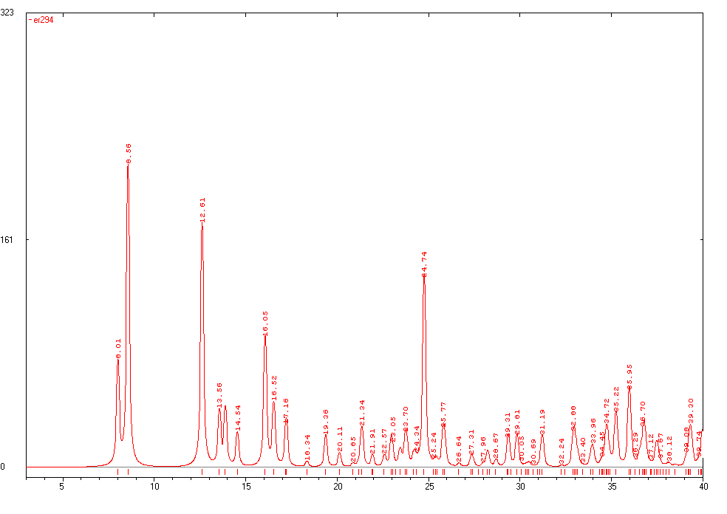

b

Figure S8. X-ray powder diffraction patterns of 1b (a) sample heated to 150ºC, (b) calculated from the single crystal structure.

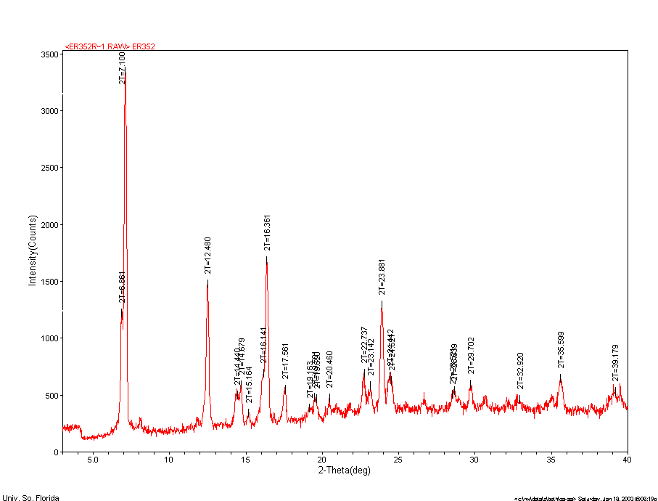

a

b

Figure S9. X-ray powder diffraction patterns of 2a (a) fresh sample, (b) calculated from the single crystal structure.

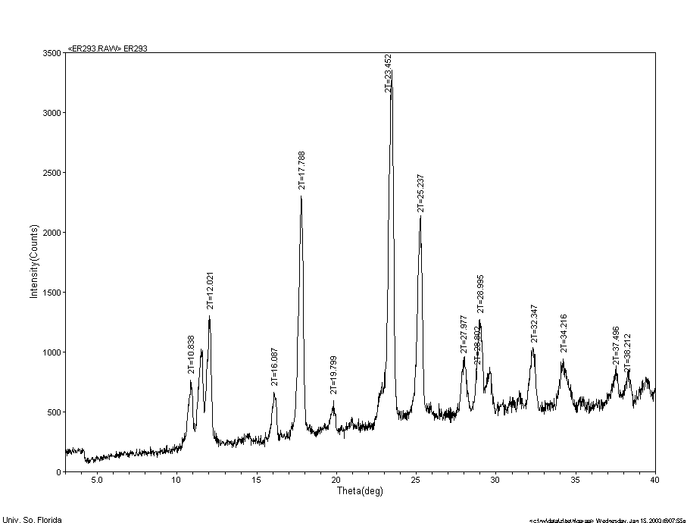

a

b

Figure S10. X-ray powder diffraction patterns of (a) blue powder formed during the synthesis of 1a and (b) simulation from the structure of [Co(4,4’-bipyridine)_{1.5}(NO₃)₂]_{n} (CSD code REJVUX).

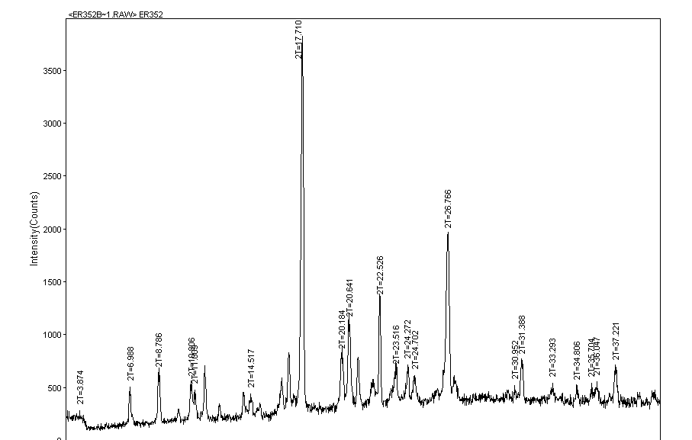

a

b

Figure S11. X-ray powder diffraction patterns of (a) blue crystals formed during the synthesis of 2a and (b) simulation from the structure of bilayer [Co(4,4’-bipyridine)_{1.5}(NO₃)₂]_{n} (CSD code NAMSEZ).

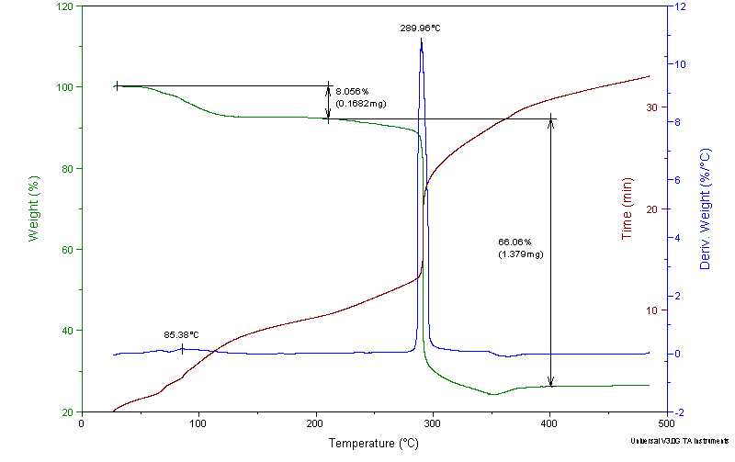

Figure S12. TGA trace of 1a.

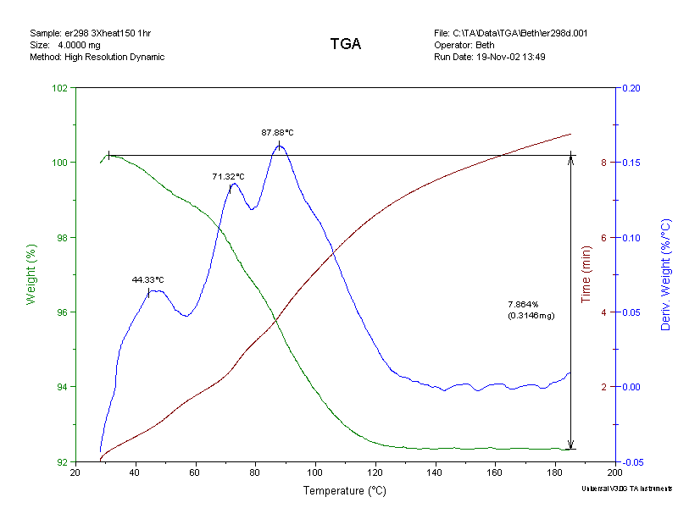
a
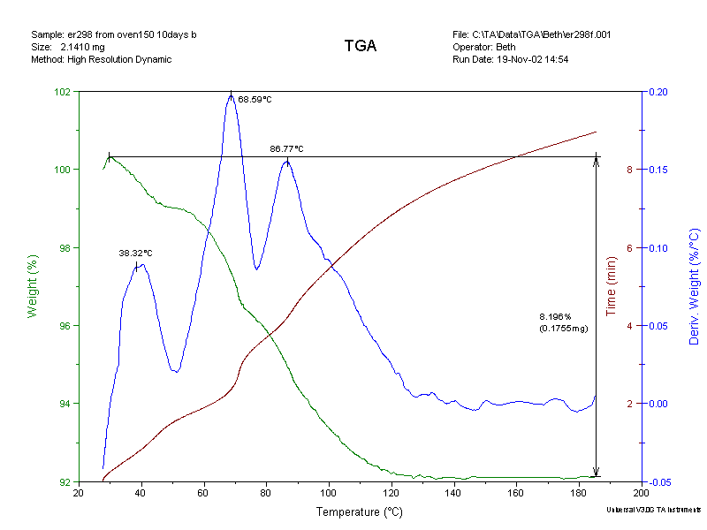
b

Figure S13. TGA traces of 1a (a) and 1b let in atmosphere for <1hour (b).

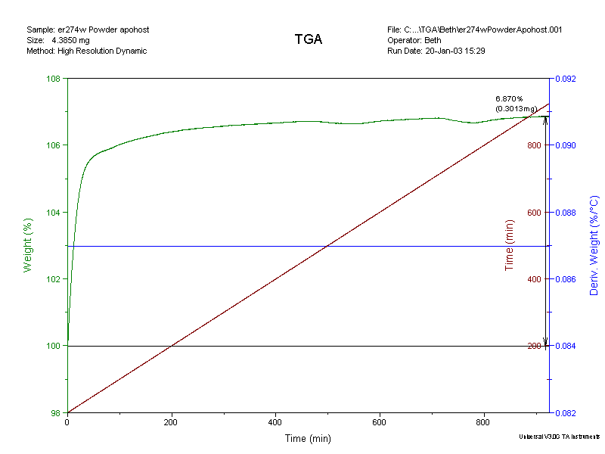
a
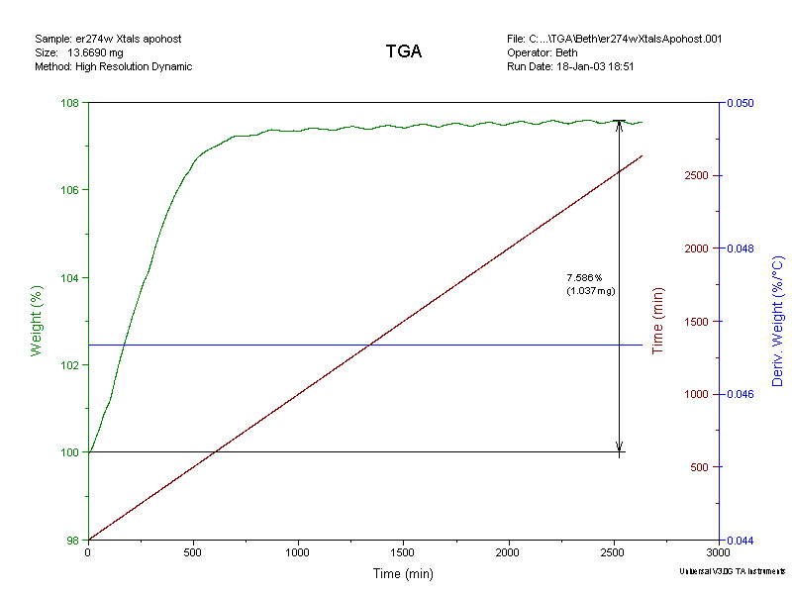
b

Figure S14. TGA traces of the rehydration of 1b powder (a) and 1b crystals (b) under ambient atmosphere.

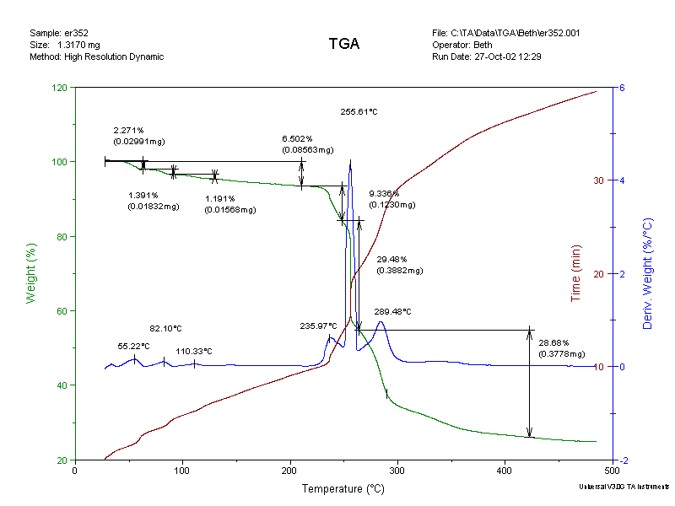
a
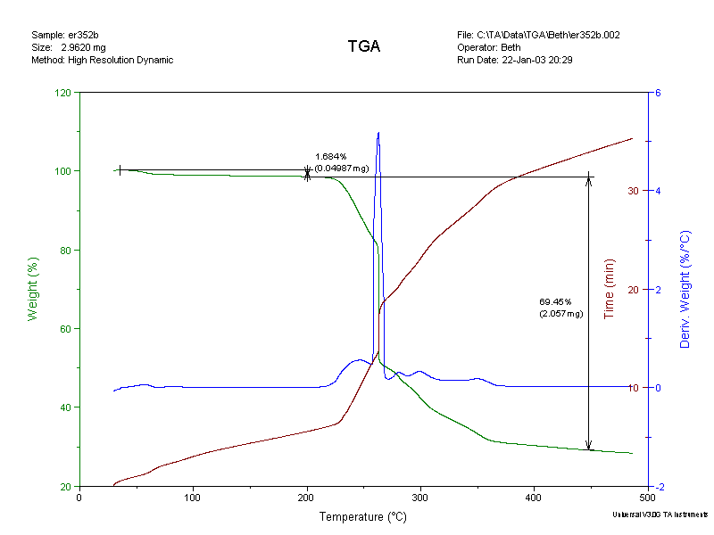
b
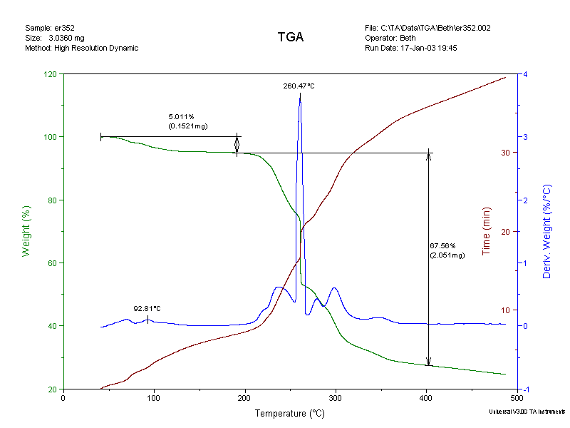
c

Figure S15. TGA traces of 2a, 2b and 2c.

Guest G | Guest (mol) included per unit formula of 1b
MeOH | 5.00.10⁻⁹
EtOH | 3.94.10⁻⁷
CH₃CN | 6.70.10⁻⁷
n-hexane | 1.21.10⁻⁸

Figure S16. Inclusion of apohost solid 1b with various guests from GC experiments.

