Supplementary information

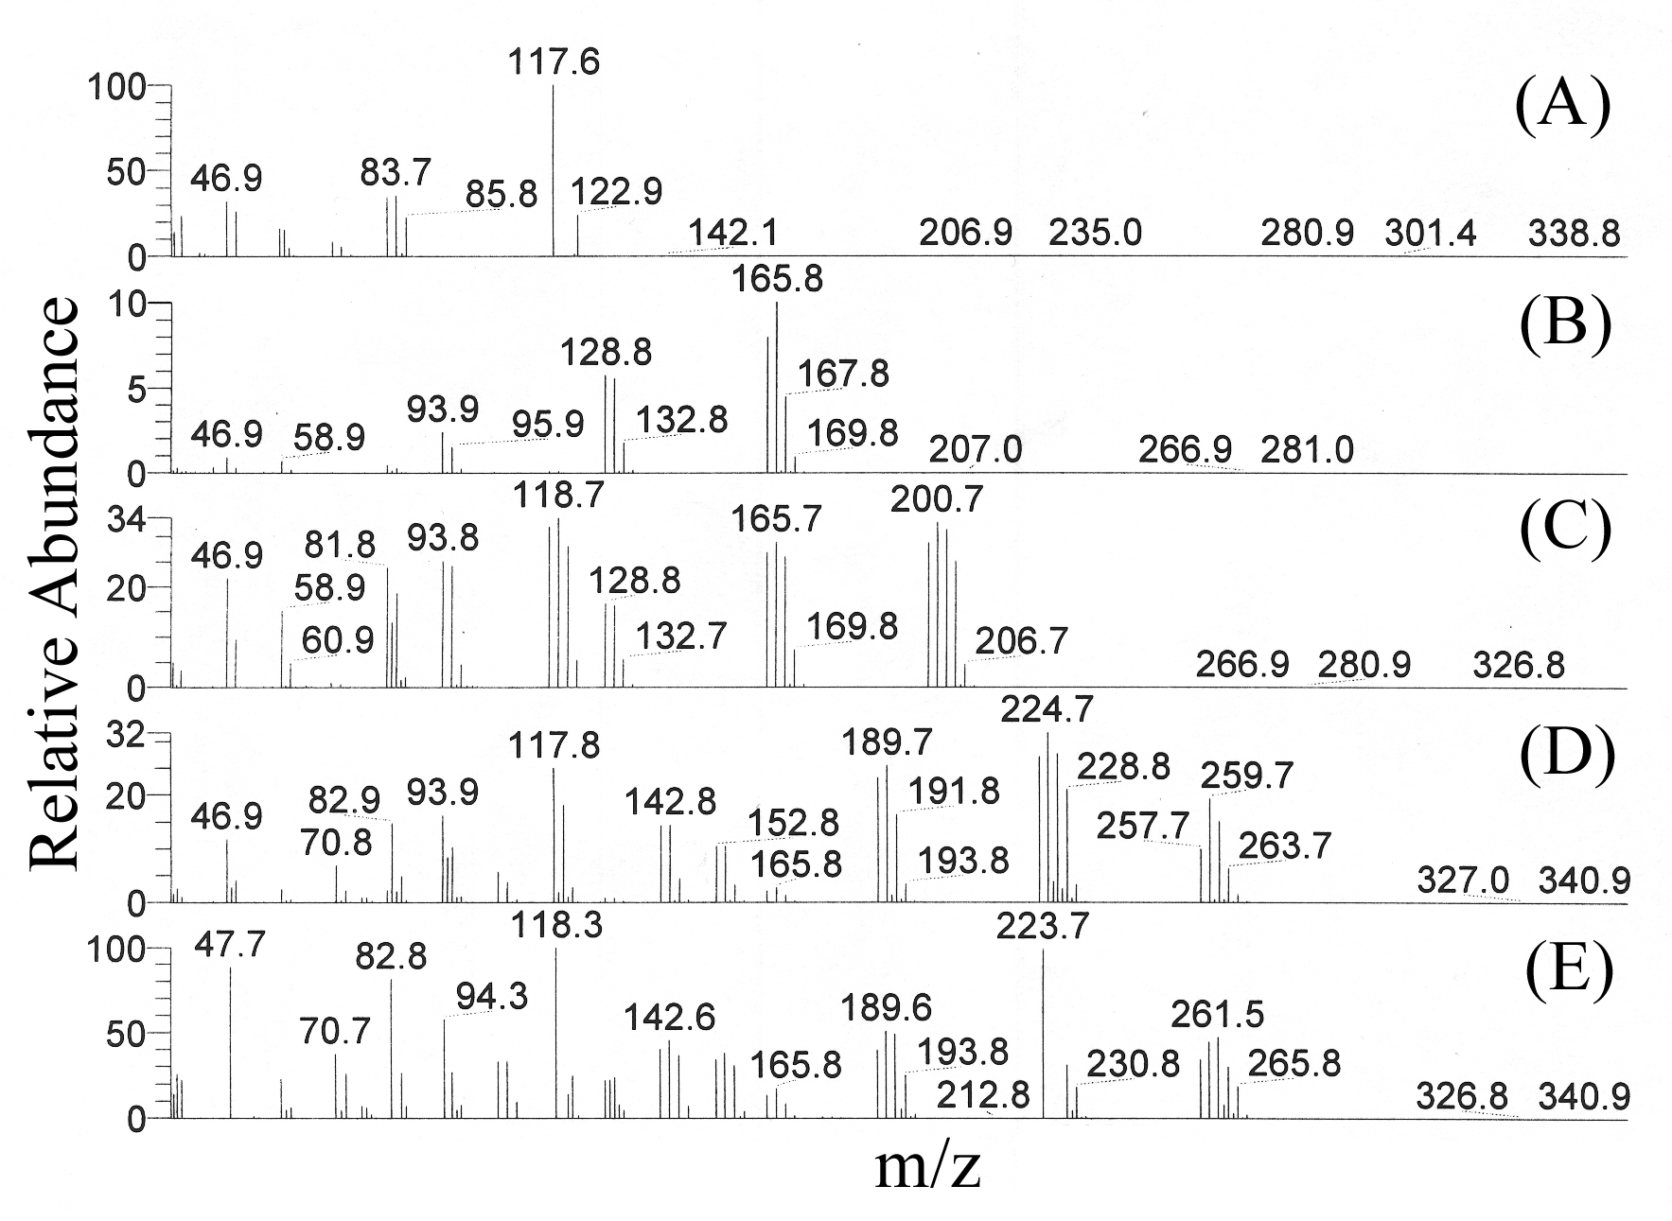

Mass spectra (MS) of the filtered solution after reaction, corresponding to the retaining time (A) 2.05 min; (B) 3.13 min; (C) 6.61 min; (D) 8.34 min; (E) 8.78 min, taking the formation of carbon hollow spheres as the example.
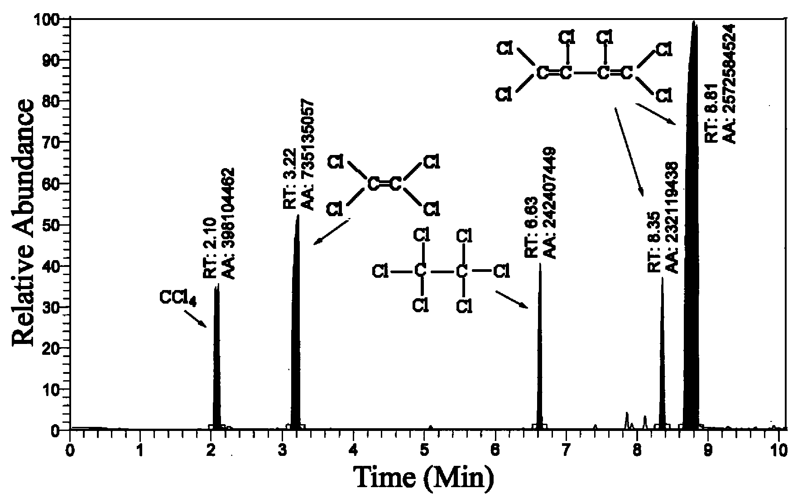

GC spectrum of purified liquid phase after reaction and filtering.

