Electronic Supporting Information for
Facile Resolution of Constrained Geometry Indenyl-Phenoxide Ligation.
Luke E. Turner,ª Mathew G. Thorn, ª Phillip E. Fanwickª and Ian P. Rothwell*ª
ª Department of Chemistry, Purdue University,560 Oval Drive, West Lafayette, IN 47907-2038, USA. Fax: 765-494-0239; Tel: 765-494-5473; E-mail: rothwell@purdue.educ
This submission was created using the RSC ChemComm Template (DO NOT DELETE THIS TEXT)
(LINE INCLUDED FOR SPACING ONLY - DO NOT DELETE THIS TEXT)

Experimental

Synthesis of 2-(inden-3-yl)-4,6-di-tert-butylphenol (1)

A sample of 2-bromo-4,6-di-tert-butyl phenol (143 g, 0.50 mol) was dissolved in diethyl ether (500 mL) and cooled to 0°C using an ice/acetone bath. Under a nitrogen atmosphere Bu^{n}Li was added (400 mL of a 2.5M hexane solution, 1.0 mol). The solution became white in color and was allowed to slowly warm to room temperature over the course of 2 hours. To this solution was slowly added 1-indanone (66.3 g, 0.50 mol) dissolved in ether and the yellow solution was allowed to stir overnight. The solution was then hydrolyzed with 6 M HCl (300 mL) and allowed to stir for 1 hour. The orange ether layer was separated from the aqueous layer, washed three times with water (500 mL), dried with MgSO₄, and evaporated to dryness affording a brown oil. This oil was vacuum distilled at 150°C to remove 1-indanone and 2,4-di-tert-butylphenol leaving a brown oil (100 g, 62%). Elution of this oil on silica-gel with hexane afforded a yellow oil that yielded white crystalline material from cold pentane. Anal. Calcd for C₂₃H₂₈O: C, 86.20; H, 8.81. Found: C, 86.23; H, 8.72. (HRMS): Calcd: 320.2140, Found: 320.2139. ¹H NMR (CDCl₃, 30°C): δ 7.27-7.67 (aromatics); 6.78 [t, ³J(¹H-¹H) = 2.1 Hz, CH]; 5.68 (s, OH); 3.69 [d, ³J(¹H-¹H) = 1.6 Hz, CH₂]; 1.57 (s), 1.44 (s, CMe₃). ¹³C NMR (CDCl₃, 30°C): δ 149.3 (O-C); 144.4, 144.2, 141.7, 141.5, 135.3, 132.7, 126.5, 125.5, 124.1, 123.9, 123.8, 121.2, 120.9 (unsaturated C); 38.7 (CH₂); 35.1, 34.3 (CMe₃); 31.7, 29.7 (CMe₃).

Synthesis of 2-(2,3-dimethylinden-3-yl)-4,6-di-tert-butylphenol (2)

Using an identical procedure as for (1), 65 g of 2-bromo-4,6-di-tert-butylphenol (0.22 mol) was treated with Bu^{n}Li (180 mL of a 2.5 M hexane solution, 0.45 mol), followed by addition of 35 g of 2,3-dimethylindanone (0.21 mol). Hydrolysis and work-up of the reaction mixture produced a brown oil that was vacuum distilled at 150ºC. The reddish brown residue was dissolved in 400 mL of pentane and cooled to -20ºC to produce a light yellow crystalline material overnight (22 g, 30%). Anal. Calcd for C₂₅H₃₂O: C, 86.15; H, 9.25. Found: C, 85.99; H, 9.26. (HRMS): Calcd: 348.2453, Found: 348.2454. ¹H NMR (C₆D₆, 25°C): δ 7.10-7.61 (aromatics); 5.23 (s), 5.11 (s, OH); 3.01 (m, CH); 1.72 (s), 1.71 (s, CH₃); 1.66 (s), 1.65 (s), 1.33 (s), 1.32 (s, CMe₃); 1.09 (d), 0.99 [d, ³J(¹H-¹H) = 7.5 Hz, CH₃]. ¹³C NMR (CDCl₃, 25°C): δ 149.2, 149.0, 148.9, 148.5, 144.4, 141.6, 134.9, 133.3, 126.6; 124.8, 124.7, 124.5, 124.3, 123.4, 122.6, 120.5, 120.4, 119.8; (unsaturated C); 47.7, 47.4 (CH); 35.0, 34.3 (CMe₃); 31.7, 29.6 (CMe₃); 16.2, 15.9, 13.3, 13.2 (CH₃).

Synthesis of Ti(OC₆H₂-{η⁵-Ind}-2-Bu^{t}₂-4,6)(NMe₂)₂] (3)

A flask was charged with [Ti(NMe₂)₄] (500 mg, 2.2 mmol) and benzene (~10 mL). As this mixture was stirring 1 (710 mg, 2.2 mmol) dissolved in benzene was slowly added. The reaction was stirred for 30 minutes and evacuated. Pentane was added to this initial crude material and upon standing orange crystals of 7 formed (700 mg, 70%). Anal. Calcd for C₂₇H₃₈N₂OTi: C, 71.35; H, 8.43; N, 6.16. Found: C, 70.81; H, 8.64; N, 6.03. ¹H NMR (C₆D₆, 25°C): δ 6.75-7.61 (m, aromatics); 6.43 (d), 6.33 [d, ³J(¹H-¹H) = 3.3 Hz., η⁵-CH₂]; 3.27 (s), 2.49 (s, NMe₂); 1.68 (s), 1.44 (s, CMe₃). ¹³C NMR (C₆D₆, 25°C): δ 172.5 (Ti-O-C); 152.0, 144.8, 142.8, 141.5, 134.9, 129.9, 125.4, 124.8, 124.7, 124.0, 123.2, 122.5, 121.7, 120.2 (unsaturated C); 101.3 (η⁵-CH₂); 48.5, 46.5 (NMe₂); 35.3, 34.6 (CMe₃); 32.1, 30.1 (CMe₃).

Synthesis of Ti(OC₆H₂-{η⁵-Ind-Me₂-2,3}-2-Bu^{t}₂-4,6)(NMe₂)₂] (4)

A flask was charged with [Ti(NMe₂)₄] (1.03 g, 4.60 mmol) and xylenes (50 mL). As this mixture was stirring 3 (1.60 g, 4.60 mmol) dissolved in xylenes was slowly added at room temperature. The reaction was stirred for 30 minutes, sealed under nitrogen, and transferred to an oil bath. The deep red reaction mixture was slowly heated to 150°C with occasional nitrogen flushing to remove HNMe₂. After 8 hours the deep red solution was evacuated to produce a glassy red solid that was pure by ¹H NMR. Dissolution of the solid in minimal hexane yielded red blocky crystals on standing overnight. A second and third crop were collected following slow evaporation of the solvent (1.45 g, 65.3%). Anal. Calcd for C₂₉H₄₂N₂OTi: C, 72.18; H, 8.77; N, 5.81. Found: C, 71.80; H, 8.87; N, 5.75. ¹H NMR (C₆D₆, 25°C): δ 7.60 (d), 7.28-7.36 (m), 6.92, (t), 6.81 (t, aromatics); 3.11 (s), 2.59 (s, NMe₂); 2.22 (s), 1.99 (s, η⁵-C-Me); 1.65 (s), 1.44 (s, CMe₃). ¹³C NMR (C₆D₆, 25°C): δ 172.2 (Ti-O-C); 141.8, 135.0, 133.2, 128.5, 126.9, 125.6, 124.6, 124.5, 124.1, 123.5, 123.2, 122.9, 122.0 (unsaturated C); 108.1 (η⁵-CH); 48.1, 46.9 (NMe₂); 35.3, 34.6 (CMe₃); 32.2, 30.2 (CMe₃); 11.6, 10.5 (η⁵-C-Me).

Synthesis of [Zr(OC₆H₂-{η⁵-Ind}-2-Bu^{t}₂-4,6)(NMe₂)₂] (5)

A sample of Zr(NMe₂)₄ (520 mg, 1.9 mmol) was dissolved in toluene. This solution was stirred vigorously as 1 (620 mg, 1.9 mmol) dissolved in toluene was slowly added. The mixture was stirred for 8 hours and the solution evacuated to dryness affording a light brown solid. Dissolution in pentane produced clear needle crystals on standing overnight (430 mg, 44%). Anal. Calcd for C₂₇H₃₈N₂OZr: C, 65.14; H, 7.69; N, 5.63. Found: C, 64.89; H, 7.54; N, 5.54. ¹H NMR (C₆D₆, 25°C): δ 7.59 (d), 7.51 (d), 7.28-7.36 (m), 6.78-6.85 (m, aromatics); 6.55 (d), 6.19 [d, ³J(¹H-¹H) = 3.3 Hz., η⁵-CH₂]; 2.91 (s), 2.31 (s, NMe₂); 1.64 (s), 1.44 (s, CMe₃). ¹³C NMR (C₆D₆, 25°C): δ 171.0 (Zr-O-C); 141.3, 136.1, 129.4, 128.3, 126.3, 125.1, 124.7, 124.3, 123.8, 123.4, 122.6, 121.8 (unsaturated C); 95.5 (η⁵-C₅H₂); 43.8, 41.8 (NMe₂); 35.4, 34.6 (CMe₃); 32.1, 30.0 (CMe₃).

Synthesis of [Ti(OC₆H₂-{η⁵-Ind}-2-Bu^{t}₂-4,6)(S-O₂C₂₀H₁₀-{SiMe₃}₂-3,3’)] (6)

To a stirred toluene solution (50 mL) of 3 (520 mg, 1.1 mmol) was slowly added (S)-3,3'-bis(trimethylsilyl)-2,2'-dihydroxy-1,1-dinaphthyl (490 mg, 1.1 mmol) in toluene (10 mL). The deep crimson solution was stirred overnight and evacuated to dryness. ¹H NMR analysis of the crude material revealed a 9:1 ratio of the (p-S, S)/(p-R, S) isomers, determined from the presence of two diastereotopic pairs of -SiMe₃ signals. The red solid was dissolved in minimal pentane and allowed to stand for days affording red blocky crystals of the (p-S, S) isomer determined unambiguously by X-ray crystallography (610 mg, 67%). Satisfactory microanalysis could not be obtained. (p-S, S)-6: ¹H NMR (C₆D₆, 25°C): δ 8.25 (s), 8.01 (s), 7.77 (d), 7.54-7.52 (m), 7.44 (d), 7.16-6.65 (m, aromatics); 5.44 [d, ³J(¹H-¹H) = 3.0 Hz, η⁵-CH]; 1.35 (s), 1.32 (s, CMe₃); 0.42 (s), 0.29 (s, SiMe₃). Selected ¹³C NMR (C₆D₆, 30°C): δ 173.1, 165.6, 156.6 (Ti-O-C); 106.3 (η⁵-CH); 35.2, 34.6 (CMe₃); 31.8, 30.1 (CMe₃); 0.8, 0.2 (SiMe₃). (p-R, S)-6: ¹H NMR (C₆D₆, 25°C): δ 0.40 (s), 0.34 (s, SiMe₃).

Synthesis of [Ti(OC₆H₂-{η⁵-Ind-Me₂-2,3}-2-Bu^{t}₂-4,6)(S-O₂C₂₀H₁₀-{SiMe₃}₂-3,3’)] (7)

60 mg (0.1 mmol) of 4 was weighed in an NMR tube followed by dissolution in C₆D₆. 30 mg (0.1 mmol) of (S)-3,3'-bis(trimethylsilyl)-2,2'-dihydroxy-1,1-dinaphthyl was added to this solution and allowed to react for 15 minutes at room temperature. ¹H NMR analysis of the mixture revealed a 1:1 ratio of the (p-S, S)/(p-R, S) isomers. Dissolution of the red solid in minimal pentane (for days) produced crystals of the (p-S, S) isomer suitable for X-ray analysis (30 mg, 30%). Satisfactory microanalysis could not be obtained. (p-S, S)-7: ¹H NMR (C₆D₆, 25°C): δ 8.16 (s), 7.99 (s), 7.74 (d), 7.60-7.52 (m), 7.37 (d), 7.11-6.80 (m), 6.61 (t), 6.49 (d, aromatics); 2.27 (s), 1.62 (s, CH₃); 1.35 (s), 1.22 (s, CMe₃); 0.49 (s), 0.28 (s, SiMe₃). Selected ¹³C NMR (C₆D₆, 25°C): δ 173.2, 163.8, 160.7 (Ti-O-C); 100.3 (η⁵-CMe); 35.1, 34.7 (CMe₃); 32.0, 29.9 (CMe₃); 13.4, 9.9 (CH₃); 1.6, 0.6 (SiMe₃). (p-R, S)-7: ¹H NMR (C₆D₆, 25°C): δ 7.96 (s), 7.87 (s), 7.71 (d), 7.58-6.54 (m), 6.20 (d), 5.81 (d, aromatics); 2.24 (s), 1.59 (s, CH₃); 1.47 (s), 1.33 (s, CMe₃); 0.46 (s), 0.16 (s, SiMe₃). Selected ¹³C NMR (C₆D₆, 25°C): δ 173.0, 168.7, 156.9 (Ti-O-C); 108.1, (η⁵-CMe); 30.3 (CMe₃); 12.9, 9.9 (CH₃); 1.0, 0.4 (SiMe₃).

Synthesis of [Zr(OC₆H₂-{η⁵-Ind}-2-Bu^{t}₂-4,6)(R-O₂C₂₀H₁₀-{SiMe₃}₂-3,3’)](THF)₂] (8)

Using an identical procedure as for 6, 250 mg (0.50 mmol) of 5 was reacted with (R)-3,3'-bis(trimethylsilyl)-2,2'-dihydroxy-1,1-dinaphthyl (220 mg, 0.51 mmol). ¹H NMR analysis of the crude material revealed a complex mixture of isomers that could not be distinguished. Dissolution of the crude material in THF followed by slow cooling to -20°C produced clear needles after weeks (110 mg, 22%). X-ray diffraction analysis confirmed the identity of the (p-R, R) isomer in the form of an octahedral cis-bis(THF) adduct. Satisfactory microanalyis could not be obtained. (p-R, R)-8: ¹H NMR (C₆D₆, 25°C): δ 8.28 (s), 8.10 (s), 7.72 (d), 7.57-7.48 (m), 7.16-6.81 (m), 6.76 (d), 6.53 (d, aromatics); 5.59 (s, η⁵-CH); 3.57 (s, O-CH₂-CH₂); 1.39 (s, O-CH₂-CH₂); 1.35, 1.26 (s, CH₃); 1.35 (s), 1.22 (s, CMe₃); 0.49 (s), 0.36 (s, SiMe₃). Selected ¹³C NMR (C₆D₆, 25°C): δ 171.9, 160.7 (Zr-O-C); 99.4 (η⁵-CH); 68.3 (O-CH₂-CH₂); 35.5, 35.0 (CMe₃); 32.3, 30.5 (CMe₃); 26.1 (O-CH₂-CH₂); 0.3, 0.2 (SiMe₃).

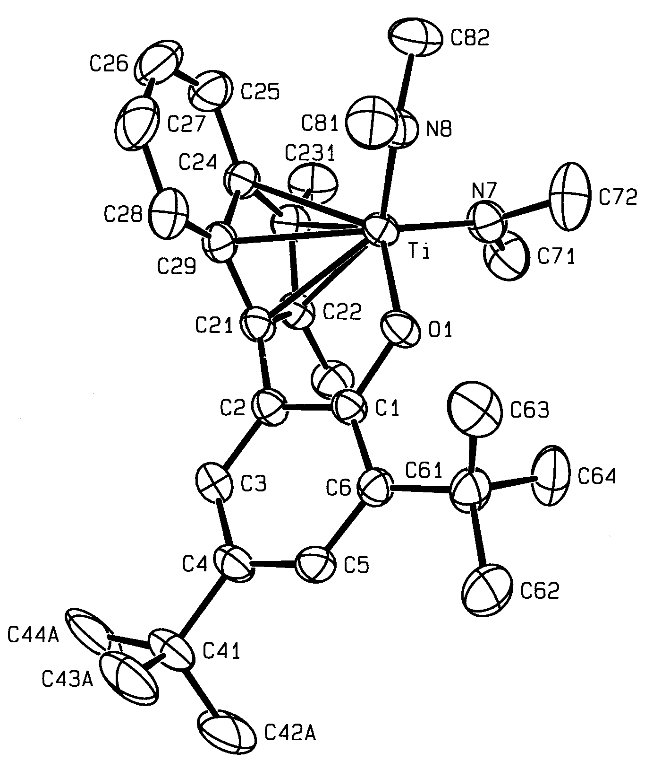

ORTEP view of 4.

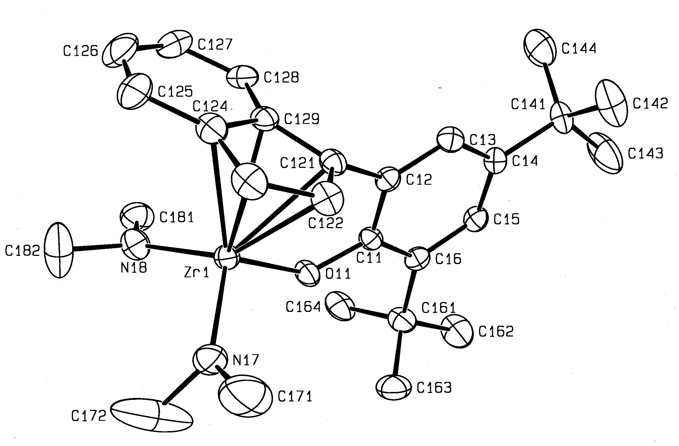

ORTEP view of 5.

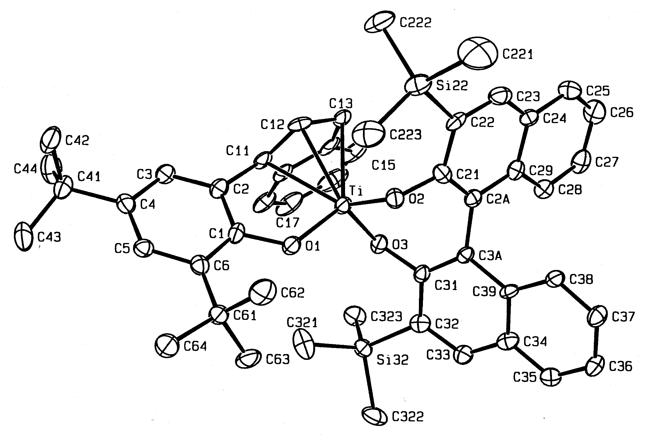

ORTEP View of 6.
Table 1. Selected Bond Distances (Å) and Angles (°) for Ti(OC₆H₂-{η⁵-Ind}-2-Bu^{t}-4,6)(NMe₂)₂] (3).

Ti-O(1) | 1.895(1) | Ti-C(129) | 2.4048(17)
Ti-N(2) | 1.905(2) | C(121)-C(122) | 1.410(2)
Ti-N(3) | 1.913(2) | C(122)-C(123) | 1.414(2)
Ti-C(121) | 2.366(2) | C(123)-C(124) | 1.426(3)
Ti-C(122) | 2.381(2) | C(124)-C(129) | 1.362(3)
Ti-C(123) | 2.380(2) | C(129)-C(121) | 1.437(2)
Ti-C(124) | 2.417(2)
O(1)-Ti-N(2) | 107.07(6) | O(1)-Ti-C(122) | 99.78(6)
O(1)-Ti-N(3) | 100.22(6) | O(1)-Ti-C(123) | 132.45(6)
N(2)-Ti-N(3) | 102.02(6) | O(1)-Ti-C(124) | 124.90(6)
Ti-O(1)-C(11) | 126.5(1) | O(1)-Ti-C(129) | 90.28(5)
O(1)-Ti-C(121) | 75.22(5)

Table 2. Selected Bond Distances (Å) and Angles (°) for Ti(OC₆H₂-{η⁵-Ind-Me-2,3}-2-Bu^{t}-4,6)(NMe₂)₂] (4).

Ti-O(1) | 1.889(2) | Ti-C(29) | 2.411(2)
Ti-N(8) | 1.898(3) | C(21)-C(22) | 1.425(4)
Ti-N(7) | 1.929(2) | C(22)-C(23) | 1.419(4)
Ti-C(21) | 2.365(2) | C(23)-C(24) | 1.421(4)
Ti-C(22) | 2.428(3) | C(24)-C(29) | 1.431(4)
Ti-C(23) | 2.430(3) | C(29)-C(21) | 1.419(4)
Ti-C(24) | 2.441(2)
O(1)-Ti-N(7) | 104.6(1) | O(1)-Ti-C(22) | 95.69(8)
O(1)-Ti-N(8) | 99.92(9) | O(1)-Ti-C(23) | 129.04(9)
N(7)-Ti-N(8) | 100.7(1) | O(1)-Ti-C(24) | 127.55(8)
Ti-O(1)-C(1) | 127.5(2) | O(1)-Ti-C(29) | 93.73(8)
O(1)-Ti-C(21) | 74.70(8)

Table 3. Selected Bond Distances (Å) and Angles (°) for [Zr(OC₆H₂-{η⁵-Ind}-2-Bu^{t}-4,6)(NMe₂)₂] (5).

Zr-O(11) | 2.026(2) | Zr-C(129) | 2.540(3)
Zr-N(17) | 2.033(3) | C(121)-C(122) | 1.411(4)
Zr-N(18) | 2.038(3) | C(122)-C(123) | 1.413(5)
Zr-C(121) | 2.522(3) | C(123)-C(124) | 1.420(5)
Zr-C(122) | 2.547(3) | C(124)-C(129) | 1.436(4)
Zr-C(123) | 2.526(3) | C(129)-C(121) | 1.435(4)
Zr-C(124) | 2.544(3)
O(11)-Zr-N(17) | 107.9(1) | O(11)-Zr-C(122) | 90.6(1)
O(11)-Zr-N(18) | 104.5(1) | O(11)-Zr-C(123) | 122.4(1)
N(17)-Zr-N(18) | 105.7(1) | O(11)-Zr-C(124) | 122.7(1)
Zr-O(11)-C(11) | 128.4(2) | O(11)-Zr-C(129) | 90.79(9)
O(11)-Zr-C(121) | 71.21(9)

Table 4. Selected Bond Distances (Å) and Angles (°) for [Ti(p-S-OC₆H₂-2-{η⁵-Ind}-4,6-Bu^{t})(S-O₂C₂₀H₁₀-3,3’-{SiMe₃}₂)] (6).

Ti-O(1) | 1.859(4) | Ti-O(2) | 1.844(4)
Ti-O(3) | 1.871(4) | Ti-C(11) | 2.367(6)
Ti-C(12) | 2.323(6) | Ti-C(13) | 2.340(6)
Ti-C(14) | 2.453(6) | Ti-C(19) | 2.452(6)
O(1)-Ti-O(2) | 99.3(2) | O(2)-Ti-O(3) | 101.2(2)
O(1)-Ti-O(3) | 113.0(2) | Ti-O(1)-C(1) | 128.0(4)
Ti-O(2)-C(21) | 117.2(4) | Ti-O(3)-C(31) | 126.2(4)

Table 5. Selected Bond Distances (Å) and Angles (°) for [Ti(p-S-OC₆H₂-2-{η⁵-2,3-Me-Ind}-4,6-Bu^{t})(S-O₂C₂₀H₁₀-3,3’-{SiMe₃}₂)] (7).

Ti-O(1) | 1.864(2) | Ti-O(2) | 1.862(2)
Ti-O(3) | 1.866(2) | Ti-C(11) | 2.310(3)
Ti-C(12) | 2.318(3) | Ti-C(13) | 2.361(3)
Ti-C(14) | 2.522(3) | Ti-C(19) | 2.472(3)
O(1)-Ti-O(2) | 96.91(9) | O(2)-Ti-O(3) | 102.09(9)
O(1)-Ti-O(3) | 115.72(9) | Ti-O(1)-C(1) | 127.4(2)
Ti-O(2)-C(21) | 121.7(2) | Ti-O(3)-C(31) | 125.0(2)

Table 6. Selected Bond Distances (Å) and Angles (°) for [Zr(p-R-OC₆H₂-2-{η⁵-Ind}-4,6-Bu^{t})(R-O₂C₂₀H₁₀-3,3’-{SiMe₃}₂)(THF)₂] (8).

Zr-O(1) | 2.100(3) | Zr-O(2) | 2.017(3)
Zr-O(3) | 2.095(3) | Zr-O(4) | 2.387(3)
Zr-O(5) | 2.356(3) | Zr-C(11) | 2.531(4)
Zr-C(12) | 2.511(4) | Zr-C(13) | 2.564(4)
Zr-C(14) | 2.723(4) | Zr-C(19) | 2.696(4)
Zr-O(1)-C(1) | 128.6(3) | Zr-O(2)-C(21) | 129.1(3)
Zr-O(3)-C(31) | 122.1(3) | Zr-O(4)-C(404) | 127.0(3)
Zr-O(4)-C(401) | 124.5(3) | Zr-O(5)-C(504) | 107.8(3)
Zr-O(5)-C(501) | 128.7(3) | O(1)-Zr-O(2) | 99.1(1)
O(2)-Zr-O(3) | 92.6(1) | O(1)-Zr-O(3) | 150.5(1)
O(2)-Zr-O(5) | 82.3(1) | O(3)-Zr-O(5) | 76.0(1)
O(1)-Zr-O(5) | 78.8(1) | O(2)-Zr-O(4) | 159.0(1)
O(3)-Zr-O(4) | 79.2(1) | O(1)-Zr-O(4) | 80.3(1)
O(5)-Zr-O(4) | 77.1(1)

