Zn-Proline catalyzed direct Aldol reaction in aqueous media
Tamis Darbre* and Miguel Machuqueiro

Department of Chemistry and Biochemistry, University of Bern, Freiestrasse 3, CH-3012,
Switzerland. Tel: +41 31 6314375; E-mail: darbre@ioc.unibe.ch

Supporting Information

General: The reactants used were of puriss. grade. Solvents were distilled before use. ¹H and ¹³C NMR spectra were recorded on Brucker Spectrospin AM300 spectrometer (¹H, 300 MHz; ¹³C, 75 MHz). Chemical shifts are given in ppm referred to CHCl₃. Coupling constants (J) are reported in Hertz (Hz) and ¹³C multiplicities are obtained from DEPT spectra. HPLC performed using a Waters system consisting of a Waters 600 Controler, a Waters 600 Pump and a Waters 996 Photodiode Array Detector. The chiral column used was the Chiralpak AS from Dancel Chemical Industries, Ltd. The assignment of the stereoisomers was obtained by comparing the retention time of our reaction product with the retention time obtained by the reaction with proline alone.

General Procedure for the Preparation of the Zinc Complexes: Triethylamine (0.6 ml) was added to a mixture of the corresponding amino acid (4.34 mmol) in methanol (10 ml). Complete solubilization was achieved with the help of ultrasound and (in some cases) with the addition of a small amount of water. The reaction mixture was stirred for 10 min and zinc acetate (2.17 mmol) was added. A white precipitate was readily formed and after 45 min it was collected by filtration to give the desired complex (23%-95% yields). These zinc complexes are characteristically insoluble in non-aqueous solvents.

L-Pro₂Zn:
¹H-NMR (300 MHz, D₂O) δ: 1.81 (m, br, 3H); 2.22 (m, br, 1H); 2.98 (s, br, 1H); 3.14 (m, br, 1H); 3.85 (m, br, 1H) (Spectrum Included)
¹³C-NMR (75 MHz, D₂O) δ: 25.74, 30.21, 47.59, 61.39.

General Procedure for the Preparation of 4-Hydroxy-4-(4-nitro-phenyl)-butan-2-one (1): A solution of the catalyst (5 μmol) in water (1 ml; 66% vol./vol.) was added to a mixture of the 4-nitrobenzaldehyde (0.1 mmol) in acetone (0.5 ml). The resulting mixture stirred at room temperature for 24-96 h under N₂ pressure in order to avoid evaporation. The mixture was dried under reduced pressure. Addition of CDCl₃ and filtration of the non-soluble complex catalyst affords the desired product and 4-nitrobenzaldehyde (when present). The ¹H-NMR spectra of the crude product obtained, with complete (figure 1S) and partial (figure 2S) conversion are included.

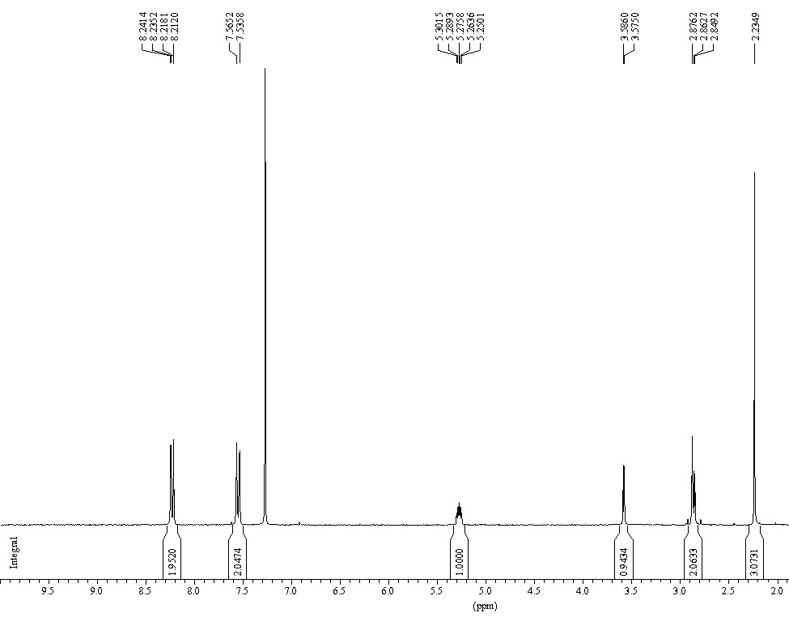
Figure 1S. ¹H-NMR (CDCl₃) of the crude product 1 from the aldol reaction with 100% yield.

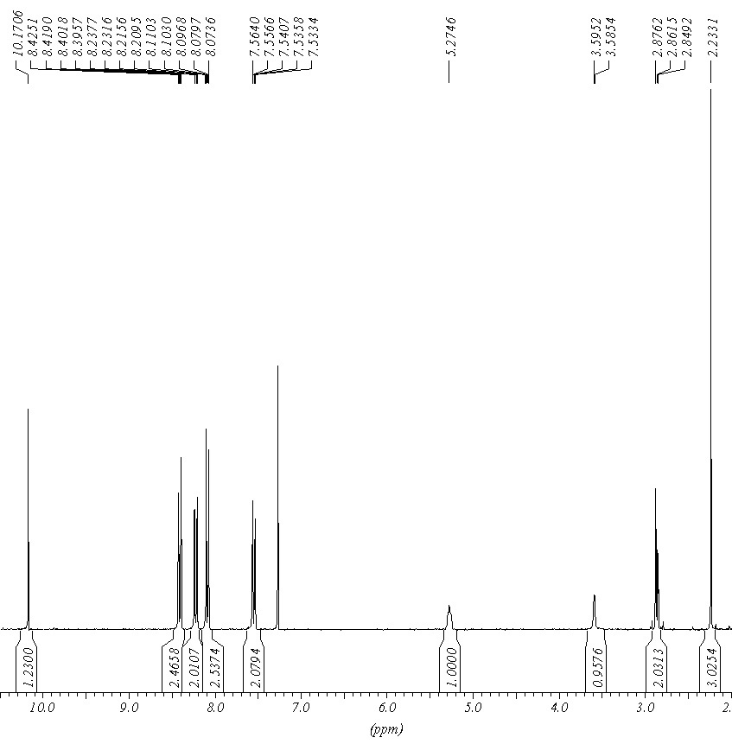
Figure 2S. ¹H-NMR (CDCl₃) of the aldol product 1 together with p-nitro benzaldehyde. The NMR yield calculated is 45%

Some relevant complex spectra

¹H-NMR:
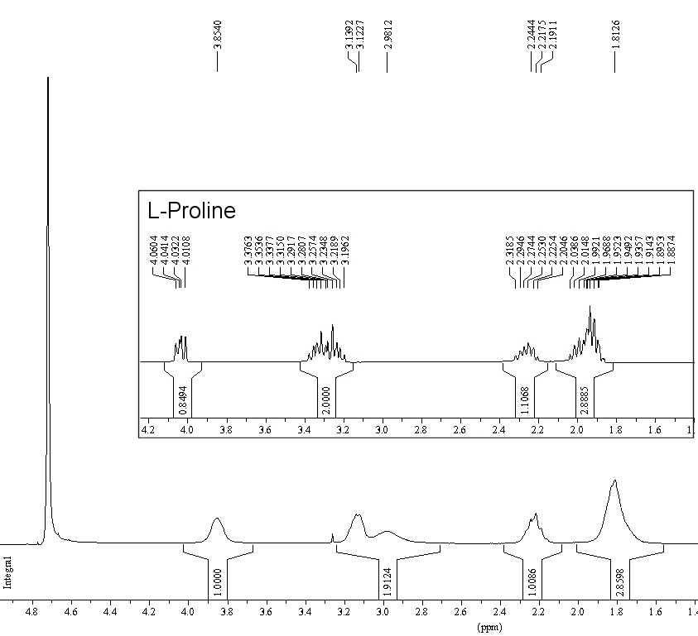
Figure 3S. ¹H-NMR (D₂O) of the complex L-Pro₂Zn and L-Proline (box)

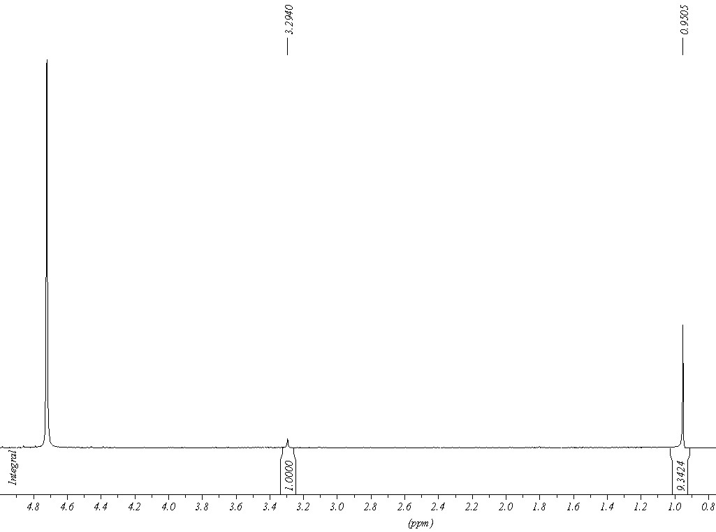
Figure 4S - ¹H-NMR of the complex L-tert-Leu₂Zn.

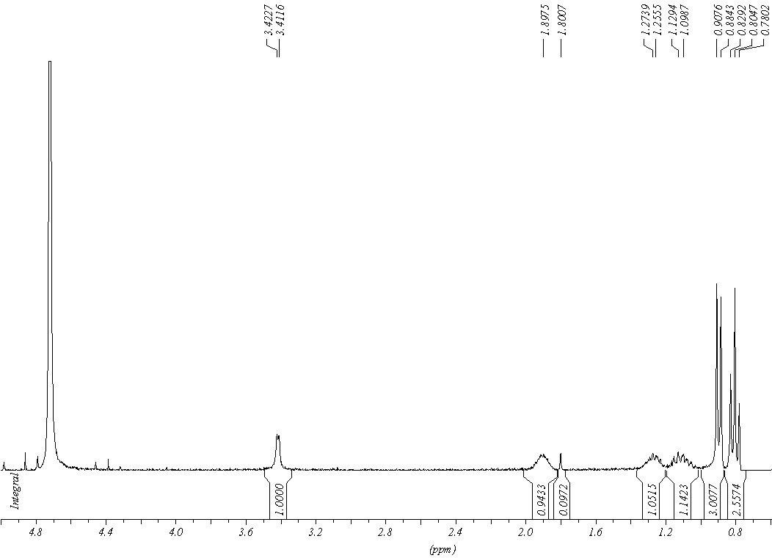
Figure 5S - ¹H-NMR of the complex L-IsoLeu₂Zn.

ESI-MS:

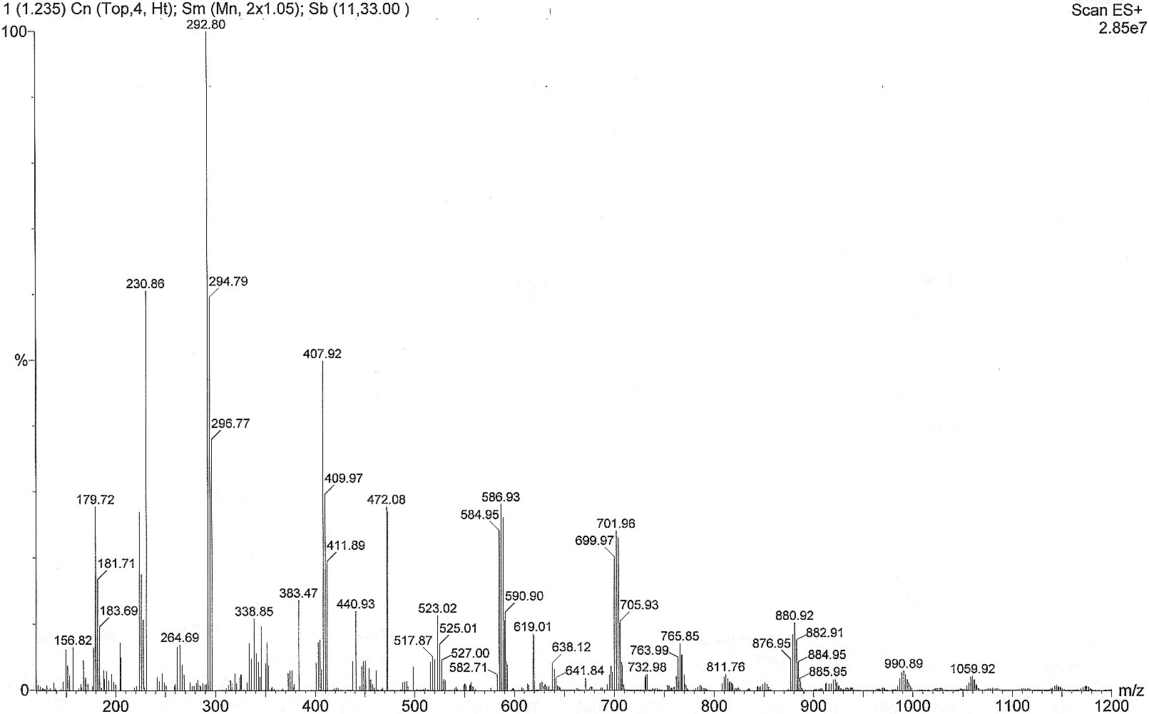
Figure 6S. ESI-MS of the complex L-Pro₂Zn

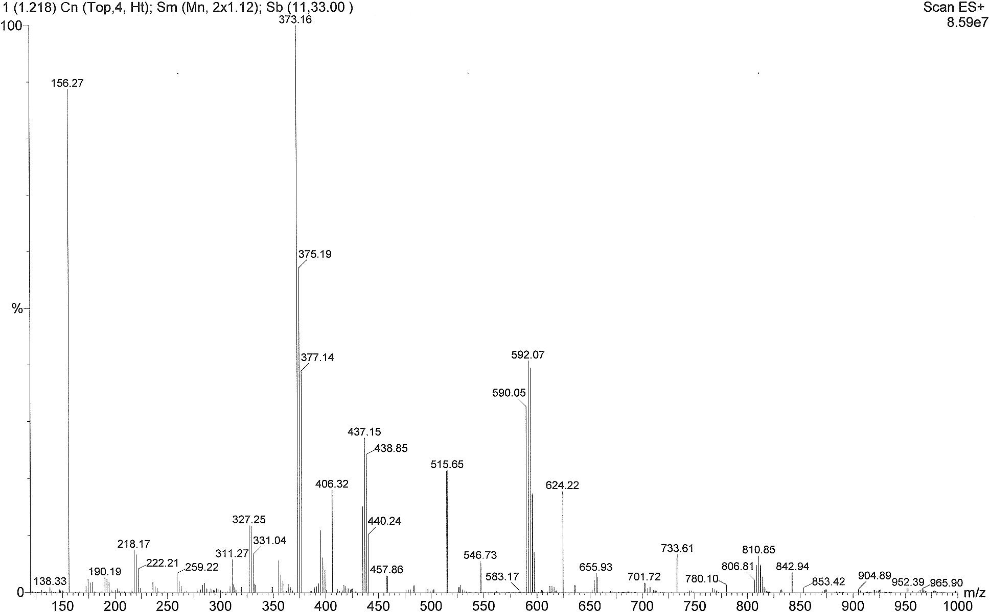
Figure 7S - ESI-MS of the complex L-His₂Zn

