Supplementary Information

Fig. 4 Effect of oxygen on the conversion of CF₄ over AlPO₄-Al₂O₃ (Al/P = 39) (T= 640 ºC, Catalyst = 5g, PFCs = 1.1 ml/min, He = 87 ml/min and water = 0.04 ml/min); this figure shows clearly that the hydrolysis activity is not influenced by the presence of oxygen.

Fig. 5. FTIR spectra of (a) Al₂O₃ and (b) AlPO₄-Al₂O₃(Al/P=39) after pyridine adsorption at ambient temperature and outgassing at 100 ºC: (A) before and (B) after CF₄ hydrolysis at 750 ºC for 45 hours; this figure shows clearly that the hydrolysis activity is strongly influenced by the acidity of catalyst, which can be maintained even after long exposure to the reaction when the catalyst is promoted with phosphate.

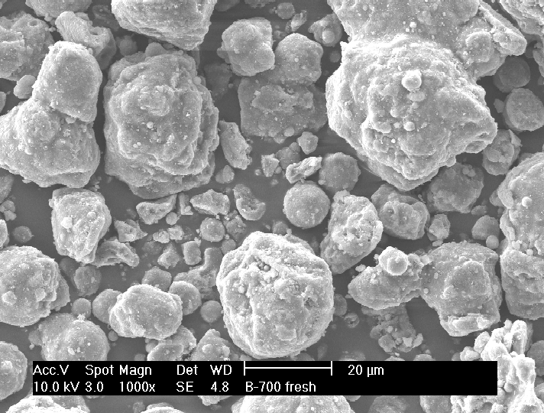
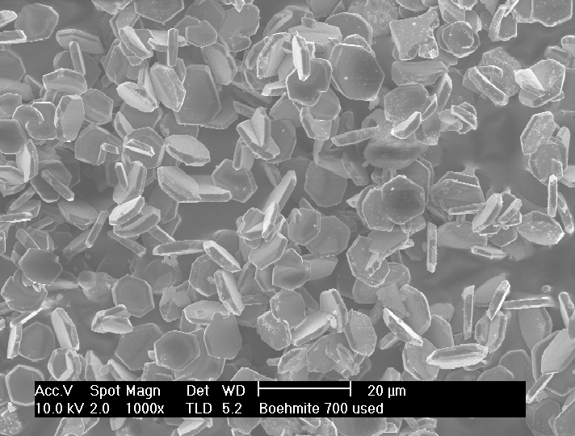
Fresh
Used

(a) γ-Al₂O₃

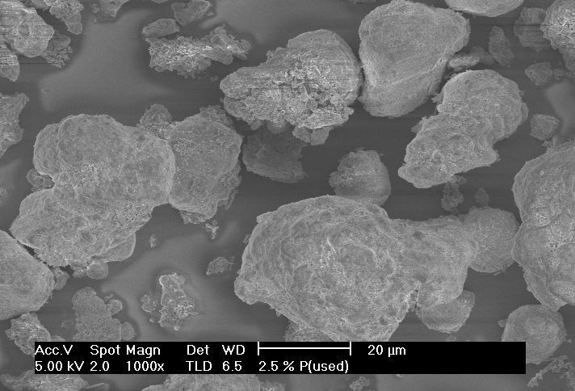
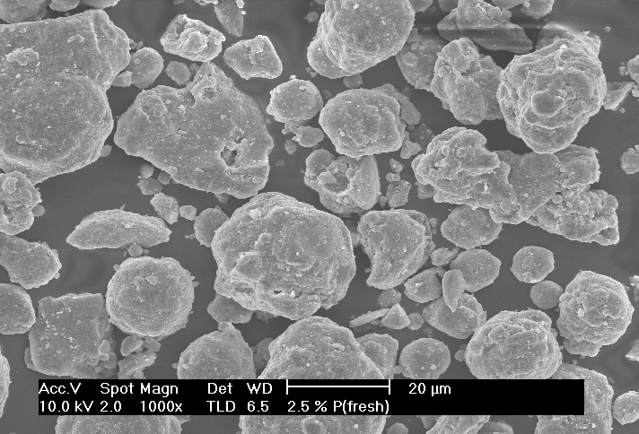

(b) AlPO₄-Al₂O₃ (Al/P=39)

Fig. 6. SEM images of (a) γ-Al₂O₃ and (b) AlPO₄-Al₂O₃ (Al/P=39) before and after CF₄ hydrolysis at 750°C for 45 hours; in the case of pure γ-Al₂O₃, it showed an irregular shapes before reaction but converted to a hexagonal disk having a α-phase of alumina after 45 hours of hydrolysis. On the contrary, the AlPO₄-Al₂O₃ promoted with phosphate revealed no big change in morphology even after long exposure to the hydrolysis.

