Supplementary data

Selected backbone torsion angles (°) for peptide 1

O16-C15-N14-C13 | -169.0(4) ω₀ | C9-N8-C7-C6 | -66.4(6) φ₃
C15-N14-C13-C12 | -55.5(6) φ₁ | N8-C7-C6-N5 | -21.7(6) ψ₃
N14-C13-C12-N11 | -40.1(7) ψ₁ | C7-C6-N5-C4 | -178.6(5) ω₃
C13-C12-N11-C10 | -172.9(5) ω₁ | C6-N5-C4-C3 | -81.1(6) φ₄
C12-N11-C10-C9 | -58.1(7) φ₂ | N5-C4-C3-C2 | -65.3(5) θ₁
N11-C10-C9-N8 | -28.7(6) ψ₂ | C4-C3-C2-O1 | -35.8(6) ψ₄
C10-C9-N8-C7 | -171.7(4) ω₂

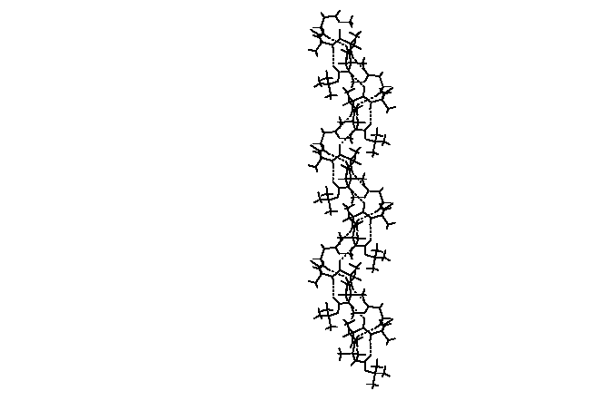

Figure 1: The packing of the peptide 1 showing the intermolecular hydrogen-bonded supramolecular helix along the b axis. Hydrogen bonds are shown as dotted lines.

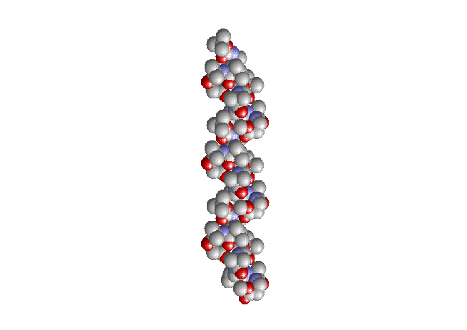

Figure 3: Space-filling model of a supramolecular helical array showing the staking of subunits maintaining the proper registry, generating a nano-structure of an average diameter of 10Å as determined by single X-ray crystallographic studies. Nitrogen atoms are blue, oxygen atoms are red and carbon atoms are gray. Hydrogen atoms are omitted for clarity.

