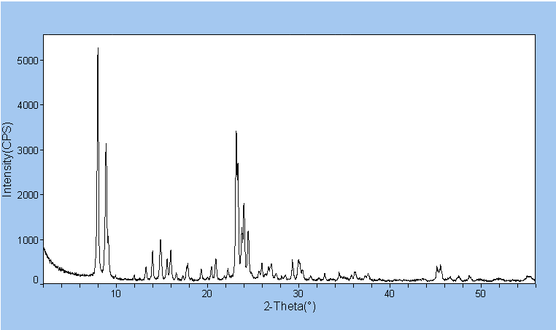

Figure 1 XRD pattern of TS-1 (reference)
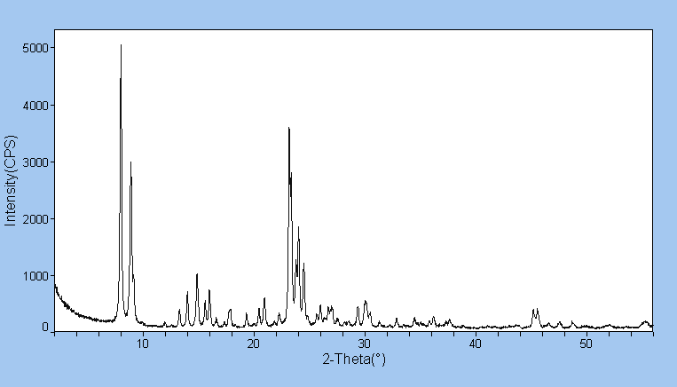

Figure 2 XRD pattern of Ti-Sn-S-1 [1]
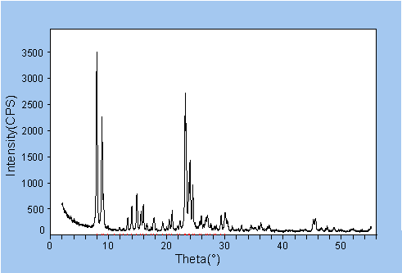

Figure 3 XRD pattern of Ti-Sn-S-1 [2]
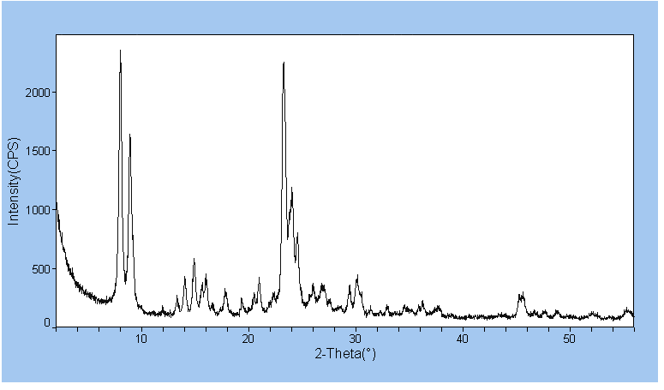

Figure 4 XRD pattern of Ti-Sn-S-1 [3]

Note: XRD patterns were detected by a SCINTAG XDS 2000 theta-theta diffractometer, generating Cu tube K_{∝1} radiation with Peltier detector. A full scanning was performed between 2-70 º2θ, step size 0.02 º2θ, 1 sec/step with the slits: 0.3 nm, 0.5 nm, 2 nm and 4 nm.

Table 1 NH₃-TPD summary results
Catalyst | mmol of NH₃ per gram in specified temperature region |  |  |  | Total mmol NH₃ per gram 200 – 550 ºC
Catalyst | 200 – 300 ºC | 300 – 400 ºC | 400 – 500 ºC | 500 – 550 ºC | Total mmol NH₃ per gram 200 – 550 ºC
TS-1 | 0.004 | 0.012 | 0.010 | 0.004 | 0.030
Sn-S-1 | 0.022 | 0.026 | 0.017 | 0.007 | 0.072
Ti-Sn-S-1 [1] | 0.006 | 0.015 | 0.014 | 0.005 | 0.040
Ti-Sn-S-1 [2] | 0.007 | 0.018 | 0.017 | 0.006 | 0.049
Ti-Sn-S-1 [3] | 0.036 | 0.040 | 0.022 | 0.008 | 0.106
Sn on TS-1 | 0.006 | 0.015 | 0.011 | 0.004 | 0.036
Ti on Sn-S-1 | 0.015 | 0.021 | 0.017 | 0.006 | 0.059
Note: All samples have been pretreated at 550 ºC in UHP grade He

Table 2 Some characterization results
Catalyst | Pore Volume  (cc g ⁻¹) | Pore Diameter  (Å) | Micropore Area  (m² g ⁻¹) | Micropore Volume  (cc g ⁻¹) | Mesopore Area (m² g ⁻¹)
TS-1 | 0.44 | 32.0 | 370.0 | 0.19 | 28.0
Sn-S-1 | 0.46 | 40.0 | 287.0 | 0.16 | 169.0
Ti-Sn-S-1 [1] | 0.40 | 40.0 | 365.0 | 0.20 | 38.0
Ti-Sn-S-1 [2] | 0.40 | 39.0 | 323.0 | 0.20 | 101.5
Ti-Sn-S-1 [3] | 0.43 | 38.0 | 281.0 | 0.20 | 165.0
Sn on TS-1 | 0.32 | 32.0 | 371.0 | 0.20 | 29.0
Ti on Sn-S-1 | 0.43 | 40.0 | 345.0 | 0.20 | 169.0
Note: All samples have been pretreated by N₂ adsorption at 300 ºC overnight

