Supporting information
Caption

Fig. 1. UV-visible absorption spectra of prepared samples, measured with Varian Cary 100 Scan UV-Visible system equipped with a Labsphere diffuse reflectance accessory

Fig. 2. XRD patterns of prepared samples (Δ anatase TiO₂, * CdS cubic phase).

Fig. 3. EPR spectrum of anatase TiO₂, irradiated for 20 min.

Fig. 1.

Fig. 2.

Fig. 3

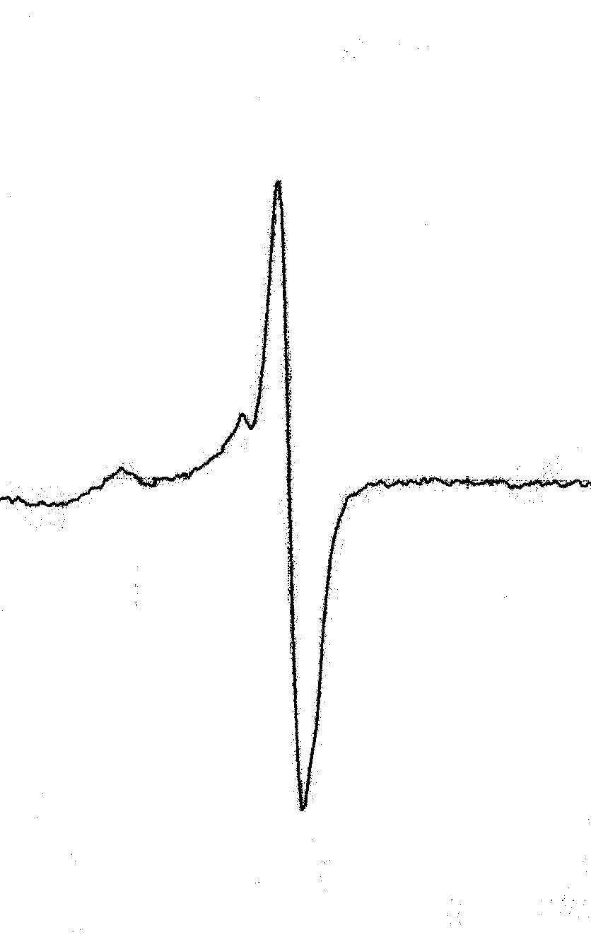
50 Gauss

