Electronic Supplementary Information

Primary processes in photoinduced multielectron storage systems. A dinuclear ruthenium(II) species featuring a charge-separated state with a lifetime of 1.3 μs.

Claudio Chiorboli, Sandro Fracasso, Franco Scandola, Sebastiano Campagna, Scolastica Serroni, Rama Konduri and Frederick M. MacDonnell.

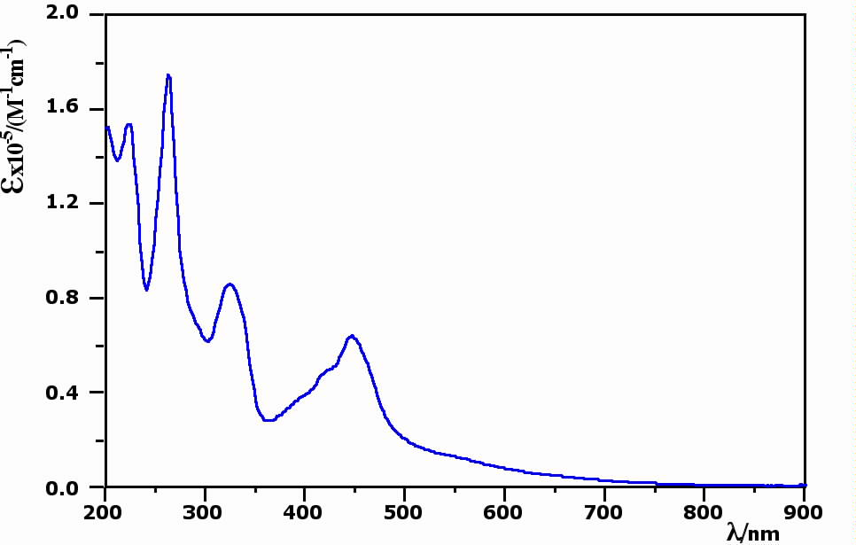

Figure S1. Absorption spectrum of P in acetonitrile solution

