Supplementary Material
for
“Gold(III) Porphyrins as a New Class of Anticancer Drugs: Cytotoxicity, DNA Binding and Induction of Apoptosis in Human Cervix Epitheloid Cancer Cells”

Chi-Ming Che,* Raymond Wai-Yin Sun, Wing-Yiu Yu, Chi-Bun Ko, Nianyong Zhu and Hongzhe Sun*

Part I. Experimental Section
Materials. All chemicals, except otherwise noted, were purchased from Sigma-Aldrich Chemical Co. Acetonitrile and dichloromethane were freshly distilled from CaH₂. Analytical grade organic solvents and double distilled deionized water were used throughout the experiments. meso-Tetraphenylporphyrin, meso-tetrakis(4-tolyl)porphyrin, meso-tetrakis(4-methoxyphenyl)porphyrin, meso-tetrakis(4-bromophenyl)porphyrin and meso-tetrakis(4-chlorophenyl)porphyrin were synthesized and purified by the literature methods [Adler, A. D. J. Org. Chem. 1967, 32, 476. Keinan, E.; Benory, E.; Sinha, S. C.; Sinha-Bagchi, A.; Eren, D.; Eshhar, Z.; Green, B. S. Inorg. Chem. 1992, 31, 5433-5438. Barnett, G. H.; Hudson, M. F.; Smith, K. M. Tetrahedron. Lett. 1973, 30, 2887-2888]. Tetrabutylammonium tetrachloroaurate (nBu₄N[AuCl₄]) was prepared from the metathesis reaction of [nBu₄N]Cl with H[AuCl₄] in 0.01 M HCl. It was isolated as a yellow solid, washed with diethyl ether and dried by vacuum.
The calf thymus DNA was purchased from Sigma and was purified by phenol-chloroform extraction. The concentration (per base pair) of calf thymus DNA in buffer (5 mM Tris, 5 mM NaCl, pH 7.2) was determined spectrophotometrically on the basis of ε₂₆₀, 13,200 M⁻¹cm⁻¹bp.
Human promyelocytic leukemia (HL-60), human hepatocellular carcinoma (HepG2), Human cervix epitheloid carcinoma cells (HeLa), human oral epidermoid carcinoma cells (KB-3-1) and normal human lung fibroblast cell line (CCD-19Lu) were obtained commercially from American Type Culture Collection (ATCC). The multidrug-resistant KB-V1 cell line was obtained by stepwise selection for vinblastine resistance [Shen, D. W.; Cardarelli, C.; Hwang, J. J. Biol. Chem. 1986, 261, 7762-7770] and was generously provided by Dr Michael Gottesman (NIH, Bethesda). Human nasopharyngeal carcinoma cells (SUNE1 and its cisplatin-resistant variant, CNE1) were derived from poorly differentiated NPC in Chinese patients [Gu, S. Y.; Tang, W. P.; Zeng, Y.; Zhao, E. W.; Deng, W. H.; Li, K. Chin. J. Cancer 1983. 2, 270- 272] and were generously provided by Dr S. W. Tsao (Department of Anatomy, The University of Hong Kong, Hong Kong). Cell culture flasks and 96-well microtitre plates were purchased from Nalge Nunc Int. Culture medium, other medium constituents and phosphate buffered saline (PBS) were from Gibco BRL. Cell Proliferation Kit I (MTT) was purchased from Roche.
Physical Measurement. All the absorption spectra were recorded on a Perkin-Elmer Lambda 19 or a Varian Cary 50 UV-visible spectrophotometer equipped with a PCB-150 water circulator. ¹H NMR spectra were recorded on Bruker DPX-300 or DPX-500 NMR spectrometers. Positive ion FAB mass spectra were recorded on a Finnigan MAT95 mass spectrometer. Cyclic voltammetry was performed by using a PAAR model 175 universal programmer and a Model 173 potentiostat, and the cyclic voltammograms were recorded with a Kipp & Zonen BD 90 X-Y recorder at scan rates of 200 mVs⁻¹. Electrochemical measurements were performed using 0.1 M tetrabutylammonium hexafluorophosphate (TBAP)/acetonitrile as supporting electrolyte at room temperature after purging the solution with nitrogen. The working electrode was a glassy carbon (Atomergic Chemetal V25, geometric area of 0.35 cm²) electrode and the counter-electrode was a platinum gauze. A non-aqueous Ag/AgNO₃ (0.1 M in acetonitrile) reference electrode was contained in a separate compartment connected to the test solution via fine sintered glass disks. The ferrocenium/ferrocene couple was used as internal standard.
X-ray Crystal Determination. Crystals of 1a were obtained by a slow diffusion of n-pentane into a solution of 1a in chloroform. A purple crystal having dimensions 0.4 × 0.1 × 0.1 mm mounted on a glass fiber was used for data collection at 28ºC on a MAR diffractometer with a 300 mm image plate detector using graphite monochromatized Mo-K_{α} radiation (λ = 0.71073 Å). Data collection was made with 3º oscillation step of ϕ, 300 seconds exposure time and scanner distance at 120 mm. 48 images were collected. The images were interpreted and intensities integrated using program DENZO [Otwinowski, Z. and Minor, W. In Processing of X-ray Diffraction Data Collected in Oscillation Mode, Methods in Enzymology, Carter C. W., Sweet Jr. & R. M., Eds.; Academic Press.: 1997; Vol. 276, p. 307-326].. The structure was solved by direct methods employing SHELXS-97 program [Sheldrick, G., M. SHELX97. Programs for Crystal Structure Analysis (Release 97-2). University of Goetingen, Germany, 1997]. Au, Cl and many non-H atoms were located according to the direct methods. The positions of the other non-hydrogen atoms were found after successful refinement by the full-matrix least-squares using program SHELXL-97.
Stability Analysis. The UV-vis absorption spectra of 2.5 μM (7 nmoles) of all the gold(III) complexes studied in this work was monitored over 72 h in (1: 19) MeCN/ Tris buffer solution. ¹H-NMR experiments were carried out with a d₃-MeCN/D₂O (1: 9) solution of 1a (0.5 mM) in the presence of four equivalents of GSH [Sun, H.; Yan, S. C.; Cheng, W. S. Eur. J. Biochem. 2000, 267, 5450-5457]. The pH of the solution was adjusted to 7.4 with NaOD, and the solution was then degassed for 10 min by purging with nitrogen to minimize GSH oxidation.

Biological Studies and Measurement. KB-3-1, KB-V1, HepG2 and HeLa were maintained in a minimum essential medium with Earle's balanced salts (MEM). The human cancer cell lines HL-60, SUNE1 and CNE1 were maintained in the RPMI 1640 medium (Life Technologies, Inc.). All the media were supplemented with 2 mM L-glutamine and 10 % fetal bovine serum. Penicillin (100 U/mL) and streptomycin (100 μg/mL) were added to all media. Cultures were incubated at 37 ºC in a 5% CO₂/ 95% air humidified atmosphere. Flow cytometric analysis was performed with a Coulter EPICS flow cytometer (Coulter, Miami, FL) equipped with 480 long, 525 band and 625 long pass mirrors. Samples were excited by 15 mW air-cool argon convergent laser at 488 nm. Fluorescence signals were manipulated with Coulter Elite 4.0 software (Coulter) and were analyzed by Winlist 1.04 and Modfit 5.11 software (Verity Software House, Topsham, ME).
Anticancer studies of the gold(III) porphyrins. Assays on the cytotoxic effects were conducted in 96-well flat-bottomed microtitre plates. The supplemented culture medium (100 μL) with cells (3 ×10⁵ cells/ mL) was added into each well and was incubated (37 ºC, 5% CO₂/ 95% air) for 24 h. All the media were then removed and serum free supplemented medium (100 μL) was added into each well. After further incubation for 24 h, 1a dissolved in the culture medium (100 μL + < 1 % DMSO) was added into a set of wells. After mixing, the 1a-containing media (100 μL) were drawn and added to another set of wells. Such processes were repeated to provide a set of two-fold dilution series. Controlled wells only contained 100 μL of supplemented media. Microtitre plates were incubated at 37 ºC in a 5% CO₂/ 95% air humidified atmosphere for further 48 h. All the cytotoxcity assays were run in parallel with a negative control (i.e., untreated population) and a positive control using cisplatin as cytotoxic agent. Assessment of the cytotoxicity was carried out using a modified method of Mosmann based 3-(4,5-Dimethylthiazol-2-yl)-2,5-diphenyltetrazolium bromide (MTT) Assay [Mosmann, T. J. Immunol. Methods 1983, 65, 55-63]. At the end of each incubation period, 10 μL of the MTT solution (Cell Proliferation Kit I, Roche) were added into each and the cultures were further incubated for 4 h at 37ºC in a 5% CO₂/ 95% air humidified atmosphere. Then 100 μL of the solubilization solution was added into the wells to lyse the cells and solubilize the formazan complex formed. The microtitre plates were maintained in a dark, humidified chamber overnight. The formation of formazan was measured with a microtitre plate reader at 550 nm and the percentages of cell survival were determined. The cytotoxicity was evaluated based on the percentage cell survival in a dose-dependence manner relative to the negative control.
Absorption Titration. A solution of 1a (2.5 μM ) in a DMSO/ Tris (1: 9) medium (3000 μL) was placed in a thermostatic cuvette in a UV-vis spectrometer, and an absorption spectrum was recorded. Aliquots of a millimolar stock ctDNA solution were added to the gold(III) porphyrin solution and absorption spectra were recorded after equilibration for 10 min per aliquot until saturation point has reached. The intrinsic binding constant (K_{b}) was determined by the Scatchard equation: [ctDNA] / Δε_{ap} = [ctDNA] / Δε + 1 / (Δε × K_{b}), where Δε_{ap} = |ε_{A} – ε_{B}| in which ε_{A} = A_{obs} / [1a], and Δε = |ε_{B} – ε_{F}| with ε_{B} and ε_{F} corresponding to the extinction coefficients of the DNA-bound and –unbound 1a, respectively.
Confocal Microscopic Experiment. A monolayer of HeLa cells was incubated in the presence of 1a (0.5 μM) at 37 ºC and 5% CO₂ for 15 hours. After 15 h, the cell culture (in 1 mL culture medium) was stained with of the AO/EB solution (40 μL, containing 2 μg AO and 2 μg EB in phosphate buffer). The staining procedure was carried out just before microscopic examination and the samples were examined immediately by using a laser confocal microscope (Zeiss Axiovert 100M).
Flow Cytometric Studies of the Gold(III) Porphyrin-induced Apoptosis. HeLa cells (100K cells/ mL) were cultured in two separate 60-mm tissue culture dishes with 1 mL of culture medium per dish. Complex 1a (0.5 μM) was added to the dishes after 24 h incubation in the 5% CO₂/ 95% air humidified atmosphere. The plates were then further incubated for 2, 6, 15 or 24 h more. Annexin-V / propidium iodide staining was performed by following the Annexin-V-Fluos Staining Kit user’s manual provided by Roche.
Preparation of Gold(III) Porphyrin Complexes. The synthesis of the gold(III) porphyrins was conducted under a nitrogen atmosphere using the standard Schlenk technique. Complexes 1a-e were prepared according to the literature method with some modifications [MacCragh, A.; Koski, W. S. J. Am. Chem. Soc. 1965, 87, 2496. Fleischer, E. B.; Laszlo, A. Inorg. Nucl. Chem. Lett. 1969, 5, 373-376]. In general, K[AuCl₄] or nBu₄N[AuCl₄] (0.508 mmol) and sodium acetate (2.538 mmol) were heated to 80 ºC in acetic acid (20 mL) for 15 minutes. A solution of free porphyrin (0.406 mmol) in acetic acid (10 mL) was added dropwise. The mixture was heated under reflux for 0.5 to 2 h; complete metallation was checked by disappearance of the Q band using UV-Vis spectrophotometry. Upon removal of solvent by vacuum, the residue was dissolved in CH₂Cl₂ (40 mL). The CH₂Cl₂ solution was washed twice with water (2 × 40 mL) to remove any unreacted KAuCl₄ and NaOAc, and concentrated to ca. 3 mL. It was chromatographed on a neutral 90-alumina packed column with CH₂Cl₂ as eluant to remove the unreacted free base porphyrin, and the gold(III) porphyrin complex was then eluted using a CH₂Cl₂/ MeOH (99:1, v/v) mixture. A reddish-purple solid was obtained after solvent evaporation and the complex was recrystallized from a CHCl₃/ petroleum ether (1:1, v/v) mixture.
(1a) UV-vis (CH₂Cl₂) λ_{max}/nm (log ε): 409 (5.68), 521 (4.73). ¹H NMR (CDCl₃): δ 9.28 (s, 8H), 7.89 (m, 8H), 8.24 (d, 8H) 7.89 (m, 4H). m/z = 809. Yield 70%. Anal. Calcd. for C₄₄H₂₈N₄ClAu (%): C, 62.53; H, 3.34; N, 6.63. Found: C, 62.50; H, 3.61; N, 6.74.
(1b) UV-vis (CH₂Cl₂) λ_{max}/nm (log ε): 413 (5.41), 522 (4.62). ¹H NMR (CDCl₃): δ 9.29 (s, 8H), 7.67 (d, 8H), 8.10 (d, 8H) 2.75 (s, 12H). m/z = 865. Yield 69%. Anal. Calcd. for C₄₈H₃₆N₄ClAu (%): C, 63.97; H, 4.03; N, 6.22. Found: C, 63.82; H, 4.39; N, 5.82.
(1c) UV-vis (CH₂Cl₂) λ_{max}/nm (log ε): 423 (5.26), 527 (4.34). ¹H NMR (CDCl₃): δ 9.31 (s, 8H), 7.38 (d, 8H), 8.13 (d, 8H) 4.13 (s, 12H). m/z = 929. Yield 63%. Anal. Calcd for C₄₈H₃₆N₄O₄ClAu (%): C, 59.73; H, 3.76; N, 5.80. Found: C, 59.55; H, 3.49; N, 5.99.
(1d) UV-vis (CH₂Cl₂) λ_{max}/nm (log ε): 411 (5.53), 522 (4.48). ¹H NMR (CDCl₃): δ 9.24 (s, 8H), 7.80 (d, 8H), 8.14 (d, 8H). m/z = 1125. Yield 60%. Anal. Calcd. for C₄₄H₂₄N₄Br₄ClAu (%): C, 45.53; H, 2.08; N, 4.83. Found: C, 46.01; H, 2.35; N, 4.79.
(1e) UV-vis (CH₂Cl₂) λ_{max}/nm (log ε): 409 (5.47), 520 (4.34). ¹H NMR (CDCl₃): δ 9.23 (s, 8H), 7.88 (d, 8H), 8.20 (d, 8H). m/z = 947. Yield 61%. Anal. Calcd. for C₄₄H₂₄N₄Cl₅Au (%): C, 53.77; H, 2.46; N, 5.70. Found: C, 53.46; H, 2.72 N, 5.68.
Part II. Figures and Tables
Figure S2. ORTEP drawing of [Au^{III}(TPP)]ClO₄ with atom-numbering scheme. Hydrogen atoms and the perchlorate ion are omitted for clarity. Thermal ellipsoids are drawn at the 30% probability level. Selected bond distances (Å): Au-N(1), 2.032(5) and Au-N(2), 2.033(5). Selected bond angles (º): N(1)-Au-N(1*), 89.8(3); N(1)-Au-N(2*), 177.31(19); N(1*)-Au-N(2*), 90.1(2); N(1)-Au-N(2), 90.1(2); N(1*)-Au-N(2), 177.31(19) and N(2*)-Au-N(2), 90.1(3)

Figure S2. UV-visible spectra of [Au^{III}(TPP)]Cl (5.0 μM) in Tris buffer/MeCN (19:1) at (a) time = 0 h and (b) time = 48 h.

Figure S3. UV-visible spectra of [Au^{III}(TPP)]Cl (2.5 μM) in 2 mM GSH Tris buffer/MeCN (19:1) at (a) time = 0 h and (b) time = 48 h.
Figure S4. Cytotoxicity profiles of (a) normal human lung fibroblast cell line (CCD19-Lu) and (b) human cervix epitheloid carcinoma (HeLa) toward [Au^{III}(TPP)]Cl (1a). Graphs show the percentage of growth compared to control upon incubation of increasing amounts of the complex. IC₅₀ = 0.28 μM for HeLa and IC₅₀ = 0.91 μM (CCD-19Lu).

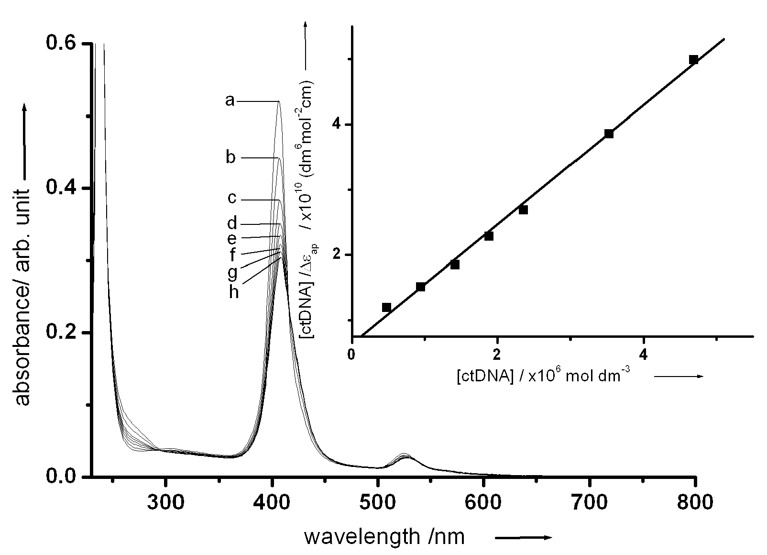

Figure S5. UV-vis spectral changes of [Au^{III}(TPP)]Cl in Tris buffer (5 mM Tris, 5 mM NaCl, pH 7.2) with increasing concentration of ctDNA: (a) r = 0, (b) r = 0.21, (c) r = 0.41, (d) r = 0.62, (e) r = 0.83, (f) r = 1.03, (g) r = 1.24, and (h) r = 1.45 at 292.8 K. Inset: plot of [ctDNA] / Δε_{ap} vs [ctDNA]. Absorbance was monitored at 410 nm

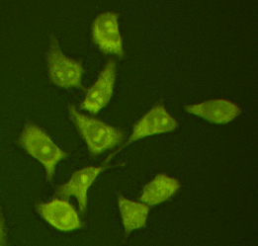
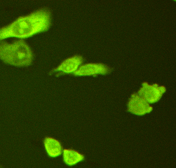
(b)
(a)

Figure S6. Laser confocal micrographs of the HeLa cells treated with [Au^{III}(TPP)]Cl (0.5 μM) at time interval of (a) 0 h and (b) 15 h. The formation of apoptotic bodies are marked by a red circle

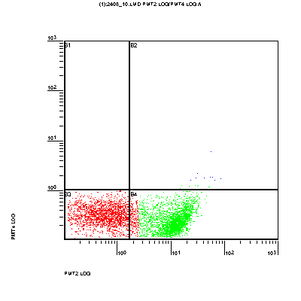
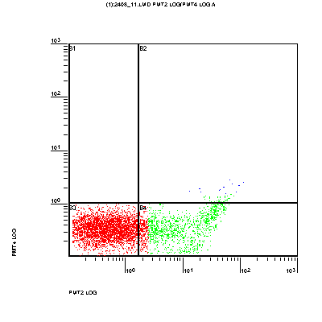
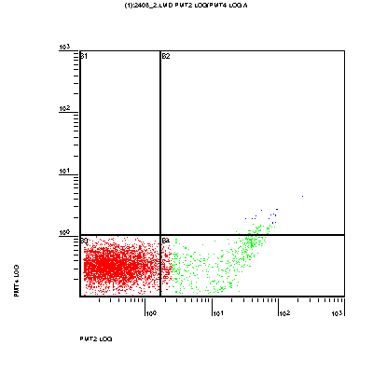
PI
emission
annexin-V FITC emission
annexin-V FITC emission
annexin-V FITC emission
(a)
(b)
(c)

Figure S7. Flow cytometric studies of the [Au^{III}(TPP)]Cl (1a)-induced apoptosis of the HeLa cells. Plots show the occurrence of events as functions of propidium iodide (PI; y-axis) and annexin V-fluorescein (x-axis) fluorescence intensities. Panel (a) shows the fluorescent data for the untreated cells as negative control, corresponding to 9.8 % apoptotic cells after 15 h incubation. Panels (b) and (c) show the fluorescent data for the cells treated with 1a (0.5 μM), corresponding to 24.6% (time = 6 h) and 57.3% (time = 15 h) apoptotic cells respectively
Table S1. Reduction potentials of [Au^{III}(p-Y-TPP)]Cl
entry | Y | couple I ^{[a]}/V | couple II ^{[a]}/V
1 | Cl | -0.96 | -1.44
2 | Br | -0.97 | -1.45
3 | H | -1.00 | -1.48
4 | Me | -1.01 | -1.49
5 | OMe | -1.02 | -1.51

[a] Couples I and II (vs Cp₂Fe^{+/0}) correspond to the first and second reductions of [Au^{III}(p-Y-TPP)]Cl respectively.

Table S2. Crystallographic Data for [Au^{III}(TPP)]ClO₄
empirical formula C₄₄H₂₈AuClN₄O₄
formula weight 909.12
temperature 253(2) K
wavelength 0.71073 Å
crystal system Orthorhombic
space group P n n a
unit cell dimensions a= 8.1020(16) Å α= 90º
b= 20.964(4) Å β= 90º
c= 20.060(4) Å γ= 90º
volume 3407.2(12) Å
Z 4
density (calculated) 1.772 mg/m³
absorption coefficient 4.451 mm⁻¹
F(000) 1792
crystal size 0.4 x 0.1 x 0.1 mm³
theta range for data collection 1.40 to 25.63º
index ranges -9<=h<=9, -24<=k<=25, -24<=l<=24
reflections collected 13426
independent reflections 3006 [R(int) = 0.0478]
completeness to theta = 25.63º 95.3 %
absorption correction None
refinement method Full-matrix least-squares on F²
data / restraints / parameters 3066 / 0 / 248
goodness-of-fit on F² 0.934
final R indices [I>2sigma(I)] R₁ = 0.0308, wR₂ = 0.0790
R indices (all data) R₁ = 0.0645, wR₂ = 0.1040
largest diff. peak and hole 0.716 and –1.590 e Å⁻³

Table S3. Percentage apoptotic and necrotic/late-apoptotic cell death induced by 1a

 | incubation time (h) | apoptosis (%) | necrosis /late apoptosis (%)
blank (-ve control) | - | 4.4 | 2.6
straurosporine (+ve control) | 2 | 27.7 | 3.0
 | 6 | 55.1 | 1.9
 | 15 | 76.9 | 0.3
 | 24 | 21.9 | 29.3
1a (IC₄₀) | 2 | 8.6 | 3.4
 | 6 | 19.4 | 1.7
 | 15 | 32.4 | 4.7
 | 24 | 24.1 | 30.1
1a (IC₆₀) | 2 | 27.7 | 4.8
 | 6 | 45.6 | 1.5
 | 15 | 64.2 | 2.4
 | 24 | 19.1 | 32.3

Table S4. IC₅₀ ratios for [Pt(NH₃)₂Cl₂] and the Au(III) porphyrins

 |  |  |  | IC₅₀ ratio [Pt(NH₃)₂Cl₂ / Au(III) porphyrins]
entry | compound | KB-3-1 |  |  | HeLa | SUNE1 |  | KB-V1 | CNE1
1 | 1a | 17.8 |  |  | 40.0 | 114.5 |  | 25.1 | 240.2
2 | 1b | 32.1 |  |  | 21.5 | 11.5 |  | 18.4 | 41.2
3 | 1c | n.d.^{[a]} |  |  | 17.0 | 18.5 |  | n.d.^{[a]} | 53.0
4 | 1d | 10.3 |  |  | 12.6 | 17.0 |  | 8.96 | 41.6
5 | 1e | 26.4 |  |  | 16.2 | 37.1 |  | 20.4 | 99.5

[a] n.d. = not determined

