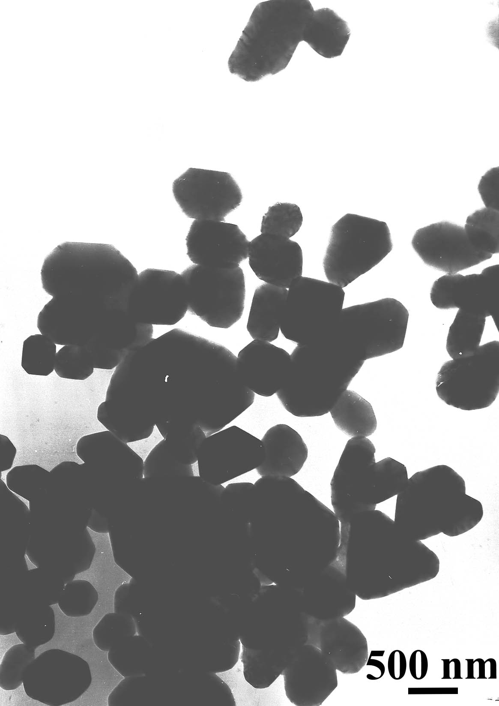
Figure S1: products obtained at the same condition as figure 3(a) except that concentration increased to 0.04M.
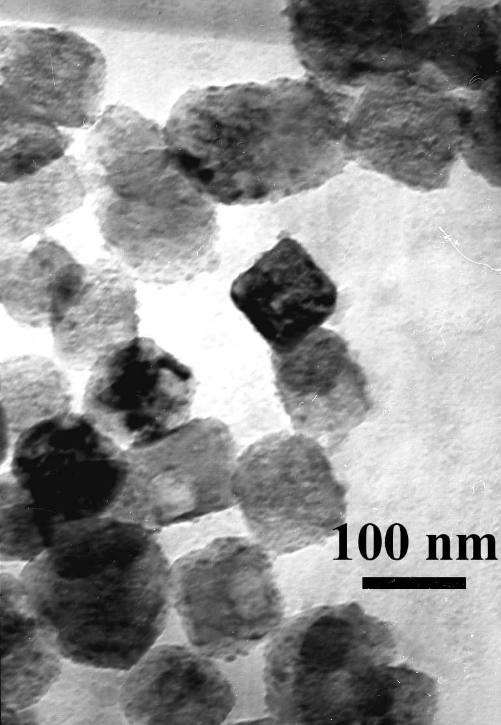
Figure S2 products obtained at the same condition as figure 4(a) except that pH value increased to 9.

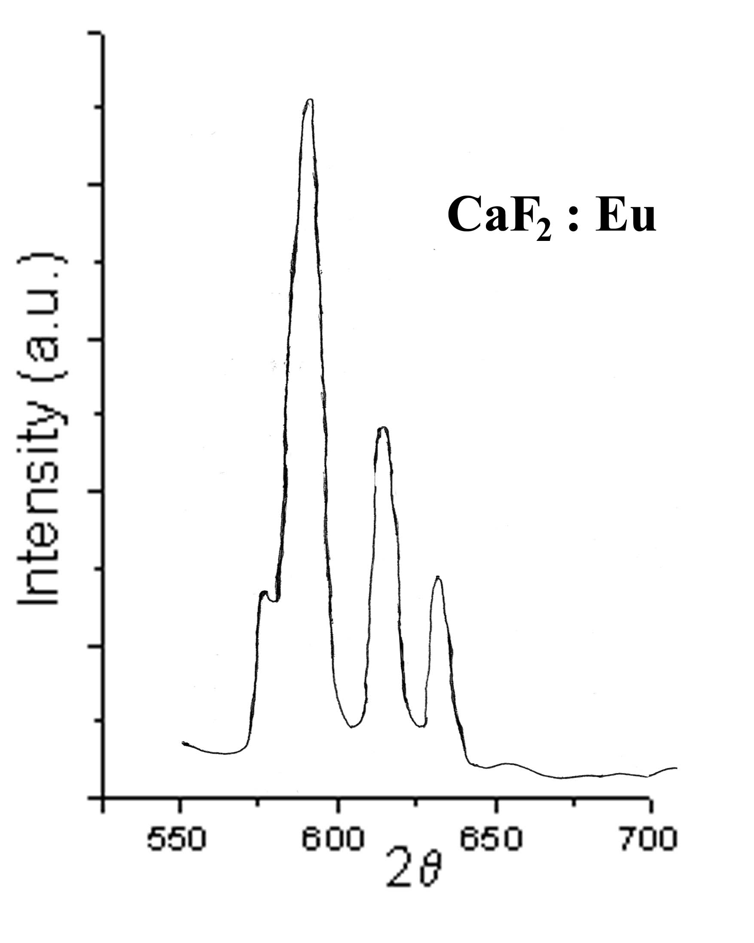
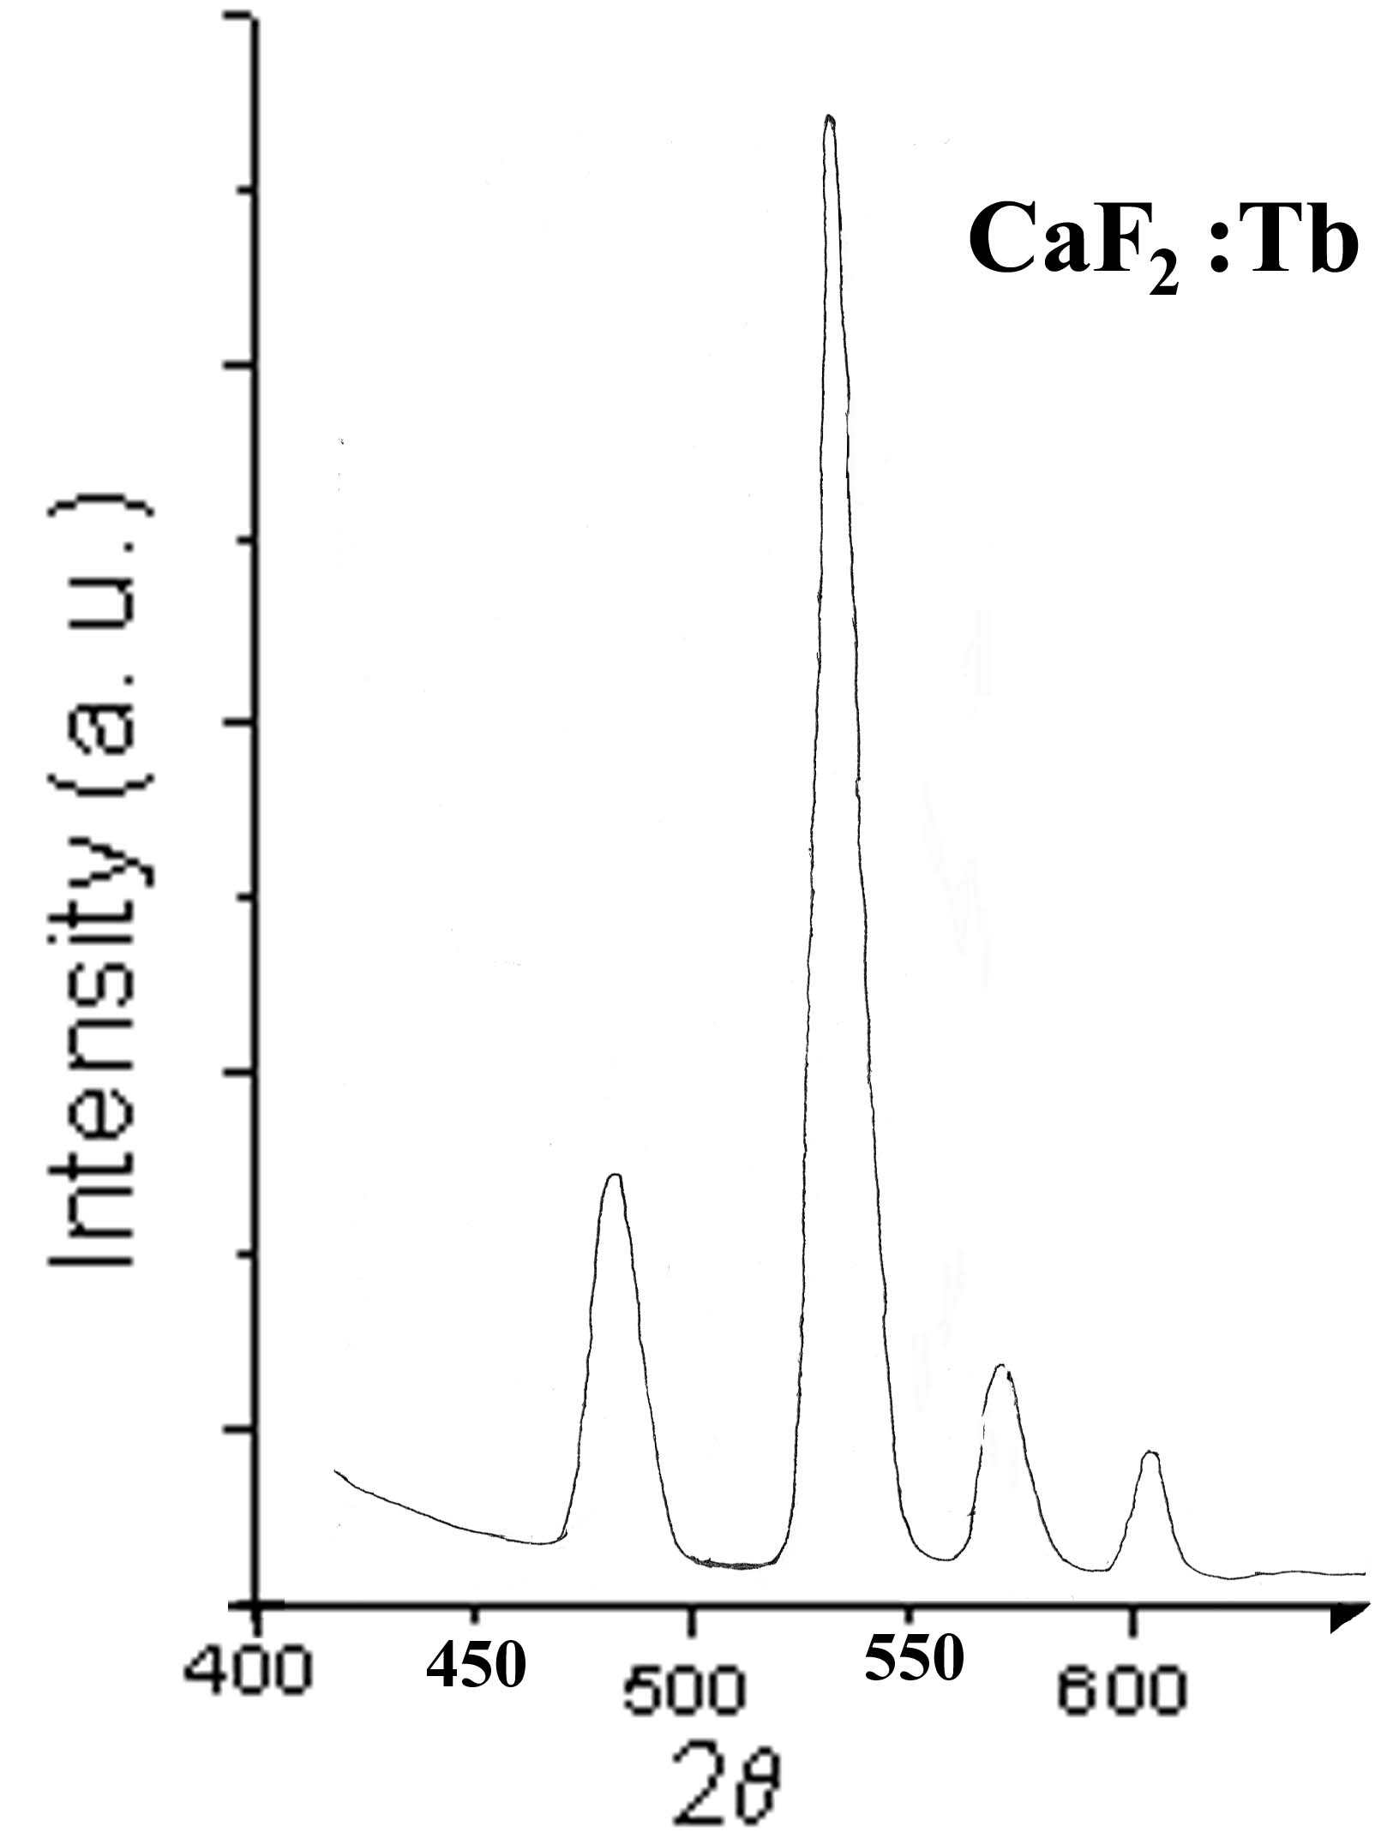
a b
Figure S3 Photoluminescence spectra of CaF₂ nanocubes doped with: a) Eu (III) and b)Tb(III).

