Supplementary information for

Monodispersed ZnO nanoparticles from a single molecular precursor

Chang G. Kim, Kiwhan Sung, Taek-Mo Chung, Duk Y. Jung,ª and Yunsoo Kim*
Thin Film Materials Laboratory, Advanced Materials Division, Korea Research Institute of Chemical Technology, Yuseong P.O. Box 107, Daejon 305-600, Korea
E-mail: yunsukim@krict.re.kr

ªDepartment of Chemistry, Sungkyunkwan University, Suwon 440-746, Korea

Experimental section

General procedure:
All manipulations were performed under an inert atmosphere using standard Schlenk line techniques or in a glove box. The solvents and 2-propanol was dried and distilled prior to use. Et₂Zn (1.0 M in hexane) purchased from Aldrich Chemical Co. was used without further purification.

Synthesis of EtZnO^{i}Pr
A 125 mL Schlenk flask was charged with Et₂Zn (25 mL, 24 mmol), a magnetic spin bar and 50 mL of hexane. To this reaction mixture, HO^{i}Pr (1.5 g, 24 mmol) was added slowly at 0 ºC for 10 h. The solution was filtered to remove impurity and the solvent from the filtrate was removed in vacuo to yield a white solid product. Finally, pure white crystalline products were obtained by sublimation (at 100 °C and 10⁻² Torr) (2.94 g, 80%).

NMR spectrum of EtZnO^{i}Pr

¹H NMR (300 MHz, C₆D₆): δ 0.57 (q, CH₃CH₂Zn),
1.18 (d, ZnOCH(CH₃)₂ ), 1.53 (t, CH₃CH₂Zn), 3.99 (m, ZnOCH(CH₃)₂ )
Preparation of ZnO nanoparticles
EtZnO^{i}Pr (1.5 g, 9.77 mmole) and trioctylphosphine oxide (10 g, 19.54 mmol) were placed into a round-bottom flask equipped with a condenser and a bubbler. The solid mixture was slowly heated to dissolve homogeneously up to 80 °C. The clear solution mixture was then stirred at 160 °C for 5 h. During the reaction at 160 °C, gaseous products were generated. ZnO nanoparticles were separated from the solution by centrifugation after a simple workup, in which the solid product was dissolved in a small amount of toluene and flocculated with the addition of excess methanol. The workup could be repeated several times. 0.75 g of TOPO-stabilized ZnO nanoparticles was obtained after vacuum drying. The yield of the product is 78.7 % based on the Zn content by inductive coupled plasma-atomic emission spectrometry (ICP-AES). The ZnO nanoparticles stabilized with TOPO were well dispersed in organic solvents.

GC-MS data for the gaseous products collected in a liq. N₂ trap: (a) ethane from the products (upper) and a known spectrum of ethane (bottom), (b) propene from the products (upper) and a known spectrum of propene (bottom).

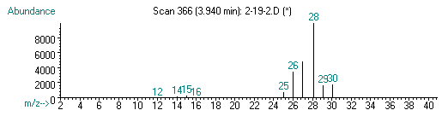

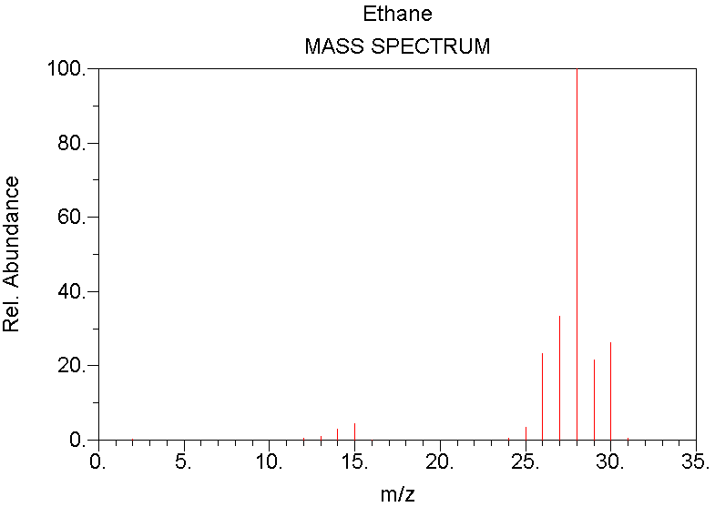

(a) Ethane from products (upper) and known spectrum of ethane (bottom).
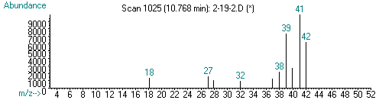

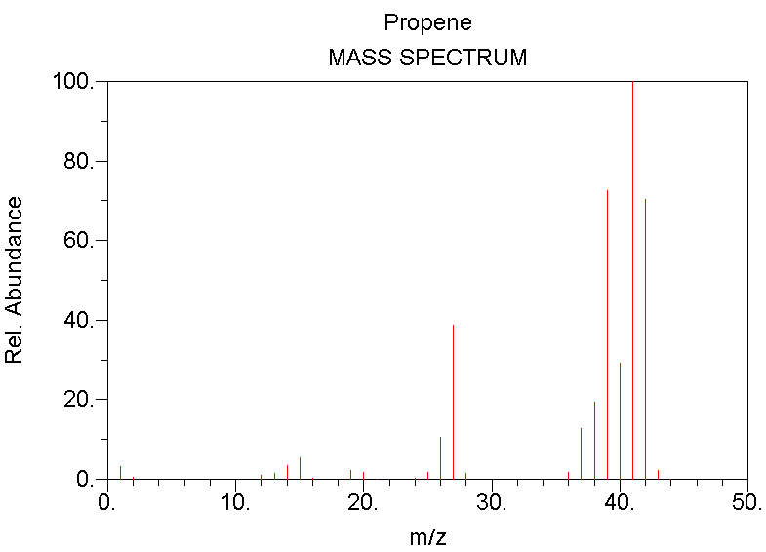

(b) Propene from products (upper) and a known spectrum of propene (bottom).

Infrared spectrum of ZnO nanoparticles

Energy-dispersive x-ray analysis (EDAX) of ZnO nanoparticles
